Top Alternative

Alt Path: |ADMS_Cyient

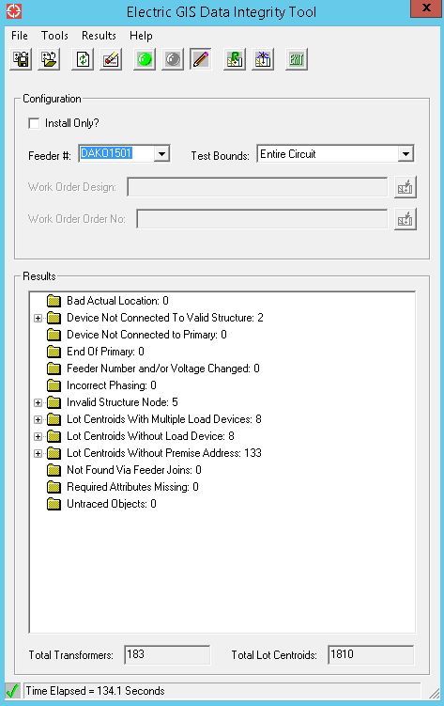

Delivered Alternative

Alt Path: |ADMS_Cyient|Extended_Pilot|DAKO1501

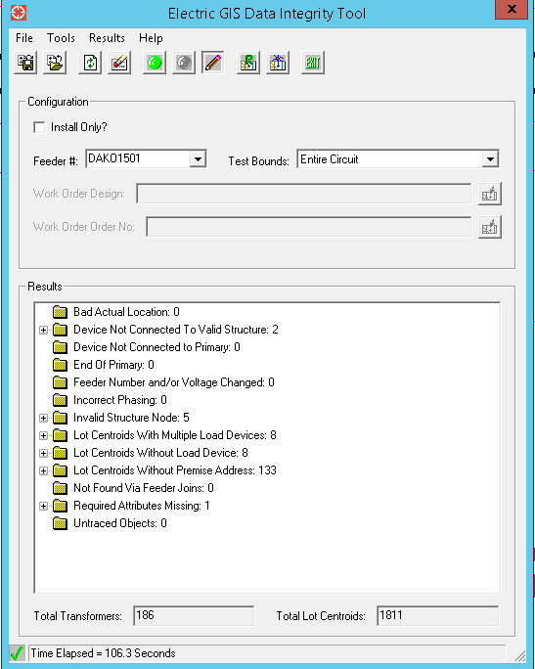

**Required Attributes Missing: 1**

**OH Fuse: 1**

* New Inserted feature, Values not found on Field