Top Alternative

Alt Path: |ADMS_Cyient

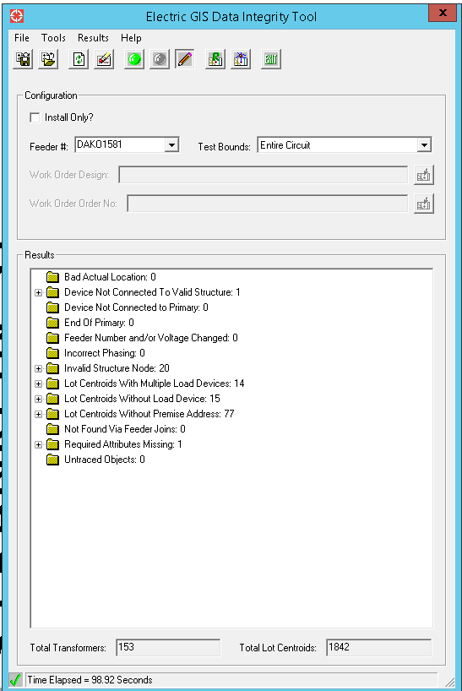

Delivered Alternative

Alt Path: |ADMS_Cyient|Extended_Pilot|DAKO1581

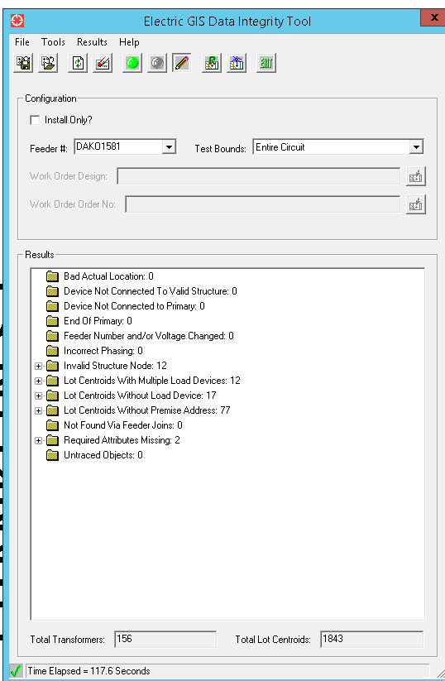

**Required Attibutes Missing: 2**

* New Inserted features, Values not found on Field.