Top Alternative

Alt Path: |ADMS_Cyient

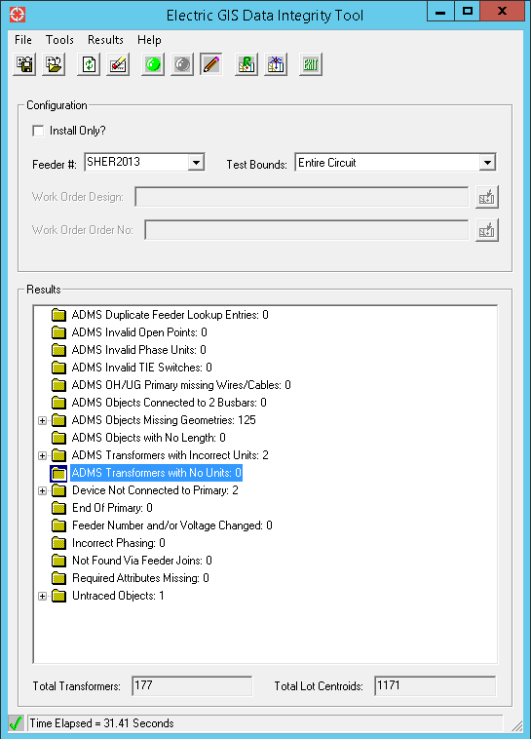

Delivered Alternative

Alt Path: |ADMS_Cyient|Extended_Pilot|SHER2013

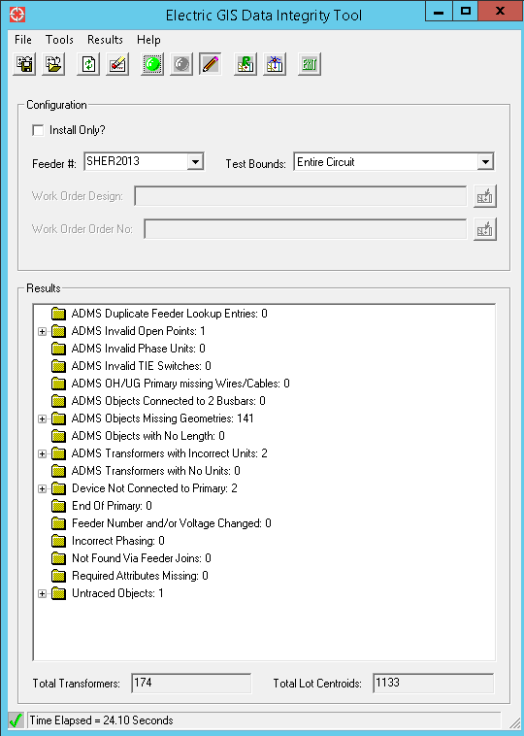

**ADMS Invalid Open Points: 1**

* OH Fuse: 1
* As per vendor photo fuse Normal positions are apeared as Open. Hence these are reported as Invalid Open Points.

**ADMS Objects Missing Geometries: 141**

* Newly inserted features doesn’t have actual route.