Top Alternative

Alt Path: |ADMS_Cyient

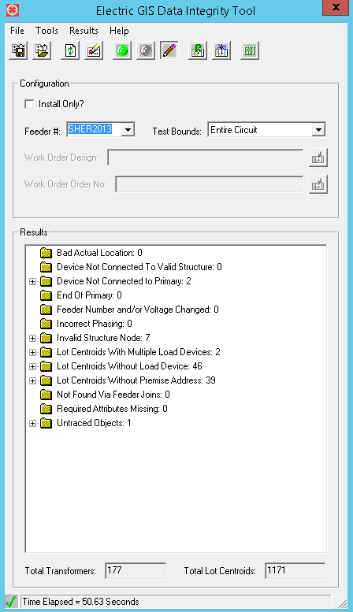

Delivered Alternative

Alt Path: |ADMS_Cyient|Extended_Pilot|SHER2013

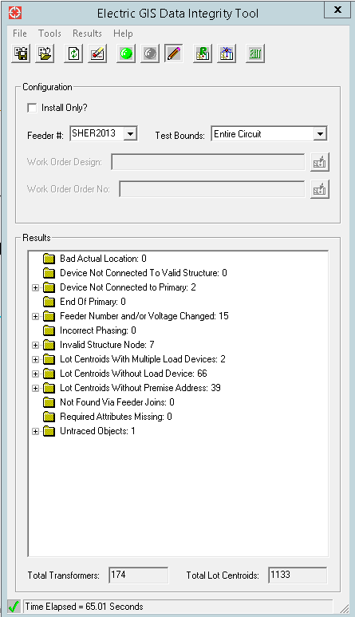

**Lot Centroids Without Load Device: 66**

* Merge down issue. Related Transformers deleted while mergedown.