Assignment SAMPLE SIZE AND CASE STUDY
2 USERS | ADMIN TO APPROVE
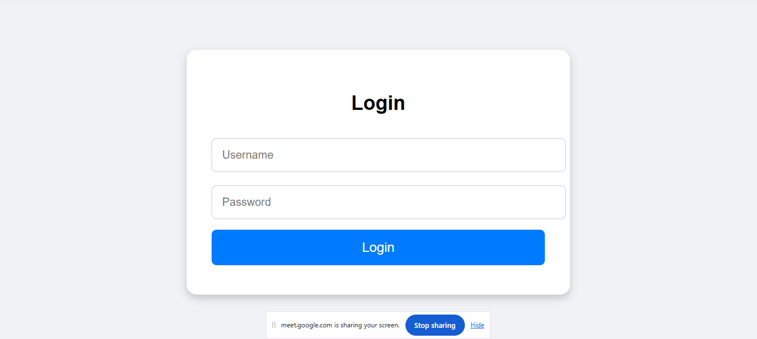
Forgot password
Reset password

Sign up
Email

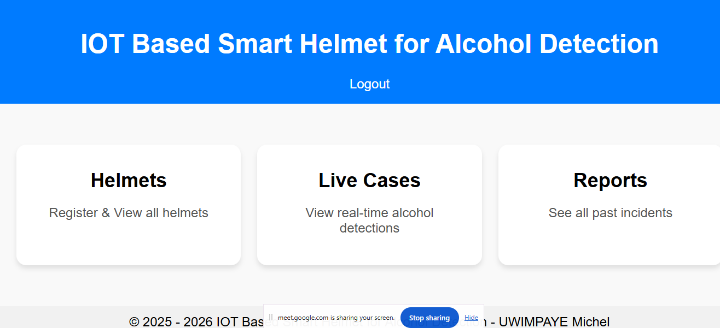
Sessions on each page to ensure security
(USER)REGISTER

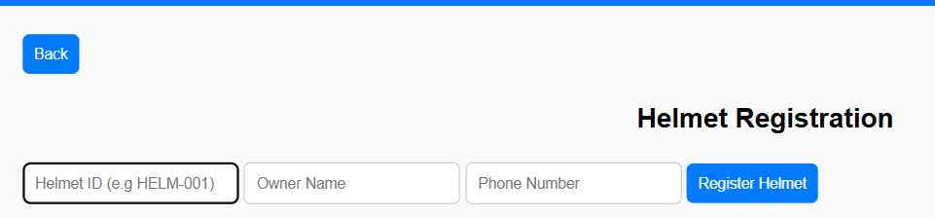
SCROLL
ID (LANDRY-PRACTICE)
FORMAT
PRINT
SEARCH
VALIDATION
PLATE NO
PROVIDE YOUR CODE

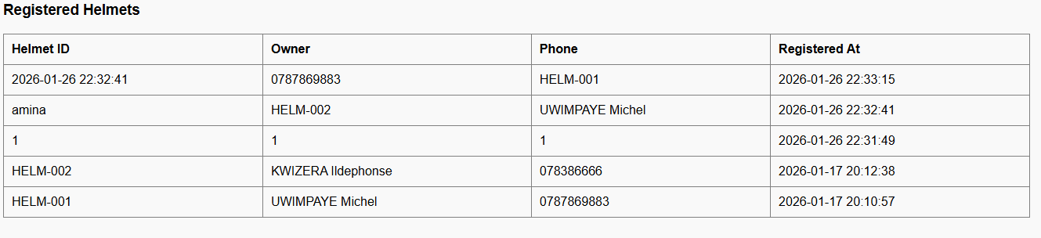
ACTIONS(UPDATE/VIEW ALL
/DISABLE)
FIX FOOTER AND HEADER(ADD PROFILE SETTINGS/LOGOUT)
javascRIPT

