📘 Arduino Uno Ultrasonic Sensor with LED Alert – Project Documentation

🧾 Project Title
Proximity-Based LED Alert System Using Ultrasonic Sensor and Arduino Uno

🎯 Objective
To build a simple embedded system using an ultrasonic distance sensor and an LED that turns ON when an object is detected within a distance of 10 cm.
🧰 Components Required
Component | Quantity
Arduino Uno | 1
Ultrasonic Sensor (HC-SR04) | 1
LED | 1
220Ω Resistor (for LED) | 1
Breadboard | 1
Jumper wires | as needed

🧠 Working Principle
The HC-SR04 ultrasonic sensor emits sound waves and listens for the echo. The time delay between sending and receiving the echo is used to calculate the distance of an object.
If the measured distance is less than 10 cm, an LED connected to a digital pin is turned ON; otherwise, it remains OFF.
🔌 Circuit Connections
Ultrasonic Sensor Pin | Arduino Pin
VCC | 5V
GND | GND
Trig | Pin 13
Echo | Pin 12

LED Terminal | Arduino Pin
Anode (+) | Pin 11 (via 220Ω resistor)
Cathode (–) | GND

💻 Code (main.cpp)
Place this code in src/main.cpp if you're using PlatformIO:
#include <Arduino.h>

// Define pin connections
#define trigPin 13
#define echoPin 12
#define led 11

void setup() {
Serial.begin(9600);
pinMode(trigPin, OUTPUT);
pinMode(echoPin, INPUT);
pinMode(led, OUTPUT);
}

void loop() {
long duration;
float distance;

// Send ultrasonic pulse
digitalWrite(trigPin, LOW);
delayMicroseconds(2);
digitalWrite(trigPin, HIGH);
delayMicroseconds(10);
digitalWrite(trigPin, LOW);

// Measure echo duration
duration = pulseIn(echoPin, HIGH);

// Convert time to distance (cm)
distance = (duration / 2.0) / 29.1;

// LED alert logic
if (distance < 10) {
digitalWrite(led, HIGH);
} else {
digitalWrite(led, LOW);
}

// Print distance to Serial Monitor
Serial.print("Distance: ");
Serial.print(distance);
Serial.println(" cm");

delay(500); // Delay for stability
}

⚙️ PlatformIO Setup (platformio.ini)
[env:uno]
platform = atmelavr
board = uno
framework = arduino
monitor_speed = 9600

🧪 Testing Procedure
- Connect all components on a breadboard as per the circuit diagram.
- Upload the code to the Arduino Uno using PlatformIO.
- Open the Serial Monitor.
- Place an object in front of the ultrasonic sensor.
- Observe:
  - If the object is closer than 10 cm, the LED turns ON.
  - If farther, the LED stays OFF.
  - Serial Monitor shows the distance.

📌 Applications
- Obstacle detection systems
- Smart parking sensors
- Distance-based triggering devices

✅ Conclusion
This project demonstrates the integration of an ultrasonic sensor with a basic output device (LED) using Arduino Uno. It forms a foundational understanding of how to use sensor data for real-time control and feedback in embedded systems.
APPENDIX:
    - Wiring Diagram
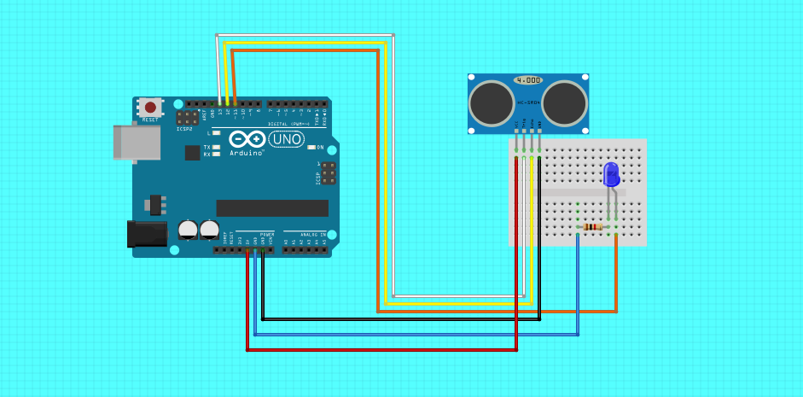
    - PROJECT RESULTS:
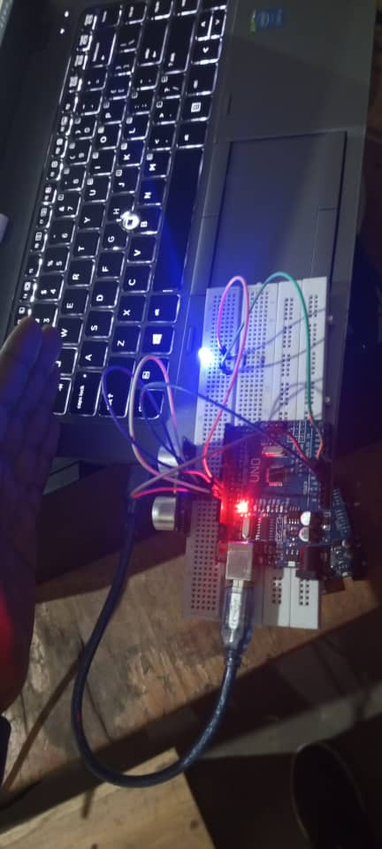 | 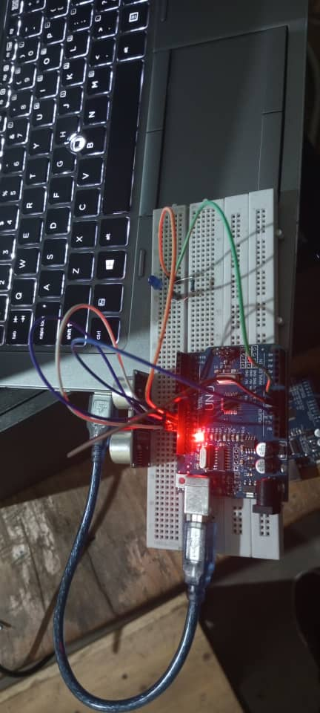

DONE BY:
1. MPAYIMANA CYIZA Landry – DEVELOPER
2. UKWISHAKA PHILEMON - CO DEV
3. IYOKWIRINGIRWA ABDOUL YAHAYA RAMADHAN—CO DEV
4. BYIRINGIRO HERO BLESS – CO DEV
5. MUTSINDASHYAKA Bertin—CO DEV

