Baseline Site Plan

Michael Hanis

WDD 130

Overview

Purpose
To give brief information about topics people may be interested in, including historical events or famous people.

Audience
Anybody looking to study a particular topic and wanting to know a brief rundown about it

Branding

Website Logo


Style Guide

Color Palette
Primary | Secondary | Accent 1 | Accent 2
#101418 | #242e37 | #1c3735 | #033720

Typography

Heading Font: Times New Roman

Paragraph Font: Sans Serif

Navigation
Home Pages Random Page

Content

[put all content for the pages here, including written text and images]

Nav Bar: Home | All Pages | Random Page
Footer: [Home | All Pages | Random Page] [Created in 2025]
Home Page

Baseline is a site for anyone wishing to get quick information about a topic. It has brief descriptions about various topics which people can learn and then build their knowledge off.

Random Topic:
[Selects a random topic using javascript, displays its main photo and information, background color is accent 1, border color is accent 2]

View All Pages [links to ‘all pages’ page]

All Pages

Every topic currently available on baseline, with more hopefully to come.

George Washington [links to ‘George Washington’ Page]

Michael Jackson [links to ‘Michael Jackson’ Page]

Among Us [links to ‘Among Us’ Page]

Lorem Ipsum [links to ‘Lorem Ipsum’ Page]
George Washington

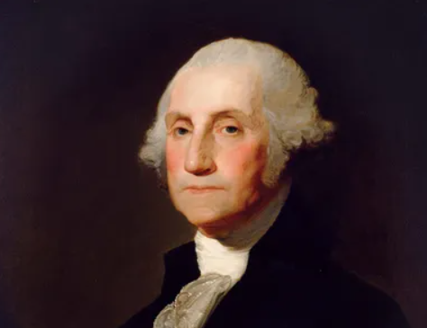

George Washington was the first president of the United States. He served his term with Vice President John Adams and held office for two four-year terms. He was born February 22, 1732, and died December 14, 1799. He served as a commander in the Continental Army, and led his forces against the British in the Revolutionary War.

Michael Jackson


Born August 29, 1958, Michael Jackson became a pop superstar, being known as the King of Pop. He started his career in The Jackson 5, a band comprised of him and his 4 brothers. He later went on to perform solo, and was considered one of the greatest artists of all time. Popular albums include Thriller, Bad, Off the Wall, and Dangerous. Popular songs include Thriller, Billie Jean, and Smooth Criminal. Michael Jackson died on June 25, 2009.

Among Us

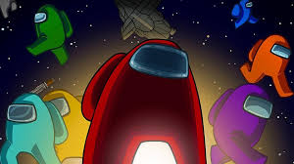

Among Us is a game developed by the team Innersloth on PC, Console, and Mobile, first released June 15, 2018. Up to 15 players can play in one game. In a game, there are 1-3 ‘impostors,’ who are tasked with killing off the rest of the players. The other players must either complete all the tasks which they are given, or deduce and vote out the impostors before they are all killed.

Lorem Ipsum

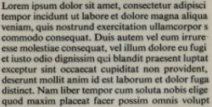

Lorem Ipsum is a type of placeholder or flavor text used in things such as web development and graphical design. It is generally used to signify where text will be in a website, before the actual text is planned out. It is a scrambled version of an old text from 45 BC, with ‘lorem ipsum dolor sit amet’ being a scrambling of ‘dolorem ipsum’, meaning ‘pain itself’.

[planned with javascript in mind, since we haven’t gone over javascript just link ‘random page’ button to a topic and display a topic on the home page]

Wireframes

Home
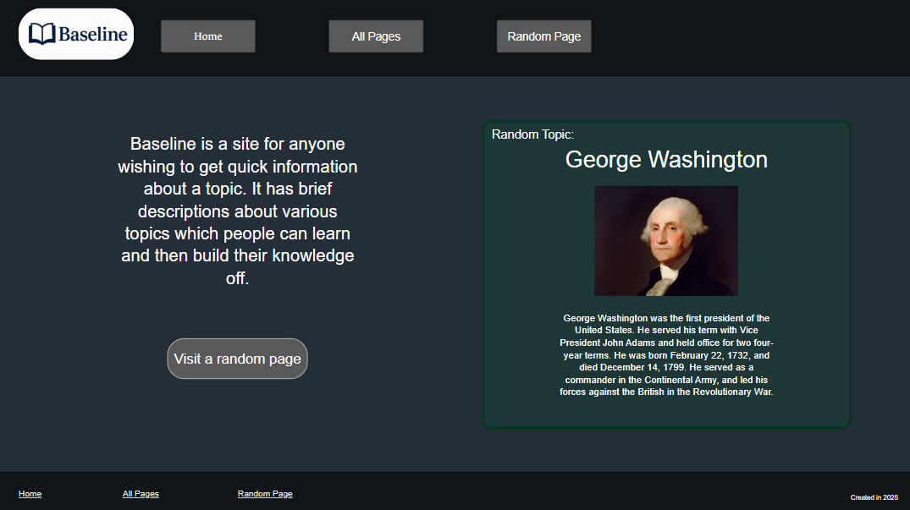
Topic Page [replace picture and text with the ones appropriate for the topic]
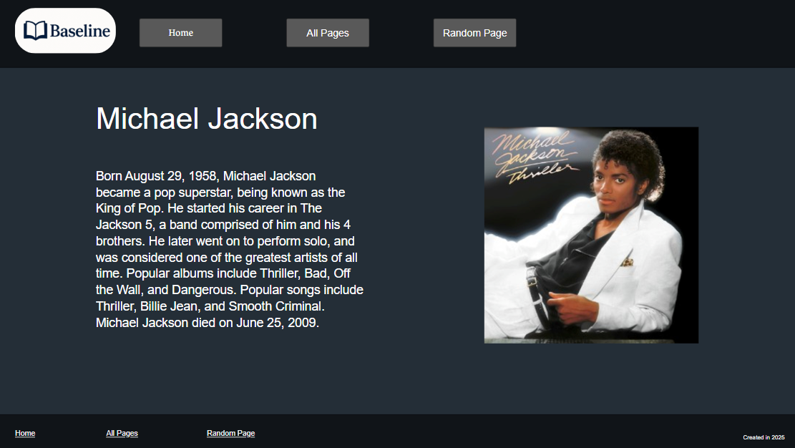

All Pages
