First visualisation

[https://data-explorer.oecd.org/vis?tm=Malaysia&pg=0&snb=127&vw=rw&df[ds]=dsDisseminateFinalDMZ&df[id]=DSD_REV_ASAP%40DF_REVMYS&df[ag]=OECD.CTP.TPS&df[vs]=1.0&dq=..S13....A&lom=LASTNPERIODS&lo=10&to[TIME_PERIOD]=false&ly[cl]=TIME_PERIOD&ly[rs]=REF_AREA%2CCOMBINED_UNIT_MEASURE&ly[rw]=COMBINED_MEASURE](https://data-explorer.oecd.org/vis?tm=Malaysia&pg=0&snb=127&vw=rw&df%5bds%5d=dsDisseminateFinalDMZ&df%5bid%5d=DSD_REV_ASAP%40DF_REVMYS&df%5bag%5d=OECD.CTP.TPS&df%5bvs%5d=1.0&dq=..S13....A&lom=LASTNPERIODS&lo=10&to%5bTIME_PERIOD%5d=false&ly%5bcl%5d=TIME_PERIOD&ly%5brs%5d=REF_AREA%2CCOMBINED_UNIT_MEASURE&ly%5brw%5d=COMBINED_MEASURE)

This dataset provides detailed information on Malaysia’s tax revenue from 1990 onwards, presented in Malaysian Ringgit (MYR). It includes both tax and non-tax revenues, classified according to the OECD Revenue Statistics methodology. The data allows for comparison of tax revenue levels and structures across 36 Asian and Pacific economies, as well as with OECD member countries. The dataset is part of the “Revenue Statistics in Asia and the Pacific” annual publication, produced in collaboration with the Asian Development Bank (ADB), the Pacific Islands Tax Administrators Association (PITAA), and the Pacific Community (SPC). The dataset contains 5095 unfiltered data points and was last updated on June 25, 2024.

This bar chart illustrates tax revenue on the y-axis and tax categories on the x-axis, covering data from 2013 to 2022. Each year includes multiple data points, with many values being similar. The chart displays both tax and non-tax revenues. Due to the high volume of information, the columns are very thin, making them difficult to discern. Additionally, the bars are all the same color, and there are spaces between the columns.

There are several areas for improvement in this bar chart. For instance, categorizing the data by year could help manage the high data density. Grouping multiple columns from the same year together would allow viewers to compare values more effectively across different years.

To enhance visual clarity, using different colors and adjusting the size of the bars can help differentiate between data categories. The size of the bars can also indicate the magnitude or importance of data points. For example, setting the same color for bars representing the same year would make the chart easier to interpret.

The same dataset can also be displayed using a timeline graph, which plots tax revenue on the y-axis and years on the x-axis. This type of graph illustrates how individual data points change over time, showing historical trends and their relationships to other data points. While the lower half of the graph may appear cluttered, the overall flow of data across the years is clearly visible.

However, a significant drawback of using a timeline graph is that an excessive amount of data can lead to confusion, as overlapping data points may obscure the information and make it difficult for viewers to interpret the graph accurately.

This vertical symbol graph displays tax revenue on the y-axis, similar to the bar chart, but categorized by time period. It shows the number of different data points (tuples) within the dataset. By reducing the amount of data displayed in each column, this graph enhances readability and makes it easier to interpret the information.

Second visualisation

[https://data-explorer.oecd.org/vis?tm=Malaysia&pg=0&snb=128&vw=sp&df[ds]=dsDisseminateFinalDMZ&df[id]=DSD_CBCR%40DF_CBCRII&df[ag]=OECD.CTP.TPS&df[vs]=1.0&dq=AUS..A....._T.&lom=LASTNPERIODS&lo=1&to[TIME_PERIOD]=false&ly[cl]=MEASURE%2CCOMBINED_UNIT_MEASURE&ly[rw]=COUNTERPART_AREA](https://data-explorer.oecd.org/vis?tm=Malaysia&pg=0&snb=128&vw=sp&df%5bds%5d=dsDisseminateFinalDMZ&df%5bid%5d=DSD_CBCR%40DF_CBCRII&df%5bag%5d=OECD.CTP.TPS&df%5bvs%5d=1.0&dq=AUS..A....._T.&lom=LASTNPERIODS&lo=1&to%5bTIME_PERIOD%5d=false&ly%5bcl%5d=MEASURE%2CCOMBINED_UNIT_MEASURE&ly%5brw%5d=COUNTERPART_AREA)

This table presents interquartile mean values for Country-by-Country Reporting (CbCR) based on the jurisdiction of tax residence or country groups, depending on confidentiality. It includes three sections: one for all sub-groups, one for sub-groups with positive profits, and one for sub-groups with negative profits. For the years 2016 and 2017, the table reported variable averages.

This stacked bar chart displays the counterpart area on the x-axis and the value of the combined unit of measures on the y-axis, representing the interquartile mean of a distribution for 2021. However, there is a distortion issue due to one column requiring a significantly large value, which causes the graph to extend and nearly obscure data with smaller values close to the x-axis. This issue can be resolved by using an appropriate map scale, such as a 1:1000 scale, where one unit on the graph represents 1000 units in the dataset. This approach ensures that all data points are visible and not overlooked by viewers.

Additionally, the chart’s color scheme poses a problem. The column bars are almost the same color as the background, with varying shades of darker blue. To improve readability, the graph should use distinct colors that are easily distinguishable. For example, the top stacked value in the first column is very similar to the background color, making it difficult to notice without a white border line. Using multiple, clearly differentiated colors would enhance the chart’s clarity.

Despite these issues, the graph successfully displays all data, including the largest values, maintaining the integrity of the dataset.

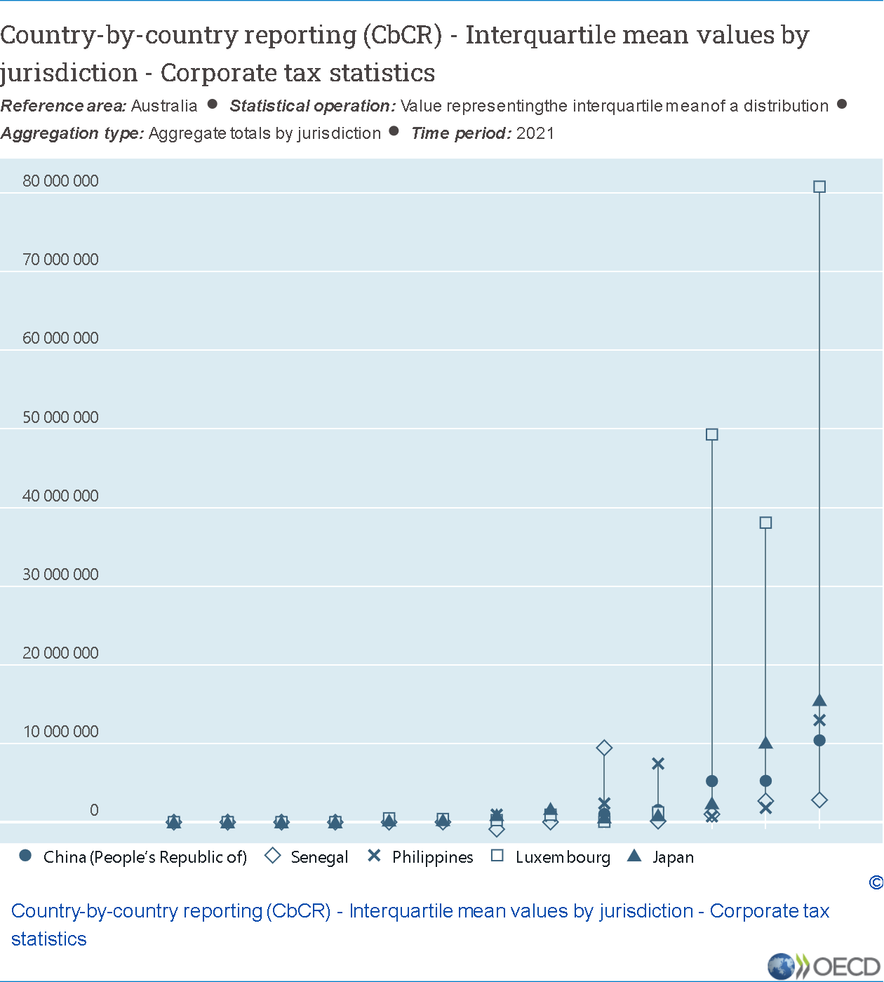

This vertical symbol graph displays unit measures on the y-axis, with shapes representing different countries. It addresses the issue found in the stacked bar chart by clearly displaying all values, even those close to the x-axis, ensuring that viewers are aware of these values. The graph effectively shows which country each shape corresponds to, and it avoids the problem of excessively tall columns.

Additionally, this graph does not require specific colors for the values, as it uses shapes and lines to represent the data. This makes the use of colors unnecessary, simplifying the visualization while maintaining clarity.

This bar chart displays the interquartile mean values of tax residence, with unit measures on the y-axis and counterpart areas on the x-axis. However, a bar chart may not be suitable for this dataset due to the significant gaps between data points, making it difficult for users to read. The bars are also very narrow, almost to the point where the lines between them can be ignored. This chart only provides an overview of the data flow and highlights the highest value, which is around 1.750 million.

Third visualisation

[https://data-explorer.oecd.org/vis?tm=%20currency&pg=0&snb=343&vw=br&df[ds]=dsDisseminateFinalDMZ&df[id]=DSD_PPP_M%40DF_PP_CPL_M&df[ag]=OECD.SDD.TPS&df[vs]=1.0&dq=.M....&lom=LASTNPERIODS&lo=1&to[TIME_PERIOD]=false&ly[cl]=COUNTERPART_AREA%2CCURRENCY&ly[rw]=REF_AREA](https://data-explorer.oecd.org/vis?tm=%20currency&pg=0&snb=343&vw=br&df%5bds%5d=dsDisseminateFinalDMZ&df%5bid%5d=DSD_PPP_M%40DF_PP_CPL_M&df%5bag%5d=OECD.SDD.TPS&df%5bvs%5d=1.0&dq=.M....&lom=LASTNPERIODS&lo=1&to%5bTIME_PERIOD%5d=false&ly%5bcl%5d=COUNTERPART_AREA%2CCURRENCY&ly%5brw%5d=REF_AREA)

This dataset presents monthly Comparative Price Levels (CPL) for OECD countries. CPLs are calculated as the ratios of Purchasing Power Parities (PPPs) for private consumption to exchange rates, reflecting price differences between countries. Each column in the table indicates the number of monetary units required in each country to purchase the same basket of goods and services, with the base country set at 100. For instance, if Canada’s column is set at 100 and Finland’s is at 120, it signifies that prices in Finland are 20% higher than in Canada.

The monthly PPPs are derived from 2022 data, adjusted for inflation differences between countries. Typically, unless a country experiences high inflation, its PPP changes gradually. Month-to-month variations in CPLs are primarily due to exchange rate fluctuations.

This bar chart displays currency on the y-axis and different countries on the x-axis. This approach is effective for comparing simple currency values across countries. However, due to the high density of information, viewers need to hover over the bars to see the country names, as there is insufficient space to display them directly. When hovering, the country name and currency value are shown.

The main issue with this chart is the excessive amount of information, making it difficult to read. Adding color coding could improve clarity by highlighting different sections of the graph. For example, values between 0 and 50 could be colored red, values between 51 and 100 green, and so on. This would help users quickly grasp the data distribution and identify value ranges more easily.

This stacked column bar chart displays currency values on the y-axis and the currencies of various countries on the x-axis, comparing them with the currencies of five other countries (AUD, JPN, KOR, MXN, NOR). The chart is based on the values from the table. The stacked columns allow users to compare each country’s currency with the five reference currencies. However, since the ratios between the reference currencies and each country are almost the same, only the differences in the compared countries’ currencies are noticeable.

The color scheme of the stacked bar chart could be improved. Currently, it uses varying shades of blue, which, although distinguishable, could be made clearer with sharper, more distinct colors. This would make it easier for viewers to compare the data.

This is a stacked bar chart similar to the previous one, but it is based on percentages. It shows the percentage of each currency within the column, allowing for proportional comparison. Although the overall appearance is similar to the previous chart, there are subtle differences between each stacked bar, which become more noticeable when the value differences are larger.

The percentage-based stacked bar chart is useful for visualizing the relative proportions of each currency. It highlights how each currency contributes to the total, making it easier to compare different segments. For example, if one currency makes up a larger percentage in one column compared to another, this difference is immediately visible.

This chart is more effective when there is greater variation in the data. When the differences between values are more pronounced, it provides clearer insights into the distribution and importance of each currency. Using distinct colors for each segment can further enhance readability and make it easier to differentiate between currencies.

Overall, while this chart may not show dramatic differences in this dataset, it is valuable for highlighting relative proportions and can be especially informative with more varied data. It is beneficial for identifying trends and patterns over time, making it useful for both detailed analysis and high-level overview.

This vertical symbol chart compares the currencies of five countries (AUS, AUT, BEL, CHE, COL). Despite the lower half of the chart being cluttered with many lines, the overlapping shapes make it easy to view the graph. This chart allows users to compare the currency trends of one country against others. By categorizing the same countries in the same section, it helps viewers clearly see the relationships between them.

Conclusion:

There are many types of graphs and charts that can be applied to a dataset or table. However, it is crucial to select the one that is most suitable and useful for the viewers. Careful observation and analysis are necessary to determine the best graph or chart to use.

Reference:

<https://www.polymersearch.com/blog/10-good-and-bad-examples-of-data-visualization>

<https://medium.com/@lyc78339/5-ways-to-optimize-data-density-for-effective-visualization-c89426c27057#:~:text=By%20thoughtfully%20applying%20color%20and,or%20importance%20of%20data%20points>.