**Lab1**

Lab Task 1.1

<https://github.com/Cylim1507/COS30045/blob/main/COS30045/lab1/lab1-1.html>

Lab Task 1.2

<https://github.com/Cylim1507/COS30045/blob/main/COS30045/lab1/lab1-2.html>

Lab Task 1.3

<https://github.com/Cylim1507/COS30045/blob/main/COS30045/lab1/lab1-3.html>

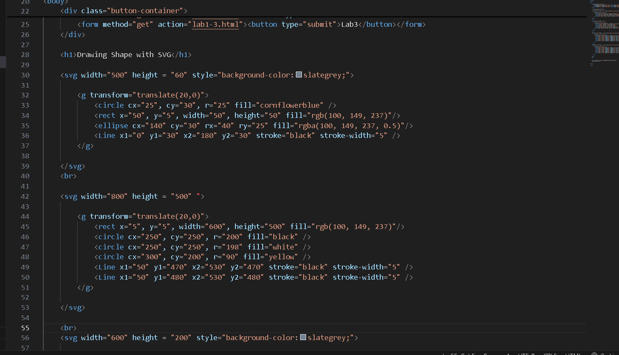

**Lab2**

Lab Task 2.1

<https://github.com/Cylim1507/COS30045/blob/main/COS30045/lab2/lab2-1.html>

Lab Task 2.2

<https://github.com/Cylim1507/COS30045/blob/main/COS30045/lab2/lab2-2.html>

Lab Task 2.3

<https://github.com/Cylim1507/COS30045/blob/main/COS30045/lab2/lab2-3.html>

Lab Task 2.4

<https://github.com/Cylim1507/COS30045/blob/main/COS30045/lab2/lab2-4.html>

<https://github.com/Cylim1507/COS30045/blob/main/COS30045/lab2/Task_2.4.js>

