DustCast
A dust-aware, uncertainty-calibrated forecasting platform for Tunisia's invisible rooftop solar
PESTGM 7.0 CDC Tech Challenge · Track 1: National Intelligent Platform for Forecasting Rooftop Solar Production · Technical Report
Summary. Tunisia has roughly 500 MW of residential rooftop PV that STEG cannot see. It is behind the meter, unmetered at the granularity that matters, and driven by weather the operator does not forecast at that scale. DustCast forecasts it at three temporal scales and three spatial scales, attaches a calibrated 90% uncertainty band to every number, models the Saharan dust that generic solar forecasting ignores, and converts all of it into three decisions: how much reserve to hold, when the ramp arrives, and which governorates to send a cleaning crew to. Every component is gated on a measurable criterion, every gate is reported including the ones that initially failed, and the upscaling method is validated against a real metered fleet rather than asserted.

1 The problem STEG actually has
As of end-June 2026 STEG reports approximately 500 MW of residential rooftop PV on the low-voltage network, plus 130 MW connected at medium and high voltage, inside a national PV fleet of about 895 MW (IRENA, 2026). The rooftop share is the problem: it is behind the meter, it is not telemetered, and it is weather-driven. The operator therefore carries more spinning reserve than necessary against a quantity it cannot observe, and is surprised by ramps it could have anticipated.
The constraint that shapes every design decision in this project is that no open Tunisian PV generation or per-site installation dataset exists. STEG and ANME publish nothing equivalent to Australia's CER postcode capacity data or the UK's Sheffield Solar PVLive. There is no registry to train on, no aggregate to validate against, and no ground truth for soiling. A platform for Tunisia has to be built so that it works without those things and says so plainly.
The question we set out to answer is therefore not “is my model accurate?” — which a scatter plot and an R² can answer — but “what should STEG do on Thursday?” An operator sizes reserve off the pessimistic edge of a forecast interval, not off the point forecast. A narrower interval that still contains the truth 90% of the time is directly worth money in avoided reserve. That is the argument the platform is built to make.

2 Approach
Four ideas, stacked. Each is independently defensible and each earns its place against a measured gate.

2.1 Physics first, machine learning on the residual
A clear-sky physical model (pvlib, Ineichen–Perez, PVWatts DC and inverter models) computes what a panel should produce from sun geometry, array tilt and azimuth, and forecast weather. The machine-learning layer never predicts power; it predicts only the gap:
residual = measured power − clear-sky physics prediction
This target has no diurnal cycle, no seasonal cycle, and no dependence on installed capacity — physics has removed all three. What remains is a small, roughly zero-centred loss signal driven by cloud, heat, dust and forecast bias. It needs far less training data than raw power, and it generalises across climates because loss mechanisms are physical and portable in a way that a site-specific power curve is not. That is what makes training on Australian data and deploying in Tunisia defensible.

2.2 Uncertainty as a first-class output
Every forecast carries a conformal prediction interval — distribution-free, model-agnostic, with a finite-sample coverage guarantee. Coverage (PICP) and sharpness (PINAW) are always reported together, because either alone is trivially gamed: a band from zero to infinity has perfect coverage and no value.

2.3 Saharan dust as the differentiator
Free CAMS forecasts of dust concentration and aerosol optical depth feed two physically distinct mechanisms: AOD attenuates today's beam, while surface dust deposits on glass and integrates into soiling over weeks. Almost no competing solution will model either. The mechanism is well established elsewhere — a March 2022 Saharan plume halved the Spanish national fleet's capacity factor for over two weeks, with an 80% peak-day drop (Micheli et al., 2024) — and those figures establish order of magnitude, not Tunisian values.

2.4 Spatial upscaling from a monitored sample
A small monitored sample is scaled to governorate and national totals by specific yield — sample output divided by sample capacity, multiplied by regional capacity. This is precisely how AEMO and Sheffield Solar / Open Climate Fix handle invisible distributed PV on real registries. Section 6 validates the method against a real metered fleet.

2.5 Why gradient boosting and not a transformer
This is an engineering decision, not a shortcut. A 2025 Tunisia-sited study (Rjim Matouk) found a Prophet plus mutual-information pipeline beat iTransformer, PatchTST, TimesFM, Chronos and SOFTS on MAPE with roughly 96% less training time, and flagged 6–13 h training and 156–507 ms inference as operational barriers. PatchTST is the strongest transformer for solar because its patching aligns with the diurnal cycle, but it does not reliably beat gradient boosting at site level and needs far more data than Tunisia has. We use XGBoost on the residual and spend the complexity budget on uncertainty, dust and upscaling — the parts that change the operator's decision.

3 Data
Source | Role | Coverage | Cost
DKASC Alice Springs | Training target — real desert PV output | 17 yr, 5-min | free
Open-Meteo forecast | Live weather, 15-min and hourly | global, real-time | free
Open-Meteo archived forecast | NWP at known lead times, for calibration | 2022-09 onward | free
Open-Meteo air quality (CAMS) | Dust concentration and AOD | 2022-08 onward | free
pvlib / PVGIS | Clear-sky physics, panel geometry | global | free
STEG / IRENA | National installed capacity only | aggregate | published
Table 1. Every data source is free and covers North Africa. There is no Tunisian generation or installation data in this list because none is published.
The training set is DKASC Alice Springs array 3 — a 4.95 kW fixed-tilt, roof-mounted poly-Si array with seventeen years of five-minute output. It was chosen as the closest structural analogue to a Tunisian residential rooftop in the whole DKASC fleet, in a hot, arid, dusty climate. The transfer assumption is stated openly in Section 9 and partially tested in Section 6.

4 Method

4.1 The physics layer, and what belongs in it
pvlib computes plane-of-array irradiance, cell temperature and AC power. Three quantities that a naive design would leave to the ML are deliberately placed here instead:
- Array ageing. Measured at −1.32 %/yr on the training array — roughly three times the 0.5 %/yr rule of thumb. A gradient-boosted tree cannot extrapolate a trending feature: trained on ages 0–13 and asked about age 16, every split routes the row to the same terminal leaf. Left in the ML target, a monotone 22% drift would survive into the test period as pure bias.
- Aerosol bias in the weather forecast. Measured against 9,041 well-lit DKASC hours, Open-Meteo's GHI runs 9.8% low in clean air and about 7% high once AOD passes 0.5, a smooth function of log(AOD). Correcting a measured bias in the input is stronger than hoping a tree rediscovers it from five weak columns, and it transfers on the mechanism.
- Low-sun beam instability. DNI recovered from the GHI/DHI closure explodes near sunrise. Bounding it by clear-sky DNI below 10° elevation cut a 5.2× over-prediction in the 0–2° band to 0.5×.

4.2 The residual model
XGBoost on 22 features, all computable from an NWP forecast at run time. No lagged measured power appears anywhere, because STEG cannot observe rooftop output — the deployment constraint the project exists to work around. Early stopping uses the chronological tail of the training window, never the calibration split, so the conformal guarantee stays intact. Training is restricted to daylight hours: night rows have a target of exactly zero and are half the record.
Two features were redesigned to make the Australia-to-Tunisia transfer valid at all. Compass azimuth does not transfer across hemispheres — DKASC's sun sits near 0° and Tunisia's near 180°, values the tree has never seen — so it is replaced by the sun's bearing relative to the panel, which reads zero at “straight ahead” everywhere. Day-of-year is worse than useless across the equator, since DKASC's summer is December; it is replaced by solar declination signed by hemisphere. Both changes also improved accuracy at the training site, lifting MAE skill from +6.5% to +12.2%.

4.3 Conformal calibration, and why the textbook version fails
Split conformal prediction guarantees marginal coverage only if the calibration and test hours are exchangeable. On this array they demonstrably are not: the base model's error standard deviation is 0.0885 kW over the 2022–23 calibration window and 0.1654 kW over 2024–25 — 1.8× wider. A band sized on the former cannot cover the latter, and the three static methods we tried all under-covered by 10–14 points.
The fix is to stop treating calibration as a one-off. The correction is recomputed from the errors observed in a trailing 60-day window, lagged 24 hours so nothing is used before it could have been known. This achieves 90.3% coverage against a 90% target. It carries a real deployment assumption: it needs measured output back within about a day, which exists only for the monitored sample sites the upscaling layer already depends on — and which is exactly what the hardware node in Section 7.3 provides.

4.4 Temporal scales
Forecast error was measured against lead time using Open-Meteo's archived forecasts and seventeen years of real output. Relative MAE is 18.2% at lead 0, 21.2% at lead 1, and 21.5% at lead 7 — it jumps once and then flattens. A seven-day forecast is barely worse than a one-day forecast.
The platform therefore publishes a 15-minute nowcast to 6 h, an hourly day-ahead to 48 h, and an hourly week-ahead to 168 h, and calibrates the nowcast separately. Reusing one correction across all three leaves the nowcast over-covering by 9 points and wasting three times the necessary band width. Day-ahead and week-ahead need corrections within 8% of each other, so they are honestly one product at two horizons rather than two — and we say so rather than claiming three.

4.5 Spatial scales and interval aggregation
Twenty-four governorates, nine sampled rooftop archetypes each, drawn from plausible tilt, azimuth, capacity and age distributions. The fleet effect matters: real rooftops are not all south-facing at optimal tilt, and a mixture of orientations produces a lower, flatter peak with fatter shoulders than a single optimal array would.
Summing the 24 regional interval widths assumes forecast errors are perfectly correlated across an 800 km country, which overstates the national band. Estimating the correlation from the clear-sky index gives ρ = 0.55, and the national width becomes 75% of the naive sum. Required reserve falls by roughly a quarter for the same confidence. Correlating the power forecasts instead returns ρ = 0.985 no matter what the weather is doing, because power is dominated by the diurnal cycle every governorate shares — the anomaly must be correlated, never the level.

5 Results
Every stage is gated on a criterion fixed before the result was known. All nine pass; two failed first and are reported as such in Section 10.
Step | Gate | Result | Verdict
1 | Residual model beats clear-sky physics alone | +9.2% MAE, +25.3% RMSE | PASS
2 | Coverage within ±3% of nominal 90% | 90.3% (rolling conformal) | PASS
3 | Runs end-to-end on real forecast data | 1,511 forecast hours, live | PASS
4 | Intervals widen on dust events | +17.7% at 90.3% coverage | PASS
5 | National number plausible vs installed capacity | 289 MW peak = 58% of 500 MW | PASS
6 | Demo-able | live operator dashboard | PASS
7 | Field node closes the loop | 88.5% → 53.1% coverage detects soiling | PASS
8 | Multiple temporal scales, each calibrated | worst coverage error +9.0% → +1.9% | PASS
9 | Upscaling validated on real measured data | 5.9% rMAE from a 1.6% sample | PASS
Table 2. Build gates. The reference baseline in step 1 is chosen automatically at run time as whichever non-ML baseline actually wins, so the comparison cannot be flattered by a weak comparator.

5.1 Forecast accuracy
Held-out test period 2024-01-01 to 2025-08-23, 4,715 daylight hours, all models scored on identical hours, 6.0 kW AC capacity.
Model | MAE kW | RMSE kW | nMAE % | Skill vs best baseline
Smart persistence | 0.3676 | 0.6407 | 6.13 | −190% / −191%
Clear-sky physics, raw | 0.7908 | 0.9048 | 13.18 | −524% / −311%
Physics + PVWatts losses | 0.5678 | 0.6557 | 9.46 | −348% / −198%
Physics + fitted derate | 0.4954 | 0.5765 | 8.26 | −291% / −162%
Physics + ageing trend (baseline) | 0.1268 | 0.2202 | 2.11 | —
Physics + ML (DustCast) | 0.1151 | 0.1645 | 1.92 | +9.2% / +25.3%
Table 3. The ML's edge is far larger on RMSE than MAE. It is not shaving a little off typical hours; it is removing large errors — the behaviour that matters when the operator is exposed to the tail rather than the average.

5.2 Uncertainty
Interval method | PICP | Error | PINAW | Verdict
Split conformal, absolute | 76.0% | −14.0% | 0.0515 | FAIL
Split conformal, normalised | 79.3% | −10.7% | 0.0588 | FAIL
Conformalized quantile regression | 79.0% | −11.0% | 0.0498 | FAIL
Rolling CQR (DustCast) | 90.3% | +0.3% | 0.0691 | PASS
Table 4. Nominal 90%. The three static methods are narrower — and wrong. CQR is 28% sharper than the calibrated method while covering 79%: that narrowness is bought by missing 990 hours, not by being better informed.

5.3 Operator metrics
RMSE says nothing about whether the operator is caught short or sees a ramp coming. Both are reported directly.
Scale | Reserve shortfall | Worst shortfall | Ramp-down POD / FAR / CSI
Nowcast (15 min) | 1.7% of hours | 12.7% of capacity | 0.96 / 0.11 / 0.86
Day-ahead (1 h) | 1.8% | 20.0% | 0.94 / 0.20 / 0.77
Week-ahead (1 h) | 2.7% | 27.4% | 0.95 / 0.19 / 0.77
Table 5. Down-ramps — the expensive direction, met by dispatchable plant — are caught at every horizon. Nowcast up-ramps are the weak point (POD 0.61, FAR 0.43): sub-hourly clearing is genuinely hard.

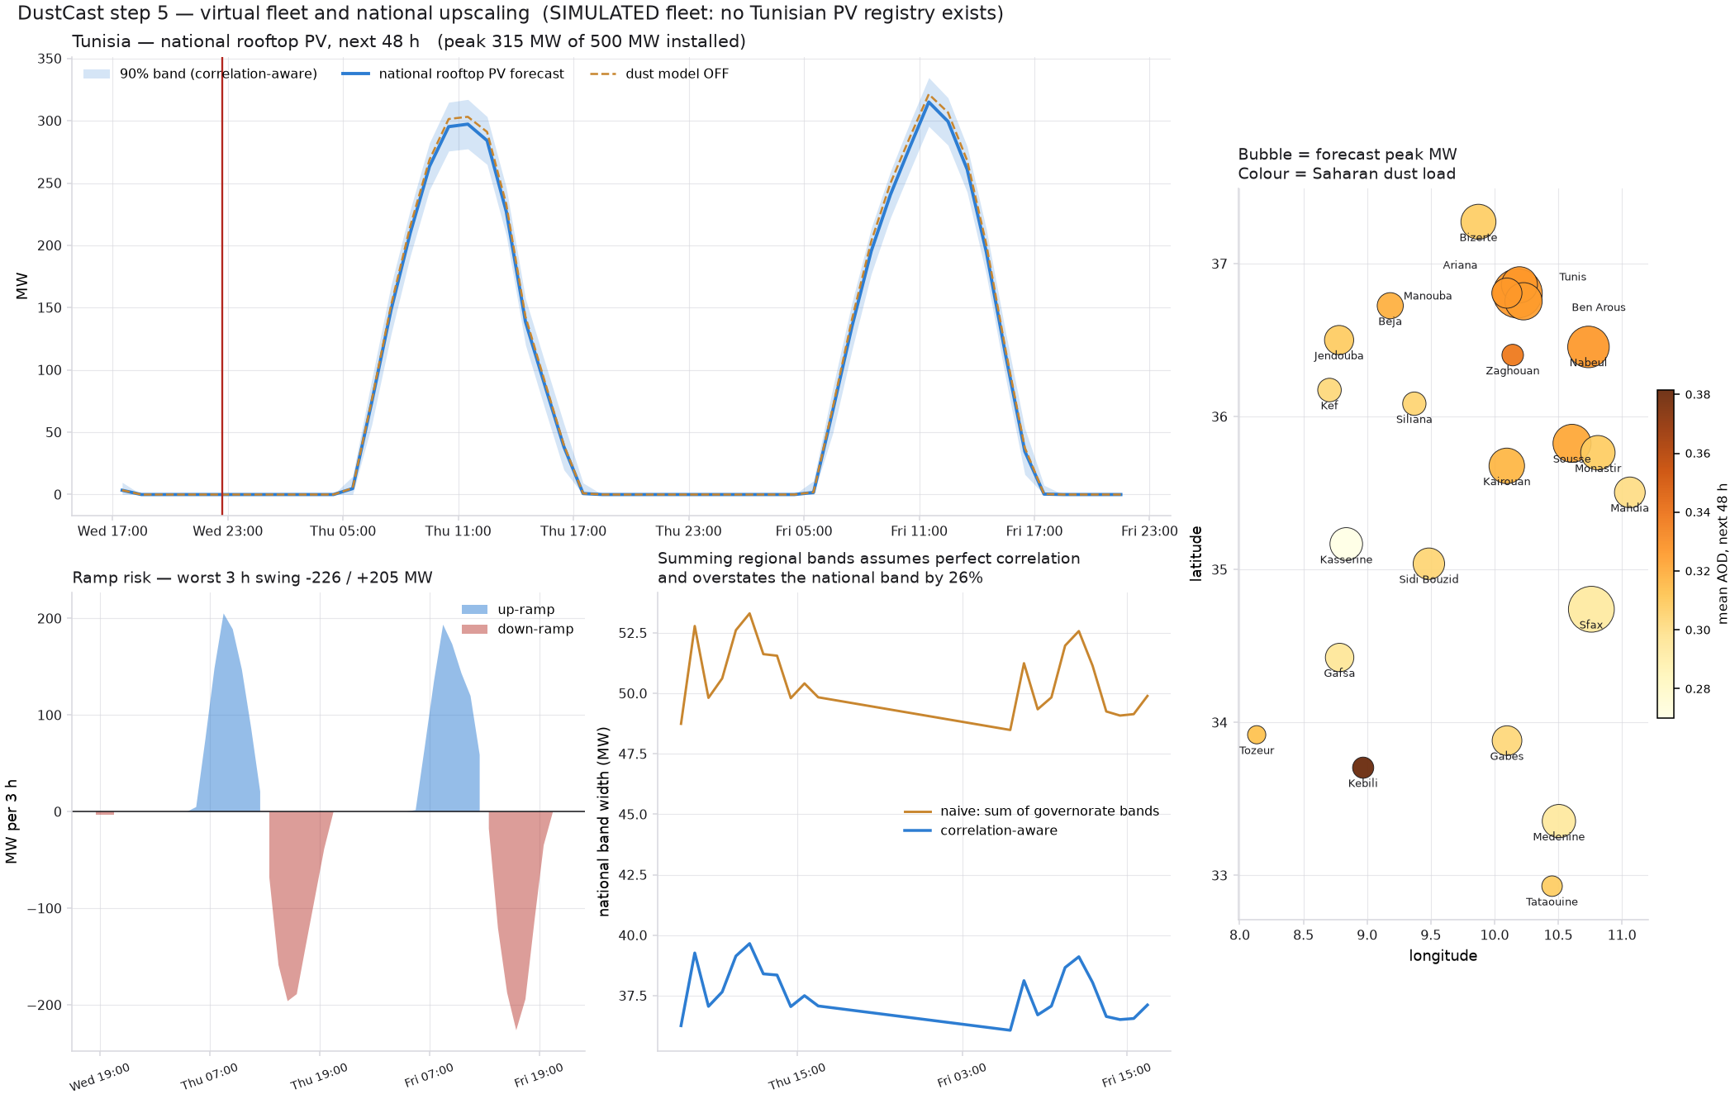
Figure 1. National rooftop PV forecast with the 90% band and the dust ablation (left), 3-hour ramp risk (bottom left), the effect of correlation-aware interval aggregation (bottom centre), and the 24 governorates sized by forecast peak and shaded by aerosol load (right). The Saharan gradient is visible: Kebili in the deep south carries roughly twice the aerosol of Kef in the north.

5.4 The national picture
Quantity | Value
Installed residential rooftop (STEG, end-June 2026) | 500 MW
Forecast peak, next 48 h | 289 MW (58% of installed)
90% interval at peak | 199 – 380 MW
Reserve required to cover the downside | 91 MW
Worst 3-hour ramp | −198 MW down, +210 MW up
Dust correction, effect on 48 h energy | −3.6%
Governorates flagged for cleaning | 11 of 24, concentrated in the south
Table 6. A live run. The 500 MW total is STEG's; its split across governorates is ours, allocated by population because no registry exists.

6 Validation against a real metered fleet
The Tunisian fleet is simulated, and being transparent about that is necessary but not sufficient — the method still has to be shown to work somewhere real. DKASC publishes both its individual arrays and its metered site PV total, so the upscaling chain can be tested end to end.
Taking one 4.95 kW array — 1.6% of the fleet it is asked to predict — and upscaling it by capacity gives 5.9% relative MAE, +0.6% bias and r = 0.985 on held-out data. Pierro et al. report 3% for Italy using a clustered multi-site sample; one array standing in for a whole fleet is the hardest possible case, so this is an upper bound on the error.
The spatial half is tested separately. DKASC also operates Yulara, about 330 km away. Correlating the clear-sky index at both sites — the same quantity the national aggregation uses — gives ρ = 0.465. Tunisia's governorates sit a mean 197 km apart, where we estimate ρ = 0.55. Correlation falls with distance, so a lower measured value at a larger separation is consistent, and the assumption the national interval rests on can now be cited rather than asserted.

6.1 The finding that matters more than the accuracy
Half the DKASC fleet stopped reporting in March 2024; metered p99 output fell from 341 kW to 196 kW. Holding the forecast completely fixed and changing only the assumed installed capacity:
Capacity register | rMAE | Bias
Current (303 kW) | 6.8% | −1.6%
Stale (589 kW) | 92.0% | +91.3%
Table 7. Identical forecast, one stale number, a 13× amplification of error.
Upscaling accuracy is bounded by the capacity register, not by the forecaster. Tunisia has no register at all. That is the honest ceiling on any national figure in this project, including ours — and it is a stronger argument for building a national PV registry than any accuracy claim we could make.
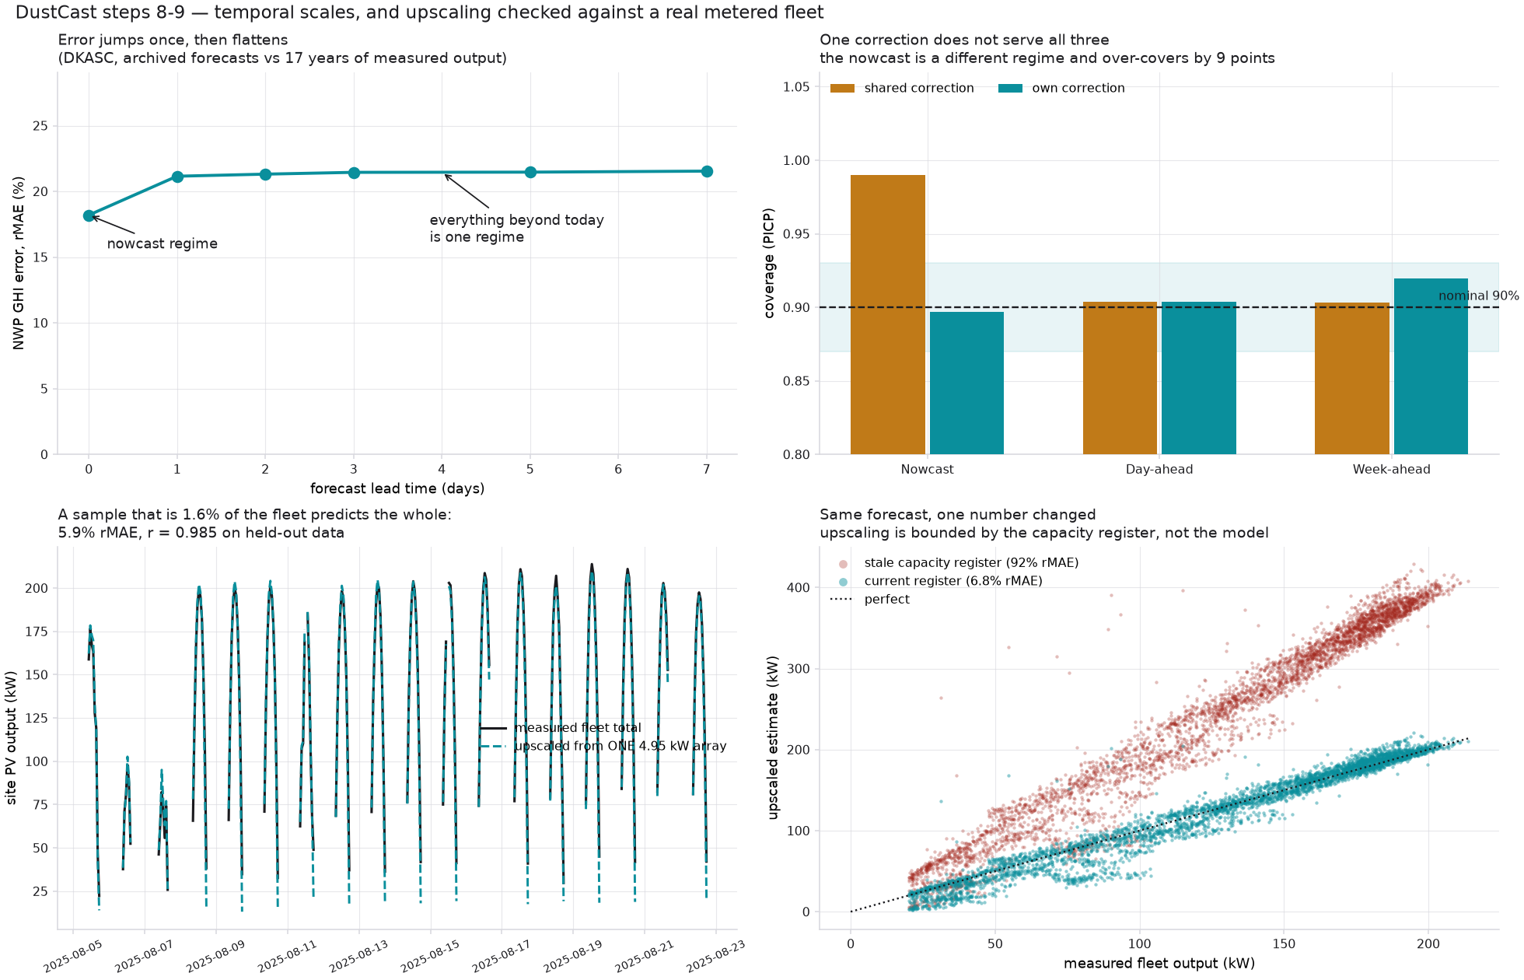
Figure 2. Forecast error against lead time, showing one jump and then a plateau (top left). Coverage per temporal scale with a shared versus per-scale conformal correction (top right). One array upscaled to the measured fleet total (bottom left). The cost of a stale capacity register, with the forecast held fixed (bottom right).

7 Grid impact and decision support
The platform outputs three decisions, not a curve.
- Reserve. Sized off the pessimistic edge of the interval, never the point forecast, because the operator's exposure is asymmetric: being short costs far more than being long. A live run gives 91 MW against a 289 MW forecast peak. Modelling spatial correlation properly rather than summing regional bands reduces this by about a quarter.
- Ramp. Worst three-hour swings of −198 MW and +210 MW on a 500 MW fleet — roughly 40% of installed capacity moving inside three hours. Up- and down-ramps are reported separately because they cost differently: a down-ramp must be met by dispatchable plant, an up-ramp threatens minimum generation limits and curtailment.
- Cleaning. A soiling index integrates dust deposition and resets on rain above 3 mm. A crew is dispatched only when modelled loss exceeds threshold and no rain is forecast — the second condition is what makes it a decision rather than an alarm, since sending a crew the day before rain wastes the visit. In a live run 11 of 24 governorates are flagged, concentrated in the south.

7.1 The operator dashboard
A published web dashboard presents the national total, reserve, ramp and dust cost in a summary strip; the 48-hour band beside a governorate map coloured by aerosol load; and the cleaning table ranked by soiling. Clicking a governorate retargets the chart, and a toggle runs the dust ablation live. Every caveat in Section 9 appears on the page itself rather than in a footnote.

7.2 Deployment shape
The whole national run costs two API calls — Open-Meteo accepts comma-separated coordinates, so 24 governorates and two endpoints do not become 48 requests against a rate-limited free tier. Training is a one-off on a laptop; inference for the entire country is seconds. There is no GPU anywhere in the stack.

7.3 The field node
An ESP32 with an INA219 current/voltage sensor and a DS18B20 panel-temperature probe publishes production over MQTT. Its purpose is not training data — one node cannot train anything. It is the monitored sample that makes the rolling recalibration in Section 4.3 deployable: that method needs measured output within about a day, and behind-the-meter rooftops give the operator none. Driving the real ingest path with a simulated node, a clean array sits inside the band 88.5% of the time while a 15% soiling loss drops it to 53.1% with a persistent one-directional bias. That signature is both the recalibration trigger and a cleaning trigger arriving from the array itself. The firmware has been written against datasheets and library APIs but not yet run on hardware.

8 Feasibility in the Tunisian context
- Data. Every source is free and covers North Africa. Nothing in the pipeline requires a commercial licence, a national data-sharing agreement, or instrumentation Tunisia does not have.
- Compute. XGBoost and pvlib on a laptop. No GPU, no cluster, no inference latency problem — the constraint that rules transformers and foundation models out of operational use for this task.
- Regulatory fit. Tunisian net metering (Decree 2016-1123) caps surplus sales to STEG at 30% of annual production, which biases households toward self-consumption sizing; the fleet archetypes are drawn accordingly.
- The adoption path. The platform is useful on day one with zero Tunisian data, and improves monotonically as a monitored sample appears. A handful of instrumented rooftops — tens of euros each — unlocks the rolling recalibration and turns an assumed band into a verified one.
- The ask. Section 6 quantifies it: a capacity register is worth roughly 13× more to a national estimate than forecast skill is. The single highest-value thing STEG or ANME could publish is not generation data but an installation registry.

9 Limitations, stated plainly
- The Tunisian fleet is simulated. The 500 MW national total is STEG's; its allocation across governorates is ours, by population — a crude proxy that probably over-weights Tunis and under-weights the Sahel. Tilt, azimuth and capacity are sampled, not observed.
- The training data is Australian. Residual learning transfers loss mechanisms rather than a power curve, and the hemisphere-invariant features make the geometry valid, but it remains a transfer assumption.
- Band coverage is verified in Australia, not Tunisia. There is no measured Tunisian output to score against. Coverage there is an assumption.
- The dust correction is extrapolated. It is fitted where the training site's 95th-percentile AOD is 0.175; Tunisia routinely sits near 0.30. Worse, the aerosol regimes barely overlap — Sfax's median AOD exceeds Alice Springs' 95th percentile — so the training site lacks the dynamic range to demonstrate the dust effect at all.
- The dust features contribute little. Bands widen 17.7% from clean to high-AOD hours, but a dust-blind model widens 17.4%. The dust value in this system lives in the measured NWP aerosol bias correction, not in the machine-learning features, and we report it that way.
- Soiling has no ground truth. It is a relative index and a maintenance trigger, never a measured loss percentage.
- Conditional coverage is unsolved. Marginal coverage is 90.3%, but it runs near 100% on overcast hours and 84.5% on clear high-output hours — where the operator is most exposed.
- The model underperforms plain physics above ~50 °C cell temperature. That is the wrong direction for Tunisia and is the first thing we would fix.

10 What we got wrong
Three errors materially changed our own numbers. We report them because a result whose failure modes have been hunted is worth more than one that has not.
- A 21× under-dispersed interval. We calibrated the conformal band on measured irradiance and deployed it on a forecast driven by an NWP. Against forecast input the same models need a correction 21 times wider. National reserve moved from 20 MW to 91 MW once corrected. Calibrating on measured weather and deploying on forecast weather is the same category of error as scoring a model on its training data.
- A timestamp convention that corrupted everything downstream. Resampling labels each hourly bin by its left edge, but we evaluated solar geometry at that label — half an hour before the average it described. The clear-sky index read 1.26 at 07:00 and 0.45 at 18:00, and time-of-day became the model's most important feature: the ML was spending its capacity undoing our bug. We first misdiagnosed it as atmospheric and spent effort fitting turbidity, which pinned to the bottom of a plausible grid — a boundary solution is the tell that a hypothesis is wrong.
- A skill score of +44.8% that was almost entirely fictitious. Our first physics baseline had no wiring, mismatch or soiling derate, so it over-predicted by 13% and the ML looked brilliant for learning a constant. Against a properly derated baseline the real figure was −0.4%. Skill is a ratio, and anything that degrades the denominator looks like progress — so the gate now selects the strongest non-ML baseline automatically at run time.

11 Future work
In priority order: conditional coverage, so the band is right on clear high-output hours and not only on average; the heat-derating failure above 50 °C; deriving clear-sky turbidity directly from CAMS AOD so dust enters the physics rather than sitting beside it; and cold-start forecasting for newly commissioned rooftops by seeding a time-series foundation model with a pvlib synthetic history — a real research direction that fits Tunisia's stream of new unmonitored installations.

