CS 255 Business Requirements Document Template

Complete this template by replacing the bracketed text with the relevant information.

This template lays out all the different sections that you need to complete for Project One. Each section has guiding questions to prompt your thinking. These questions are meant to guide your initial responses to each area. You are encouraged to go beyond these questions using what you have learned in your readings. You will need to continually reference the interview transcript as you work to make sure that you are addressing your client’s needs. There is no required length for the final document. Instead, the goal is to complete each section based on your client’s needs.

Tip: You should respond in a bulleted list for each section. This will make your thoughts easier to reference when you move into the design phase for Project Two. One starter bullet has been provided for you in each section, but you will need to add more.

System Components and Design

Purpose
What is the purpose of this project? Who is the client and what do they want their system to be able to do?
- Design a secure, cloud-based DriverPass system that allows customers to register for services, access online learning materials and practice tests, and schedule driving lessons.
- Provide DriverPass employees with role-based tools to manage customer accounts, packages, reservations, drivers, vehicles, reports, and system access.
- Create a reliable system that authorized users can access through a web browser on a computer or mobile device from any location with an internet connection.
- Give DriverPass a clear record of reservation activity, including who created, modified, or canceled each appointment.
- Deliver a high-level system design that meets the client requirements documented in the DriverPass interview and can support later project phases.

System Background
What does DriverPass want the system to do? What is the problem they want to fix? What are the different components needed for this system?
- DriverPass was created to address the number of people who fail their local Department of Motor Vehicles (DMV) driving tests because they do not have sufficient preparation or training.
- DriverPass wants to offer a combination of online education, practice examinations, in-person instruction about DMV rules and policies, and on-the-road training with a driver and vehicle.
- The system must support three service packages: six hours of driving training; eight hours of driving training plus an in-person lesson; and twelve hours of driving training, an in-person lesson, and access to online classes and practice tests.
- The system must support two-hour driving sessions and match each customer with an available driver, car, date, and time.
- The primary user groups are customers, the secretary, the owner, and the IT officer. Customers manage their own information and reservations; the secretary schedules appointments for customers; the owner reviews business activity and reports; and the IT officer manages accounts, roles, access, and system maintenance.
- The system should also support current DMV rules, policies, and sample questions through updates or notifications so DriverPass can keep its training content current.

Objectives and Goals
What should this system be able to do when it is completed? What measurable tasks need to be included in the system design to achieve this?
- The system shall allow a customer or secretary to create a customer account containing the required contact, address, payment, pickup, and drop-off information.
- The system shall allow customers to select an available package and shall allow authorized employees to disable a package so that new customers cannot register for it.
- The system shall allow customers and the secretary to create, modify, and cancel two-hour driving lesson reservations.
- The system shall display available driving appointments and prevent conflicting assignments involving a driver, vehicle, customer, date, or time.
- The system shall associate each driving lesson with the assigned customer, driver, vehicle, start time, end time, and driver comments.
- The system shall provide customers with online classes and practice tests when included in their selected package and shall display test name, time taken, score, and status.
- The system shall support the statuses not taken, in progress, failed, and passed for online practice tests.
- The system shall provide password reset functionality and allow the IT officer to reset accounts, modify access, and block accounts when necessary.
- The system shall restrict features and data according to the user's role and permissions.
- The system shall record who created, modified, or canceled a reservation and shall allow authorized users to print or download an activity report.
- The system shall allow authorized users to access reports and selected information from any supported computer or mobile device and download information for use in applications such as Excel.
- The system shall notify DriverPass when the DMV provides updates to rules, policies, or sample questions.

Requirements

Nonfunctional Requirements
In this section, you will detail the different nonfunctional requirements for the DriverPass system. You will need to think about the different things that the system needs to function properly.

Performance Requirements
What environments (web-based, application, etc.) does this system need to run in? How fast should the system run? How often should the system be updated?
- Common pages and transactions should load within three seconds under normal operating conditions; reservation searches and confirmations should return within five seconds.
- The system shall support concurrent use by customers and DriverPass employees without losing reservation or account updates.
- The system shall provide scheduled backups and maintain availability during normal business hours.
- DMV rules, policies, practice questions, and online course content should be reviewed and updated whenever DriverPass receives approved changes.
- The system shall be browser-based and support access from current Windows, macOS, Android, and iOS devices with a supported browser.

Platform Constraints
What platforms (Windows, Unix, etc.) should the system run on? Does the back end require any tools, such as a database, to support this application?
- The system shall use a relational database to store users, packages, drivers, vehicles, reservations, payments, test results, and audit history.
- The design shall support current versions of major browsers and responsive layouts for desktop, tablet, and mobile screens.
- The system shall integrate with email services for account notifications, reservation confirmations, password resets, and DMV content updates.
- The IT officer shall be able to manage configuration and access without requiring changes to the application source code.
- The application shall use a secure web architecture with an application server, database server, and encrypted browser connections.

Accuracy and Precision
How will you distinguish between different users? Is the input case-sensitive? When should the system inform the admin of a problem?
- Required customer information shall be validated before an account, package, payment, or reservation can be saved.
- The system shall prevent a driver, vehicle, or customer from being assigned to overlapping two-hour reservations.
- Reservation dates and times shall use one consistent time zone and shall clearly display start and end times.
- The system shall preserve the status and history of practice tests as not taken, in progress, failed, or passed.
- The system shall alert authorized employees when an account, reservation, payment, or integration error requires attention.
- The system shall distinguish customers, the secretary, the owner, and the IT officer by authenticated role and permissions.

Adaptability
Can you make changes to the user (add/remove/modify) without changing code? How will the system adapt to platform updates? What type of access does the IT admin need?
- The system shall support role and permission changes through the IT officer interface without changing application code.
- The system shall support approved updates to DMV rules, policies, sample questions, and course materials.
- The system shall support additional DriverPass packages and additional locations or vehicles as the business grows.
- The system shall use versioned content and configuration records so changes can be reviewed and corrected when necessary.
- Authorized users shall be able to add, modify, deactivate, or reactivate customers, employees, drivers, vehicles, packages, and system content through configuration screens.

Security
What is required for the user to log in? How can you secure the connection or the data exchange between the client and the server? What should happen to the account if there is a “brute force” hacking attempt? What happens if the user forgets their password?
- Passwords shall be stored using secure one-way hashing, and all browser-to-server traffic shall use HTTPS/TLS.
- The system shall provide password reset through a verified email process and shall not reveal whether an unrelated account exists.
- The system shall temporarily lock or rate-limit an account after repeated failed login attempts and notify the IT officer of suspicious activity.
- Role-based authorization shall prevent customers from viewing or changing other customers’ information and shall restrict administrative functions to authorized employees.
- The system shall record security events, account changes, reservation changes, and administrative actions in an audit log.
- The system shall require a unique username or email address and a password for authenticated access.

Functional Requirements
Using the information from the scenario, think about the different functions the system needs to provide. Each of your bullets should start with “The system shall . . .” For example, one functional requirement might be, “The system shall validate user credentials when logging in.”
- The system shall allow customers to select and purchase an available DriverPass package.
- The system shall allow authorized employees to activate or deactivate packages.
- The system shall allow customers and the secretary to create, modify, and cancel two-hour driving reservations.
- The system shall display available drivers, vehicles, dates, and times and prevent conflicting assignments.
- The system shall record the customer, driver, vehicle, pickup and drop-off information, start time, end time, and comments for each reservation.
- The system shall provide online classes and practice tests when included in the customer’s package.
- The system shall record practice-test name, status, score, and time taken.
- The system shall provide password reset, account blocking, and permission management functions for the IT officer.
- The system shall provide the owner and other authorized users with reports that can be viewed, printed, or downloaded.
- The system shall send confirmations, reminders, password-reset messages, and approved DMV update notifications.
- The system shall allow customers and the secretary to create and maintain customer accounts.

User Interface
What are the needs of the interface? Who are the different users for this interface? What will each user need to be able to do through the interface? How will the user interact with the interface (mobile, browser, etc.)?
- The secretary interface shall provide customer lookup, account assistance, package management, reservation scheduling, driver and vehicle assignment, and cancellation or modification functions.
- The owner interface shall provide business activity, reservation, customer, package, and performance reports with print and download options.
- The IT officer interface shall provide account, role, permission, security, system configuration, backup, and maintenance functions.
- The interface shall use clear labels, validation messages, confirmation prompts, and accessible color contrast.
- The system shall be responsive for desktop and mobile browsers and shall provide a consistent navigation menu based on the user’s role.
- The customer interface shall provide registration, package selection, payment, account maintenance, reservation search, reservation management, online classes, practice tests, and results history.

Assumptions
What things were not specifically addressed in your design above? What assumptions are you making in your design about the users or the technology they have?
- Customers will provide accurate contact, address, payment, pickup, and drop-off information.
- A payment service or approved payment process will be available for package purchases.
- DriverPass will provide current driver, vehicle, package, schedule, and DMV content information.
- The IT officer will have authority to manage accounts, permissions, configuration, and maintenance.
- Email addresses and phone numbers supplied by users will be available for account and reservation notifications.
- The project will use a hosted application and database rather than installing a full system on each customer device.
- DriverPass will have internet access and will use supported browsers and devices.

Limitations
Any system you build will naturally have limitations. What limitations do you see in your system design? What limitations do you have as far as resources, time, budget, or technology?
- The first release may not support native mobile applications, offline access, voice interaction, or integration with every DMV system.
- The system will not guarantee that a customer passes a driving test; it will provide preparation tools and training management.
- Reservation availability will depend on the drivers, vehicles, dates, and times entered by DriverPass employees.
- The quality and timeliness of DMV content will depend on updates supplied and approved by DriverPass.
- Project schedule, budget, and staffing may limit advanced reporting, automated integrations, and additional locations in the initial release.

Gantt Chart
Please include a screenshot of the GANTT chart that you created with Lucidchart. Be sure to check that it meets the plan described by the characters in the interview.

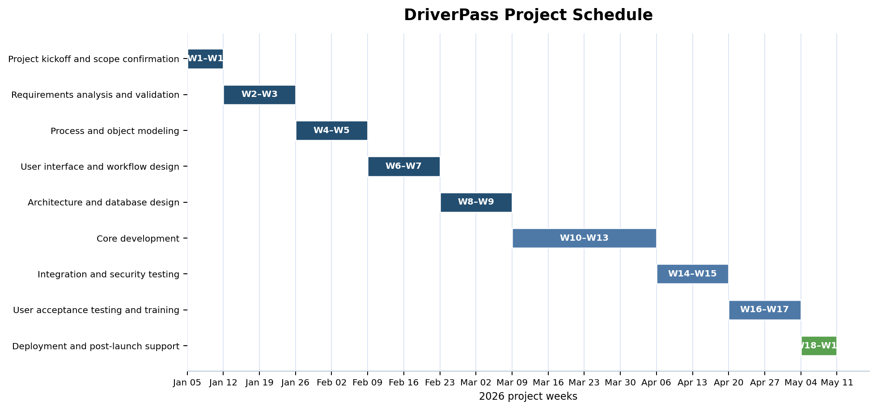
Figure 1. Proposed 18-week DriverPass project schedule

