DriverPass Client Presentation Slides and Speaker Notes
Cynthia Turner | CS 255 | October 2026

Slide 1 DriverPass | System Analysis
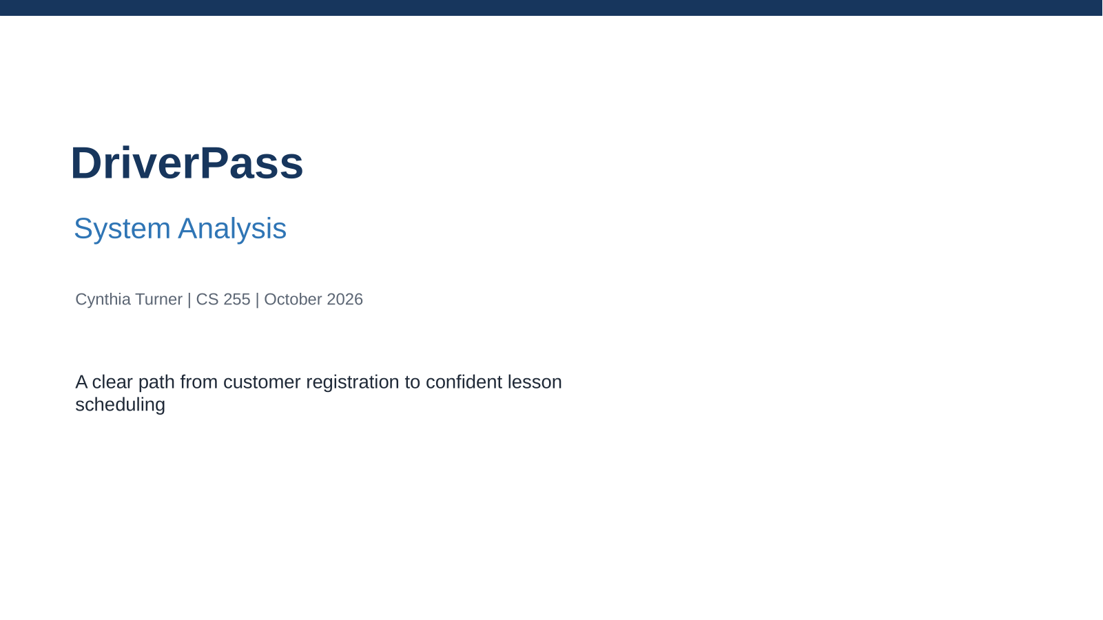

Speaker Notes
This presentation summarizes the proposed DriverPass system in plain language. I will focus on how the design supports customers and employees, while the full system design document provides the technical detail for the development team.

Slide 2 System Requirements
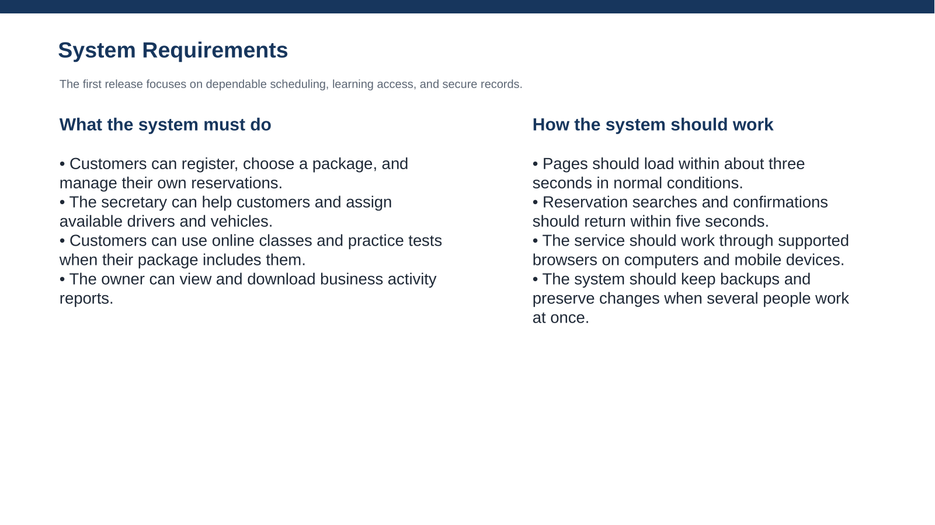

Speaker Notes
The functional requirements describe the services DriverPass employees and customers need every day. The nonfunctional requirements describe the experience around those services: reasonable response times, browser access, reliable updates, and backups. Together they support the business goal of making driver training easier to manage without creating scheduling conflicts.

Slide 3 Use Case Diagram
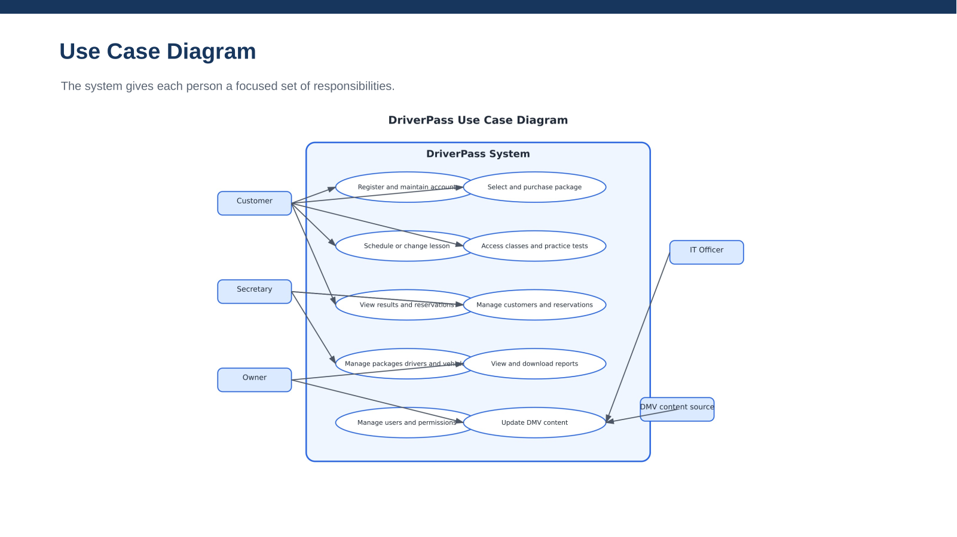

Speaker Notes
This diagram shows the people who use DriverPass and the outside source that provides DMV content. Customers manage their accounts, packages, lessons, learning materials, and results. The secretary supports account and scheduling work. The owner reviews reports. The IT officer manages access and system settings. The design meets DriverPass’s needs by separating responsibilities while keeping the customer experience connected from registration through training.

Slide 4 Activity Diagram
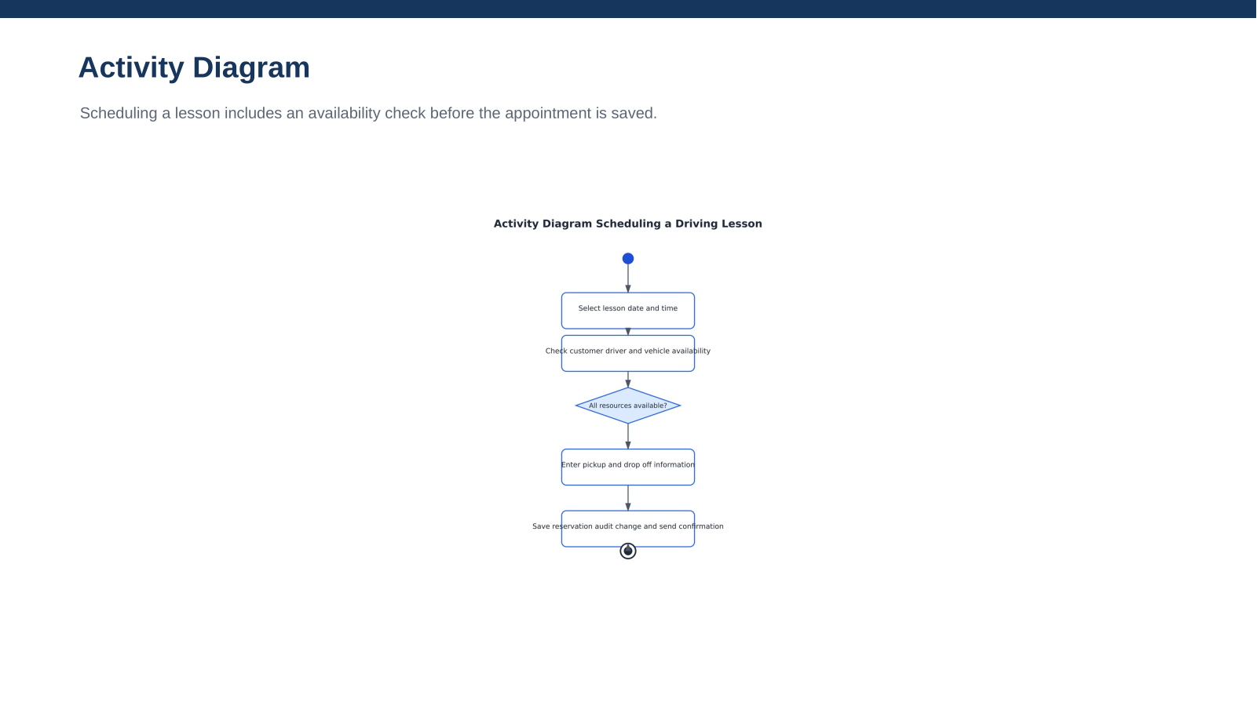

Speaker Notes
This diagram breaks down the lesson scheduling process. A customer or secretary chooses a time, and the system checks whether the customer, driver, and vehicle are available. If any resource is already assigned, the user chooses again. If everything is available, the system records the pickup and drop-off details, saves the appointment, records who made the change, and sends a confirmation. This protects DriverPass from double-booking and gives the customer a clear result.

Slide 5 Security
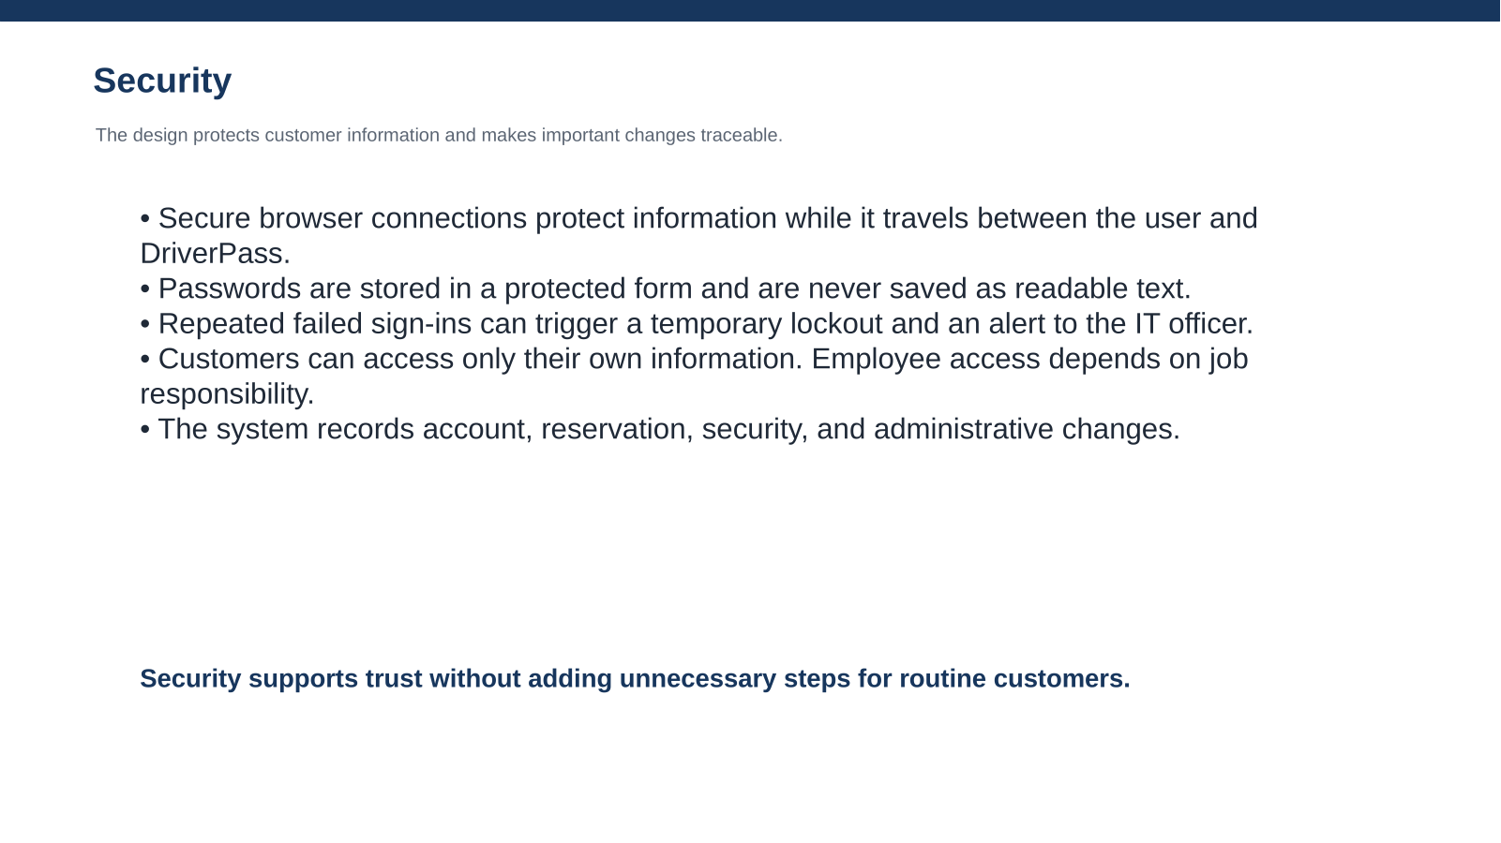

Speaker Notes
Security was included as part of the design rather than added after the main features. Customers need confidence that their contact, payment, and training information is protected. Employees need access to perform their jobs, but they should not see or change information outside their responsibilities. The activity history also helps DriverPass understand what happened when an account or reservation changes.

Slide 6 System Limitations
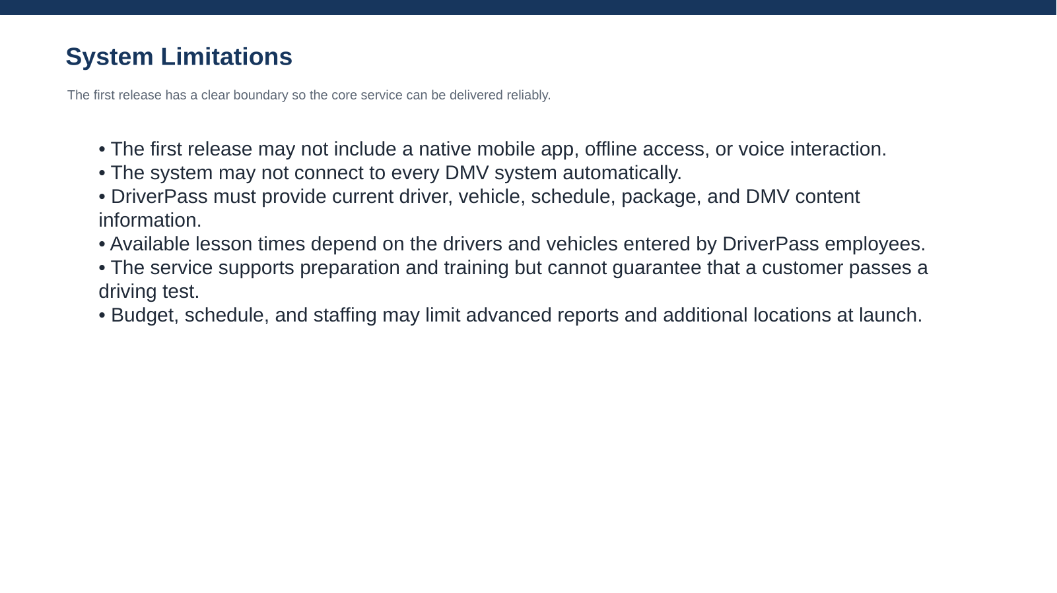

Speaker Notes
These limitations set reasonable expectations for the first release. A browser-based system allows DriverPass to support customers on many devices without maintaining a separate mobile application immediately. The service can prepare students and organize training, but the final driving-test result remains outside the system’s control. Future releases can add integrations, locations, and more advanced reporting as the business gains experience with the core system.

