DriverPass System Design Document
Prepared for DriverPass | Prepared by Cynthia Turner | October 2026
Purpose and scope
This document translates DriverPass business requirements into a blended object and process design. It focuses on the customer account, package enrollment, driving lesson reservation, practice testing, reporting, and access-control capabilities needed for the first release. The diagrams give developers a shared view of how people use the system, how key workflows proceed, how information moves between components, and which records the system must maintain.

Design Summary

The proposed DriverPass system is a secure browser-based service backed by a relational database. Customers can register, purchase an available package, schedule or change a two-hour driving lesson, access included online learning, and review results. DriverPass employees receive role-specific tools for scheduling, customer assistance, reporting, content updates, and system administration. The design records reservation changes and uses availability checks to prevent conflicting customer, driver, or vehicle assignments.

Design Priorities

• Simple customer and secretary scheduling with clear availability and confirmation messages.
• Role-based access so each user sees only the functions and information needed for the job.
• Reliable records for customers, packages, reservations, drivers, vehicles, payments, tests, and audit history.
• Responsive browser access from supported computers, tablets, and mobile devices.
• A structure that can grow to additional packages, vehicles, locations, and approved DMV content.

UML Diagrams

The following diagrams represent the required views of the DriverPass system. The use case diagram identifies the people and outside source that interact with the system. The activity diagrams show the step-by-step logic for two important customer workflows. The sequence diagram shows how a lesson reservation request moves through the web page, reservation service, database, and email service. The class diagram identifies the core records and their relationships.

UML Use Case Diagram
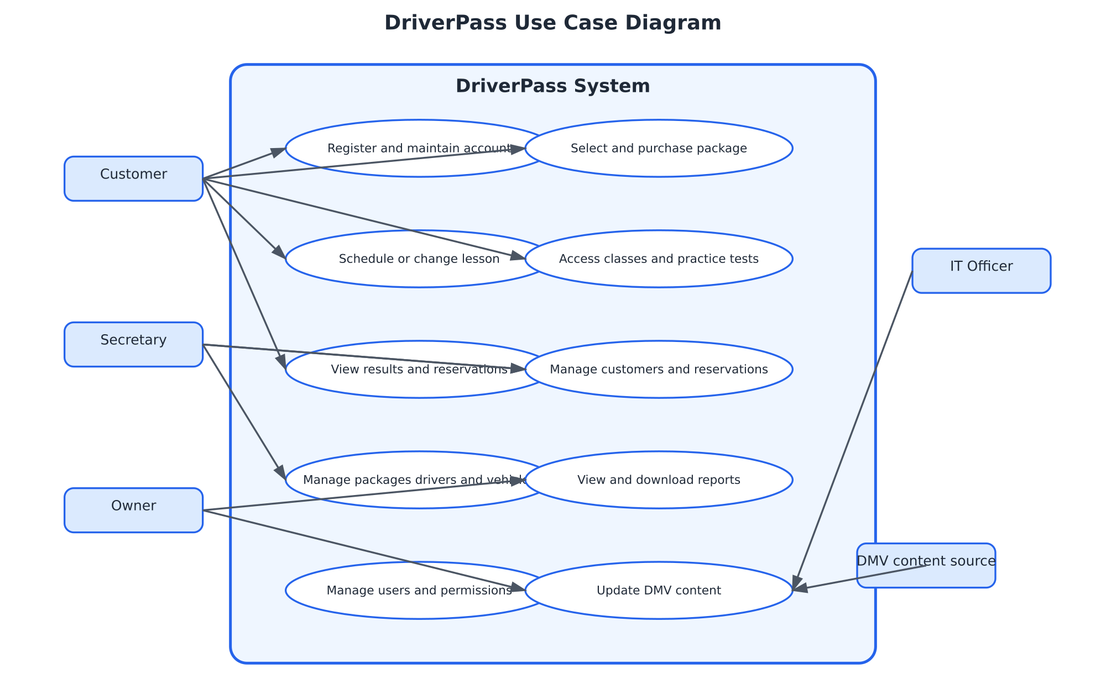
Figure 1. DriverPass users and system capabilities
The design gives customers control over their accounts, package choices, lessons, learning materials, and results. The secretary can assist customers and maintain operational scheduling data. The owner can review reports, while the IT officer manages access and configuration. DMV content is treated as an outside source that informs approved content updates.

UML Activity Diagrams
The first activity diagram expands the scheduling use case. It checks availability before saving a lesson, collects pickup and drop-off details, records the change, and sends a confirmation. This directly supports the requirement to prevent overlapping assignments and to retain reservation history.
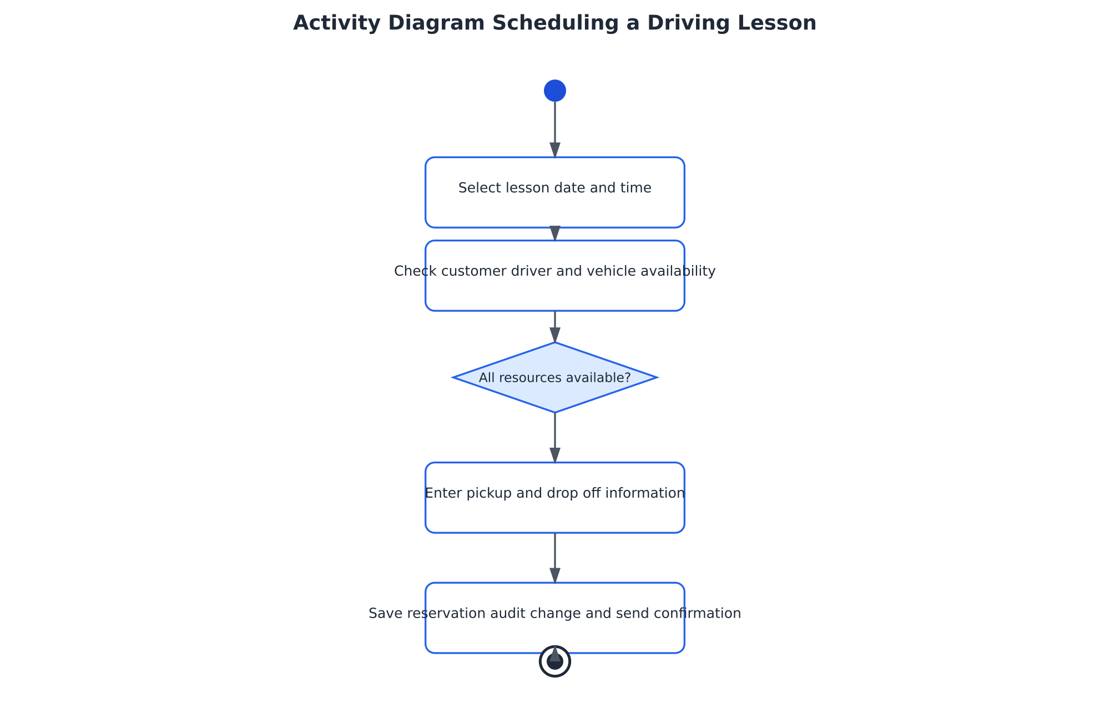
Figure 2. Activity flow for scheduling a driving lesson

The second activity diagram expands package purchase. It validates the customer information, sends the payment request, keeps the package unassigned when payment fails, and enables the included learning content after approval.
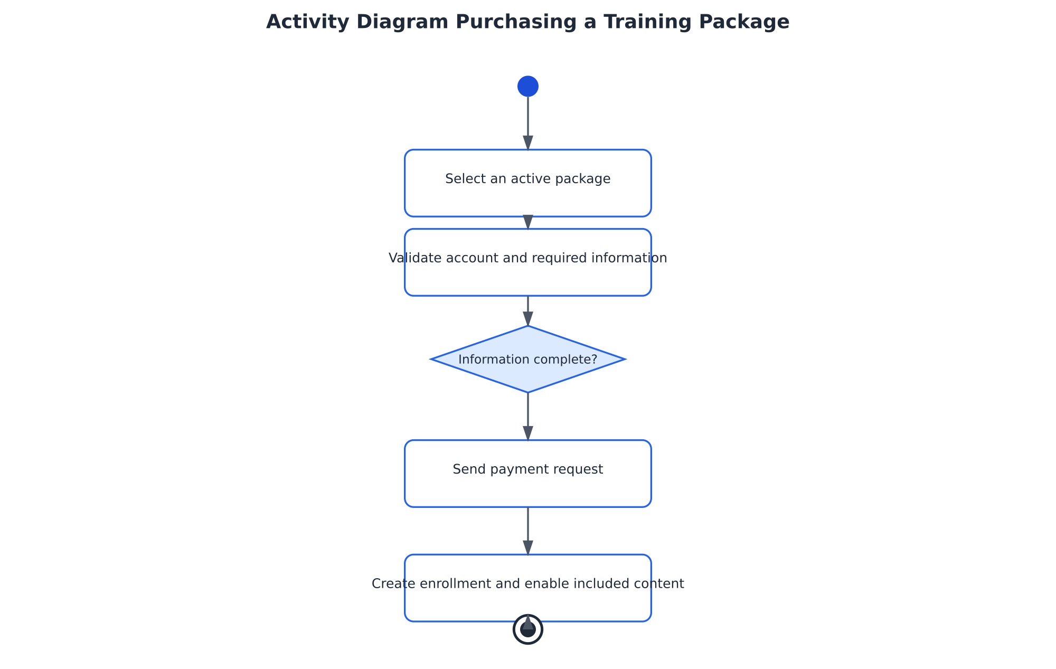
Figure 3. Activity flow for purchasing a training package

UML Sequence Diagram

This sequence shows the scheduling conversation from the user’s request through confirmation. The reservation service checks the database before presenting options, saves the selected reservation with an audit entry, and requests a confirmation message after the save succeeds. The order prevents the user from receiving a confirmation for a reservation that the system did not actually save.
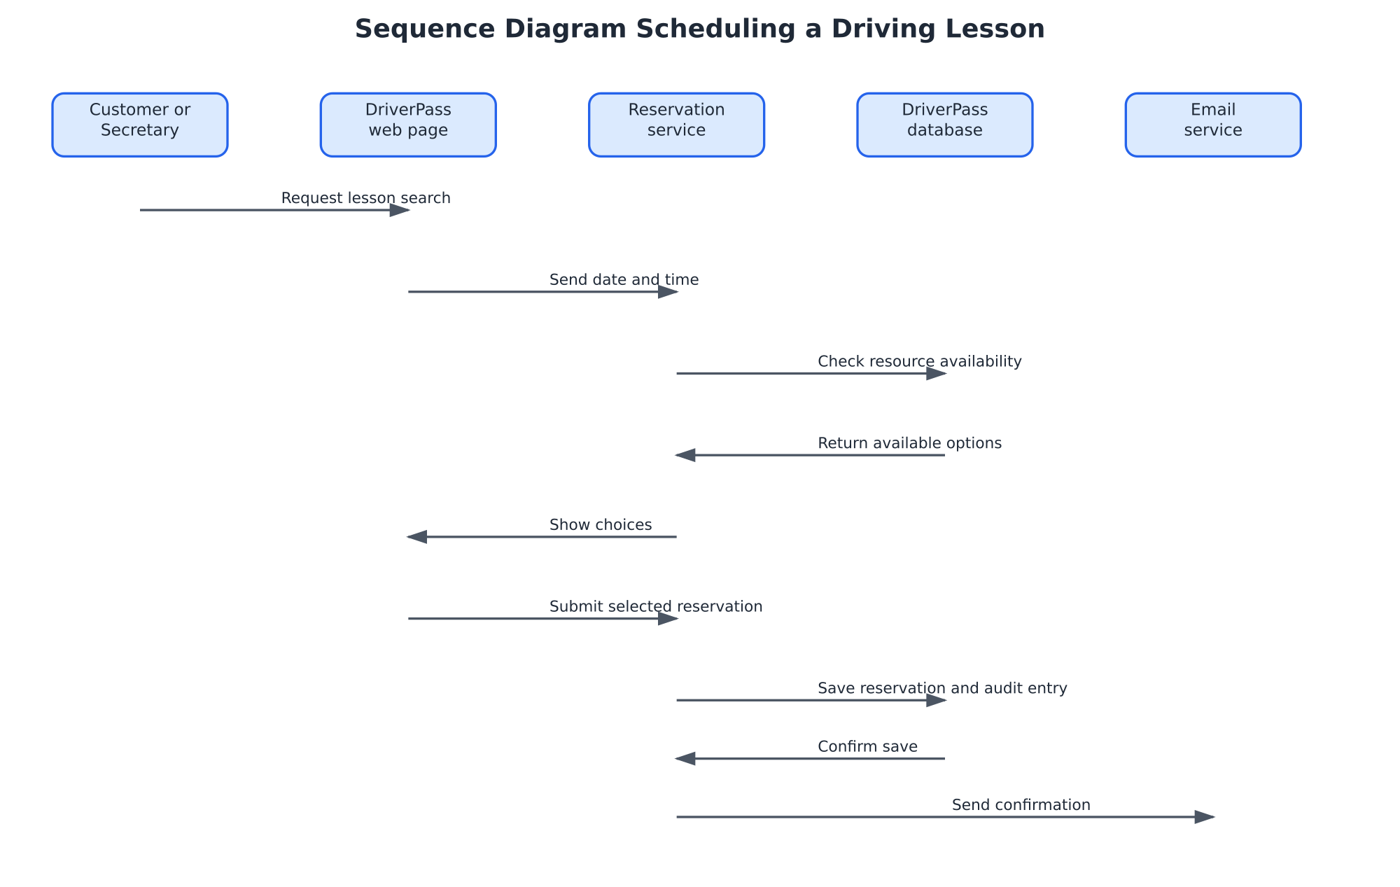
Figure 4. Sequence of messages for a driving lesson reservation

UML Class Diagram
The class model identifies the records required to support the main business functions. Customer is a specialized user record. TrainingPackage represents the three service offerings and future packages. Reservation connects a customer to a driver and vehicle at a defined time. PracticeTest stores learning results, and AuditEntry records important account and reservation changes.
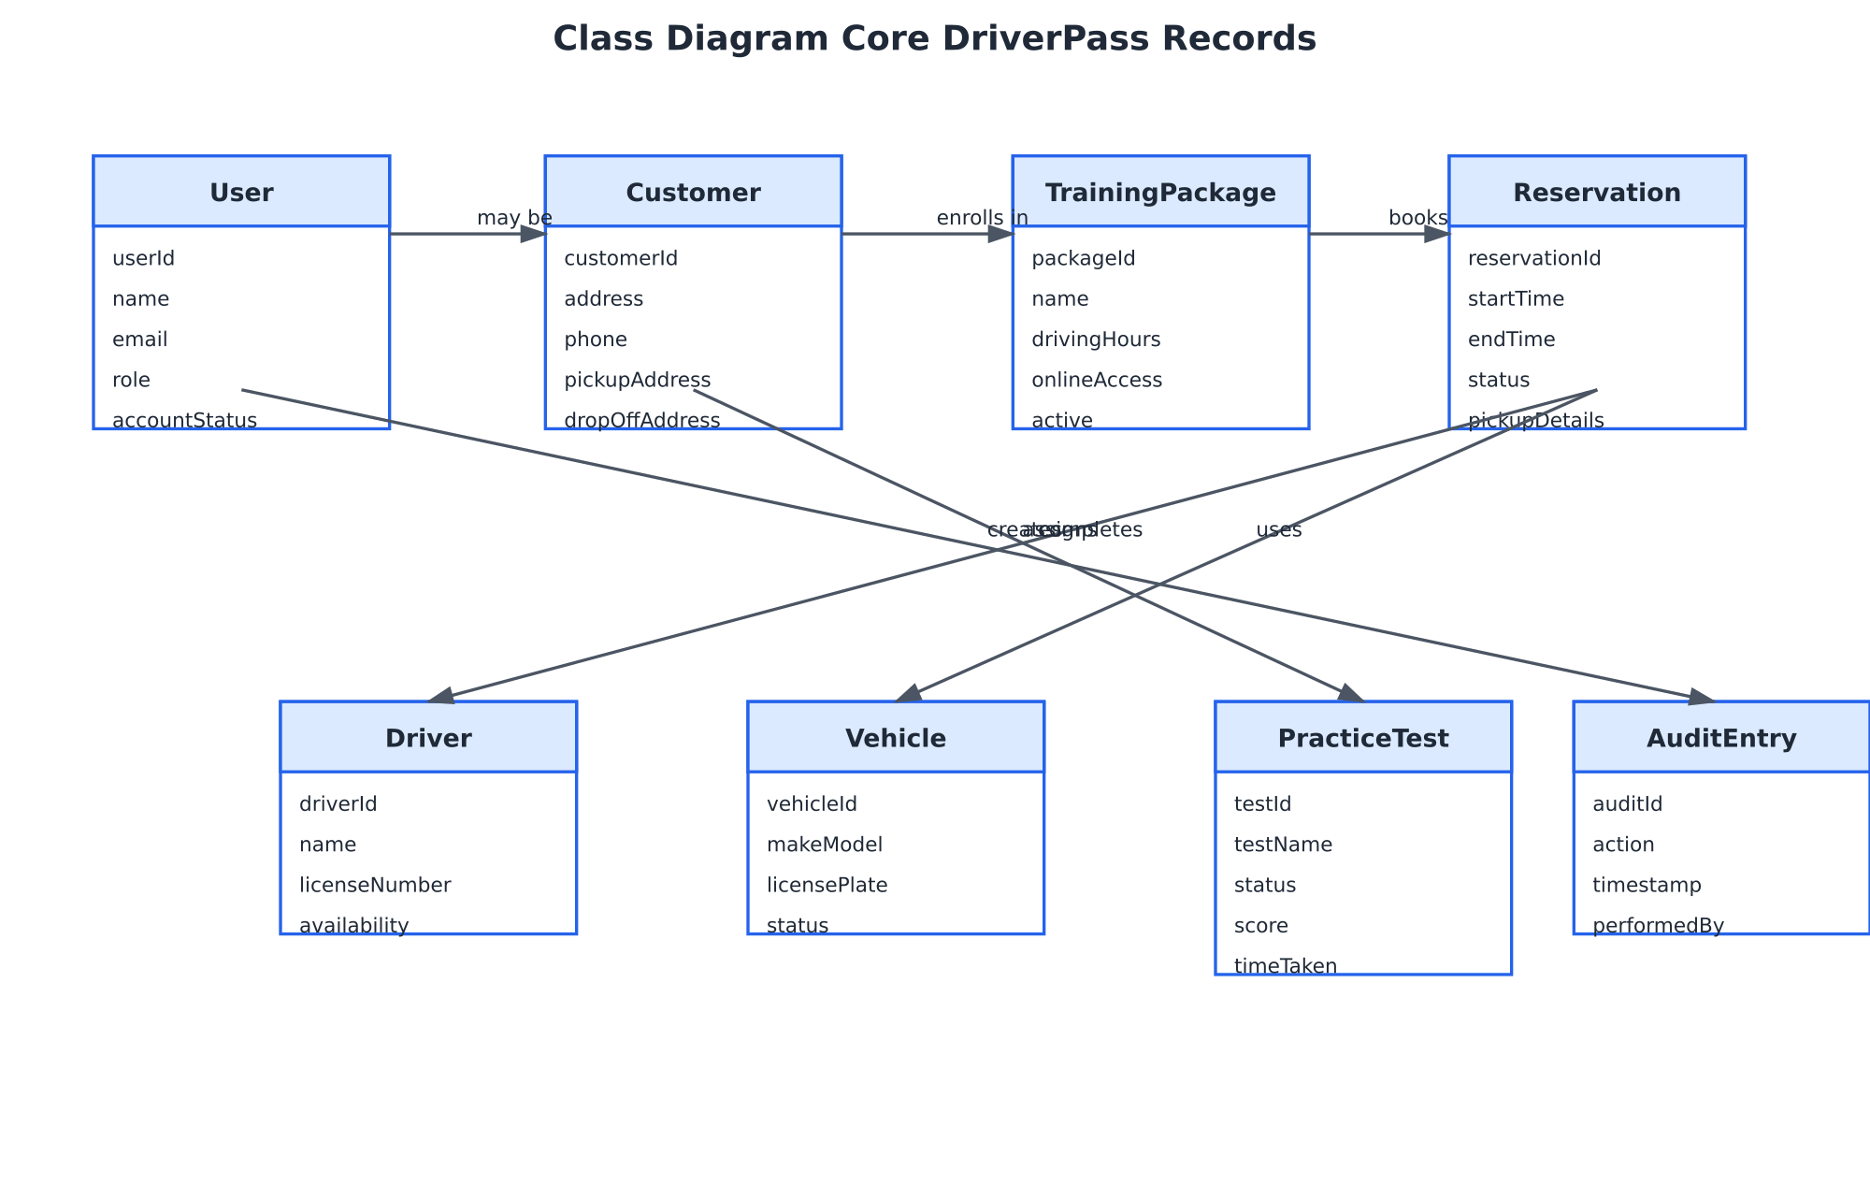
Figure 5. Core DriverPass records and relationships

Technical Requirements

The technical requirements below translate the business requirements into the hardware, software, tools, and infrastructure needed to implement and operate the proposed design. They are written for the development and implementation team, while preserving the client priorities of ease of use, reliable scheduling, secure access, and room for growth.

Hardware and Endpoint Requirements

• Customers and employees need a desktop, laptop, tablet, or smartphone with a supported modern web browser and a reliable internet connection.
• DriverPass employees need dependable computers for scheduling, customer support, reports, and administration. A printer may be used for customers or reports when a paper copy is required.
• The hosted environment needs redundant compute capacity, encrypted storage, and backup storage sized for user accounts, reservations, audit history, course content, and test results.
• The platform should support scaling compute and storage independently as DriverPass adds packages, vehicles, customers, or locations.

Software Requirements

• A responsive browser-based front end must support current versions of major browsers on Windows, macOS, Android, and iOS.
• An application server must provide authentication, role-based authorization, validation, package enrollment, scheduling logic, reporting, notifications, and configuration functions.
• A relational database must store users, customers, packages, reservations, drivers, vehicles, payments, practice tests, content, and audit entries.
• An email service must send account verification, password reset, reservation confirmation, reminder, and approved DMV update messages.
• A payment service or approved payment interface must return a clear approved or declined result before package enrollment is completed.
• The system should use a supported server-side runtime, database migration tooling, automated tests, and source control so changes can be reviewed and released consistently.

Infrastructure and Security Requirements

• Browser-to-server traffic must use HTTPS with TLS. Passwords must use one-way hashing and must never be stored as readable text.
• Authentication must require a unique username or email and password. Repeated failed logins must trigger rate limiting or temporary lockout and an alert to the IT officer.
• Authorization must be enforced on the server as well as hidden in the interface. Customers may access only their own information, while administrative functions require the appropriate employee role.
• The environment must include scheduled backups, monitored availability, recovery procedures, and a consistent time-zone configuration for reservations.
• Audit records must capture security events, account changes, reservation creation, modification, and cancellation, including the user and timestamp.
• Configuration screens must allow the IT officer to manage roles, permissions, packages, users, vehicles, drivers, and approved content without changing source code.

Performance and Quality Requirements

Area | Requirement | Reason
Response time | Common pages should load within three seconds and reservation searches or confirmations should return within five seconds under normal conditions. | Keeps scheduling practical during customer and employee use.
Concurrency | The system must preserve updates when customers and employees work at the same time. | Prevents lost changes and conflicting reservations.
Accuracy | The system must validate required information and reject overlapping customer, driver, or vehicle assignments. | Protects appointment records and daily operations.
Adaptability | Roles, packages, vehicles, content, and locations must be configurable and versioned. | Allows business growth without rewriting the application.
Accessibility | Labels, validation messages, confirmation prompts, and color contrast must be clear and usable. | Supports customers and employees with different levels of technical comfort.

Implementation Assumptions and Limitations

The design assumes that DriverPass will provide accurate driver, vehicle, package, schedule, and DMV content information; that an approved payment process and email service will be available; and that users will have internet access through supported browsers. The first release may not include a native mobile application, offline access, voice interaction, or integration with every DMV system. The system manages preparation and training services, but it cannot guarantee that a customer passes a driving test. Scheduling availability depends on the information maintained by DriverPass employees, and the quality of DMV content depends on approved updates supplied to the business.

Traceability to DriverPass Needs

DriverPass need | Design response
Simple lesson scheduling | Activity and sequence diagrams show availability checks, required pickup details, save confirmation, and email confirmation.
Prevent conflicts | Reservation service checks customer, driver, and vehicle availability before saving.
Support learning packages | TrainingPackage and PracticeTest records support online access, test status, score, and time taken.
Protect information | User roles, server-side authorization, HTTPS/TLS, password hashing, lockout, and audit records address security requirements.
Support growth | Relational records and configurable packages, users, vehicles, drivers, content, and locations allow expansion.

