Evaluating the Efficacy of Technical Analysis Indicators in Equity Trading

Eric Hansen  
 Data Science  
 University of Colorado/Boulder  
 Boulder CO USA  
 [erha9949@colorado.edu](mailto:erha9949@colorado.edu)

ABSTRACT

This project aims to address the gap in existing literature regarding the actual efficacy of various technical analysis indicators in equity trading. By creating a sample set of equities with trading ranges between $20 and $500 from 2015 to 2024, we will generate individual time series for each equity. The project involves flagging different technical indicators to assess their predictive power on future outcomes. Additionally, we will explore combinations of indicators to determine if they offer enhanced predictive capabilities.

1 Introduction

Technical analysis plays a crucial role in equity trading, yet the literature lacks a comprehensive evaluation of the efficacy of specific technical flags. This project seeks to fill this gap by conducting a detailed analysis of technical indicators and their impact on predicting future outcomes in equity trading.

2 Literature Review

A review of existing literature reveals a plethora of publications on technical analysis but limited empirical studies on the effectiveness of various technical flags. This project builds upon prior work by assessing the practical utility of these indicators in real-world equity trading scenarios.

3 Project Description

3.1 Goals and Objectives

The primary goal is to evaluate the efficacy of technical analysis indicators in predicting future outcomes in equity trading.

3.2 Methodology

1. Create a sample set of equities with trading ranges between $20 and $500 from 2015 to 2024.
2. Generate individual time series for each equity.
3. Flag different technical indicators on each time series.
4. Assess the predictive power of each indicator on future outcomes.
5. Explore combinations of indicators for improved predictive capabilities.

3.3 Tools, Datasets and Tasks

* https://eoddata.com: A provider of .csv files with all necessary daily equity performance data
* All .csv files are stored locally in advance of data processing
* Python: Will be leveraged for all data tasks, including:
  1. Data Collection(from .csv to dataframe)
  2. Data Cleaning
  3. Exploratory Data Analysis
  4. Data Transformation
  5. Model Selection
  6. Model Training
  7. Model Evaluation

3.4 Techniques: Equity Selection Criteria

Select equities based on a minimum and maximum trading range of $20 to $500. In addition, to limit the impact of volatility a minimum daily volume will be set at 250K, calculated as an average on a monthly basis.

3.5 Signals Identified for Evaluation

* Exponential Moving Average Crossover
* Money Flow Index
* Know Sure Thing Indicator
* Trendline Support/Resistance
* Bollinger Band Support/Resistance
* Stochastic Oscillator
* Relative Strength Index(RSI) Crossover
* Moving Average Convergence Divergance(MACD) Crossover
* Average True Range Support/Resistance
* Fibonacci Level Retracement Support/Resistance
* Ichimoku Cloud Support/Resistance
* On-Balance Volume(OBV)

3.6 Indicator Formulas

* Exponential Moving Average Crossover
  + These indicators smooth out price data to identify trends over specific periods, such as 50-day, 100-day, or 200-day moving averages. The crossover of short-term and long-term moving averages can signal potential trend reversals.
* Money Flow Index
  + A momentum indicator used in stock trading to measure the strength and direction of money flowing in and out of a security. It combines both price and volume data to assess buying and selling pressure.

where:

* Know Sure Thing Indicator
  + A momentum oscillator used in stock trading to identify trend changes and generate buy or sell signals. It is designed to capture both short-term and long-term trends. The KST is known for its ability to smooth out price fluctuations and provide a clearer picture of the underlying trend.

where:

*RCMA_1 = 10-period SMA of 10 period ROC*

*RCMA_2 = 10 period SMA of 15-period ROC*

*RCMA_3 = 10-period SMA of 20-period ROC*

*RCMA_4 = 15-period SMA of 30 period ROC*

*ROC = [(PriceCurrent / Price n periods ago) - 1] x 100*

* Trendline Support/Resistance
  + A fundamental tool in stock trading used to identify and analyze trends in price movements. It involves drawing lines on a price chart to connect key price points, helping traders visualize the direction and strength of a trend.

Downtrend Line:

Uptrend Line:

where:

*DN1 = Period of highest high(marked as 0)*

*DN2 = Period of second highest high*

*UN1 = Period of lowest low(marked as 0)*

*UN2 = Period of second lowest low*

*b = CloseN1*

* Bollinger Band Support/Resistance
  + Bollinger Bands consist of an upper, lower, and middle band based on a stock's volatility, helping traders identify potential overbought or oversold conditions.
* Stochastic Oscillator
  + This momentum indicator compares a stock's closing price to its price range over a set period to identify potential trend reversals.

where:

*C = The most recent closing price*

*LN = The lowest price traded of the N previous trading sessions*

*HN = The highest price traded during the same N-period*

*%K = The current value of the stochastic indicator*

* Relative Strength Index(RSI) Crossover
  + RSI measures the magnitude of recent price changes to determine overbought or oversold conditions, indicating potential trend reversals.
* Moving Average Convergence Divergance(MACD) Crossover
  + This indicator uses moving averages to identify changes in a stock's momentum and potential buy or sell signals.
* Average True Range Support/Resistance
  + ATR measures a stock's volatility, helping traders set stop-loss levels and determine potential price targets.

where:

and:

*H = Today's high*

*L = Today's low*

*Cp = Yesterday's closing price*

* Fibonacci Level Retracement Support/Resistance
  + Based on the Fibonacci sequence, this indicator helps traders identify potential support and resistance levels based on the stock's price movements.

*UR = Hp - ((Hp - Lp) * pct*

*DR = Lp + ((Hp - Lp) * pct*

where:

*UR is uptrend retracement*

*DR is downtrend retracement*

*Pct in {23.6%, 38.2%, 50%, 61.8%, 76.4%}*

* Ichimoku Cloud Support/Resistance
  + This indicator provides insights into support and resistance levels, as well as potential trend direction and momentum.

where:

*PH = Period High*

*Pl = Period Low*

* On-Balance Volume(OBV)
  + OBV measures buying and selling pressure by adding or subtracting volume based on whether the price closes higher or lower. It can help confirm price trends.

4. Evaluation Plan

4.1 Criteria and Metrics

* Determine the variance of each predictor and normalize as necessary.
* Measure the accuracy of predictions made by each technical indicator.
* Evaluate the performance of different combinations of indicators.
* Consider factors such as sensitivity, specificity, and overall predictive power.

4.2 Success Criteria

Success will be defined by the ability of the selected technical indicators to consistently predict future outcomes in equity trading.

4.3 Challenges and Limitations

Anticipated challenges include data quality issues and the dynamic nature of financial markets. Mitigation strategies will be implemented to address these challenges.

**4.4 Data Cleaning & Analysis:**

* Many input variables contained outliers which required pruning.

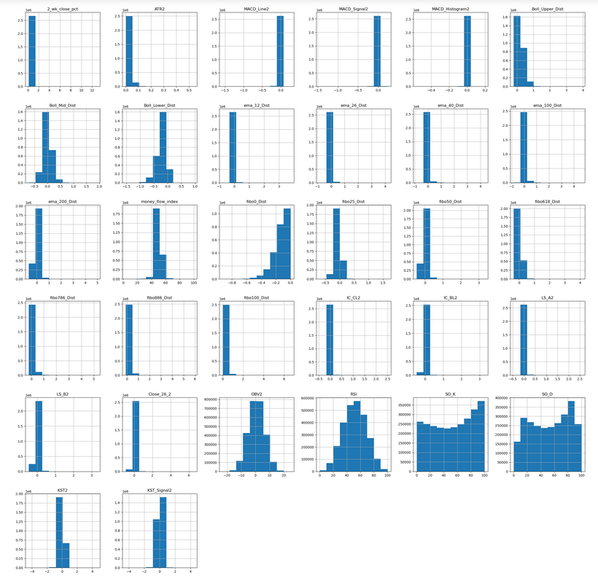*Fig 1: Histograms of dependent and independent variables*

* Datapoints outside of 3 standard deviations were removed in the data cleaning process.

*Fig 2: Histograms of dependent and independent variables after outlier pruning*

* After cleaning and min-max scaling, correlation was calculated and determined to be quite low

*Fig 3: Correllation of input vars to 2 week close pct*

*Fig 3: Hexbin charts of dependent vs.in dependent vars*

**4.5 Linear Regression**

* 20% of the population was held-out for validation purposes.
* Multiple Models were tested, none provided a satisfactory result

**4.5.1: Simple Linear Regression**

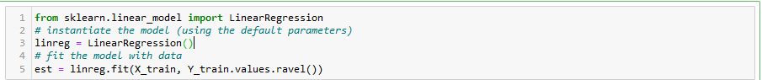

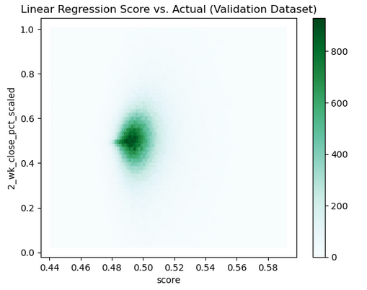

**4.5.2: Linear Decision Tree**



**4.5.3: Linear Neural Network**

**4.6 Logistic Regression**

* Rather than attempting to predict the future change itself, an attempt was made to predict the probability that a security will rise 3% within 2 weeks
* All variables were transformed from linear to categorical.
* This involved ranking the values within each variable, and subsequently creating dummy variables for each variable rank value

**4.6.1 Simple Logistic Regression**

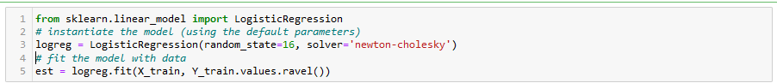

**4.6.2: Logistic Decision Tree**

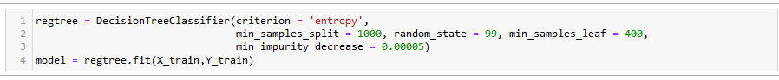

**4.6.3 Logistic Neural Network**

**4.5 Conclusion/Lessons Learned**

* Trendlines were removed due to implementation complexity. This will be revisited in future analysis.
* Individual variables are extremely low predictive value.
* Logistic models outperform linear models, and the interaction between independent variables means decision trees and neural networks outperform simple models.
* Particular predictive power in identifying the null case, or scenarios where the desired outcome does not occur, with a 90% accuracy.

5. Timeline

* Phase 1 (Data Collection): 01/15/24::01/21/24
* Phase 2 (Indicator Flagging): 01/21/24::01/26/24
* Phase 3 (Analysis and Reporting): 01/26/24::01/31/24

REFERENCES

[1] Martin J. Pring, 2002. Technical Analysis Explained, 4th Edition

Conference Name:ACM Woodstock conference

Conference Short Name:WOODSTOCK’18

Conference Location:El Paso, Texas USA

ISBN:978-1-4503-0000-0/18/06

Year:2018

Date:June

Copyright Year:2018

Copyright Statement:rightsretained

DOI:10.1145/1234567890

RRH: F. Surname et al.

Price:$15.00