import cProfile  
import hashlib  
cProfile.run("hashlib.md5(b'Pasya Vankov' * 1000000).hexdigest()")

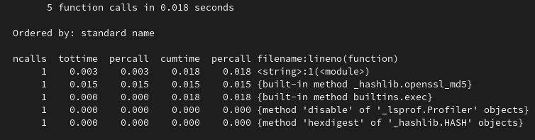

img_1.png

import cProfile  
import re  
cProfile.run("""r = re.compile("\\d\\S")  
[r.findall("sdfdsfD, 1d, 7f") for i in range(1000000)]""")

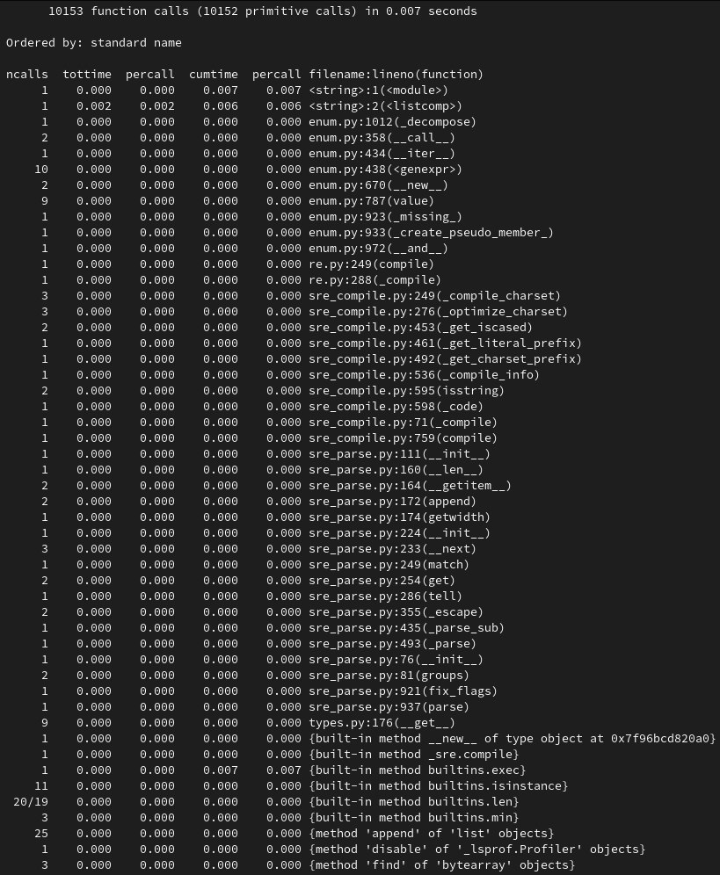

img_2.png

import cProfile  
cProfile.run("""  
def main():  
 y = int(input("Введите количество строк\\n"))  
 if 50 < y or y < 12:  
 print("При таких значениях я не могу работать нормально")  
 raise ValueError  
 x = y * 2  
 Even = True  
 if y % 2 == 1:  
 Even = False  
 if (x // 6) % 2 == 1:  
 x += 1  
 center = y // 2 - 1  
 has_text = (x * 11 // 18) >= 22  
 texts = ["CODE THE WORLD", "www.itmathrepetitor.ru"]  
 template_str = "[" * ((x * 5) // 12 + (1 if Even else 0)) + " " * (x // 12)  
 template_str_small = "[" + template_str[1:x // 4 - 2].replace("[", ":") + "[" #  
 template_str_small += " " * (len(template_str) - len(template_str_small))  
 print(template_str + "".join(reversed(template_str)).replace("[", "]"))  
 for line in range(1, y - 1):  
 if line < y // 6 or line > y - 1 - y // 6:  
 string = "[" + template_str[1:].replace("[", ":")  
 elif line == y // 6 or line == y - 1 - y // 6:  
 template_str_copy = list(template_str)  
 template_str_copy[template_str.rfind("[")] = ":"  
 template_str_copy = "".join(template_str_copy)  
 string = "[" + template_str[1: x // 4 - 1].replace("[", ":") + template_str_copy[  
 x // 4 - 1:]  
 else:  
 if line == center and has_text:  
 string = template_str_small[:(len(template_str_small) - len(texts[0]) // 2)]  
 print(string + texts[0] + "".join(reversed(string)).replace("[", "]"))  
 continue  
 elif line == center + 1 and has_text:  
 string = template_str_small[:(len(template_str_small) - len(texts[1]) // 2)]  
 print(string + texts[1] + "".join(reversed(string)).replace("[", "]"))  
 continue  
 else:  
 string = template_str_small  
 print(string + "".join(reversed(string)).replace("[", "]"))  
 print(template_str + "".join(reversed(template_str)).replace("[", "]"))  
  
  
if __name__ == '__main__':  
 cycle_do = True  
 while cycle_do:  
 try:  
 main()  
 cycle_do = False  
 input()  
 except ValueError:  
 import os  
 import time  
  
 for i in range(12):  
 os.system('cls' if os.name == 'nt' else 'clear')  
 print("ОШИБКА!!! НАЧИНАЮ ПЕРЕЗАГРУЗКУ" + "." * (i % 3 + 1))  
 time.sleep(0.2)  
 os.system('cls' if os.name == 'nt' else 'clear')  
 """)

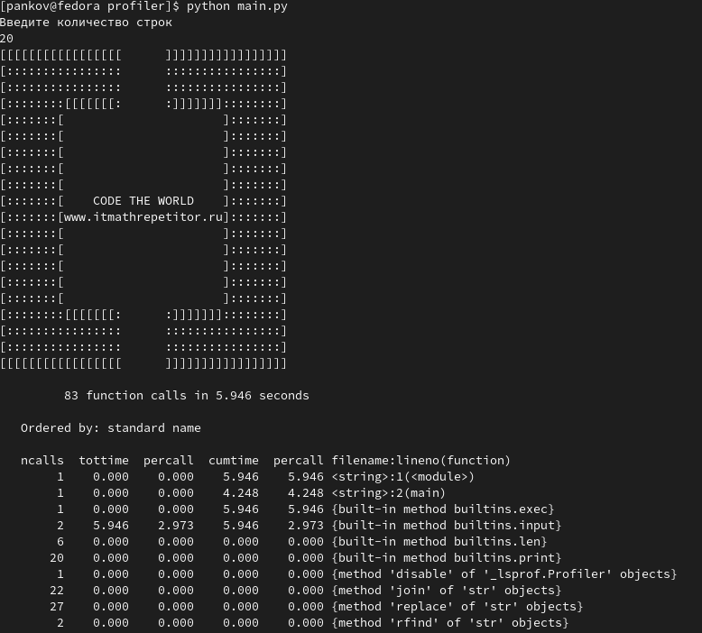

img_3.png