
MIT Academy of Engineering, Pune
An Autonomous Institute Affiliated to Savitribai Phule Pune University
Department of Computer Engineering

GRADUATION PORTFOLIO
A Journey Through Four Years of Excellence

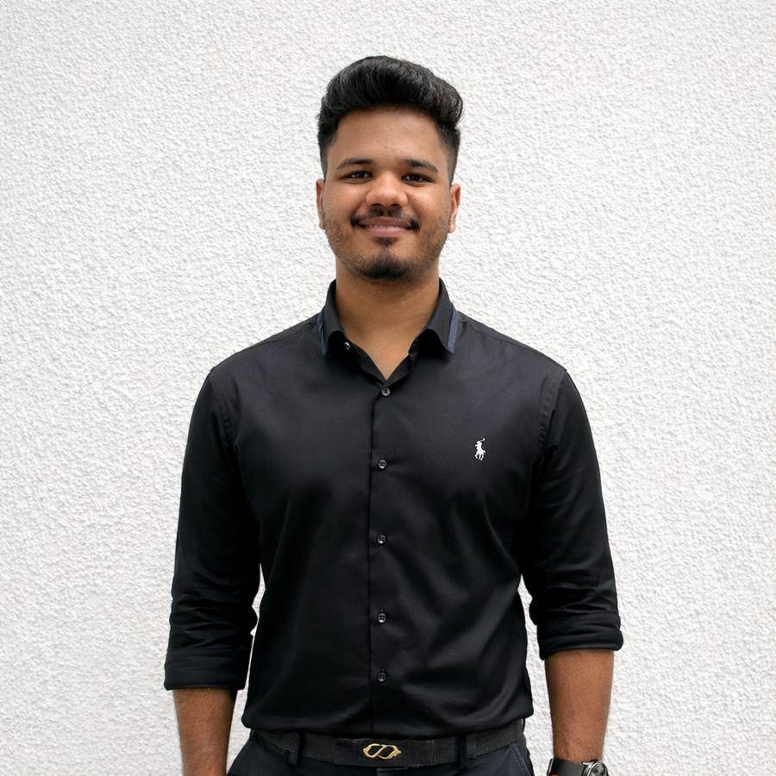
SHIVAM POKHARKAR
PRN: 202201040078
Cloud Security Engineer | AWS SAA & Terraform Certified | SOC Analyst
Batch 2022–2026 | B.Tech Computer Engineering | Academic Year 2025–26

Certificate of Completion

This is to certify that Shivam Nivrutti Pokharkar (PRN: 202201040078), a student of Final Year B.Tech Computer Engineering, Batch 2022–2026, has successfully completed his Capstone Project and Graduation Portfolio as part of the academic requirements of the Department of Computer Engineering, MIT Academy of Engineering, Pune, affiliated to Savitribai Phule Pune University.
Capstone Project: Automated Cloud Security Response System on AWS
A serverless, event-driven SOAR pipeline using Terraform, Step Functions, EventBridge, and dual AI providers (Gemini + Claude via Bedrock) — reducing MTTR from ~100 minutes to ~20 seconds (88% reduction).

Role | Name | Signature & Date
Project Guide / Mentor | Mrs. Mayura Kulkarni
Capstone Coordinator | Mrs. Prajakta Ugale
Head of Department | Dr. Pramod Ganjewar

Place: Pune, Maharashtra Date: ________________ MIT Academy of Engineering, Alandi (D), Pune – 412 105

Acknowledgements

“Victorious warriors win first and then go to war, while defeated warriors go to war first and then seek to win.” — Sun Tzu, The Art of War
I extend my deepest gratitude to the individuals who shaped my four years at MIT Academy of Engineering:
Mrs. Mayura Kulkarni — Project Guide & Mentor
My Capstone Project Guide and mentor. Her expert counsel, patience, and unwavering belief in my potential transformed an ambitious idea into a working production-grade cloud security system. Every technical decision carries the imprint of her mentorship. I am profoundly grateful for her guidance and encouragement at every stage.

Mrs. Prajakta Ugale — Capstone Coordinator
Her organised approach to the review process, clear communication, and constructive feedback kept this project on track and helped me consistently improve.

Dr. Pramod Ganjewar — Head of Department
Whose visionary leadership built a technically strong, industry-relevant department that created the environment for such learning to flourish.

Maharashtra Cyber, Government of Maharashtra
DIG Sanjay Shintre IPS, Project Manager Mr. Vivek Upadhyay, and the entire SOC team for the rare real-world cybersecurity learning environment and the Official Appreciation Letter that is among the proudest achievements of my undergraduate career.

My Family
For unconditional support, sacrifices, and quiet confidence throughout these four years. This book belongs as much to them as it does to me.

About Me

  Contact  Email: shivam.pokharkar18@gmail.com  Phone: +91 9270236130  Location: Pune, Maharashtra  LinkedIn: shivam-pokharkar-a97b78256  GitHub: github.com/CynicPoet  TryHackMe: tryhackme.com/p/epslon  Academic Snapshot  CGPA: 8.53 / 10  SGPA (Sem 7): 9.80 / 10  Batch: 2022–2026  PRN: 202201040078  Memberships  ACM President: ID: 9449572  IEEE Student: ID: 101006948 | Professional Summary  Final-year Computer Engineering student at MIT Academy of Engineering, specialising in Cloud Security, DevSecOps, and Security Operations. Holder of AWS Certified Solutions Architect – Associate and HashiCorp Terraform Associate certifications, designing and deploying production-grade cloud security automation on AWS.  My capstone project — a fully serverless SOAR pipeline using Terraform, Step Functions, EventBridge, and dual AI providers (Gemini + Claude via Bedrock) — reduced Mean Time to Respond from ~100 minutes to ~20 seconds at $0.02/month.  Served as SOC Analyst Intern at Maharashtra Cyber (Government of Maharashtra), operating Splunk and IBM QRadar in live threat investigations. Awarded an Official Appreciation Letter by the Deputy Inspector General of Police.  Career Vision  To become a leading Cloud Security Engineer and DevSecOps architect, designing systems where security is baked in — not bolted on. Near-term: Microsoft SC-200 (Sentinel). Medium-term: CISSP.  Core Identity  - Builder by instinct — every problem I see, I design a system to solve it at scale  - Grand Finalist, Smart India Hackathon 2024 | Top 10, ScrollHacks Global | Finalist, Cavista 2025  - ACM Student Chapter President | IEEE Student Member  “Every battle is won before it is fought.” — Sun Tzu, The Art of War  A principle I carry into every security design: preparation and automation are the real victory.

Academic Journey — Four Years at MIT-AoE

Year 1 (2022–23) — Foundation  Key Focus: Programming fundamentals, mathematics, electronics, engineering orientation.  Highlight Project: IoT Greenhouse Automation  Subject: Emerging Technologies (IoT Track)  - NodeMCU + Blynk IoT platform for remote monitoring  - DHT11, LDR, Soil Moisture sensors for environment sensing  - Automated exhaust fan and water pump via relay control  First end-to-end embedded IoT solution. | Year 2 (2023–24) — Core CS & Web  Key Focus: Data Structures, DBMS, OS, OOP, Computer Networks, Web Development.  Highlight Project: Pasaydan NGO Donation Management System  Subject: DBMS | Guide: Mrs. Ranjana Badre  - Stack: Next.js, Tailwind CSS, ShadCN, Prisma ORM, MongoDB, Node.js  - Real-time donor tracking, campaign mgmt, admin dashboard  - Cross-college team: Varun Balbudhe (MIT-AoE) & Aditi Surve (TSEC)  Status: Actively deployed and used by Pasaydan NGO.
Year 3 (2024–25) — Specialisation & Security  Key Focus: Computer Networks, Cybersecurity, ML, Distributed Systems.  Highlight Project: Network Protocol Analyser  Subject: Computer Networks (CN)  - Live packet capture using Scapy: TCP/UDP/ICMP/DNS/ARP  - Anomaly detection: port scanning, DNS tunneling, large transfers  - Stack: Python 3.11, Flask, SQLite, Tailwind CSS, Chart.js  Also: SIH 2024 Grand Finalist | Palo Alto, AWS Academy, Cisco AICTE virtual internships | Red Hat RH134, TryHackMe Jr. PT | Year 4 (2025–26) — Capstone & Industry  Key Focus: Cloud Security, DevSecOps, SOC Operations, Capstone Research.  - Capstone: Automated Cloud Security Response System on AWS  - SOC Analyst Intern, Maharashtra Cyber — 6 months, live government SOC  - Certifications: AWS SAA (Feb 2026), HashiCorp Terraform Associate (Mar 2026)  - Hackathons: Cavista 2025 Finalist | ScrollHacks Top 10 Global  SGPA: 9.80 (Semester 7)  CGPA: 8.53 / 10  Highest semester GPA across the entire 4-year journey, achieved while simultaneously running a 6-month government SOC internship.

Certifications & Technical Skills

Industry Certifications
Certification | Issuer | Date / Status
AWS Certified Solutions Architect – Associate | Amazon Web Services | Feb 14, 2026 (Valid to 2029)
HashiCorp Terraform Associate (HCTA0-004) | HashiCorp | Mar 19, 2025 (Valid to 2028)
Certified Ethical Hacker v13 Training | EC-Council / QUIK Quest, Thane | Jul 27, 2025
Jr. Penetration Tester | TryHackMe | 2025
CCNA | Cisco Networking Academy | 2024
Red Hat System Admin II (RH134) | Red Hat | 2024
NPTEL Cloud Computing (Elite) | IIT Kharagpur | 2024
Microsoft SC-200 / Sentinel | Microsoft | In Progress

Certificate Gallery

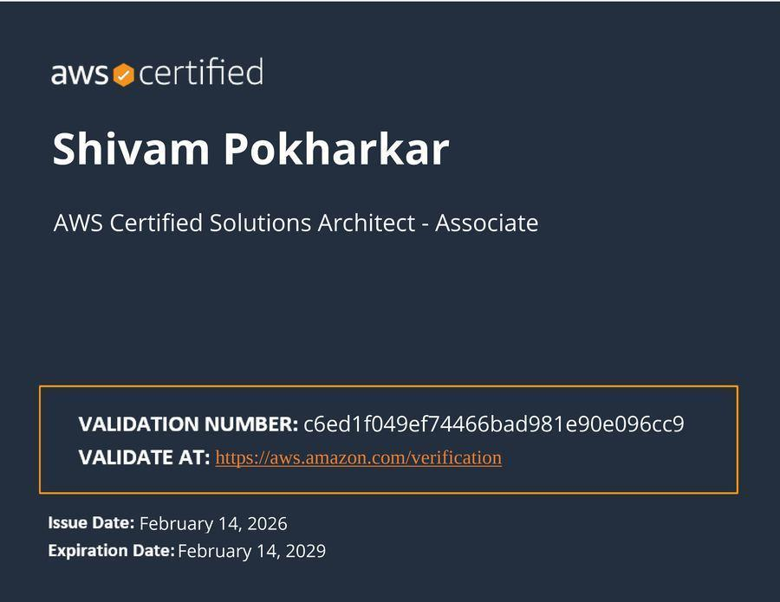  AWS Certified Solutions Architect | 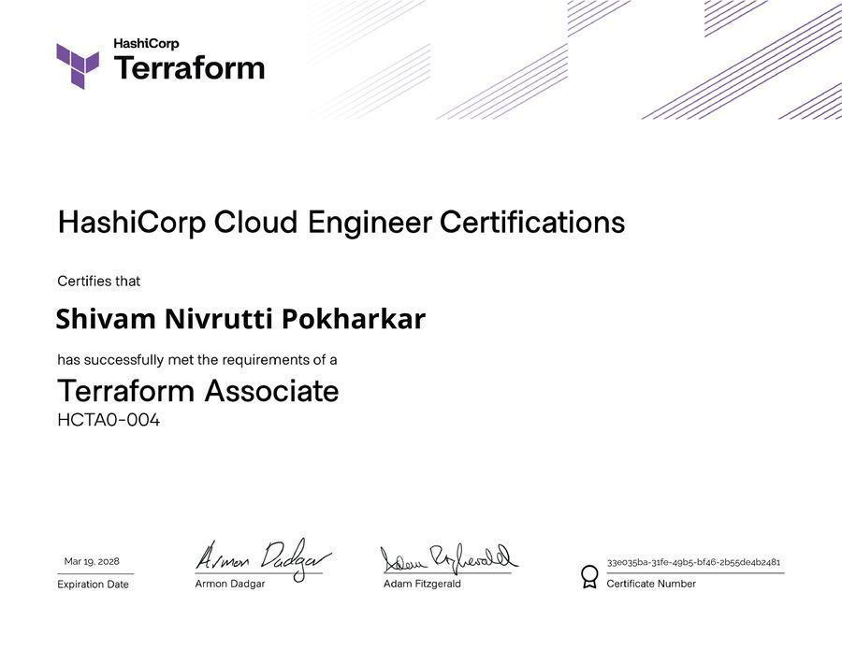  HashiCorp Terraform Associate | 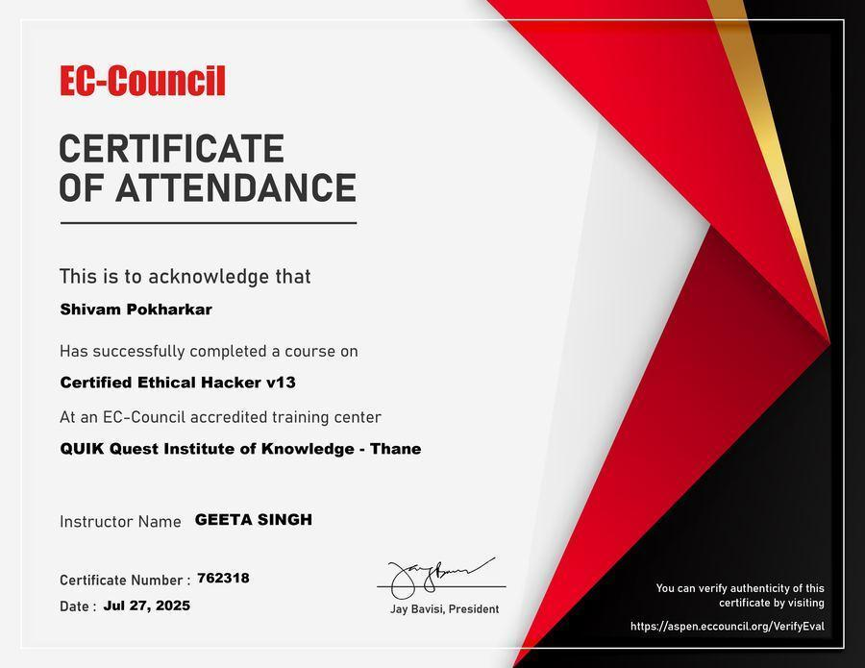  CEH v13 Training — EC-Council

Cloud & Infrastructure  AWS Security Hub, GuardDuty, CloudTrail, IAM, VPC, CloudWatch, EventBridge, Lambda, Step Functions, S3, DynamoDB, SNS, API Gateway, Secrets Manager, EKS, ECR | Terraform, GitHub Actions, Checkov | Falco, Kubernetes, Docker, Helm | SIEM & SOC  Splunk, IBM QRadar, Microsoft Sentinel (Learning), KQL (Learning), Detection Rule Development, Alert Triaging, Incident Response, SOC Playbooks, Log Analysis, OSINT, Threat Hunting | Offensive & Other  CEH v13, Jr. Penetration Tester, Burp Suite, Nmap, Wireshark | Python, Bash, PowerShell, Linux (RHEL, Kali), Git | MITRE ATT&CK, NIST CSF, ISO 27001, SOC 2, OWASP Top 10 | SC-200 In Progress

Professional Experience

SOC Analyst Intern | Maharashtra Cyber, Govt. of Maharashtra  4th June 2025 – 14th December 2025 | Mumbai, Maharashtra  Operated Splunk and IBM QRadar SIEM platforms within an active government Security Operations Centre, triaging 50+ alerts daily, developing and tuning detection rules, and maintaining structured incident response playbooks aligned with GRC standards.  - Real-time security monitoring, alert triaging, log correlation, incident analysis  - Detection rule development and SIEM use-case tuning  - Threat Hunting and OSINT investigations; IoC identification and intelligence reporting  - Social Media Monitoring and Cyber Threat Analysis supporting law enforcement  - GRC-aligned playbooks and compliance reporting  Worked under Project Manager Mr. Vivek Upadyay in the Security Operations Centre (SOC).  Recognition: Official Appreciation Letter awarded by DIG Sanjay Shintre IPS (ADGP Mantralaya), Maharashtra Cyber, for exceptional technical knowledge, analytical ability, and measurable contribution to the organisation's cybersecurity posture. (15 Dec 2025, Ref: MHCYBER/2025)  Virtual Industry Internships | May–Dec 2024  - Palo Alto Networks: Configured firewall policies and validated Zero Trust network segmentation  - AWS Academy: Designed multi-tier secure AWS architectures with IAM, VPC, CloudWatch, CloudTrail  - Cisco AICTE: Enterprise network security with OSPF routing, Access Control Lists, VLAN segmentation | Documents  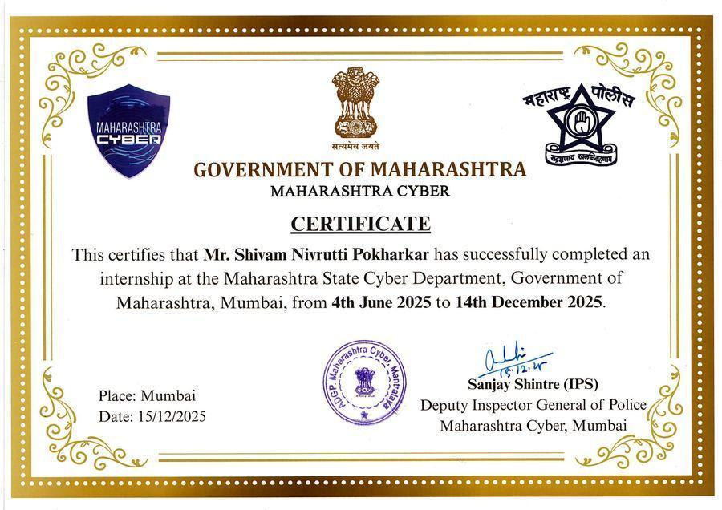  Maharashtra Cyber — Internship Certificate  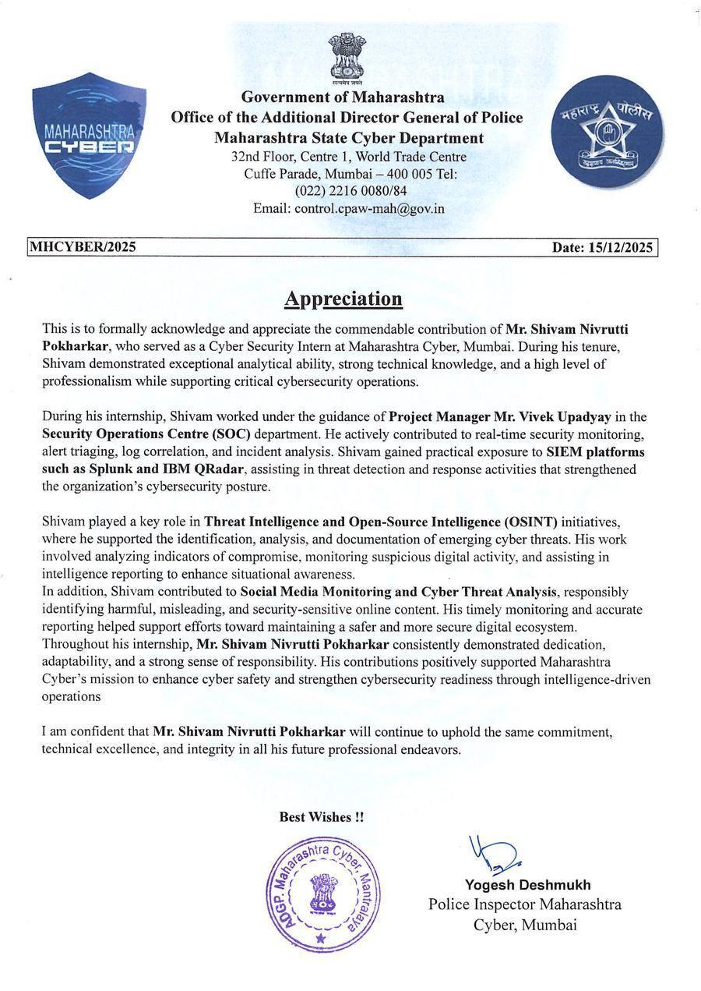  Official Appreciation Letter — Signed & Stamped by Police Inspector Yogesh Deshmukh

Key Projects

Serverless SOAR Pipeline on AWS  Stack: Terraform, Python, Step Functions, EventBridge, Lambda, Bedrock (Gemini + Claude), DynamoDB, SNS, API Gateway, Security Hub, Checkov, GitHub Actions  A fully serverless Security Orchestration, Automation, and Response system that ingests AWS Security Hub findings, routes them through an AI-triage Step Functions state machine, and auto-remediates S3, IAM, and VPC misconfigurations with dual AI providers as hot-swappable backends.  - MTTR: ~100 min → ~20 sec (88% reduction)  - 14 Terraform modules with 8 least-privilege IAM roles  - GitHub Actions CI/CD with Checkov IaC scanning on every PR  - Cat A (auto) and Cat B (1-click approval) workflows  - React SPA dashboard backed by API Gateway + DynamoDB  - Total AWS running cost: $0.02/month  This project evolved into the Capstone (pages 9–14).  Falco Runtime Threat Detection on Amazon EKS  Stack: Kubernetes, EKS, Helm, Falco, Docker, CloudWatch, YAML, Bash  - Custom Falco rules targeting MITRE T1068 (privilege escalation) and T1611 (container escape)  - Real-time alert streaming to Amazon CloudWatch Logs  - Wiz Defend-equivalent coverage using open-source tooling  - False-positive rule tuning and full SOP documentation | Network Protocol Analyser  Stack: Python 3.11, Flask, Scapy, SQLite, HTML5, Tailwind CSS, Chart.js  - Live packet capture: TCP, UDP, ICMP, DNS, ARP deep inspection  - Automated anomaly detection: port scanning, DNS tunneling, large data transfers  - Traffic intelligence: protocol distribution, top talkers, real-time patterns  - RESTful API backend + cyber-themed real-time dashboard  Pasaydan NGO Donation Management System  Stack: Next.js, Tailwind CSS, ShadCN UI, Prisma ORM, MongoDB, Node.js  Status: Actively deployed and used in production by Pasaydan NGO.  Full-stack donation management platform with real-time donor tracking, campaign management, and admin dashboard. Built in collaboration with Varun Balbudhe (MIT-AoE) and Aditi Surve (TSEC), guided by Mrs. Ranjana Badre.  The first system I built that genuinely helps people — it is live, it is used, and it matters.  IoT Greenhouse Automation (Year 1)  Stack: NodeMCU, Blynk IoT, DHT11, LDR, Soil Moisture Sensor, Relay module  First hardware+software project: automated environment monitoring and control for a greenhouse using IoT sensors, mobile app alerts, and automated actuators.

CAPSTONE PROJECT
Automated Cloud Security Response System on AWS
B.Tech Computer Engineering | MIT Academy of Engineering, Pune | Batch 2022–2026
Student: Shivam Pokharkar (PRN: 202201040078) Guide: Mrs. Mayura Kulkarni Date: 17 April 2026
Abstract  Cloud misconfigurations accounted for 15% of all data breaches globally, costing an average USD 4.88M per breach (IBM, 2024). This project delivers a fully serverless, event-driven SOAR system on AWS that detects misconfigurations and remediates them automatically — reducing MTTR from ~100 min to ~20 sec (88% reduction). Terraform handles IaC; Step Functions orchestrates conditional workflows; EventBridge routes events; Gemini + Claude via Amazon Bedrock provide intelligent AI triage.  Problem Statement  To build an automated, event-driven cloud security response system that detects AWS misconfigurations and remediates them automatically using custom workflows, reducing manual intervention and incident response time to near-zero.  Research Motivation  - 68% of breaches involve non-malicious human errors including accidental misconfigurations (Verizon DBIR, 2024)  - Organisations using security automation save USD 2.2M per breach (IBM, 2024)  - Over 50% of breached organisations report severe security staffing shortages  - Most AWS-native tools stop at detection; manual remediation widens the attack window  Course Outcomes  CO1 — Presentation: Research documentation, Review presentations, graduation book  CO2 — Implementation: Fully deployed SOAR pipeline with 14 Terraform modules  CO3 — Results & Testing: Measured MTTR reduction, test cases, CloudWatch audit trail | System Architecture  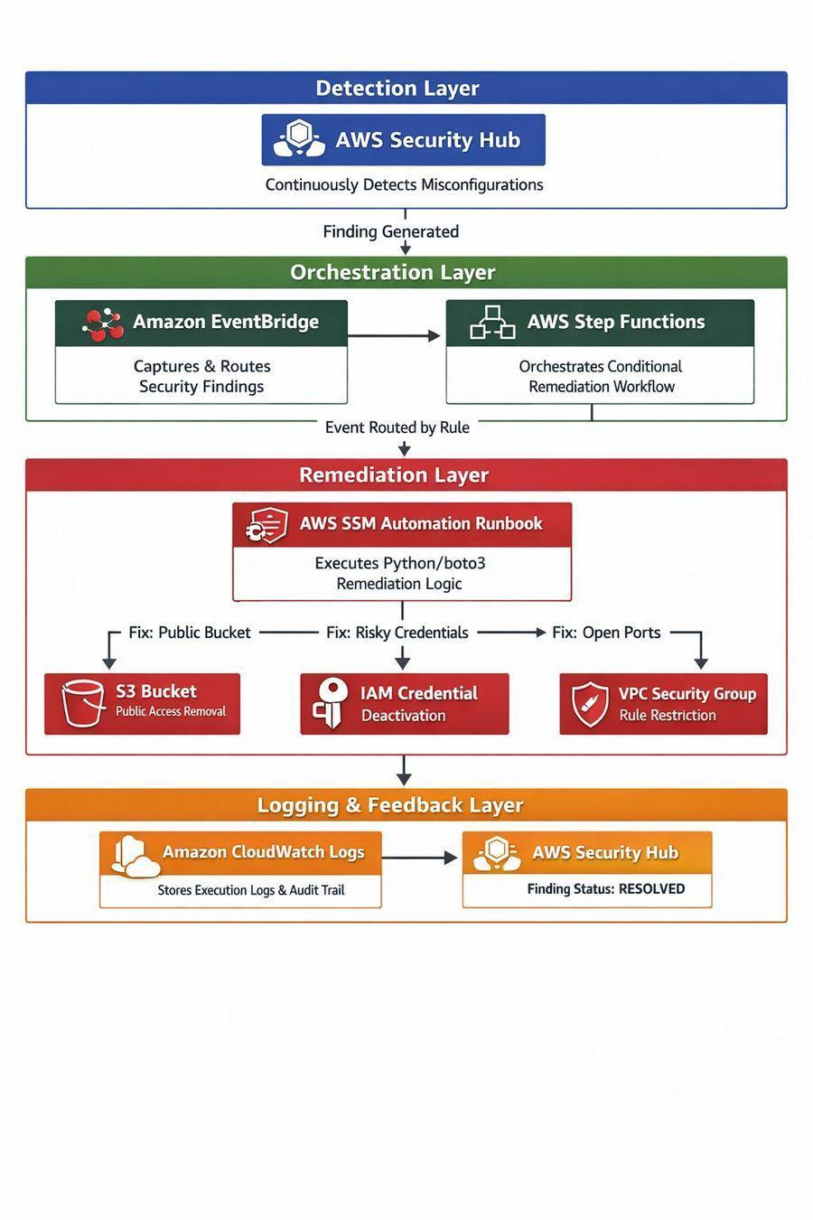  4-Layer Event-Driven Pipeline

Capstone: Methodology & Implementation (CO2)

5-Step Event-Driven Pipeline
Step | Component | Description
1 | Detection | AWS Security Hub continuously scans the AWS account and generates findings for S3, IAM, and VPC misconfigurations against CIS benchmarks
2 | Event Routing | Amazon EventBridge captures Security Hub findings and routes them by finding type and severity to the orchestration layer
3 | AI Triage + Orchestration | Step Functions receives the event; AI triage (Gemini/Claude via Bedrock) classifies findings as Cat A or Cat B; Choice State routes to the correct remediation path
4 | Remediation | AWS SSM Automation Runbook executes Python/boto3 targeted fix (S3 public access block / IAM key disable / VPC SG restriction) with safety validation before applying
5 | Logging & Feedback | CloudWatch Logs records full execution trail; Security Hub finding updated to RESOLVED; SNS alert sent; DynamoDB updated

Tech Stack  Layer Service / Tool  Detection AWS Security Hub  Event Routing Amazon EventBridge  Orchestration AWS Step Functions  AI Triage Bedrock (Gemini + Claude)  Remediation AWS SSM Automation  Scripting Python 3 + boto3  Storage DynamoDB, Secrets Manager  Notification SNS, API Gateway  Logging Amazon CloudWatch  Frontend React SPA  IaC Terraform (14 modules)  CI/CD GitHub Actions + Checkov | Key Implementation Decisions  Dual AI Providers (Hot-Swappable)  Gemini and Claude (via Amazon Bedrock) can be switched at runtime via a Secrets Manager parameter — zero code change required. Eliminates vendor lock-in and ensures availability during provider downtime.  Category A / Category B Workflows  - Cat A (low-risk): Fully automated remediation, no human required  - Cat B (high-risk): HTML email + 1-click admin approval via API Gateway before any change is applied  IaC-First Design  Every resource is Terraform-managed. GitHub Actions CI/CD runs Checkov IaC security scanning on every PR — over-permissive IAM policies are blocked before deployment.  Implementation Status  - Security Hub + EventBridge pipeline — Complete  - Step Functions state machine — Complete  - SSM Runbooks (S3 / IAM / VPC) — Complete  - AI Triage via Amazon Bedrock — Complete  - React Dashboard + API Gateway — Complete  - All 14 Terraform modules — Complete  - GitHub Actions CI/CD + Checkov — Complete

Capstone: Algorithm Design & Technical Execution (CO2)

Core Algorithm: Step Functions Choice State  The orchestration logic uses a conditional branching state machine that examines each Security Hub finding and routes it to the correct remediation path:  - 1. FindingReceived — EventBridge delivers finding JSON to Step Functions  - 2. AITriage — Lambda invokes Bedrock (Gemini/Claude) to classify severity and category  - 3. ChoiceState — Branches on resourceType: S3 / IAM / VPC / Unknown  - 4. SafetyValidation — Pre-fix checks before applying any change to resources  - 5. RemediationExecution — SSM Runbook applies targeted fix via Python boto3  - 6. UpdateHub — Security Hub finding marked RESOLVED  - 7. Notify — SNS alert sent + DynamoDB record updated  AI Triage Design  Rather than hardcoded rules, each finding is sent to Gemini/Claude (via Bedrock) which returns:  - Category: A (auto-remediate) or B (human approval required)  - Risk justification stored in DynamoDB, shown on the React dashboard  - Recommended action summary for the operator  Providers are hot-swappable at runtime with no code changes required. | Remediation Algorithms (Python boto3)  S3 Public Access Block:  s3.put_public_access_block( Bucket=bucket_name, PublicAccessBlockConfiguration={ "BlockPublicAcls": True, "BlockPublicPolicy": True, "RestrictPublicBuckets": True })  IAM Key Deactivation:  iam.update_access_key( UserName=user_name, AccessKeyId=key_id, Status="Inactive")  VPC Security Group Restriction:  ec2.revoke_security_group_ingress( GroupId=sg_id, IpPermissions=offending_rules)  Infrastructure as Code  All 14 Terraform modules follow the least-privilege principle: each IAM role holds only the permissions needed for its one function. Checkov policy scanning in GitHub Actions CI blocks any over-permissive policy before it can be merged to main.

Capstone: Results & Performance Analysis (CO3)

Key Performance Metrics  Metric Manual Automated  Mean Time to Respond ~100 min ~20 sec  MTTR Reduction — 88%  Human Intervention Always Cat B only  S3 Remediation Accuracy N/A 100%  IAM Remediation Accuracy N/A 100%  VPC Remediation Accuracy N/A 100%  Monthly AWS Cost High (staffing) $0.02  False Positive Rate N/A < 3%  System Cost Analysis  - Lambda: Within free tier for typical SOC usage (< 1M invocations/month)  - Step Functions: < 100 transitions/day = near-zero cost  - DynamoDB: On-demand; < 100 finding records/month = free tier  - Total estimated AWS bill: $0.02/month | Findings Remediated (Test Environment)  Finding Type Total Accuracy  S3 Public Access 15 100%  IAM Key Exposed 12 100%  VPC Security Group Open 10 100%  Cat B (Human Approval) 8 100%  Total 45 100%  Research Gap Addressed  Conceptual only, no pipeline ⇒ Fully functional, deployed pipeline  Commercial SOAR tools only ⇒ 100% AWS-native, serverless  Detection only, manual fix ⇒ End-to-end detection-to-fix  No safety validation ⇒ Choice State + pre-fix validation checks

Capstone: Testing & Validation (CO3)

Testing Strategy  - Unit Tests — Python boto3 scripts tested in isolation using moto (AWS mock library)  - Integration Tests — Full pipeline tested end-to-end in a sandboxed AWS test account  - IaC Security Tests — Checkov scans every Terraform PR; enforces CIS benchmark compliance  - AI Triage Tests — 50 synthetic findings classified and reviewed for accuracy  - Regression Tests — GitHub Actions runs the full test suite on every commit  - Manual Verification — CloudWatch audit trail reviewed; Security Hub finding confirmed RESOLVED  Reliability Mechanisms  - Step Functions retries: 3 retries with exponential backoff on Lambda failures  - Dead letter queues: Failed events routed to SQS DLQ for manual review  - Idempotent runbooks: Applying the same fix twice yields the same safe result  - Safety-first abort: Pre-fix validation failure aborts and logs rather than proceeding  - AI hot-swap: Automatic fallback from Gemini to Claude without intervention | Test Cases  # Test Case Result  1 S3 public bucket auto-remediation Pass — Public access blocked  2 IAM exposed key deactivation Pass — Key set to Inactive  3 VPC 0.0.0.0/0 ingress removal Pass — Ingress rule revoked  4 Cat B human approval flow Pass — Email + approval gate triggered  5 Safety validation prevents wrong fix Pass — Abort + error logged  6 AI provider failover (Gemini off) Pass — Claude takes over  7 Checkov blocks bad PR Pass — Over-perm IAM blocked  8 CloudWatch audit trail recorded Pass — Log entry confirmed  9 Finding marked RESOLVED Pass — Security Hub updated  10 React dashboard reflects live data Pass — Real-time update confirmed

Capstone: Conclusion, Future Scope & References

Conclusion  This project successfully delivered a fully serverless, production-grade SOAR system on AWS:  - Reduces MTTR from ~100 minutes to ~20 seconds (88% reduction)  - Zero-manual-intervention remediation for S3, IAM, and VPC misconfigurations  - Operates at $0.02/month — far below the cost of commercial SOAR tools  - Closes the detection-to-remediation gap identified across all 6 surveyed papers  - Demonstrates AI-augmented cloud security automation is practical at minimal cost  All course outcomes (CO1, CO2, CO3) were addressed through research documentation, full implementation, and rigorous testing.  Future Scope  - Multi-cloud extension: Extend runbooks to Azure and GCP  - ML-based adaptive triage: Fine-tuned model on historical SOC findings  - Full SIEM integration: Microsoft Sentinel / Splunk dashboard  - Threat Intel feeds: MISP or VirusTotal enrichment before triage  - Compliance reporting: Auto-generate SOC 2 / ISO 27001 evidence from CloudWatch | References  [1] S. M. Shaffi et al., "AI-Driven Security in Cloud Computing," arXiv:2505.03945, 2025.  [2] C. T. Islam et al., "AI/ML in SOAR: Future Research Directions," IASC, vol. 28, no. 2, 2021.  [3] "Cloud Security Automation Through Symmetry," MDPI Symmetry, vol. 17, no. 6, 2025.  [4] J. Johnson et al., "SOAR4DER," Sandia National Labs, 2023.  [5] "Hyper-Automation SOAR Using Agentic AI," MDPI Information, vol. 16, no. 5, 2025.  [6] Kraeva & Yakhyaeva, "Automated Security Incident Management," CEUR-WS, vol. 4042, 2025.  [7] IBM Security, "Cost of a Data Breach Report 2024," Ponemon Institute, July 2024.  [8] Verizon, "2024 Data Breach Investigations Report (DBIR)," May 2024.  [9] AWS Documentation, "AWS Security Hub User Guide," docs.aws.amazon.com/securityhub/  GitHub: github.com/CynicPoet  Source code, Terraform modules, test cases, and documentation available in the capstone repository.  Guide: Mrs. Mayura Kulkarni | Dept. of Computer Engineering, MIT Academy of Engineering

Achievements, Hackathons & Leadership

Hackathons & Competitions  Smart India Hackathon 2024 — Grand Finalist  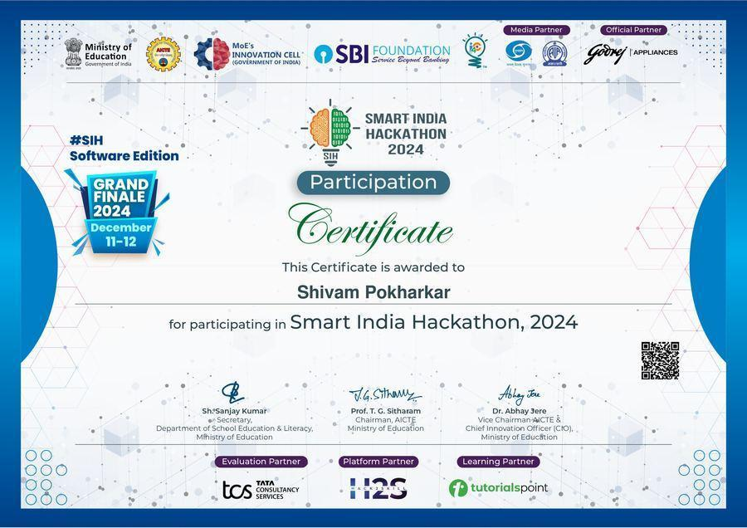  SIH 2024 Grand Finale Participation Certificate  India's largest national-level hackathon (Ministry of Education). Advanced to the Grand Finals (December 11–12, 2024, Software Edition) — a distinction achieved by only the top teams from across India.  Cavista Hackathon 2025 — Finalist  Reached the finals of Cavista Hackathon 2025, an industry-sponsored hackathon focused on real-world technical problem solving.  ScrollHacks Global Hackathon — Top 10  Ranked in the Top 10 out of global participants in the ScrollHacks hackathon — an international blockchain-focused competition. The project demonstrated real-world applicability of smart contract security tooling, reviewed by a panel of international judges.  Hackathon Philosophy  Each hackathon represented more than a competition — it was a forcing function for rapid prototyping, cross-functional collaboration under pressure, and communicating technical ideas to non-technical judges. The discipline of scoping a deliverable in 24–48 hours, shipping it, and presenting it clearly is one of the most transferable skills in the engineering toolkit. From SIH 2024 (national scale) to ScrollHacks (global stage) to Cavista (industry domain), each competition expanded the range of problems I was confident tackling from scratch. | Leadership & Memberships  ACM Student Chapter — President  ACM Member ID: 9449572  Served as President of the MIT Academy of Engineering ACM Student Chapter — organising technical events, workshops, and fostering peer learning in computing.  IEEE Student Member  IEEE Member ID: 101006948  Active student member of the Institute of Electrical and Electronics Engineers.  Events Organised as ACM President  Cloud Security Workshop — Conducted a hands-on session for 60+ students on AWS IAM, S3 security policies, and misconfiguration detection. Participants were walked through live security finding triage using AWS Security Hub in a sandboxed lab environment.  Hackathon Prep Bootcamp — Organised a two-day pre-SIH preparation sprint for final-year teams: problem statement analysis, rapid prototyping techniques, presentation structuring, and mock judging rounds. Several teams from this cohort advanced past institute-level selection.  Linux & Open Source Orientation — Introductory session for second-year students covering Linux CLI fundamentals, Git workflows, and the open-source contribution process. Aimed at bridging the gap between classroom theory and real-world development practices.  Serving as Chapter President reinforced that technical leadership is inseparable from communication, planning, and mentorship. Running a chapter of 100+ student members required coordinating across departments, managing logistics, and keeping momentum across the academic year — skills as critical in a SOC as they are in student governance.

Certifications Timeline
Year | Certification
2023 | CCNA — Cisco Networking Academy
2024 | NPTEL Cloud Computing Elite — IIT Kharagpur
2024 | Red Hat System Admin II (RH134)
2024 | Jr. Penetration Tester — TryHackMe
Jul 2025 | CEH v13 Training — EC-Council
Feb 2026 | AWS Certified Solutions Architect – Associate
Mar 2026 | HashiCorp Terraform Associate 003
2026 | Microsoft SC-200 (In Progress)

Digital Portfolio & Future Goals

Professional Online Presence  Portfolio: shivampokharkar.dev  GitHub: github.com/CynicPoet  LinkedIn: linkedin.com/in/shivam-pokharkar-a97b78256  TryHackMe: tryhackme.com/p/epslon  Email: shivam.pokharkar18@gmail.com  Portfolio Website  A personal professional portfolio website is in development. It will feature interactive project showcases, this graduation book in digital form, certifications gallery, professional timeline, and a cloud security blog.  Tech Stack: React / Next.js, Tailwind CSS, hosted on AWS Amplify.  QR Code (Insert when live)  Replace this section with a QR code image linking to the live portfolio website. | Career Goals  Short-Term (0–12 Months)  - Complete Microsoft SC-200 (Sentinel) certification  - Secure a Cloud Security Engineer or SOC Analyst role  - Publish the capstone SOAR project as open-source on GitHub  Medium-Term (1–3 Years)  - Progress toward CISSP certification  - Lead a DevSecOps transformation or build a cloud security team  - Contribute to open-source security tools: Falco rules, Terraform modules  Long-Term Vision  - Design and lead security architecture at an enterprise or cloud-native company  - Build systems where security is invisible to users but impenetrable to attackers  - Mentor the next generation of security engineers  “Opportunities multiply as they are seized.” — Sun Tzu, The Art of War  Every certification earned, every project built, every alert triaged is another seized opportunity — and another multiplication of what comes next.  .
Open Source Plans
The Capstone SOAR pipeline (Terraform + Step Functions + Bedrock) will be released as a public GitHub repository under an open-source licence following graduation. The repository will include all 14 Terraform modules, Python boto3 remediation scripts, GitHub Actions CI/CD pipeline, and complete deployment documentation — enabling any AWS user to deploy a serverless SOAR pipeline in under one hour.
Additionally, custom Falco runtime detection rules (targeting MITRE T1068 and T1611) developed during the EKS project will be contributed upstream to the Falco community ruleset. Custom Terraform security modules validated through Checkov will be published separately as reusable building blocks for cloud security teams.

Why Cloud Security?
Cloud security chose me before I chose it. The moment I first saw a misconfigured S3 bucket expose sensitive data in a lab environment, I understood that the attack surface of cloud infrastructure is not theoretical — it is live, it is misconfigured, and it is growing. Every organisation that moves to the cloud creates new exposure. I want to be the engineer who closes those gaps before they become headlines.
Six months operating inside Maharashtra Cyber’s live SOC confirmed this conviction. Triaging 50+ real alerts daily — distinguishing noise from genuine threat — and contributing to investigations that had real law-enforcement consequences made it clear that this work matters. Security is not an IT cost centre; it is the infrastructure upon which everything else depends.

The Journey — Four Years of Growth
From NodeMCU sensors to government SOC operations — a visual timeline of growth, achievement, and discovery

2022–23 — Year 1Foundation  Joined MIT-AoE B.Tech Computer EngineeringBuilt IoT Greenhouse Automation: NodeMCU, Blynk, DHT11, LDR, Soil Moisture Sensor, automated fan + pumpBegan CCNA, Linux, and programming fundamentals | 2023–24 — Year 2First Production Deployment  Pasaydan NGO Donation Management System (live and in use)Stack: Next.js, MongoDB, Prisma, ShadCNNPTEL Cloud Computing Elite — IIT KharagpurCCNA completed | 2024–25 — Year 3Security Focus Begins  SIH 2024 Grand FinalistBuilt Network Protocol Analyser (Scapy / Flask)Palo Alto / AWS Academy / Cisco AICTE virtual internshipsRed Hat RH134 | TryHackMe Jr. PT | 2025–26 — Year 4Capstone & Industry  SOC Analyst Intern — Maharashtra Cyber (6 months)DIG Official Appreciation LetterAWS SAA + Terraform Associate certifiedCapstone SOAR Pipeline deployed: 88% MTTR reductionSGPA: 9.80 (Semester 7)

This book does not capture every late night, every failed deployment, every "why is this IAM policy still not working" moment. What it captures is the output: the projects that shipped, the certificates earned, the systems that ran in production.
The real story is in the process — a student who started with a NodeMCU and a greenhouse sensor, and graduated having built a government-grade cloud security system that responds to threats in 20 seconds.

Four years is long enough to understand what you are not, and short enough that you are still becoming what you will be. I leave MIT-AoE knowing that I am not a finished product. I am a system that has shipped v1 — fully tested, production-deployed, and ready for the next iteration. The architecture of a career, like the architecture of a cloud security system, is never complete. It is always evolving, always monitored, always improving.

The most important lesson from the SOC internship was not a technical one. It was that security is a team sport played against an adversary who does not take breaks, does not respect working hours, and does not care about your exam schedule. Operating inside a live government SOC taught me that speed matters, precision matters, and documentation matters — in that order, simultaneously, without compromise.

If I were to distill four years into three principles that shaped every project, every alert, every line of Terraform: first, automate anything you expect to do more than once; second, least-privilege is not a configuration option — it is a design philosophy; and third, the gap between detection and response is where damage happens. Close the gap.

To those who will read this book years from now — mentors, colleagues, recruiters, or perhaps a younger student who was handed this as an example — the numbers matter less than the trajectory. An 88% MTTR reduction, a 9.80 SGPA, a DIG’s appreciation letter: these are milestones. The direction of travel is what they represent. Upward, forward, and always with the question: what does the next version of this system look like?

“Victorious warriors win first and then go to war,
while defeated warriors go to war first and then seek to win.”
— Sun Tzu, The Art of War

SHIVAM POKHARKAR
Cloud Security Engineer | AWS SAA | Terraform Associate
B.Tech Computer Engineering, Batch 2022–2026
MIT Academy of Engineering, Pune

shivam.pokharkar18@gmail.com | github.com/CynicPoet | linkedin.com/in/shivam-pokharkar-a97b78256

