Documentation of process

* **Background:**
  + Everything created from scratch in *Adobe Photoshop 7* **(20.12.15)**
  + 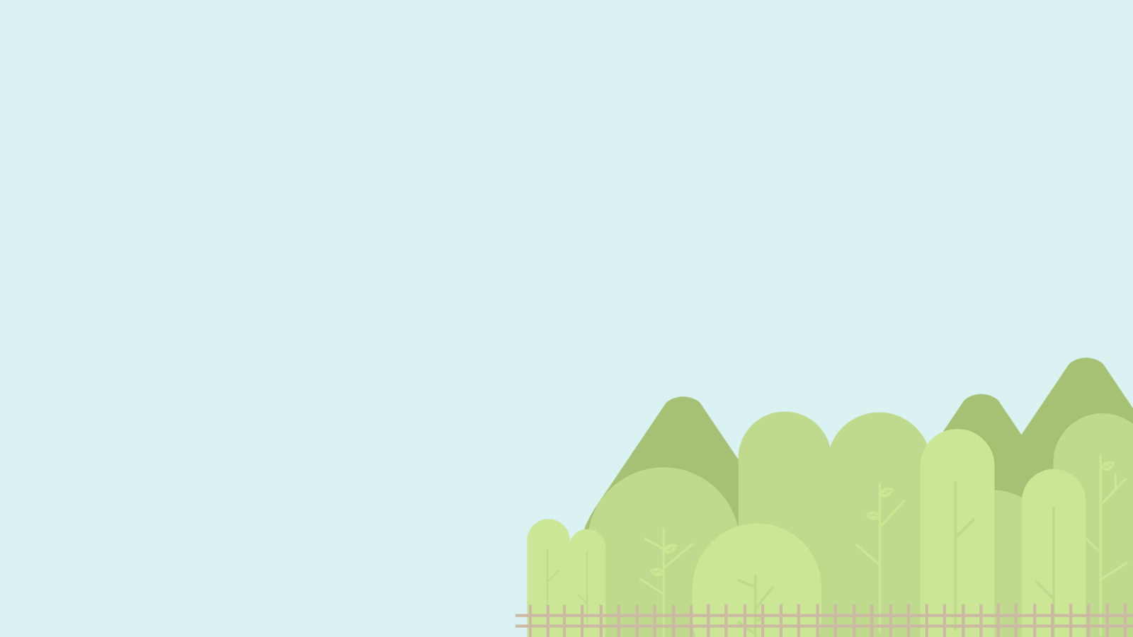Original (Ice cream theme) design (16.07.15) > to present

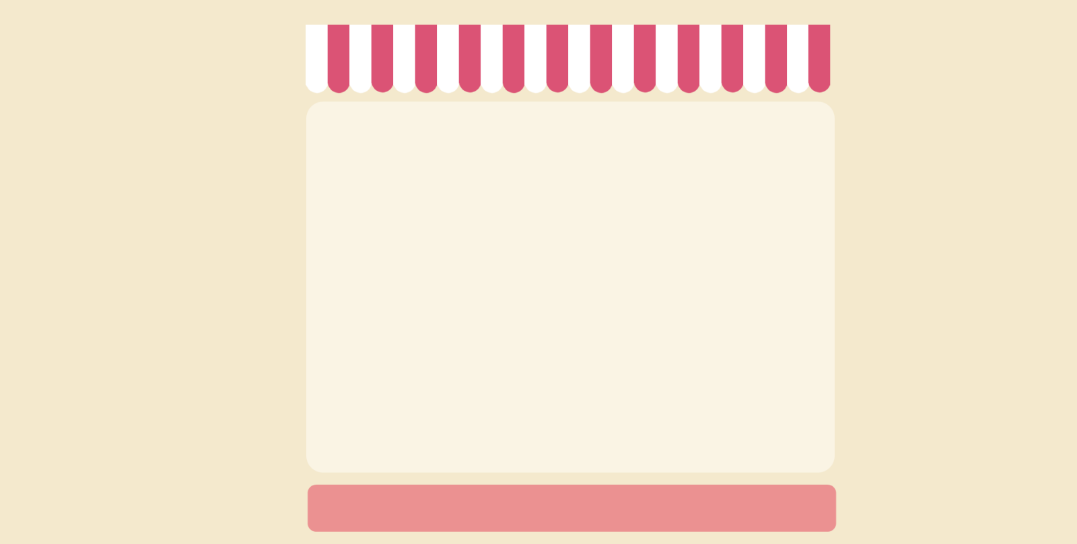

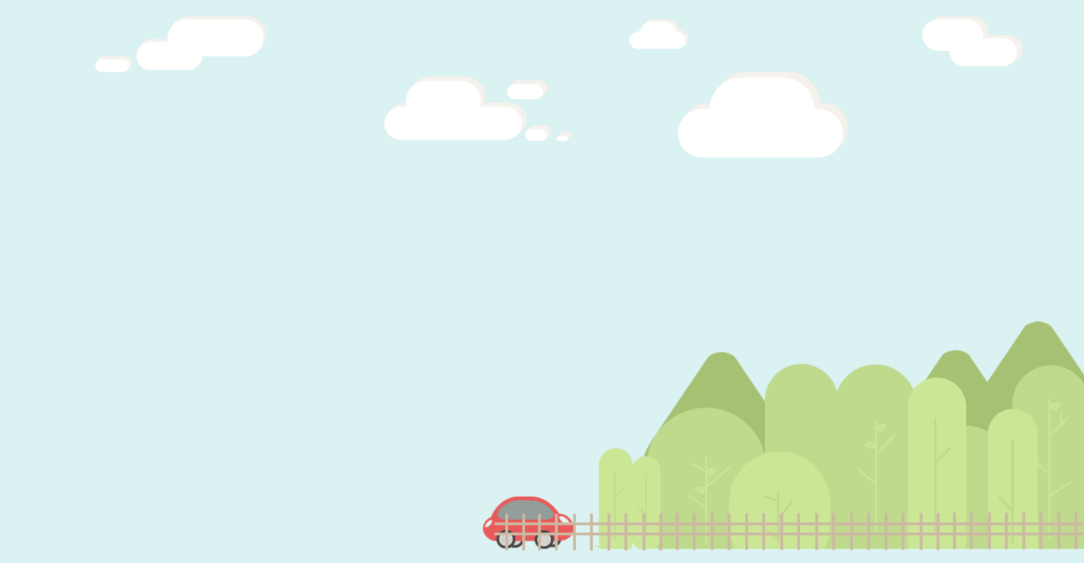

* + Had trouble with placement of image as a background in browser: fence and bottom part of the forest kept being cut out (4.12.15)
  + Added the clouds and the car (20.12.15)
  + Shifted all the ground elements up slightly so that it would show in browser: trial and error, very tedious
  + Fixed the placement of the background image – as a result, the website doesn’t scale to window size.
* **Animation**
  + Small animation of the clouds: Just placed another image on top of the clouds strip.
  + Toggles visible/hidden using setInterval timer in javascript (have read that this is not a smart thing to do but it works for now. (Can already seeing the animation playing up, inconsistent toggling and stops randomly)



**Logo (21.12.15)**

* + Created a logo that would be placed at the bottom left corner of the website (supposed to be cartoon version of me)
  + Intended to be a logo and tab icon



* + Changed logo to a home button, with the word “Home” displaying when you hover over it
  + Planning to change this into a navigation bar that will display icons when hovered over it.

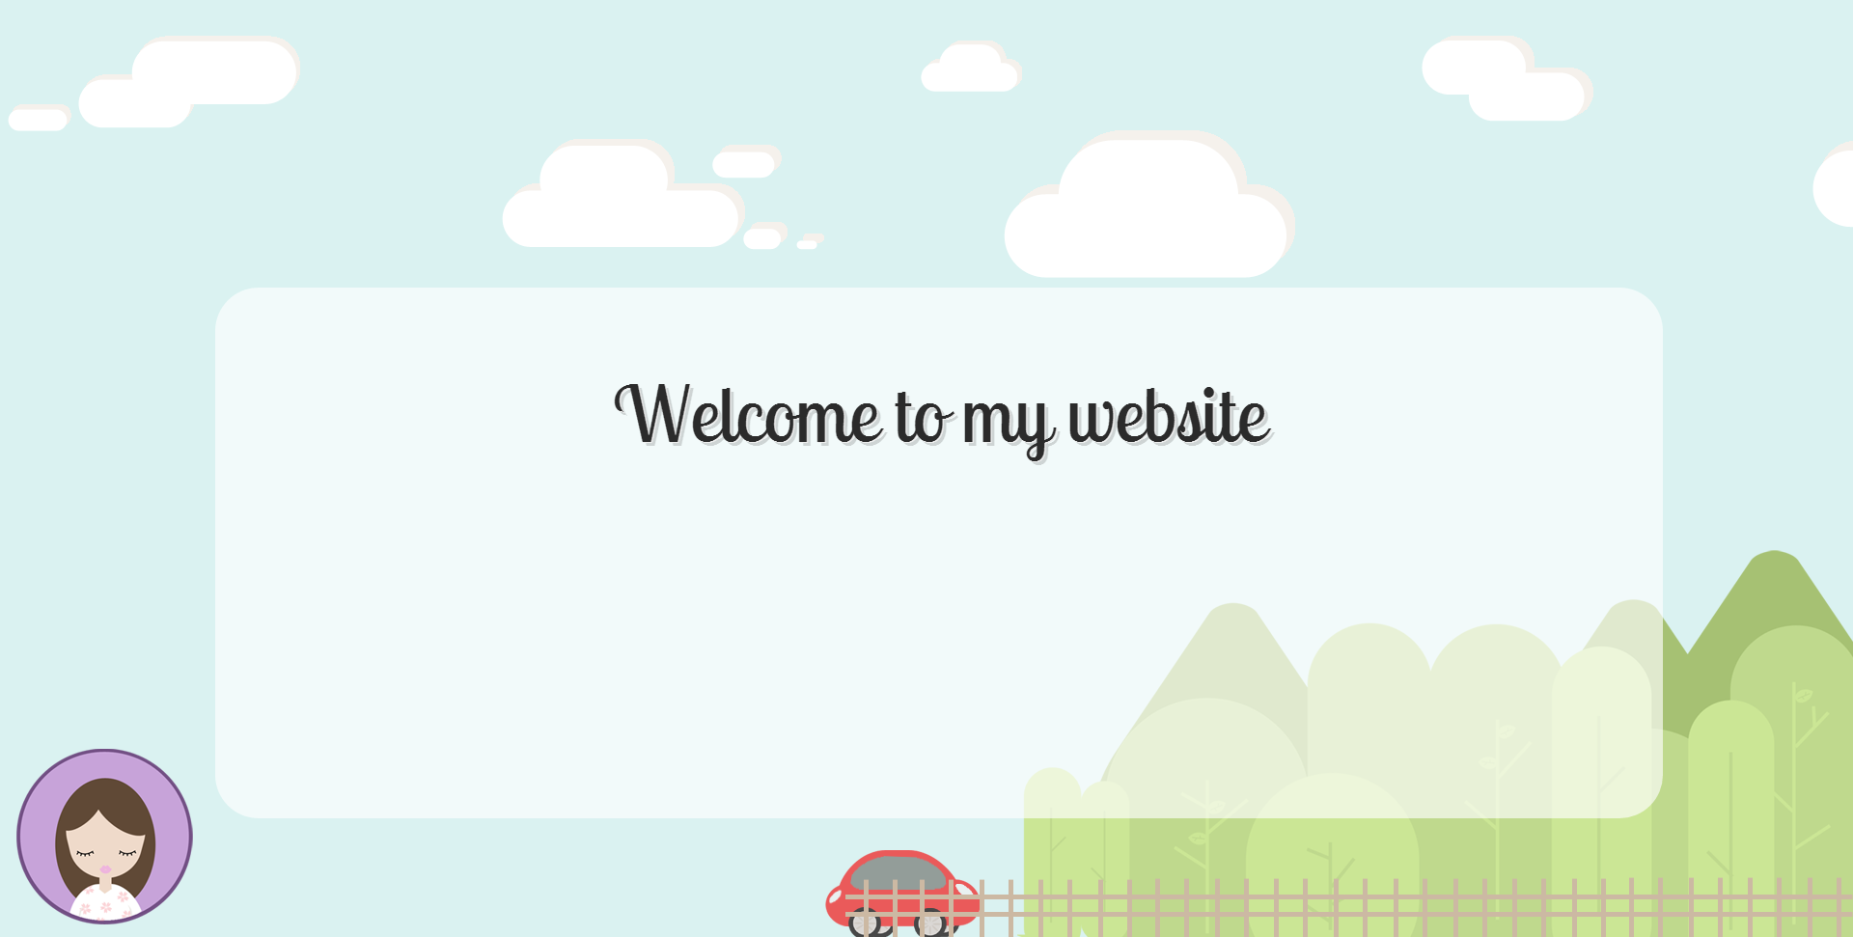

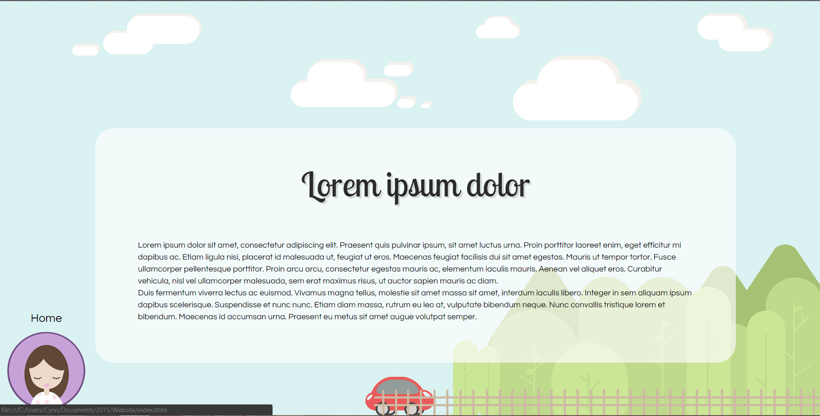

* **Body**
  + Is just a div, not sure what content to put in the middle yet. So far just planning to use it like a frame and swapping content in and out – not sure if I want to go through the hassle of creating new html pages each with the same background and animation etc
  + Google web fonts used for both heading and body text
  + Changed body content to Lorem Ipsum for now – not fussy because this is a personal website. No need to worry about the design bringing content out
* Navigation
  + Wanted to make an animation so that when you hovered over the main logo, other icons would slide out.
  + Made a test icon to see placement and see if I can animate it. (Too hard, giving up for today)

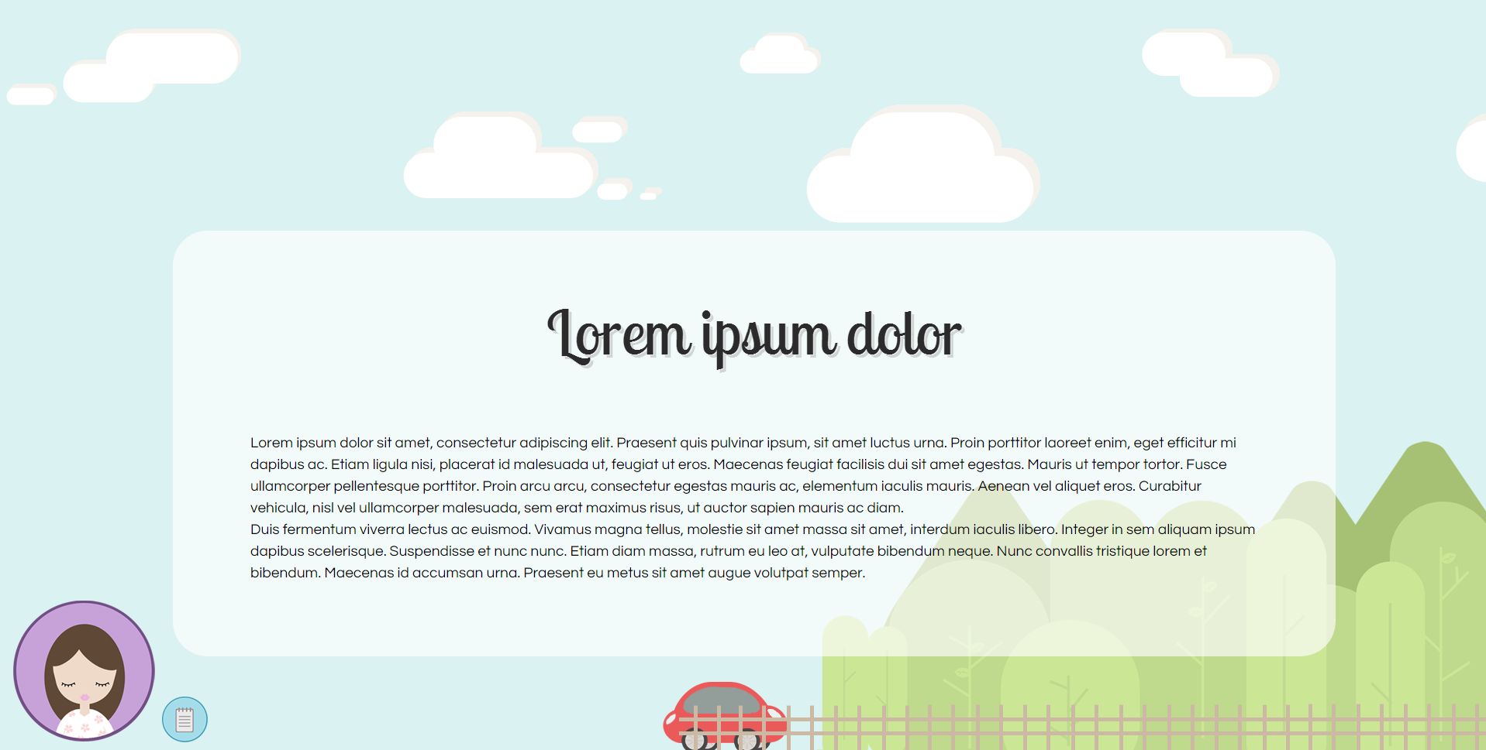

22/09/16

* Started again from scratch using Atom and Github to make syncing and uploading easier.
* Had trouble making the background image resize with window , but final code that worked was

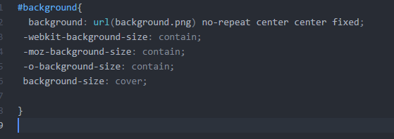

* Before this change, image didn’t resize.

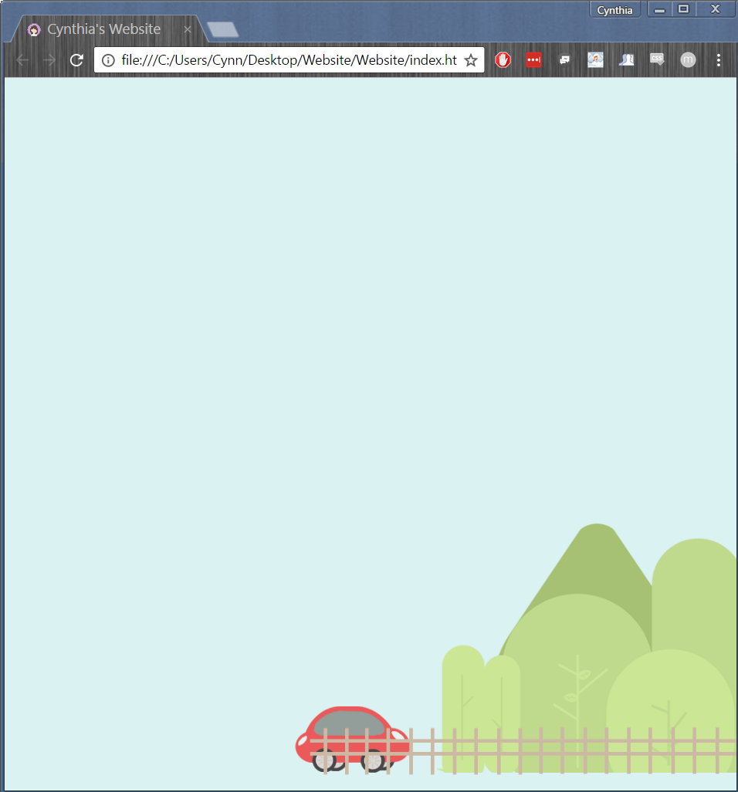

* Blank space under the car/trees etc , so decided to crop image.

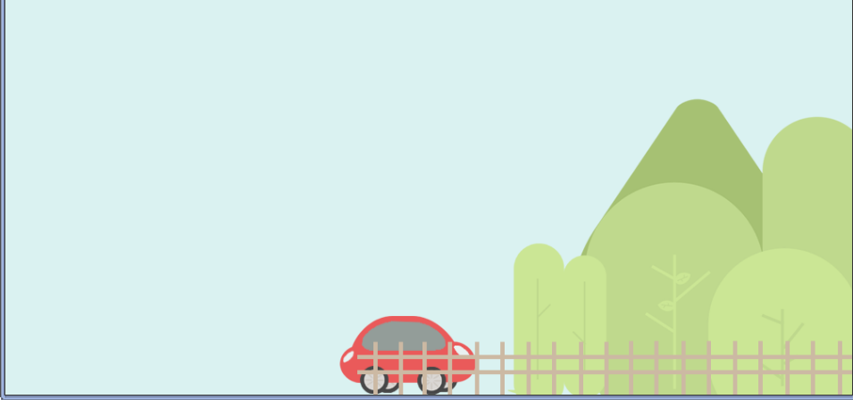

* Doesn’t fit slightly when full screen, but it’s okay.

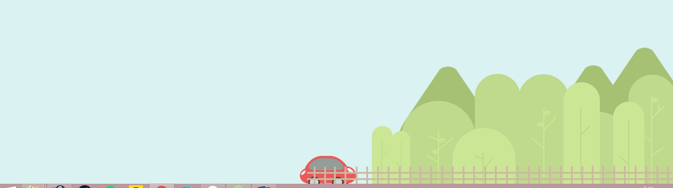

* Tried to look online for a way to animate clouds moving across screen. Initially intended to use JS or jQuery, but too much code. So went with css, and an online tutorial (<https://designshack.net/articles/css/infinitephotobanner/>)
* Difficult part was finding a dimension in which you wouldn’t catch the start and end of the loop. Played around with many numbers, but in the end changed the way clouds looks. Moved on part of the cloud so it was further away.





* The last little cloud had another one next to it, but it made the loop too obvious. So I deleted it and put the end cloud further away. This meant that the loop would start when the user is looking at the blue part.

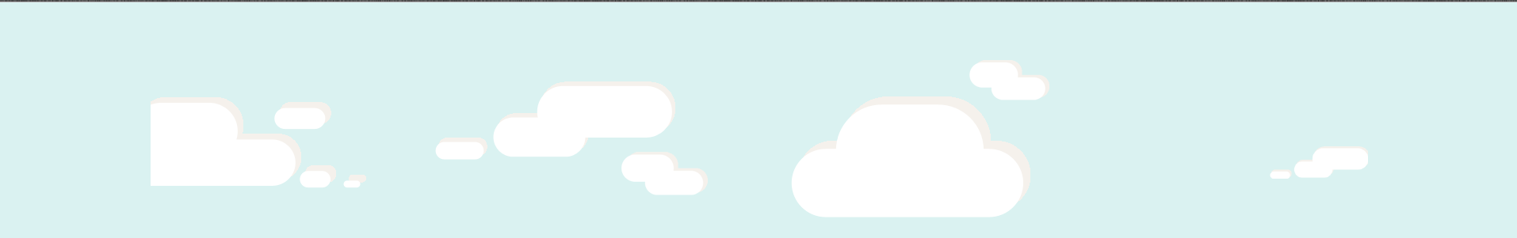

* Opened up the website on a screen with larger resolution – found out the container needs to be a lot bigger. Made it 2000px in length and fixed this issue BUT affected timing of loop too much. Changed it back to 1536px res.

**10/01/2017**

* Fixed one of the clouds (there was a portion that wasn’t erased properly)

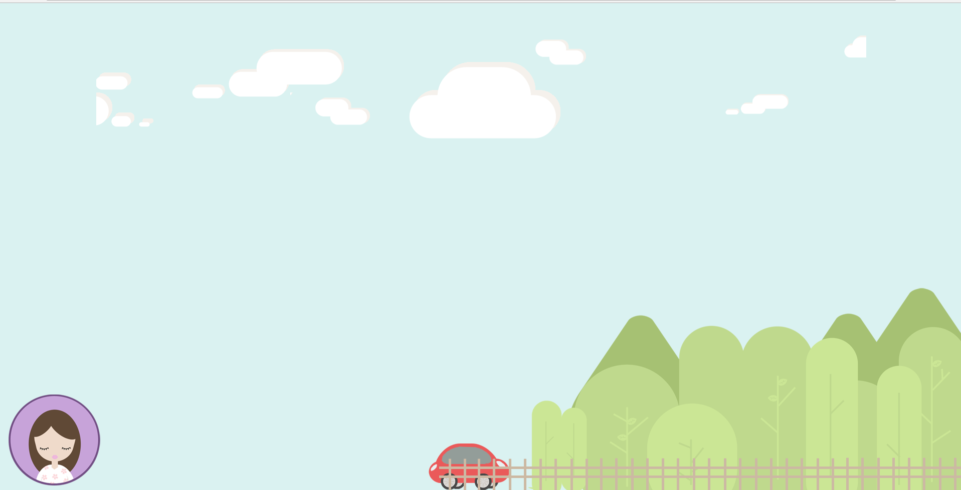

* Figured that it would be better to dynamically calculate page so clouds banner can scale accordingly. Min width remains 1536px.
* Noticed that there are still some issues with looping – however not a concern at the moment. (Need to test this change on laptop monitor (1920 x 1080)

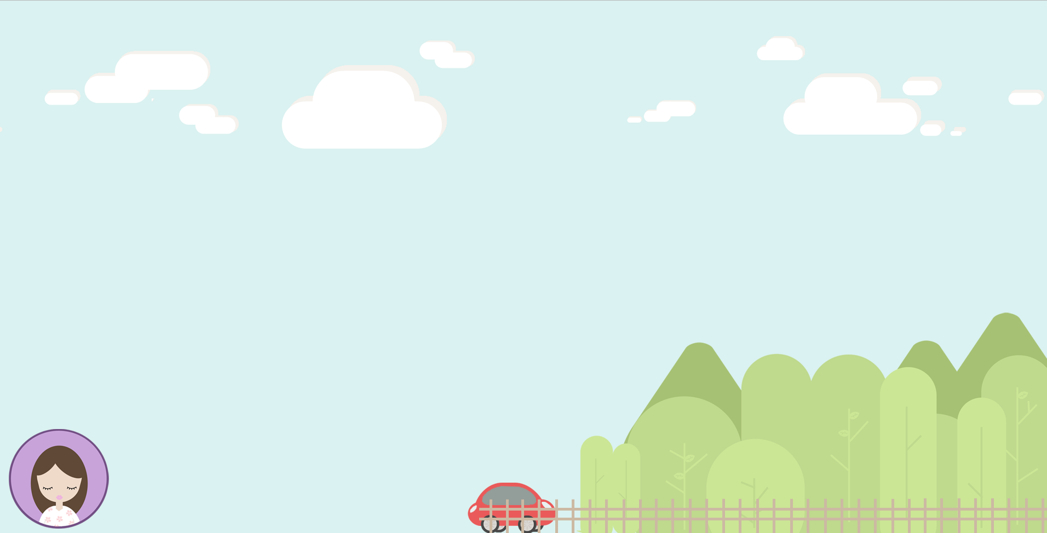

* Decided image of forest and car was taking up too much of the screen. Made smaller and moved it to the right.

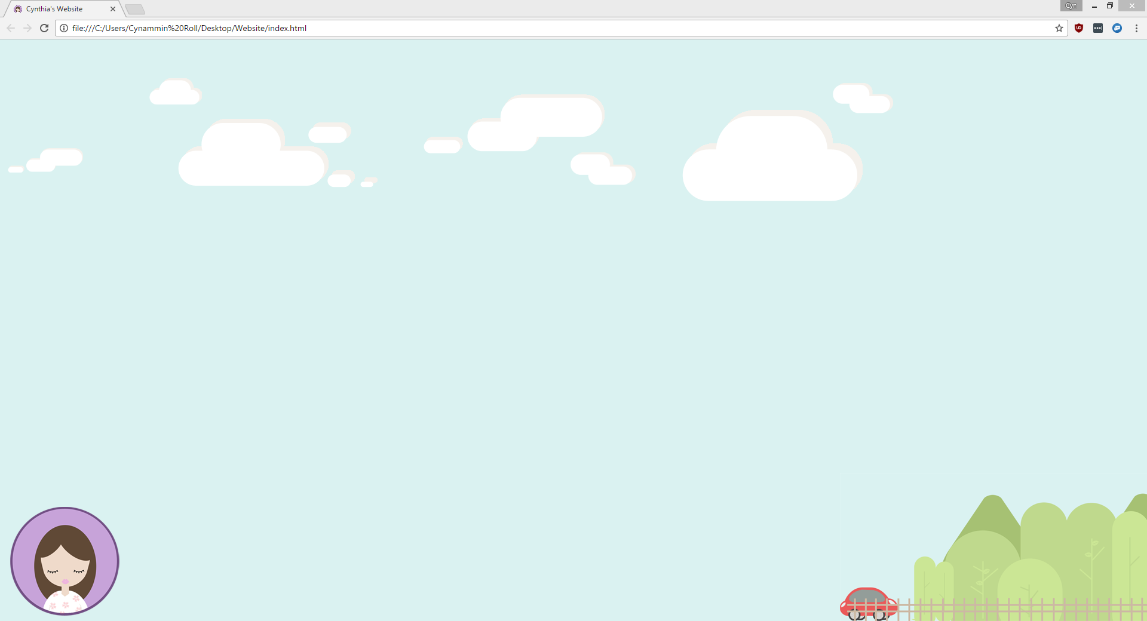

* Adding content box: Made the width 80% of page for scalability. However, not sure if I want it to dynamically change considering text will be entered in.
* 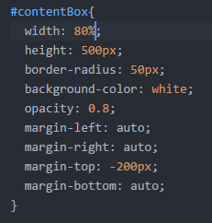Also need to consider the fact that my monitor resolution may be larger than others – having a fized size may not translate to other monitors

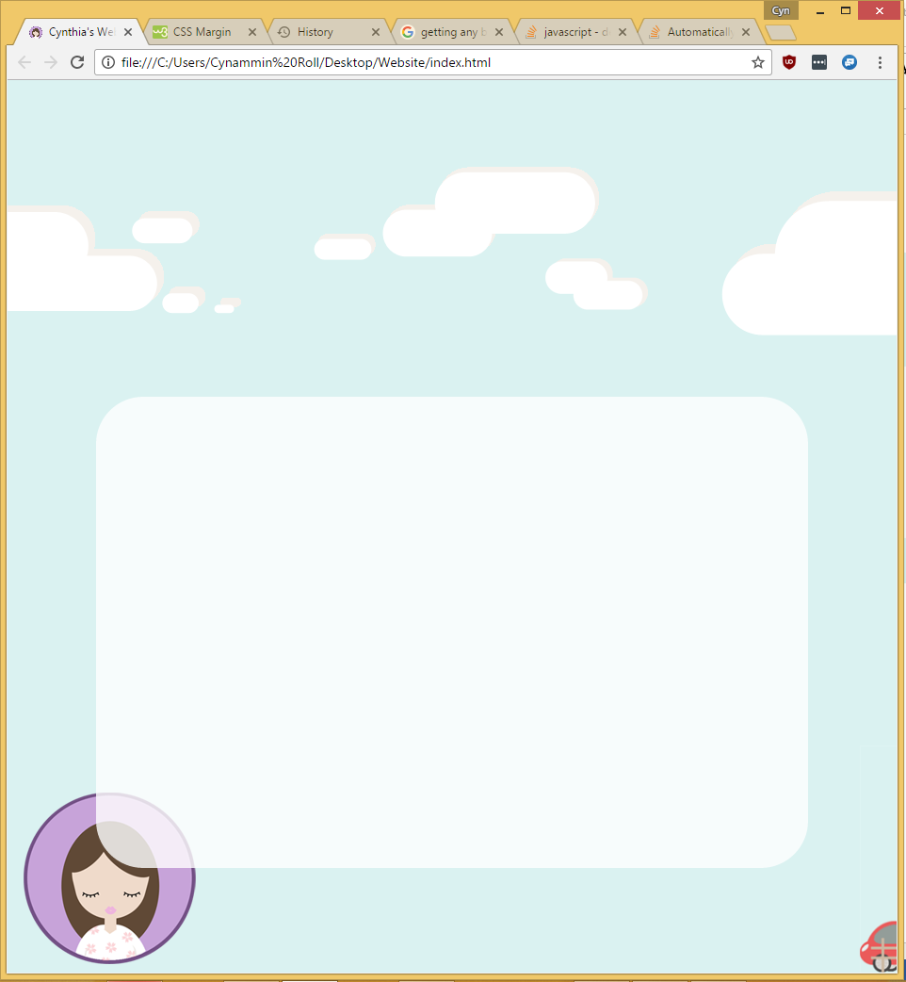

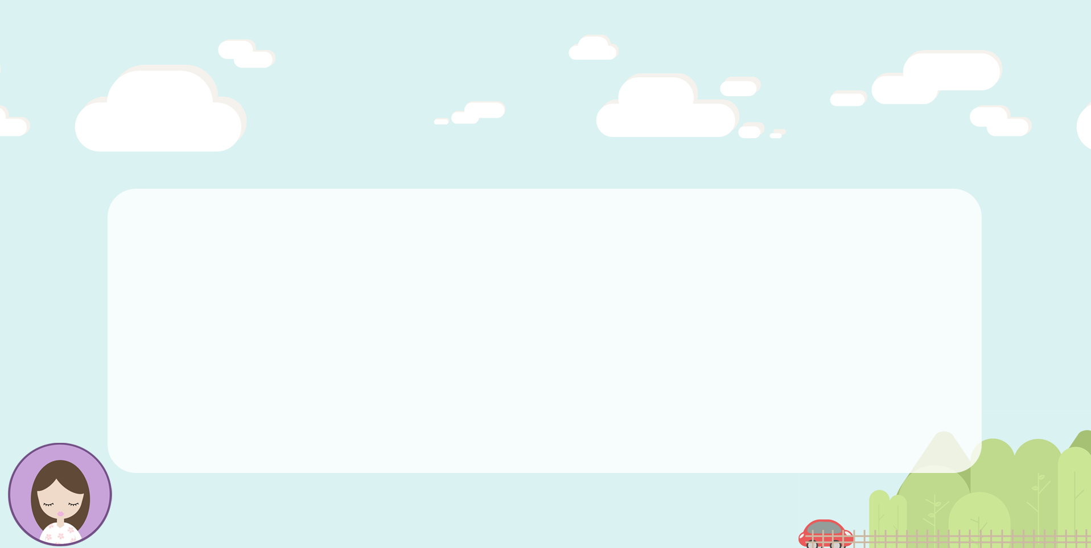Full screen below

* Added some title text and social media links.
* Used blue scheme as colour choice (for the links/images) as I didn’t want it to take the attention away from what is going to be the main navigation. Matches background themes, subtle but not too subtle that they’re not obvious

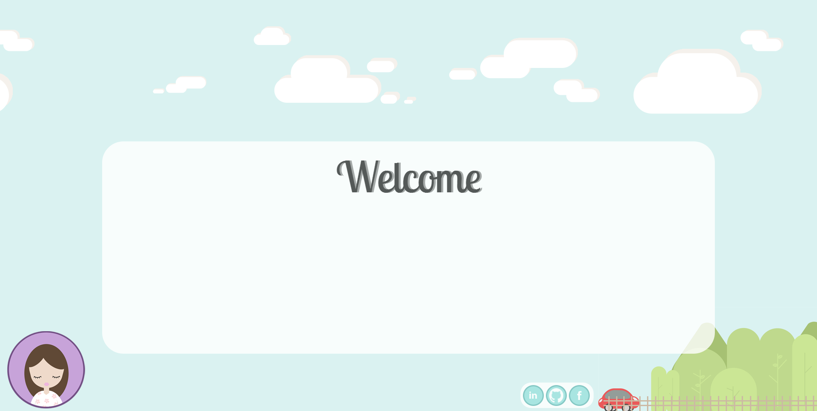

**11.01.17**

* Realised that the opacity from the rectangular div was applied onto the text. Had to separate them both into two divs. Had issues with moving the text “on top” on DIV. It required me to scroll

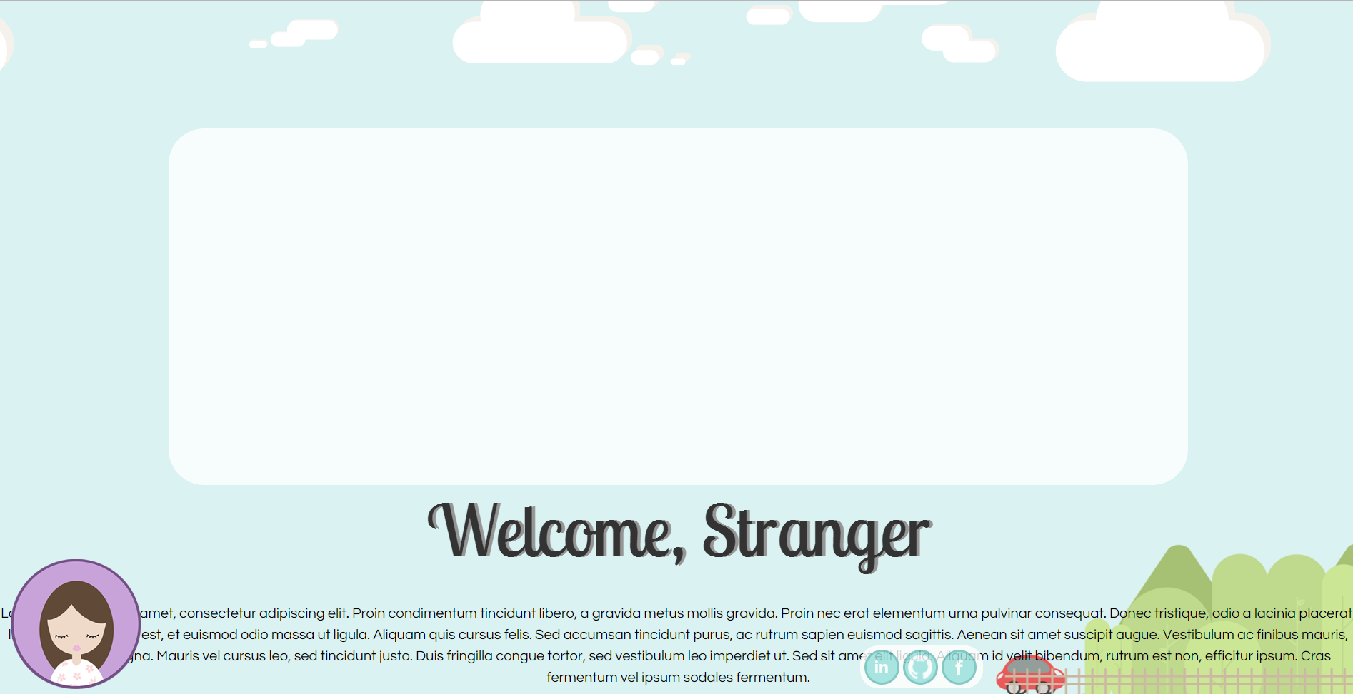

* 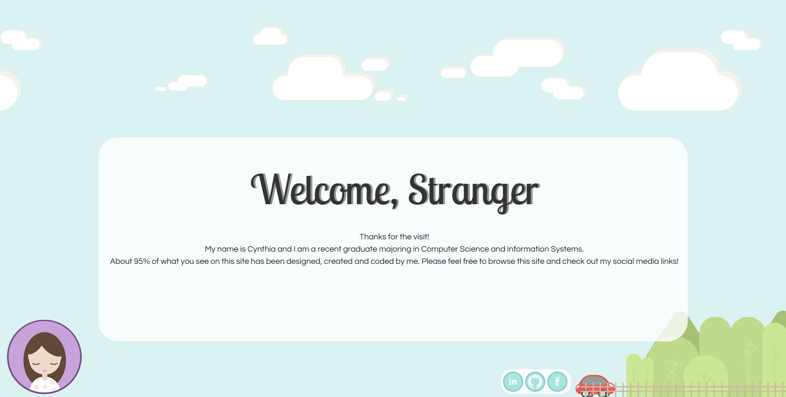Fixed this problem via alignment and z-index. Some of these values are in % so hoping that it would dynamically change depending on browser. Still need to test this.
* Decided to manage the way text shows up in the box by sampling Lorem Ipsum. Turns out there isn’t a lot of formatting (only on the left hand side.

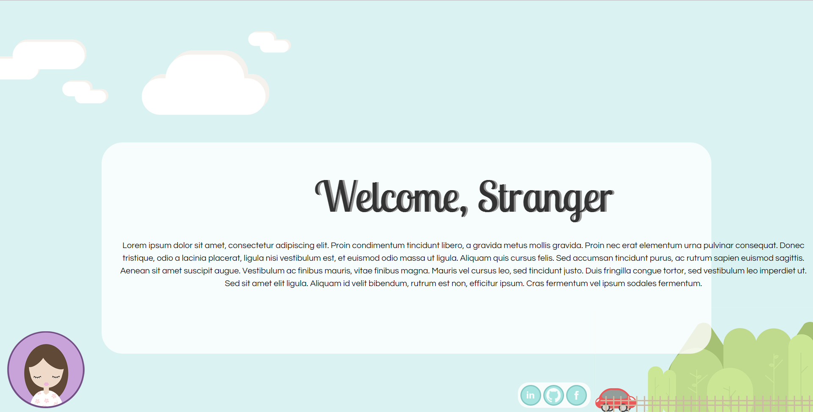

* Added some restrictions and added some auto scroll

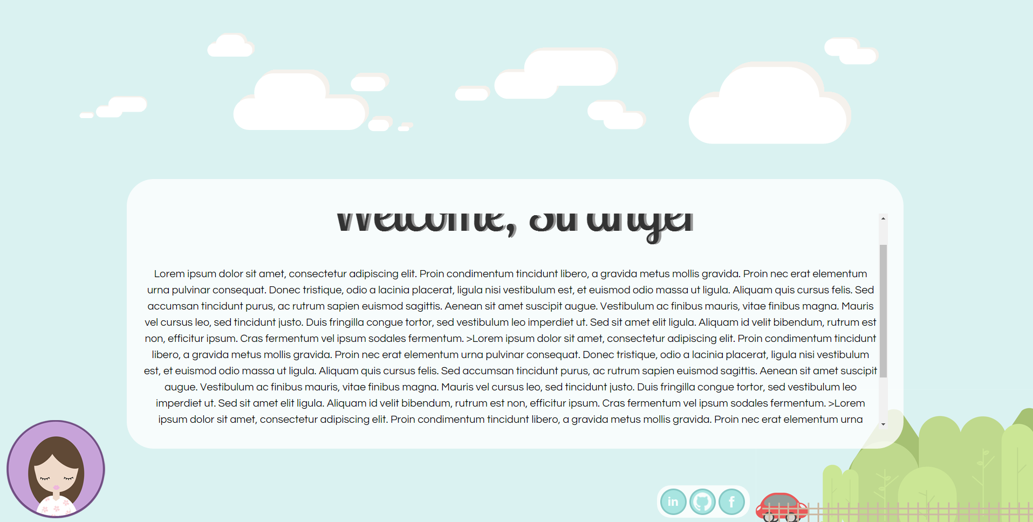

* Managed to get a rectangle to animation to “expand” across screen with help of : <http://jsfiddle.net/geometron/u3M6r/1/>
* Having a lot of issues with placing buttons inside the rectangle and hide half, then have them appear again. (Used: <https://css-tricks.com/forums/topic/how-can-i-make-this-horizontal-drop-down-menu-stretch-the-width-of-the-screen/>)
* Using a list, elements are placed inside, and when the rectangle expands, they move to fit in a line : issue is trying to hide all buttons before the expansion of rectangle (that happens when hovered over)

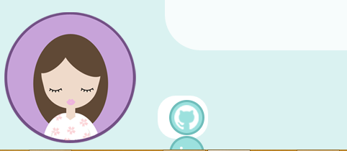

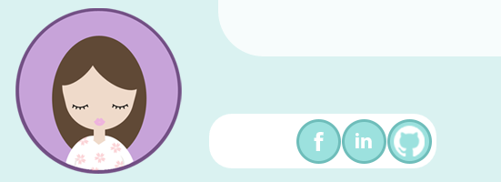

* Managed to fix it by applying some code that I used for my “home” button/logo and it seems to work. Only downside is that you can see the icons appear below the first one before it fully expands out.

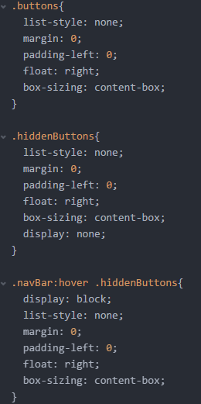

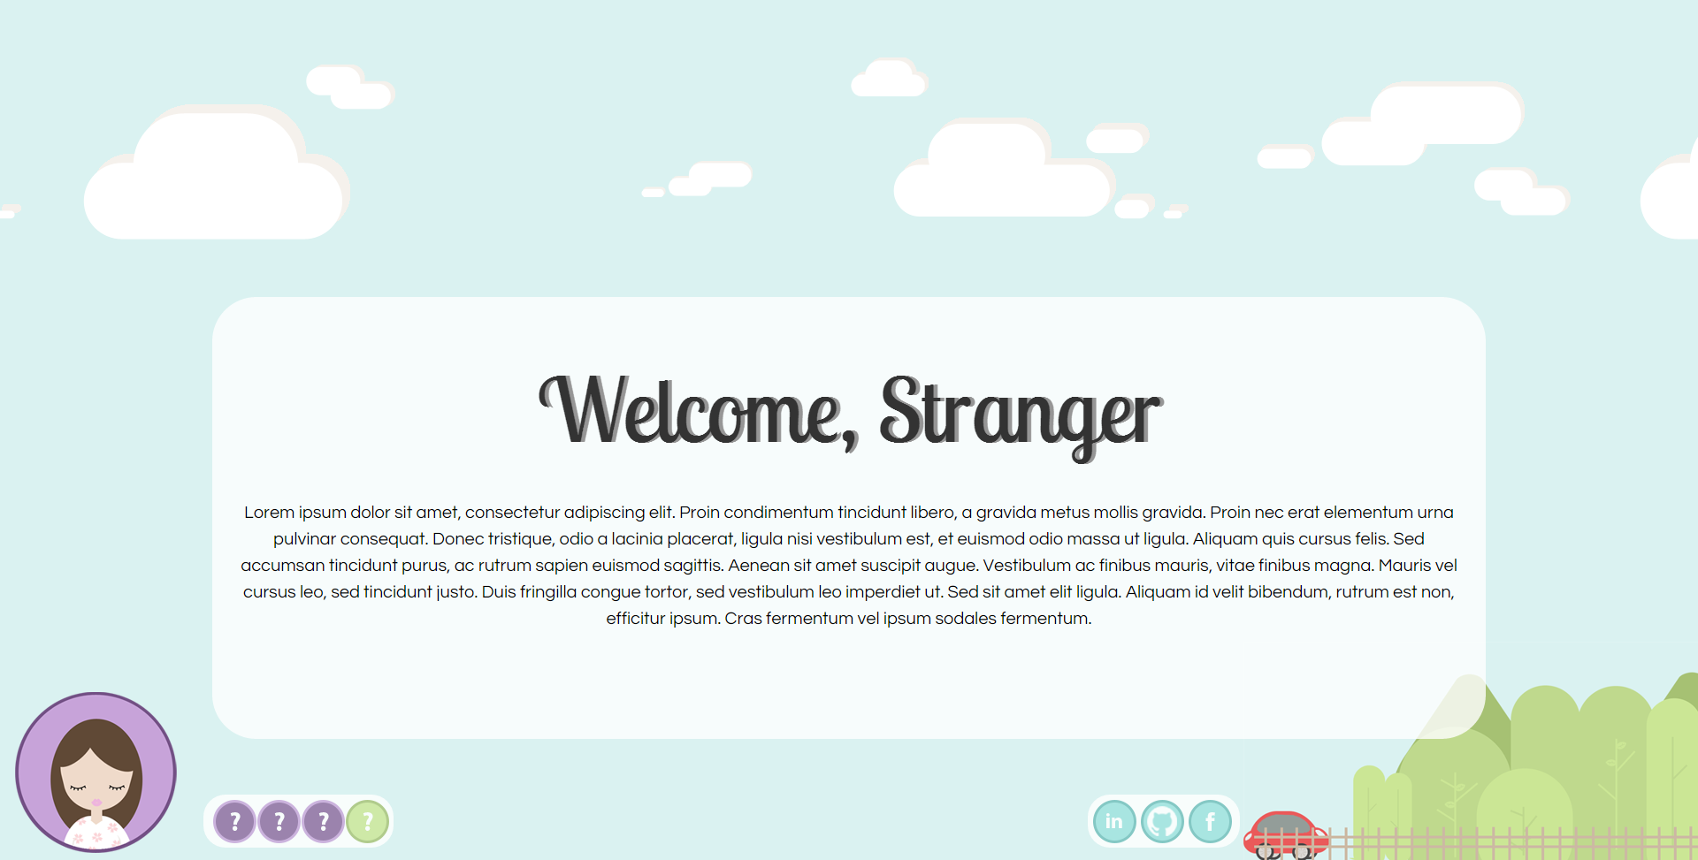**12/01/17**

* Played around with some colours for navigation buttons. Final choice were the colours used for logo except inversed.
* Also made the social media buttons slightly darker



* Started working on some designs for the other buttons. Below is the icon created for my CV page. Right one was final design as the first one is probably not as intuitive.

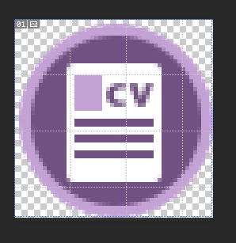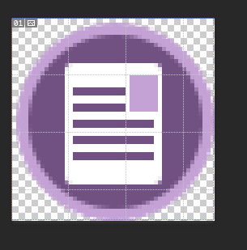

* 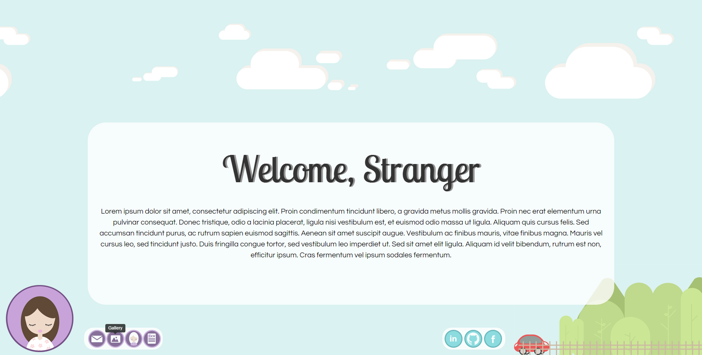Created other buttons following the colour scheme, adding tooltips. Initially planned to have it the same as the Home button/Logo, but was a big difficult to track when a button was hovered over.

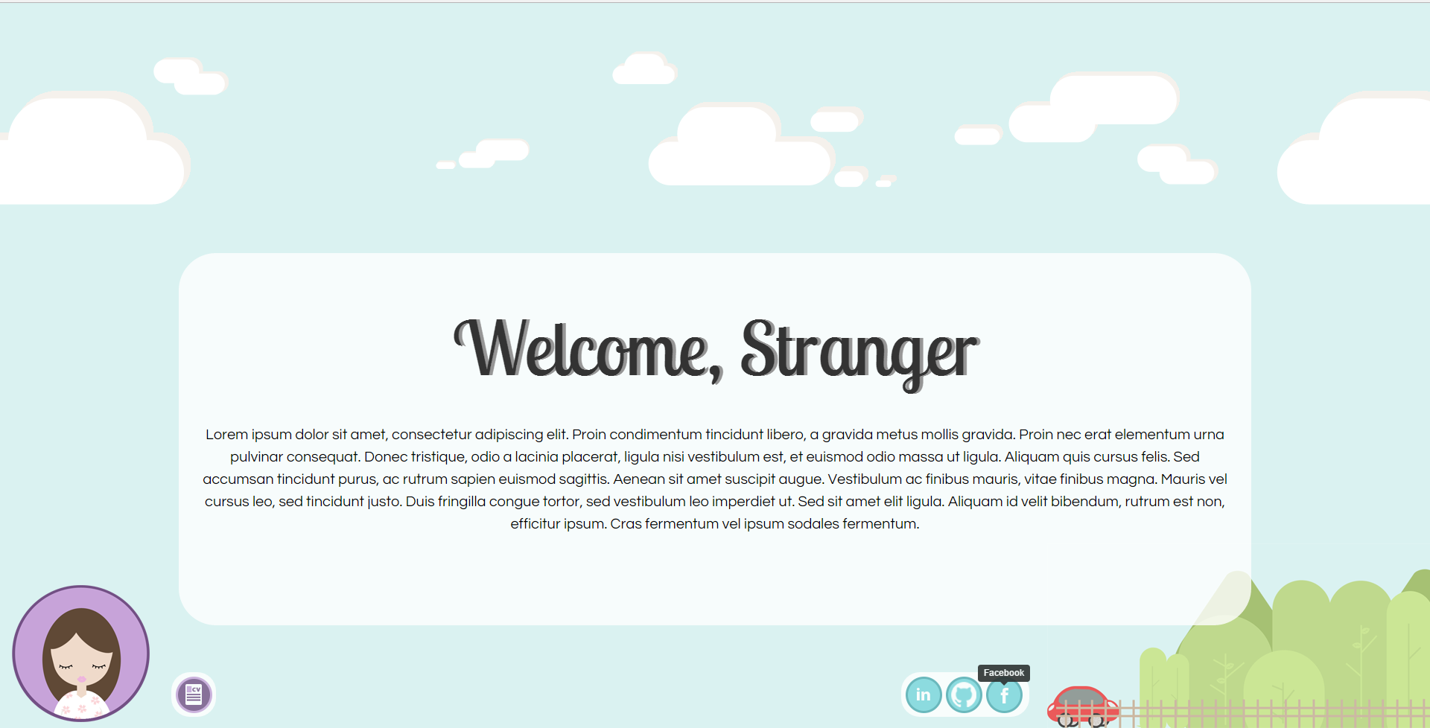

**6.02.17**

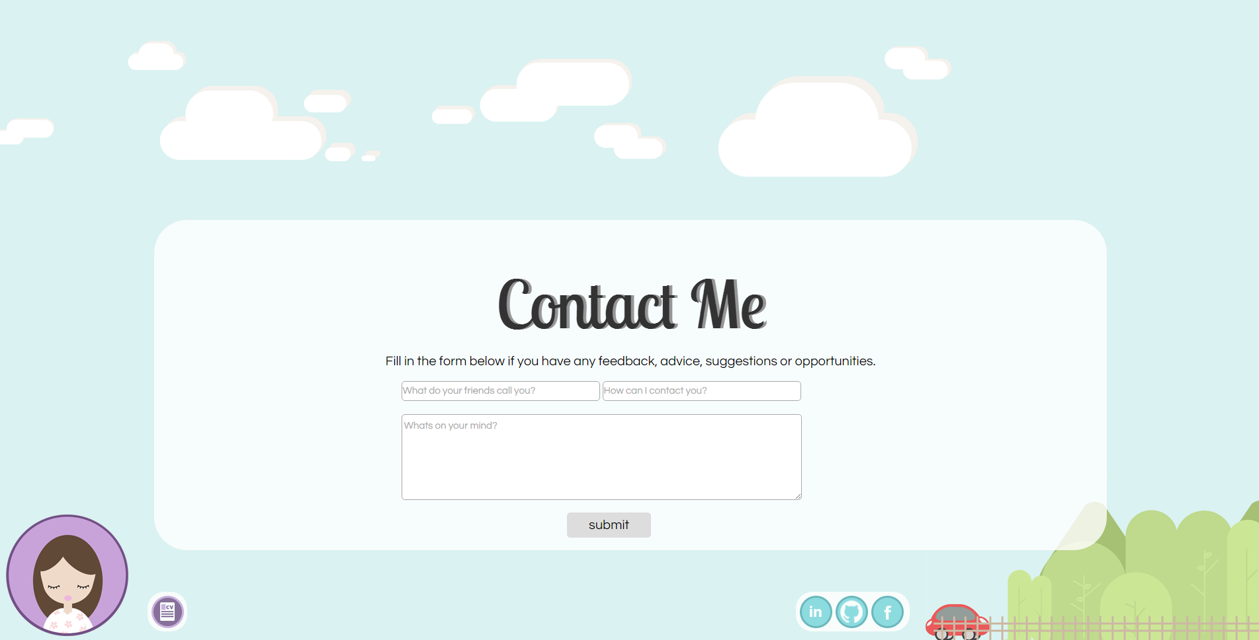

* Created contact me page using this tutorial: <http://tangledindesign.com/how-to-create-a-contact-form-using-html5-css3-and-php/>
* I can’t test it because I THINK I have to host website on a server. So page has to remain half finished because clicking “submit” just shows the php page.

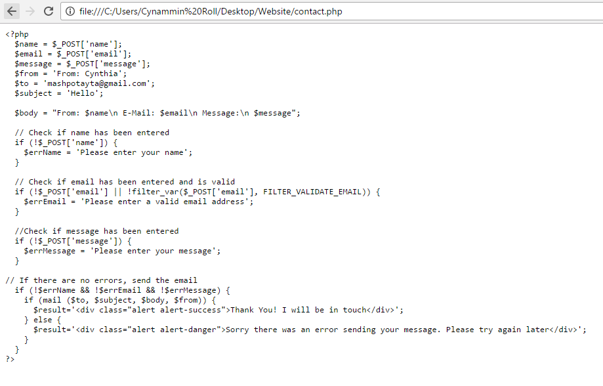



* Added some javascript to make navbar functional
* Realised that instead of me manually specifying which div to hide, I need to dynamically identify which div is “active” and then show the target page

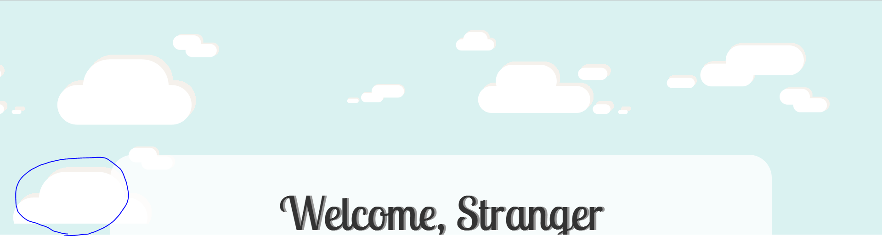

* For some reason, banner showed on a second line. Reverted my changes.

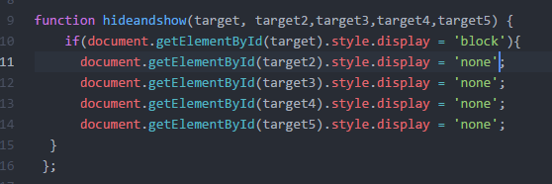

* Hard coding the navbar to save time on figuring out dynamically toggling between divs. May upgrade code later once I have time.

**14/02/17**

* Added some descriptions in the About me/Home page and the title seemed to take up too much space – opted to move the title above the white square

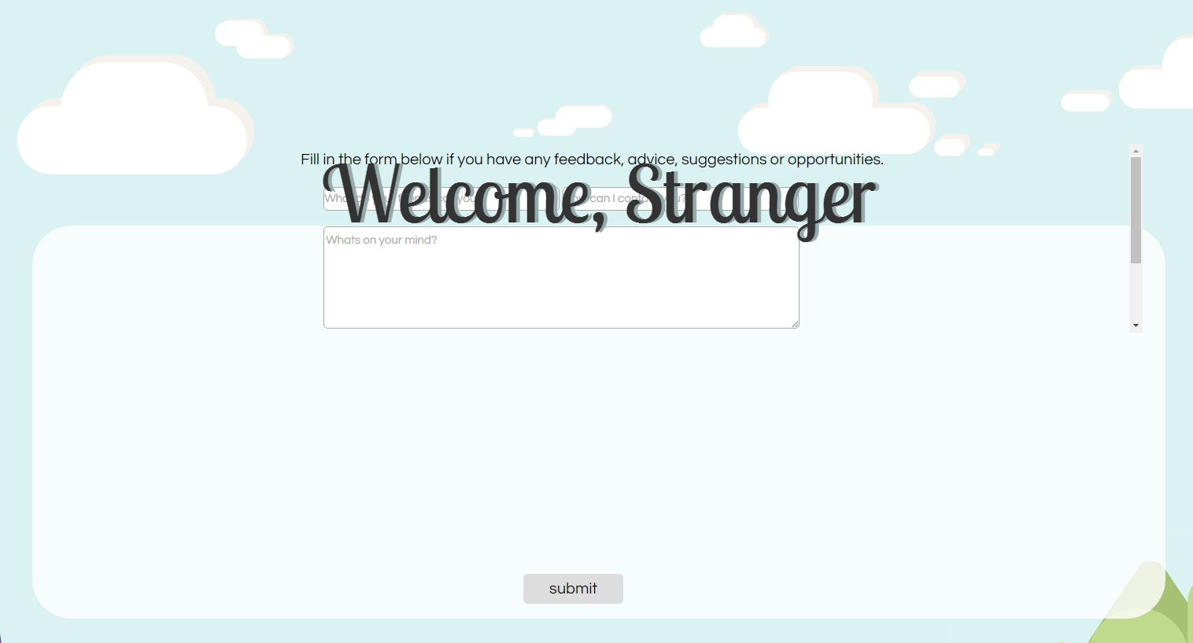

* It pushed everything up so had to reposition some of the elements



**27/02/17**

* Downloaded XAMP to simulate a server for PHP. Still doesn’t work properly
* Decided to use formspree that forwards emails from their server to my inbox

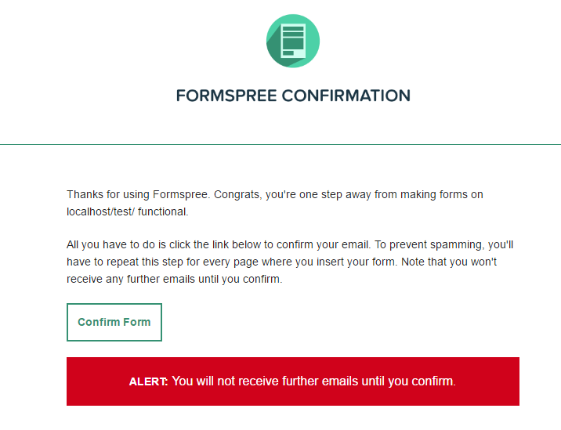

* The page would redirect user upon submitting an email, so I took out the code for it

**27/02/17**

* 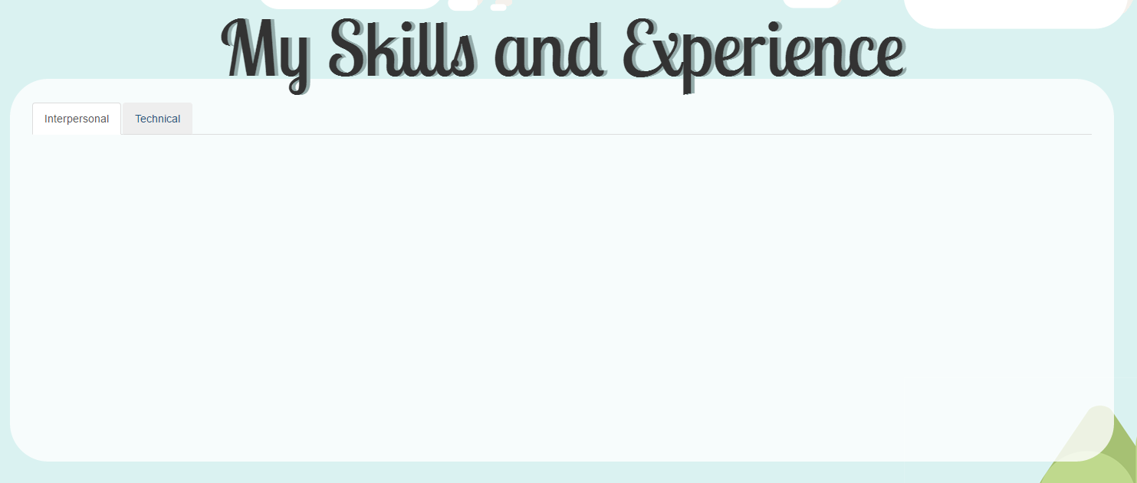Started creating tabs for the skills page. Planning to use some bootstrap progress bars

03/03/17

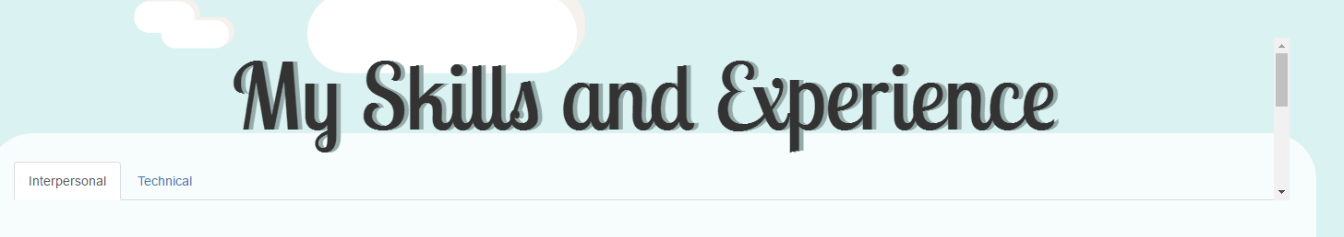

* Having a lot of issues getting the tabbed content. For some reason it’s in the “title” section of the page and not in the actual content rectangle
* Realised it was because of the way the divs were wrapped. Had to put three on this particular “page”. Manage to get the layout below after some styling (<https://www.w3schools.com/bootstrap/bootstrap_tabs_pills.asp>)

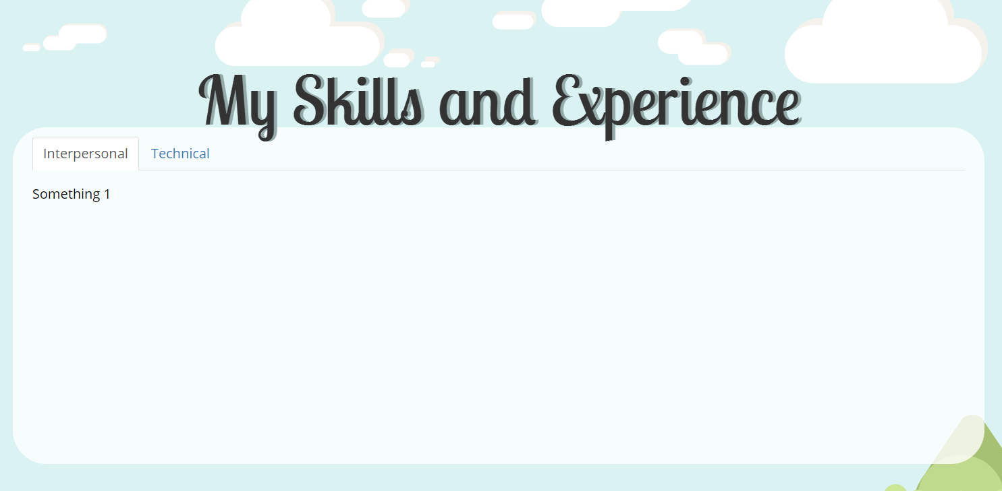

* 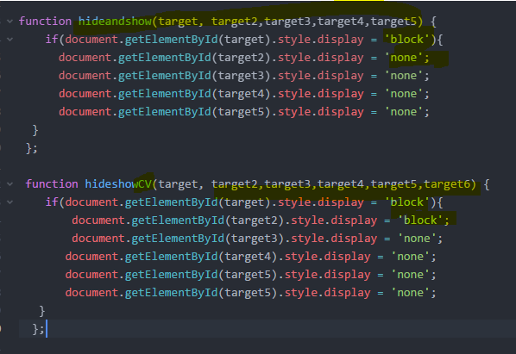Had to also create a separate function for the navbar.
* 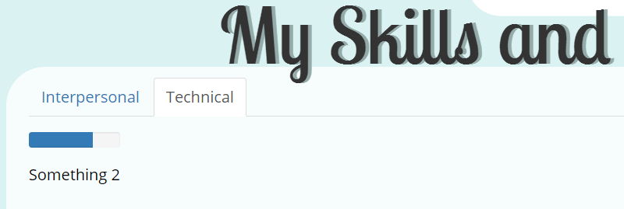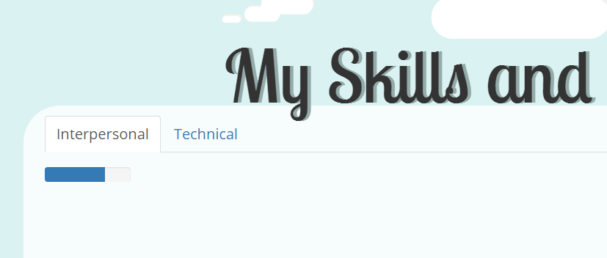Added progress bars but trouble with the tabs content. It was fine when only <p> content were inside.

