System Design Report
Stock Query Server
Data Structures & Algorithms -- Group Project
Design approach based on Chapter 23: System Design (Hemant Jain)
Group: DSA-CH23-GROUP-XX
Mount Kenya University

July 2026

Table of Contents
1. Introduction and Problem Statement
2. Use Cases Generation (Chapter 23, Step 1)
3. Constraints and Analysis (Chapter 23, Step 2)
4. Basic Design (Chapter 23, Step 3)
5. Bottlenecks (Chapter 23, Step 4)
6. Scalability (Chapter 23, Step 5)
7. Data Structures & Algorithms Justification
8. Test Plan
9. Benchmark Results
10. Limitations and Future Work
11. Conclusion
Appendix A: Team Member Roles

1. Introduction and Problem Statement
Stock exchanges generate a continuous stream of price data across thousands of listed symbols. Investors, analysts, and automated trading systems all need fast answers to questions like: what was a stock's closing price on a given day, how has it performed over the last N trading sessions, which stocks are moving the most today, and which other stocks behave similarly to a given one.
This report documents the design and implementation of a Stock Query Server that ingests daily price ticks and answers exactly these questions. The system is designed following the five-step process described in Chapter 23 of System Design (Hemant Jain): use cases generation, constraints and analysis, basic design, bottlenecks, and scalability. The implementation deliberately exercises every mandatory data structure and algorithm required by the assignment brief -- hash map, stack, queue, heap, graph, sorting, and searching -- and each choice is justified against a concrete use case rather than added for its own sake.
The project corresponds to Theme C (Stock Query Server) from the assignment's 25-group project list, Variant C2: rolling metrics (max/min/avg over a window) using heaps/deques.

2. Use Cases Generation (Chapter 23, Step 1)
The following use cases were identified as the core functionality the server must support:
- Query the exact closing price of a symbol on a specific date
- Query a symbol's price history over an arbitrary date range
- Compute rolling maximum, minimum, and average price over the last N trading days for a symbol
- Identify the top-K gaining and top-K losing symbols across the market
- Discover stocks related to a given symbol, by sector or explicit relationship, ranked by closeness
- Ingest new price ticks, whether arriving one at a time (streaming) or in a daily batch
- Undo the most recently ingested tick if it was entered in error
These use cases map directly onto the mandatory data-structure requirements of the assignment: lookups need a hash map, buffered ingestion needs a queue, rolling statistics need a deque, top-k needs a heap, stock relationships need a graph, and price ordering needs a sort plus a search strategy. Section 7 details this mapping.

3. Constraints and Analysis (Chapter 23, Step 2)

3.1 Workload characteristics
- Read-heavy: outside of trading hours the system serves almost entirely queries; writes only occur when new daily prices are published or during live trading sessions
- Write bursts: at market close, or on any given trading day, ticks for many symbols arrive within a short window
- Ordering sensitivity: rolling statistics assume ticks are processed in chronological order per symbol; late or out-of-order ticks must still be handled correctly, just at higher cost

3.2 Volume estimate
For benchmarking purposes the system was modelled at 50 symbols with up to 100,000 total price ticks (roughly 2,000 ticks per symbol, or about 8 years of daily data). A real national exchange would scale this up to several thousand symbols; the design in Section 6 addresses how the same architecture would extend to that volume.

3.3 Latency expectations
Exact-date lookups, range queries, and rolling-metric reads sit on the interactive query path and should stay in the sub-millisecond to low-millisecond range even as history grows. Section 9 shows measured results confirming this at the tested scale.

3.4 Consistency requirements
The system favours availability and low write latency over strict global consistency: a tick is durable as soon as it is drained from the ingestion queue into storage, and rolling metrics are updated incrementally at that point. This is an acceptable trade-off for a market-data query service, as opposed to a system of record for trade settlement.

4. Basic Design (Chapter 23, Step 3)
The high-level architecture is shown below. Incoming price ticks are placed on an ingestion queue, which decouples the rate at which data arrives from the rate at which it is written into storage. A worker drains the queue into hash-map-backed storage, keyed by symbol, where each symbol's history is kept sorted by date to support binary search. Four independent read-side modules then serve queries directly from storage: rolling statistics (deque), top movers (heap), the stock relationship graph (BFS/DFS), and sorting and searching. An audit stack alongside storage records every mutating action so it can be undone.
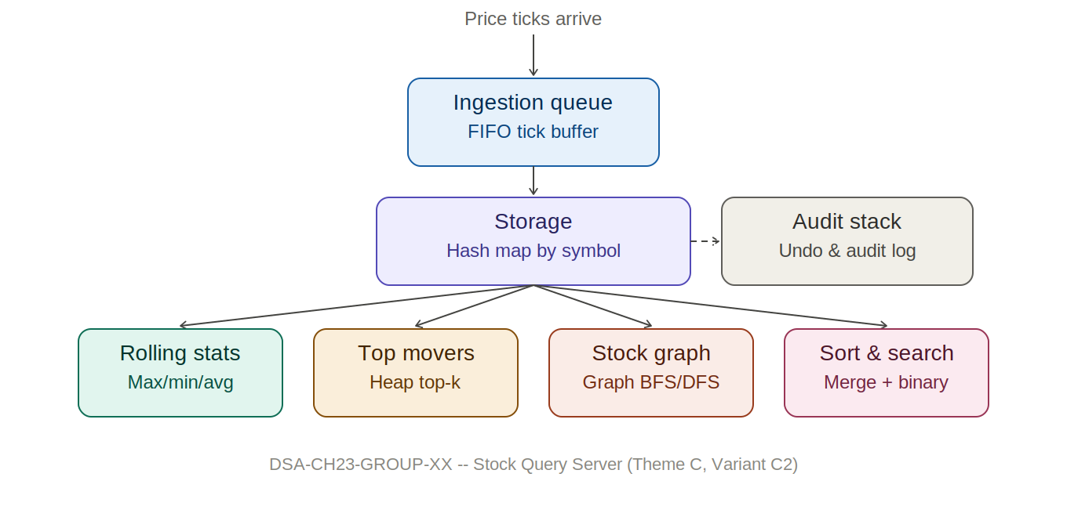

4.1 Component responsibilities
Component | Responsibility | Data structure
Ingestion queue | Buffers incoming ticks so producers never wait on storage | Queue (FIFO)
Storage | Source of truth: symbol -> chronologically sorted price history | Hash map + sorted list
Rolling stats | Sliding-window max/min/average per symbol | Monotonic deque
Top movers | Market-wide top-K gainers/losers | Heap (priority queue)
Stock graph | Related-stock discovery by sector/relationship | Graph, BFS/DFS
Sort & search | Price-ordered views and range lookups | Merge sort, binary search
Audit stack | Undo/history of mutating actions | Stack (LIFO)

5. Bottlenecks (Chapter 23, Step 4)
- A single ingestion queue becomes a throughput ceiling once tick volume exceeds what one consumer can drain in real time, since every symbol's ticks funnel through the same buffer.
- Recomputing rolling max/min from scratch on every query costs O(n) per query against the full window; a heap-based sliding window improves this but still costs O(log n) per tick and keeps stale entries around until they age out of the window.
- A hash map alone answers "does this symbol exist" in O(1) but cannot efficiently answer "give me every price between date A and date B" -- that requires the sorted-list-plus-binary-search structure this design layers on top of it.
- Computing top-K gainers by fully sorting all symbols by percent change costs O(n log n) even when only a handful of results are needed; this is wasted work once n is large relative to K.
- A single, unsharded storage instance means the entire market's data -- and therefore the entire query load -- sits behind one hash map, with no way to scale reads or writes independently of each other.

6. Scalability (Chapter 23, Step 5)
Each bottleneck above is addressed by iterating on the basic design as follows, consistent with the assignment's instruction to iterate with bottlenecks until an acceptable design is reached:
- Shard storage by a hash of the symbol across multiple storage nodes, so no single hash map is responsible for the whole market, and reads/writes for different symbols can proceed independently.
- Keep rolling metrics incremental, exactly as implemented here with a monotonic deque giving O(1) amortized updates per tick, avoiding recomputation entirely.
- Introduce a cache in front of storage for frequently queried "hot" symbols, since real markets show highly skewed query popularity (a handful of large-cap stocks dominate query volume).
- Partition the ingestion queue by symbol and run multiple consumer workers in parallel, which increases ingestion throughput while still preserving per-symbol chronological ordering (each symbol's ticks stay on one partition).
- Replicate read-only storage nodes, since the workload identified in Section 3 is read-heavy; replication increases read capacity without adding write complexity.
- For top-K queries at very large n, maintain the heap incrementally as ticks arrive rather than rebuilding it per query, trading a small amount of write-side work for consistently fast reads.

7. Data Structures & Algorithms Justification
Every mandatory data structure and algorithm required by the assignment brief is used for a concrete, load-bearing purpose in this system rather than as a token inclusion. The table below lists each requirement, where it lives in the codebase, and its complexity.
Requirement | Module | Operation | Complexity
Hash table / map | storage.py | symbol lookup / insert | O(1) average
Stack | audit_stack.py | record (push) / undo (pop) | O(1)
Queue | ingestion.py | enqueue / drain | O(1) per tick
Heap / priority queue | top_movers.py | top-k gainers/losers | O(n log k)
Graph + BFS | stock_graph.py | related stocks (bounded depth) | O(V + E)
Graph + DFS | stock_graph.py | full connected component | O(V + E)
Sorting (O(n log n)) | sorting.py | merge sort by price | O(n log n)
Searching | storage.py | binary search by date | O(log n)
Deque (sliding window) | rolling_metrics.py | rolling max/min/avg | O(1) amortized

7.1 Worked example: inserting a tick end to end
To make the interaction between components concrete, consider a single tick for EQTY at 46.50 on 2026-01-04 arriving while the rolling window size is 3:
- The tick is placed on the ingestion queue via enqueue_tick(), an O(1) append to the right end of a deque.
- A consumer drains the queue with popleft() (O(1)) and calls insert_tick() on storage. Since the new date is later than the symbol's most recent recorded date, the tick is simply appended to the sorted history in O(1) amortized time; if it had arrived out of order, bisect.insort would place it correctly in O(log n) search plus O(n) shift.
- The rolling-metrics tracker for EQTY receives the new price. If the window of 3 is already full, the oldest price is evicted from the running sum and, if it happened to be the current max or min, popped from the front of the corresponding monotonic deque. The new price is then pushed onto both the max-deque and min-deque after popping any trailing values it outclasses, and the running sum is updated. All of this is O(1) amortized.
- An audit entry is pushed onto the audit stack describing the action and holding a closure that, if called, removes the just-inserted point from storage -- giving O(1) undo if the tick turns out to have been a data-entry mistake.
This trace illustrates why the modules are kept separate rather than merged into one monolithic insert function: each data structure is doing exactly the job it is asymptotically best suited for, and each can be tested, benchmarked, and reasoned about independently.

7.2 Why a deque instead of a heap for rolling metrics
A natural first instinct for rolling max/min is a pair of heaps holding the current window, evicting stale entries lazily. This works, but each insertion or eviction costs O(log n) and stale entries can linger in the heap well past the point where they have left the window, wasting memory and comparisons. A monotonic deque solves the same problem in O(1) amortized time per tick: any element that a new, larger (or smaller) tick makes irrelevant is popped from the deque immediately, so the deque never holds more candidates than could plausibly still be the max or min. This system uses the deque for the sliding-window case and reserves the heap specifically for the market-wide top-K query, where the two structures solve genuinely different problems rather than being interchangeable.

8. Test Plan
The implementation is covered by 21 automated tests (exceeding the minimum of 15 required by the assignment brief), executed with pytest. The full suite lives in tests/test_server.py; the table below summarizes the categories covered.
Category | Example cases | Count
Basic ingestion & lookup | Exact-date lookup, missing-date lookup, range query | 3
Storage edge cases | Empty history, single data point, unknown symbol, out-of-order insert, negative price | 5
Rolling metrics (deque) | Window smaller/larger than data, window size 1, invalid window size | 4
Graph (BFS/DFS) | Same-sector neighbours found, unreachable node, unknown symbol | 3
Audit stack | Undo on empty stack, undo reverses a real insert | 2
Sorting & queue | Stable sort with ties, empty/single-element sort, drain of empty queue | 3
Top movers (heap) | Correct top gainer and top loser identified | 1
All 21 tests pass. Edge cases were prioritized to match real failure modes of a market-data system: symbols with no data yet, symbols with only one recorded price, ticks that arrive late, and queries against windows larger than the available history.

9. Benchmark Results
Ingestion, exact-date lookup, range query, and top-K query performance were measured at 10,000 and 100,000 ticks across 50 symbols, using benchmark/benchmark.py. Results from the reference run:
Ticks | Ingest total | Ingest / tick | 1,000 lookups | 100 range queries | Top-k
10,000 | 0.057 s | 5.7 us | 0.0009 s | 0.0007 s | 0.0002 s
100,000 | 0.965 s | 9.7 us | 0.048 s | 0.005 s | 0.0001 s
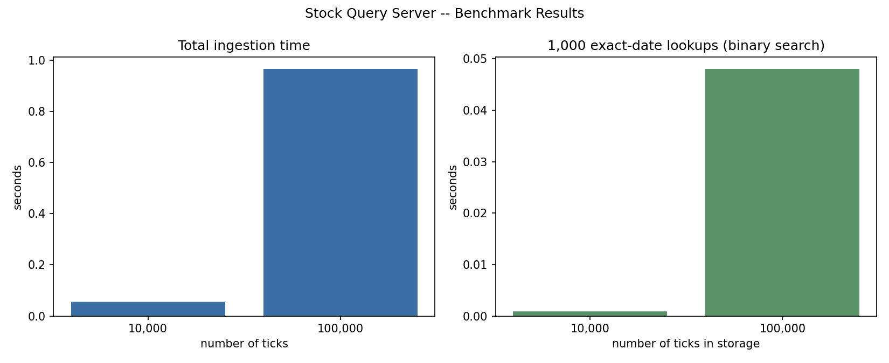
Observation: per-tick ingestion time stays roughly flat, confirming the amortized O(1) append behaviour of the storage layer's common case. Lookup time grows sub-linearly with data volume, consistent with the O(log n) cost of binary search. Top-K query time is essentially independent of total data volume, since heapq.nlargest/nsmallest cost depends on k and the number of symbols, not on the length of each symbol's history.

10. Limitations and Future Work
- The current implementation runs as a single in-process server; the sharding, caching, and replication ideas in Section 6 are designed for but not yet implemented in this codebase.
- The relationship graph currently connects stocks purely by shared sector; a production system would likely add weighted edges from historical price correlation, which would also open the door to Dijkstra-based "closest related stocks" queries as suggested in the assignment brief.
- Out-of-order tick handling is correct but not optimized; a production ingestion pipeline would likely buffer a short grace window per symbol before writing, to convert more late arrivals into the O(1) append path instead of the O(n) insort path.
- The audit stack currently supports undoing only the single most recent action; a full audit/compliance system would likely persist the log and support undoing an arbitrary historical action, which would change the stack into a more general command-history structure.

11. Conclusion
The Stock Query Server satisfies every mandatory requirement of the assignment: it uses a hash map, stack, queue, heap, graph with BFS/DFS, an O(n log n) sort, and a search strategy, each justified by a genuine use case rather than bolted on. Following Chapter 23's five-step process surfaced concrete bottlenecks -- a single ingestion queue, naive rolling-metric recomputation, and unsharded storage -- and led to a scalability plan (sharding, caching, parallel ingestion, replication) that would let the same architecture grow from the 50-symbol benchmark scale to a full exchange's worth of data without a redesign.

