**Project 1 - Group 4: The Covid-19 Pandemic’s Impact on Mobility in the United States**

**Group members:**

Lisa Harrison

Cynthia Lu

Ingrid Deukoue

Lori Ward

Stojancho Micov

**Project Repository:**

<https://github.com/LisaHarrison08/Project_G4>

**Project Proposal**:

Our group project is to research changes in mobility and transportation patterns in the United States during the Covid-19 quarantine between February 2020 and August 2020. We will examine recent data sets that illustrate how people were moving about their towns and the relationship between the different types of mobility and transportation.

**Analysis:**

**Question 1 - How does the Google data compare to the Apple data and what are their limitations?**

The Apple mobility data is based on people’s intentions whereas the Google data is actual mobility data. Specifically, Apple’s mobility data only demonstrates locations searched, meaning the data might not reflect actual mobility, only the intent to travel. Additionally, users may not use map applications for destinations they are familiar with, so it is possible that the data tracked only includes aberrant travels. Finally, Google’s data only includes a sample of users who have enabled their geo-location settings, and so may not be representative of the wider population.

**Question 2 - How did mobility change during the first few months of the Covid-19 pandemic?**

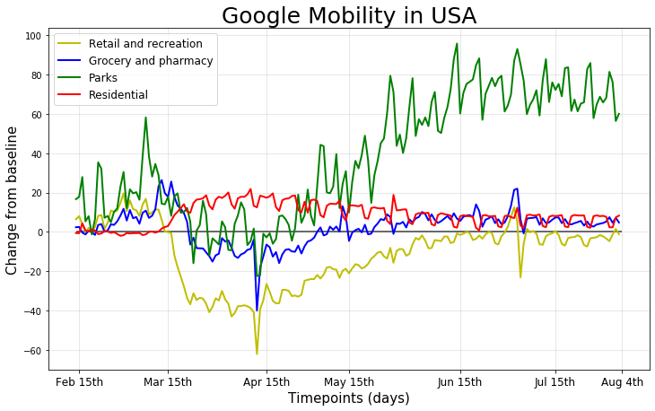The Google data set revealed that mobility decreased at the onset of the pandemic (mid-March to April), with sharp drops to retail/recreation, grocery/pharmacies, and parks. Retail/recreation and groceries /pharmacies in particular were the most heavily impacted, with the highest rate of decrease -- most likely due to the impact of quarantine guidelines as businesses are forced to close.

People stayed home at the onset of the pandemic, as denoted by a sharp incline during mid-March in the graph on the following page. However, overtime the likelihood for people to remain at home decreased. On the other end of the spectrum, visits to parks increased dramatically following April 15th. A repeating “zig-zag” pattern is also apparent within the data, which coincides with weekends, indicating that people are more likely to leave their residences during weekends.

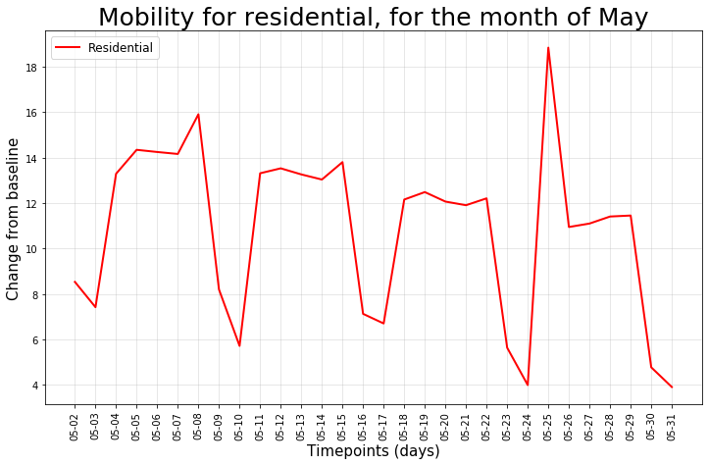

**Question 3 - How did mobility trends change relative to each other in May 2020?**

In May 2020, visits to parks increased greatly, while mobility to residential destinations and retail/recreation remained relatively stable. However, travel to retail/recreation did not recover from the sharp decline at the early onset of the pandemic, remaining in the negatives. In thinking about mobility during holidays and weekends, there is a slight increase in search activity between May 15th and 20th, indicating that people may be traveling to specific locations in advance of the Memorial holidays.

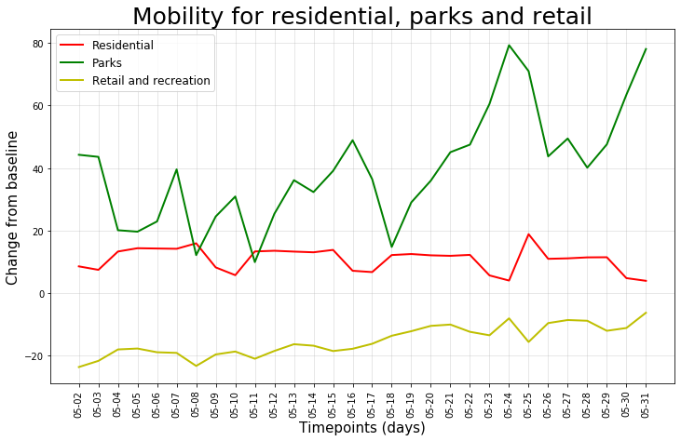

**Question 4 - How did mobility change related to different transportation types of driving, walking, and transit?**

Overall, Apple data revealed that all three transportation types, including driving, walking and transit (public transit) decreased during the beginning stages of the quarantine when people were staying at home. As the stay-at-home orders started to lift across the United States, there was a steady increase in walking and driving but transit did not recover.

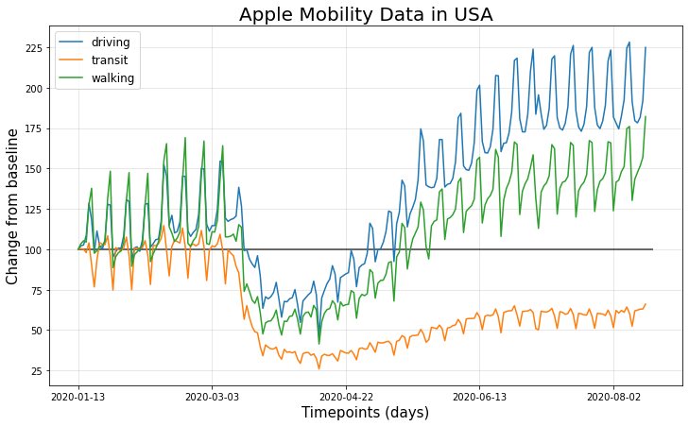

**Question 5 - How did mobility trends change in individual states?**

Using the Apple dataset, we assessed folks’ intention to travel within the United States. We identified five states/territories with the most searches incurred via the Apple map application. Search activities across the top five states followed a relatively similar pattern. However, Utah saw the highest level of spikes in destination searches around May 22. While we were unable to clearly identify a distinct reason for the spike, one may extrapolate based on the timing that the increase may be attributed to pre-Memorial Day planning.

On the other end of the spectrum, locations with the lowest search activity primarily consisted of island entities, with Washington D.C. the only land-locked region out of the five, and Hawaii the only state. Mobility may have been affected by people’s reluctance to travel by air and/or enforcement of stricter guidelines for traveling in and out of the islands. Interestingly, Guam saw an anomalous peak on February 7th. Further research revealed that the USS Theodore Roosevelt, a United States Navy aircraft carrier transporting up to 5,000 soldiers, docked in Guam during that date, which may have contributed to the spike in search activity. However, additional research would be required to ascertain that assumption.

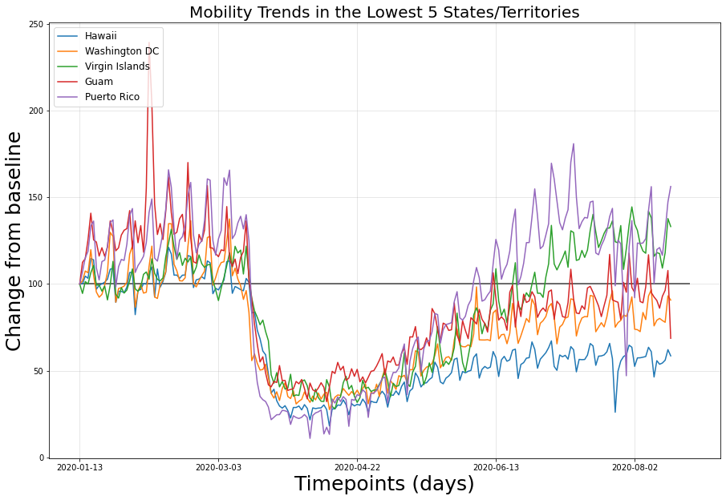

**Additional Charts**

