Lab1:
- Check if your processor supports Intel/AMD virtualization technology. Enable Intel virtualization technology in BIOS if possible.
My computer enables virtualization technology:
Open the Task Manager using Ctrl+Shift+Esc
And in the performance tab,select CPU it says my virtualization is enabled.
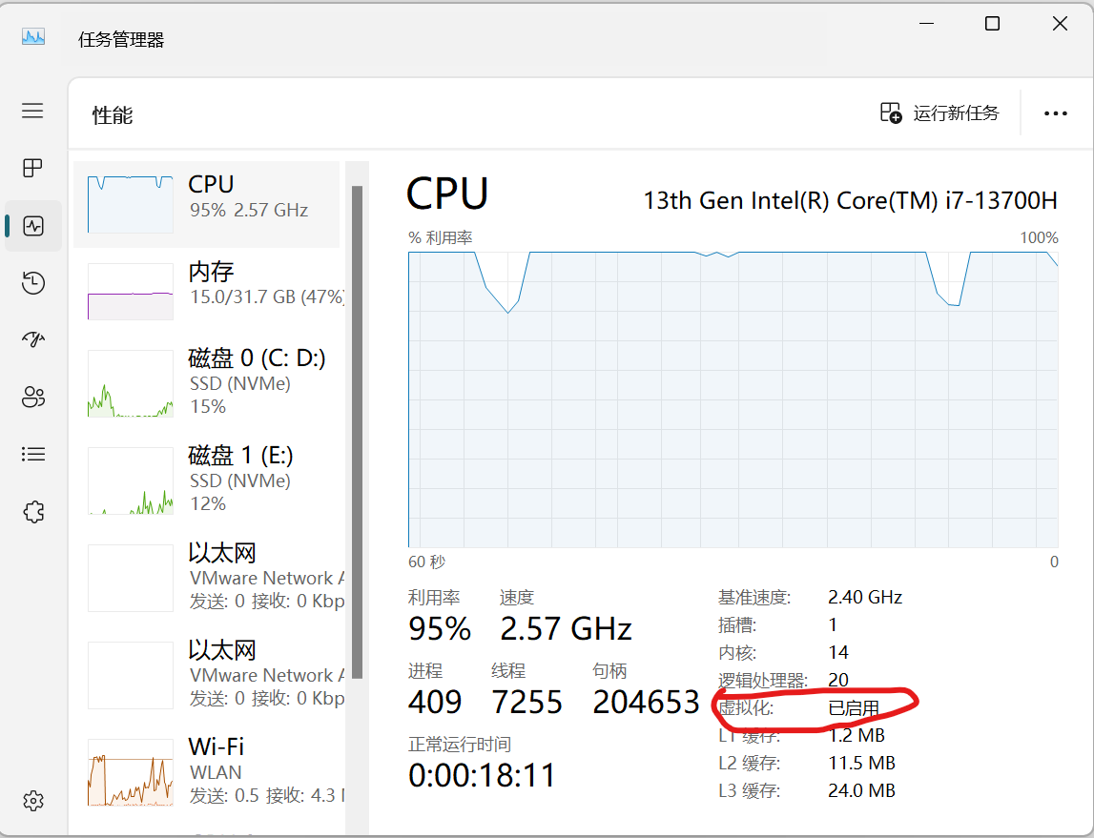

- The cloud is almost everywhere in our lives now.What do you think are the fundamental reasons behind its success? Name three pros and three cons of cloud.
I think there’s three fundamental reasons for its success.
The first one is economic efficiency.Companies no longer need to make huge capital expenditures (Capex) on building and maintaining data centers. Instead, they pay for what they use as an operational expense (Opex), making technology accessible to startups and large enterprises alike.
The second one is elasticity and scalability.Resources can be scaled up or down instantly based on demand. A business can handle a sudden traffic spike without buying and configuring new physical servers, and then scale down to avoid paying for idle resources.
The third one is global reach and speed.Cloud providers have data centers worldwide, allowing businesses to deploy applications close to their users for low latency and to meet data sovereignty laws easily.
Three Pros:
a.Cost Savings: Eliminates the cost of hardware, utilities, and physical space for on-premises servers.
b.Agility and Speed: Developers can provision resources in minutes, drastically accelerating development and deployment cycles.
c.Reliability and Disaster Recovery: Cloud providers offer built-in data backup, disaster recovery, and business continuity solutions, often with high Service Level Agreements (SLAs).
Three Cons:
a.Potential for Vendor Lock-in: It can be difficult and expensive to migrate services and data from one cloud provider (e.g., AWS) to another (e.g., Azure) due to proprietary technologies and APIs.
b.Security and Compliance Concerns: While major providers have robust security, storing sensitive data on a third-party system always carries risk. Companies must ensure the provider complies with industry-specific regulations (like HIPAA, GDPR).
c.Ongoing Costs and Potential for Overspending: The pay-as-you-go model can lead to unexpected bills if resources are not monitored and managed properly ("bill shock").

3.What is the primary function of a hypervisor in virtualization?
The primary function of a hypervisor is to create, run, and manage virtual machines. It acts as a layer of software that abstracts the physical hardware and allocates these resources to one or more guest operating systems.

4.What is a Virtual Machine?
A Virtual Machine (VM) is a software-based emulation of a physical computer. It runs its own operating system and applications as if it were a separate physical machine, but it shares the underlying hardware resources of the host computer, which are managed by a hypervisor.

- What are the benefits of using virtual machines?
Virtualization technology utilizes logical isolation mechanisms to allow multiple virtual machine instances to operate completely independently. Even if one virtual machine experiences a system crash or security vulnerability, it will not affect the host system or other virtual machines. This architecture not only enables server consolidation—deploying multiple virtual machines on a single physical server to significantly improve hardware resource utilization and reduce the number of physical devices—but also provides exceptional portability. Since the complete operational state of a virtual machine is encapsulated as independent files, tasks such as migrating, replicating, and backing up the entire system become exceptionally convenient. Additionally, this technology offers important compatibility solutions, supporting the operation of legacy operating systems and traditional application software on modern host systems. At the same time, it creates a reliable sandbox environment for software testing and security research, ensuring that various high-risk operations do not compromise the stability and security of the main system.

- List five use cases of virtual machines.
A.Running multiple server roles (e.g., web server, database server, domain controller) as separate VMs on one physical host.
B.Developers can quickly create isolated, disposable environments that match production.
C.Using a Windows VM on a Mac to run a Windows-only application, or running a legacy OS like Windows XP for an old business application.
D. Analyzing potentially malicious software in a VM to prevent it from infecting the host machine.
E.Backing up entire systems as VMs allows for rapid recovery on different hardware in case of a failure.

7. In virtualization, what is the guest operating system?
b) The operating system installed on a virtual machine.

8. What does virtual machine isolation mean?
c) Virtual machines are logically isolated from each other and the host system.

9. What is the benefit of virtual machine portability?
c) It allows virtual machines to be moved between different physical machines with compatible hypervisors.

10. What is the purpose of cloning a virtual machine?
The purpose of cloning a virtual machine is to create an exact, independent copy of an existing VM. This is used to:
A.Rapidly deploy multiple identical systems (e.g., for a cluster of web servers).
B.Create a perfect backup or template from a "golden image."
C.Create a duplicate environment for testing and development without affecting the original VM.

