Lab3
Phase 1: Preparation of Tools and Environment
- GitHub Account Registration: A new account was created by navigating to github.com , clicking the "Sign up" button in the top-right corner, and following the prompts to enter a username, email address, and password. Account verification was completed via email.
- Git Installation and Configuration: The Git command-line tool was downloaded from git-scm.com and installed on the local machine. Post-installation, the terminal was opened to configure Git with user identity using the following commands:
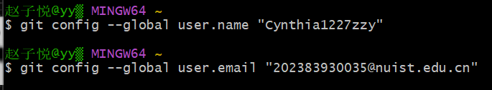
Phase 2: Creating the Dedicated GitHub Repository
- After logging into GitHub, a new repository was created by clicking the "+" icon in the top-right corner and selecting "New repository".
- The repository was configured with the following critical settings: ◦ Repository name: Set to the required format [username].github.io (e.g., janedoe.github.io ).
◦ Visibility: Set to "Public".
◦ Other options were left at their defaults.
The repository was initialized without a README, .gitignore, or license file at this stage.
- The repository was created by clicking the green "Create repository" button.
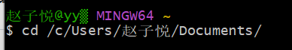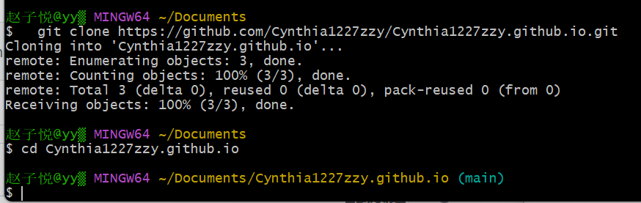
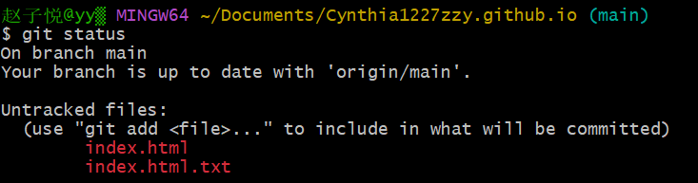
Phase 3: Developing and Uploading the Website Files
- Local File Creation: A local project folder named my-website was created. Inside, two essential files were made:
◦ index.html : The main homepage containing basic HTML structure, a personal introduction, and a link to the CSS file.
◦ style.css : A stylesheet to define the website's visual layout (colors, fonts, spacing).
2. Uploading Files via Git Command Line: The terminal was used to navigate to the local folder ( cd my-website ). The following Git commands were executed in sequence to upload the files:
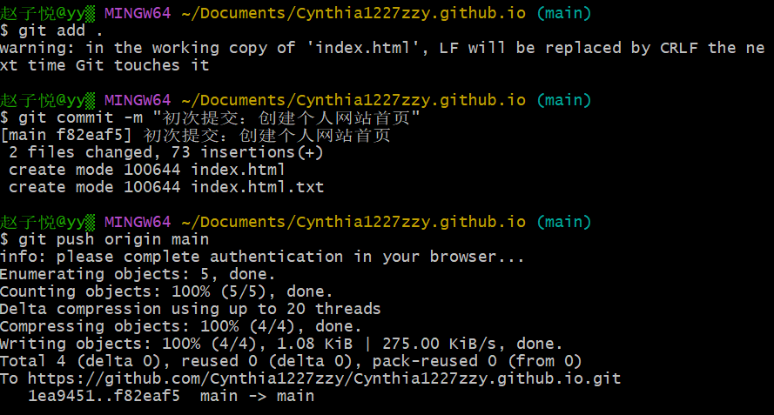
Phase 4: Enabling GitHub Pages and Publication
- On the GitHub repository page, the "Settings" tab was clicked from the horizontal navigation menu.
- From the left sidebar, the "Pages" option was selected.
- In the "Build and deployment" section, the "Source" was set to "Deploy from a branch".
- The "Branch" was set to "main" and the folder to "/(root)", then the "Save" button was clicked.
5. After a brief wait (1-2 minutes), the page refreshed automatically or a notification appeared, confirming the site was live. 