Lab5
A.What is an image?
Image is a read-only template containing the filesystem, code, libraries, and other elements required to create a container.
In this hands-on, I learned how to search and pull a container image using the Docker Desktop GUI.
- Open the Docker Desktop Dashboard and select the Images view in the left-hand navigation menu.
- Select the Search images to run button. If you don't see it, select the global search bar at the top of the screen.
3.In the Search field, enter "welcome-to-docker". Once the search has completed, select the docker/welcome-to-docker image.
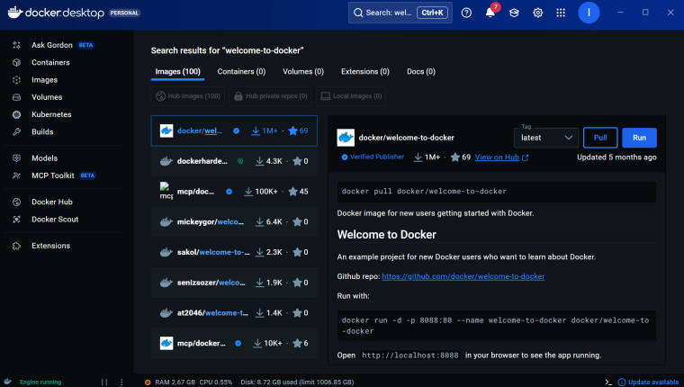
4.Select Pull to download the image.
5.In the Docker Desktop Dashboard, select the Images view.
6.Select the docker/welcome-to-docker image to open details about the image.
7.The image details page presents me with information regarding the layers of the image, the packages and libraries installed in the image, and any discovered vulnerabilities.
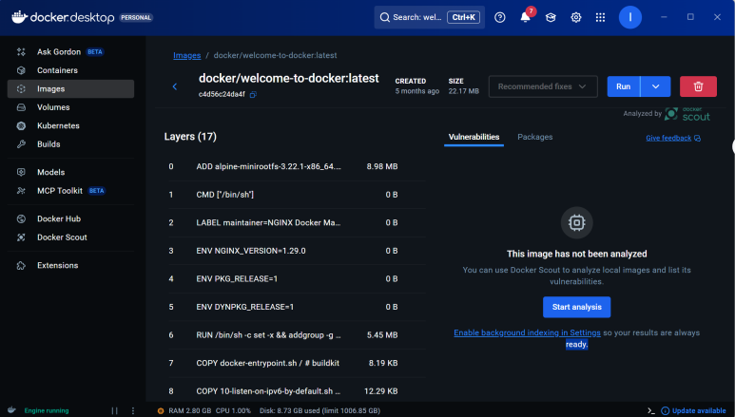
In this walkthrough, I searched and pulled a Docker image. In addition to pulling a Docker image, you also learned about the layers of a Docker Image.
- What is a container?
Container is the runnable instance of the image. A lightweight, isolated package containing everything needed to run the application.
In this hands-on, I learned how to run a Docker container using the Docker Desktop GUI.
1.Open Docker Desktop and select the Search field on the top navigation bar.
2.Specify welcome-to-docker in the search input and then select the Pull button.
3.Once the image is successfully pulled, select the Run button.
4.Expand the Optional settings.
5.In the Container name, specify welcome-to-docker.
6.In the Host port, specify 8080.
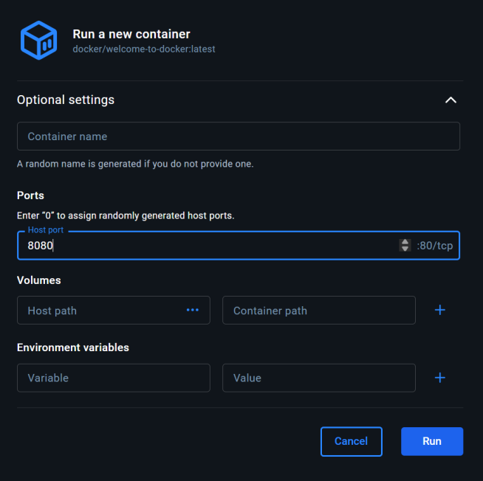
- Select Run to start the container.
- Go the the container dashboard to view my container
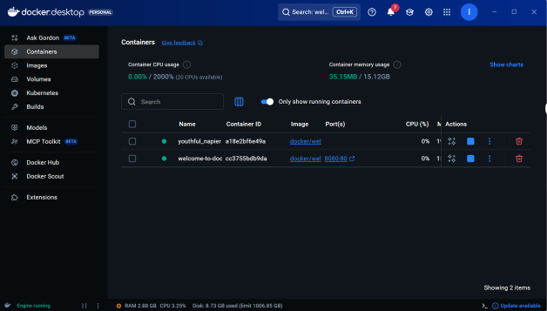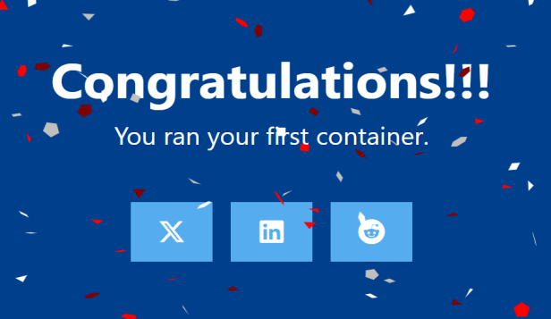
9.Go to the Containers view in the Docker Desktop Dashboard.
10.Select your container.
11.Select the Files tab to explore your container's isolated file system.
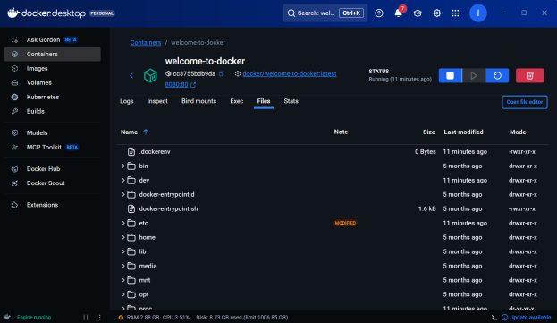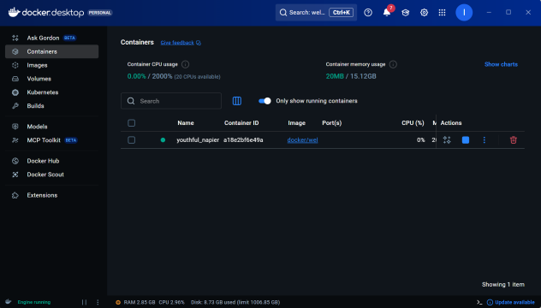
12.Go to the Containers view in the Docker Desktop Dashboard to stop my container
13.Locate the container you'd like to stop.
14.Select the Stop action in the Actions column.
- What is a Docker Compose?
Docker compose is a tool for defining and running multi-container Docker applications, configured via a `docker-compose.yml` file.
In this hands-on, I learned how to use a Docker Compose to run a multi-container application. You'll use a simple to-do list app built with Node.js and MySQL as a database server.
1.Download and install Docker Desktop.
2.Open a terminal and clone this sample application.
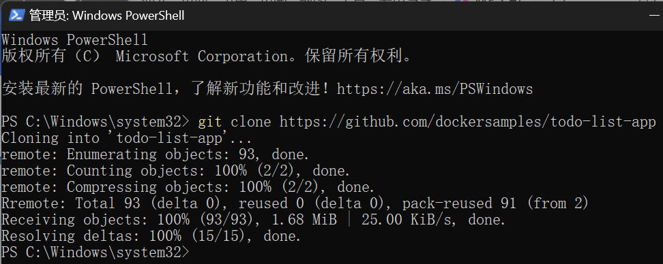
- Navigate into the todo-list-app directory:
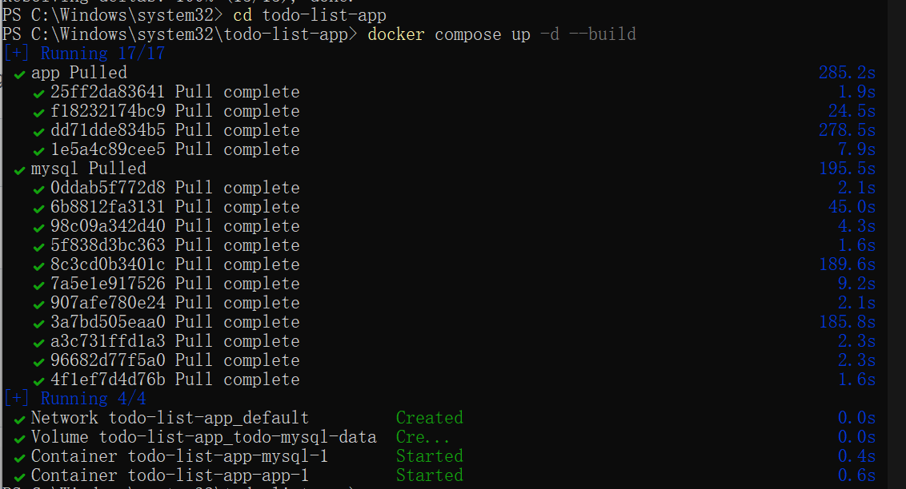
4.With everything now up and running, open http://localhost:3000 in browser to see the site.
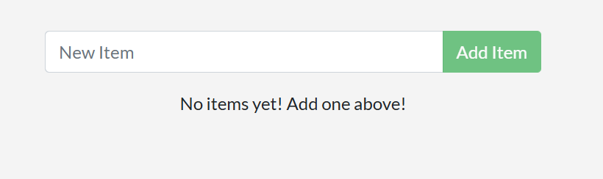
- In the CLI, use the docker compose down command to remove everything:
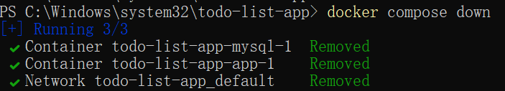
- Add the --volumes flag when running the docker compose down command to remove the volumes.
In this walkthrough, you learned how to use Docker Compose to start and stop a multi-container application.
- Publishing and exposing ports
Map the ports inside the container to the host ports, allowing you to access the services inside the container from the host.
In this hands-on guide, I learned how to publish container ports using both the CLI and Docker Compose for deploying a web application.
- In a terminal, run the following command to start a new container:
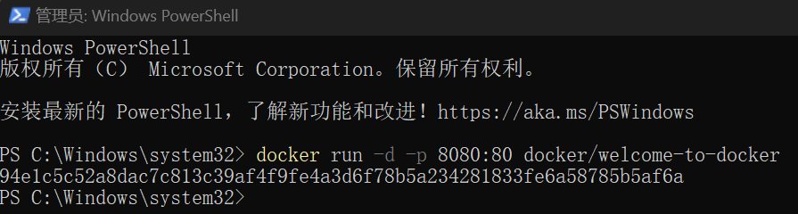
- Verify the published port by going to the Containers view of the Docker Desktop Dashboard
- Open the website by either selecting the link in the Port(s) column of your container or visiting http://localhost:8080 in your browser.
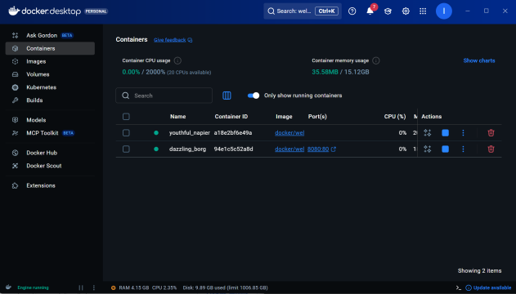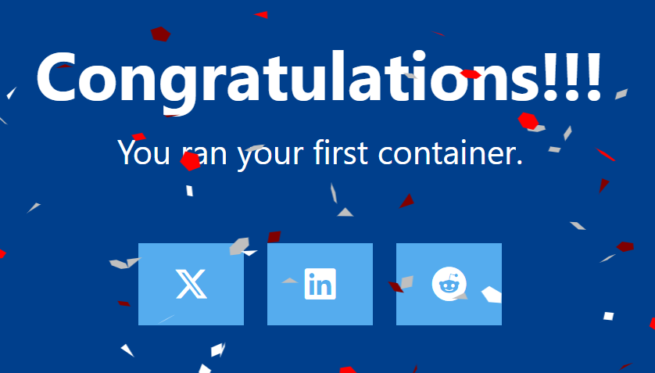
- Overriding container defaults
When running a container, override its default commands, environment variables, etc.
In this hands-on guide, I learned how to use the docker run command to override the container defaults.
- Start a container using the Postgres image with the following command:
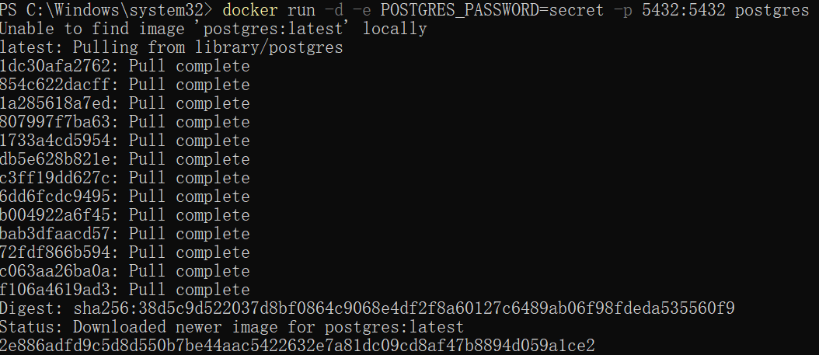
- Start a second Postgres container mapped to a different port.
- Verify that both containers are running by going to the Containers view in the Docker Desktop Dashboard.
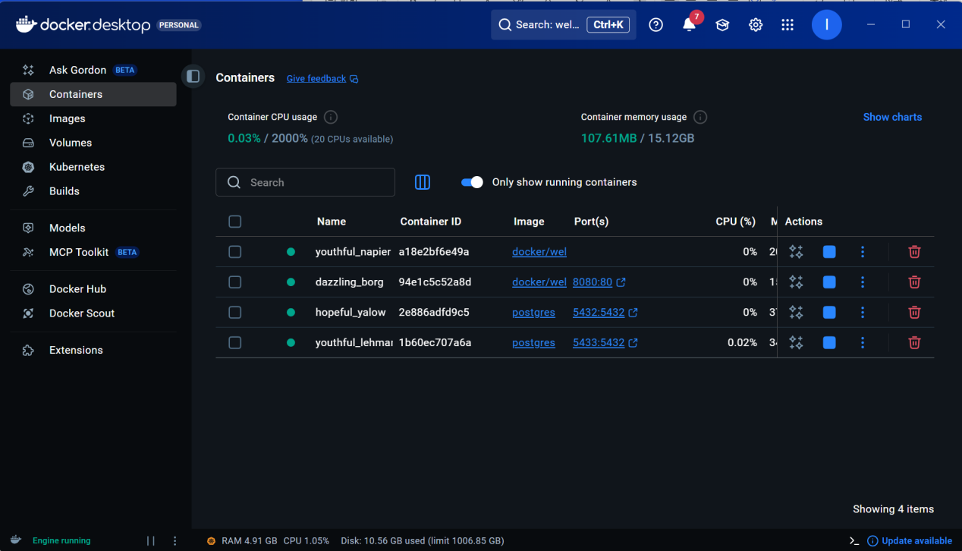
The following steps connect a Postgres container to a custom network.
- Create a new custom network by using the following command:
- Verify the network by running the following command:
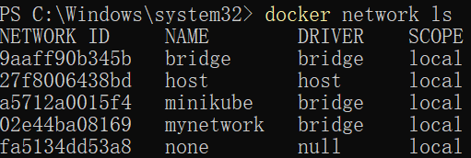
- Connect Postgres to the custom network by using the following command:
The following steps override the default CMD and ENTRYPOINT in docker compose
- Create a compose.yml file with the following content:
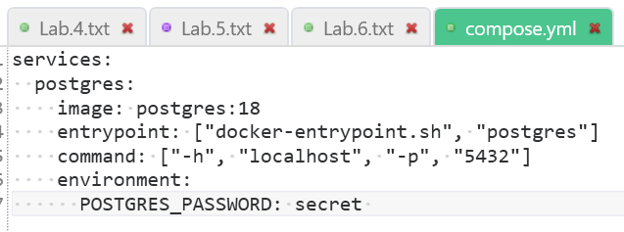
- Bring up the service by running the following command:
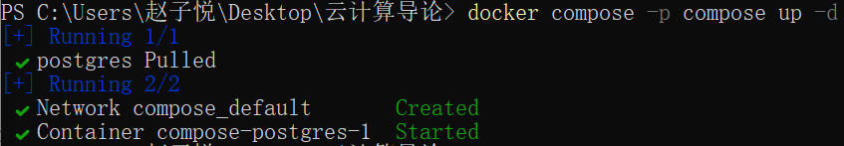
3.Verify the authentication with Docker Desktop Dashboard.
Open the Docker Desktop Dashboard, select the Postgres container and select Exec to enter into the container shell.
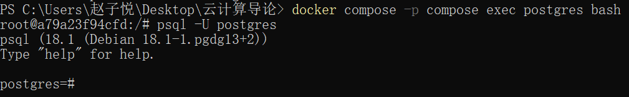
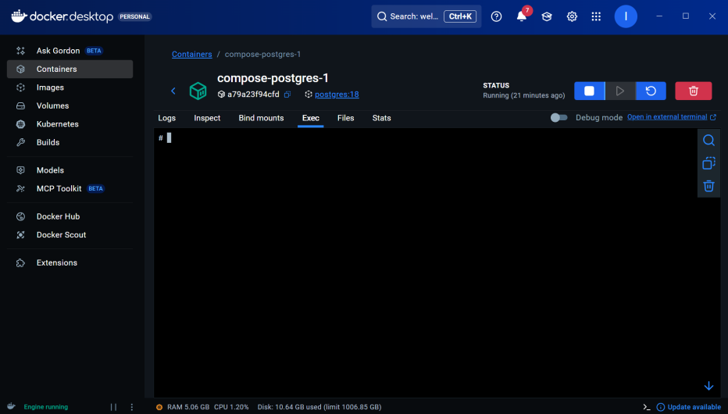
- Persisting container data
Use a volume or binding mount to store the data inside the container on the host, avoiding data loss after the container is deleted.
In this guide, I practiced creating and using volumes to persist data created by a Postgres container. When the database runs, it stores files into the /var/lib/postgresql directory. By attaching the volume here, you will be able to restart the container multiple times while keeping the data.
1.Start a container using the Postgres image with the following command:
2.Connect to the database by using the following command:
3.In the PostgreSQL command line, run the following to create a database table and insert two records:
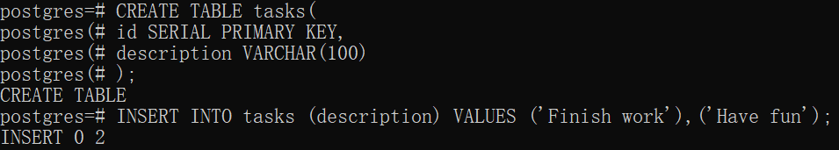
4.Verify the data is in the database by running the following in the PostgreSQL command line:
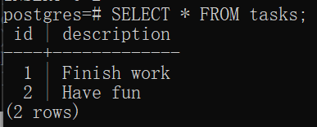
5.Exit out of the PostgreSQL shell by running the following command:\q
6.Stop and remove the database container. Remember that, even though the container has been deleted, the data is persisted in the postgres_data volume.
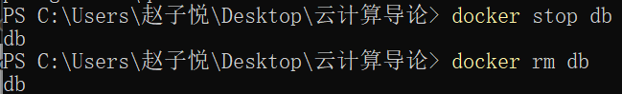
7.Start a new container by running the following command, attaching the same volume with the persisted data:
8.Verify the database still has the records by running the following command:
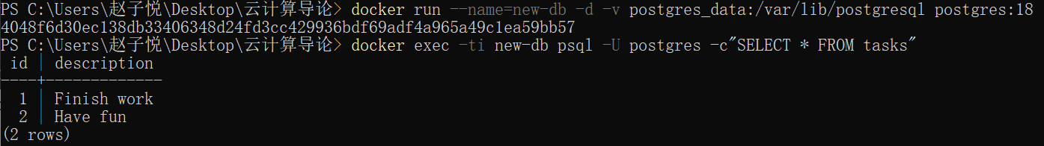
- Remove volumes
- Sharing local files with containers
In this hands-on guide,I practiced how to create and use a bind mount to share files between a host and a container.
- Start a container using the httpd image with the following command:
- Open the browser and access http://localhost:8081
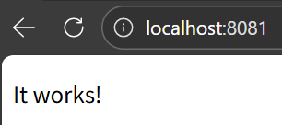
- Delete the existing container by using the Docker Desktop Dashboard:
- Create a new directory called public_html on your host system.
- Navigate into the newly created directory public_html and create a file called index.html with the following content. This is a basic HTML document that creates a simple webpage that welcomes you with a friendly whale.
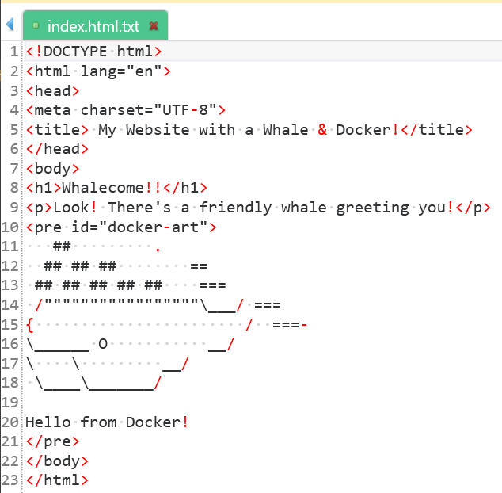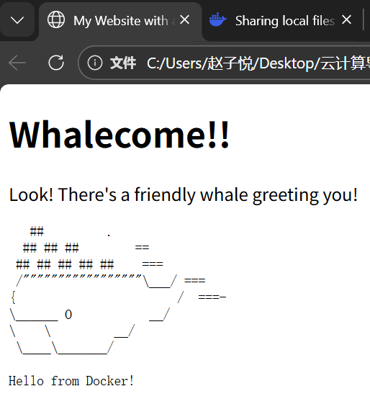
- Run the container with the following command
7.With everything now up and running, we should be able to access the site via http://localhost:8080 and find a new webpage that welcomes you with a friendly whale.
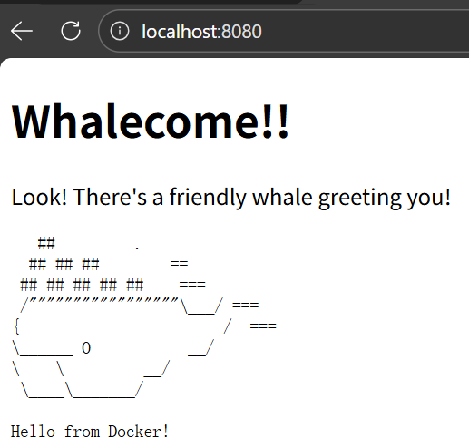
8.We can view the mounted files inside a container by selecting the container's Files tab and then selecting a file inside the /usr/local/apache2/htdocs/ directory. Then, select Open file editor.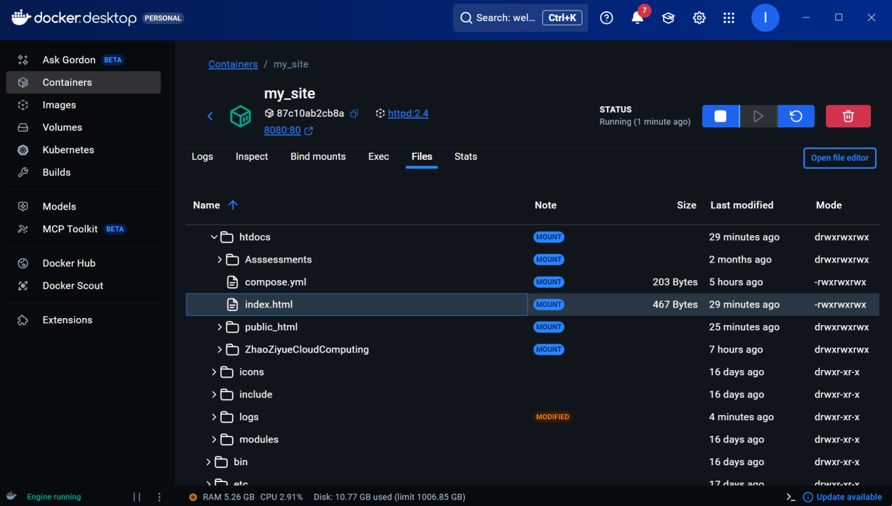
9.Delete the file on the host and verify the file is also deleted in the container. You will find that the files no longer exist under Files in the Docker Desktop Dashboard.
10.Recreate the HTML file on the host system and see that file re-appears under the Files tab under Containers on the Docker Desktop Dashboard. By now, you will be able to access the site too.
- Multi-container applications
In this hands-on guide, we'll first see how to build and run a counter web application based on Node.js, an Nginx reverse proxy, and a Redis database using the docker run commands. You’ll also see how you can simplify the entire deployment process using Docker Compose.
- Download the sample application.
- Navigate into the nginx directory to build the image by running the following command:
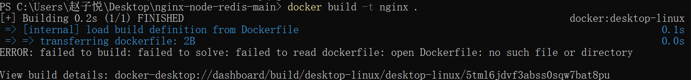
- Navigate into the web directory and run the following command to build the first web image:
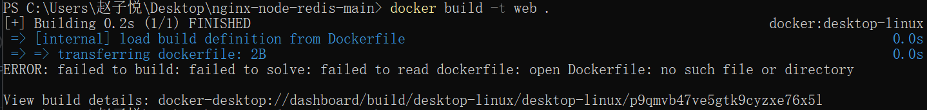
- Before we can run a multi-container application, we need to create a network for them all to communicate through. We can do so using the docker network create command:
- Start the Redis container by running the following command, which will attach it to the previously created network and create a network alias (useful for DNS lookups):
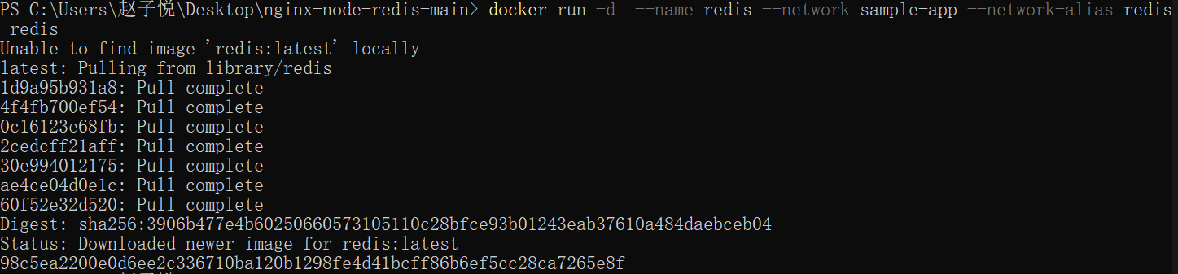
- Start the first web container by running the following command:
- Start the second web container by running the following:
- Start the Nginx container by running the following command:
- Verify the containers are up by running the following command:
- If we look at the Docker Desktop Dashboard, we can see the containers and dive deeper into their configuration.
- With everything up and running, you can open http://localhost in your browser to see the site. Refresh the page several times to see the host that’s handling the request and the total number of requests:
- You can use the Docker Desktop Dashboard to remove the containers by selecting the containers and selecting the Delete button.

