Lab6
- Hello minikube
I.Create a minikube cluster
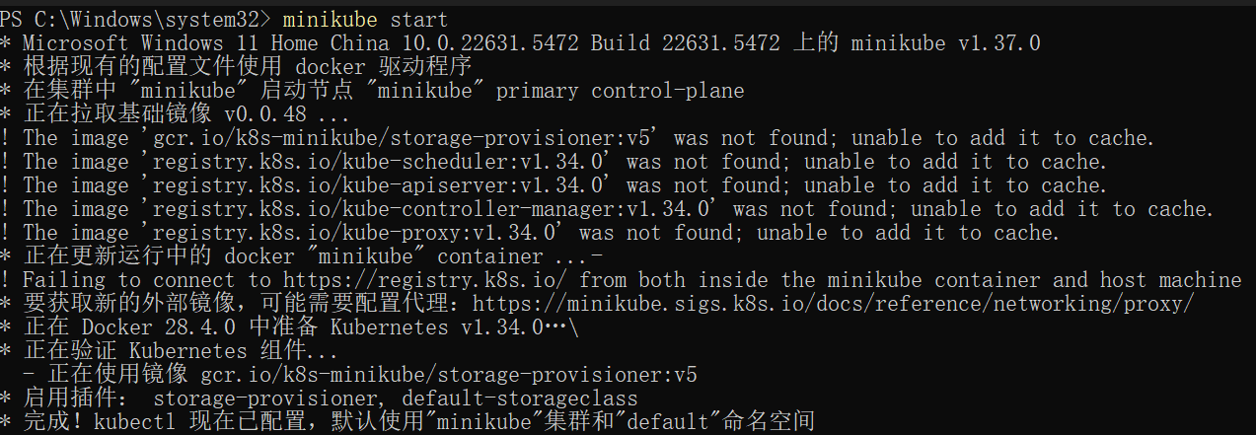
II.Open the dashboard
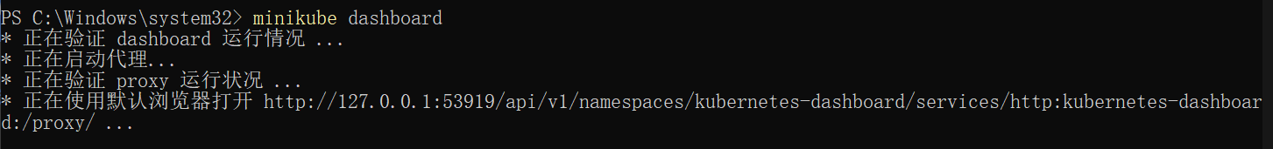
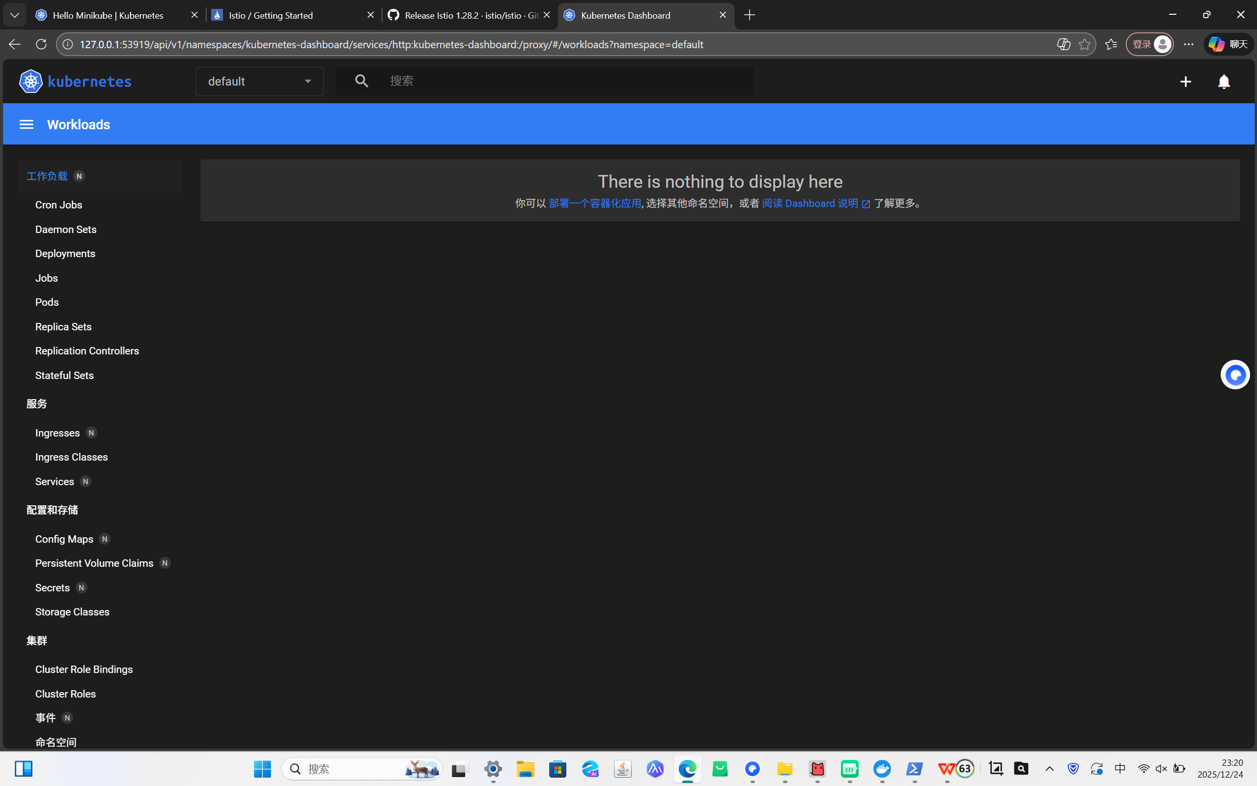
III.Create a Deployment
- Use the kubectl create command to create a Deployment that manages a Pod. The Pod runs a Container based on the provided Docker image.
- View the Deployment:
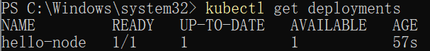
- View the Pod:
- View cluster events:
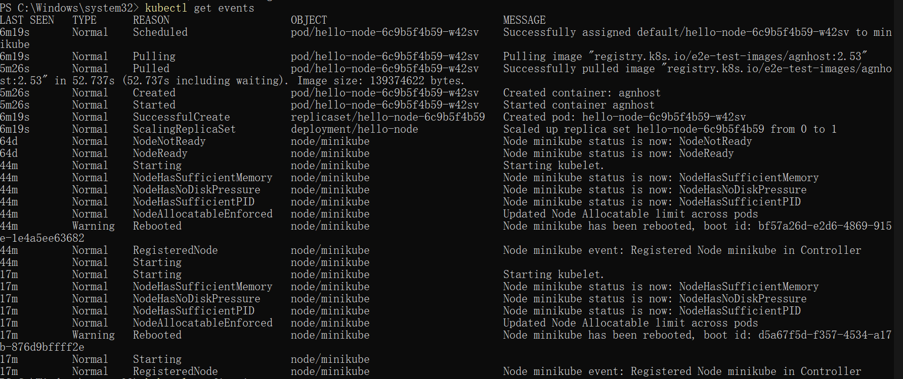
- View the kubectl configuration:
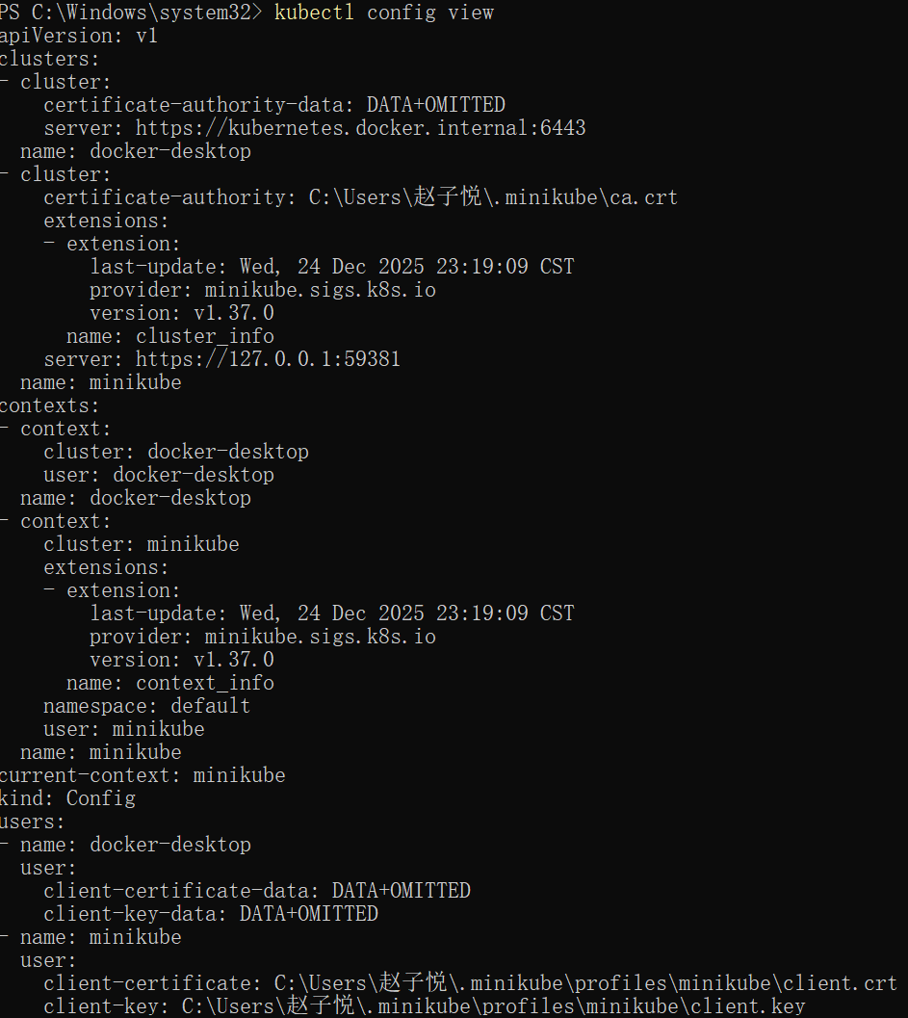
- View application logs for a container in a pod (replace pod name with the one you got from kubectl get pods).
IV.Create a Service
1.Expose the Pod to the public internet using the kubectl expose command:
- View the Service you created:
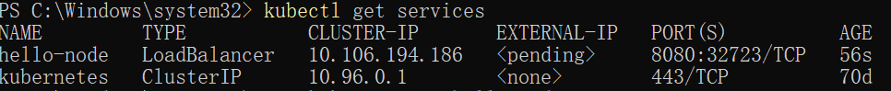
3.Run the following command:
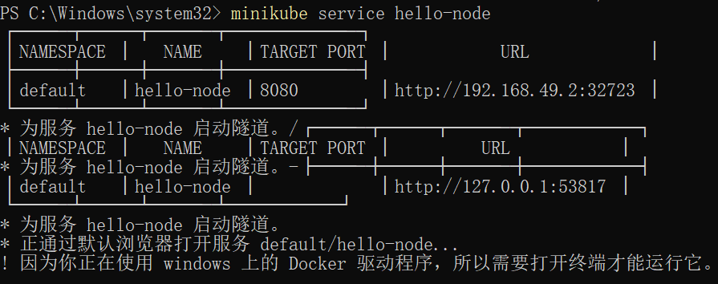
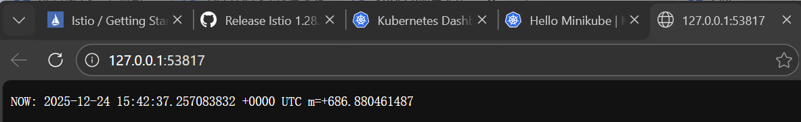
V.Enable addons
1.List the currently supported addons:
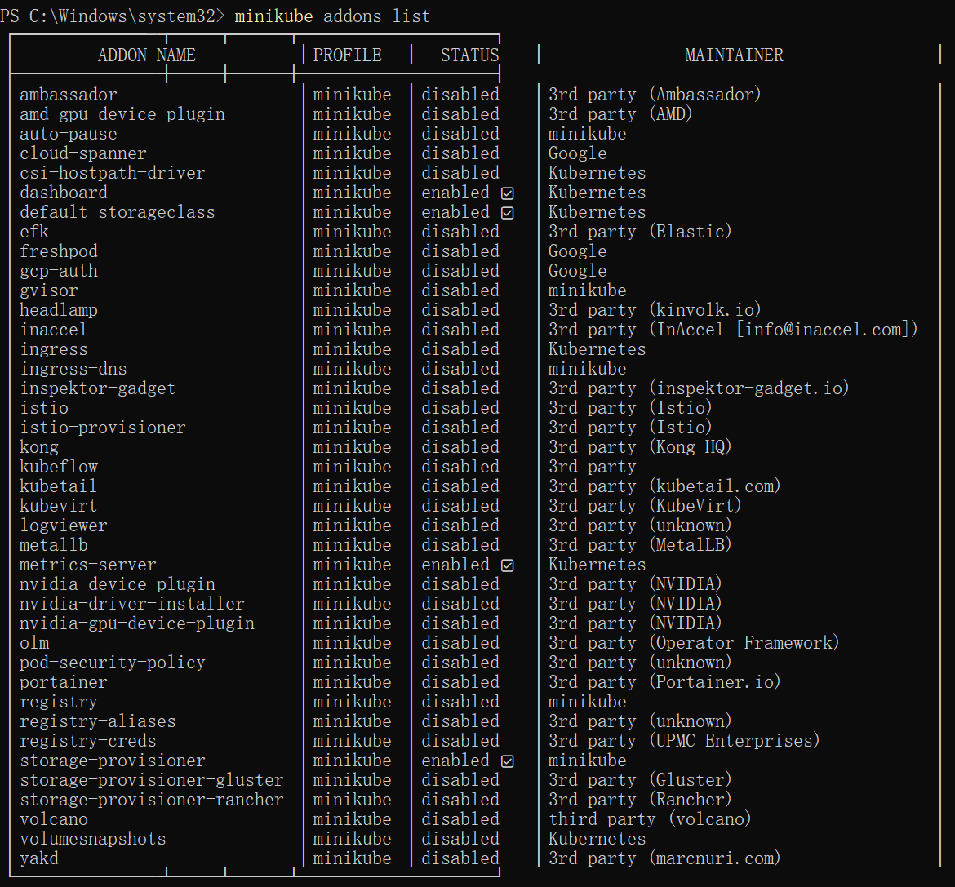
2.Enable an addon, for example, metrics-server:
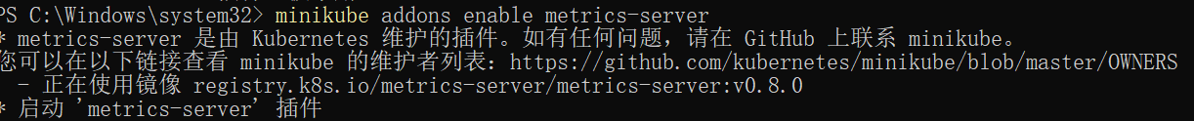
- View the Pod and Service you created by installing that addon:
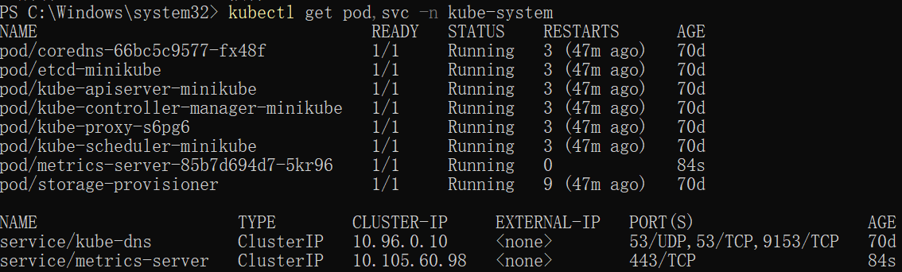
- Check the output from metrics-server:
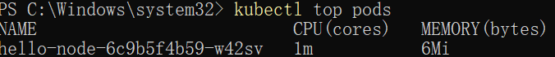
- Disable metrics-server:
VI.Clean up
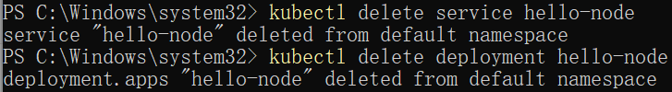

- Using kubectl to create a deployment
- Let’s deploy our first app on Kubernetes with the kubectl create deployment command. We need to provide the deployment name and app image location (include the full repository url for images hosted outside Docker Hub).
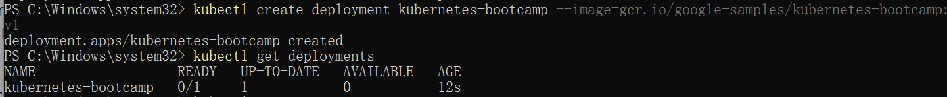
- To list your deployments use the kubectl get deployments command:
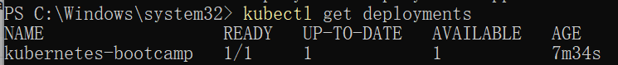
- We need to open a second terminal window to run the proxy.
You can see all those APIs hosted through the proxy endpoint. For example, we can query the version directly through the API using the curl command:
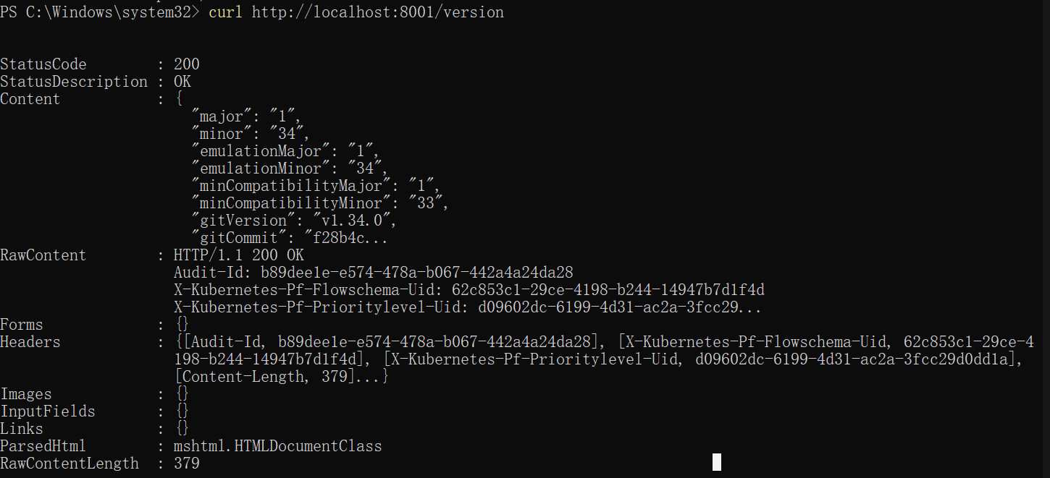
4.The API server will automatically create an endpoint for each pod, based on the pod name, that is also accessible through the proxy.
First we need to get the Pod name, and we'll store it in the environment variable POD_NAME.
5.We can access the Pod through the proxied API, by running:
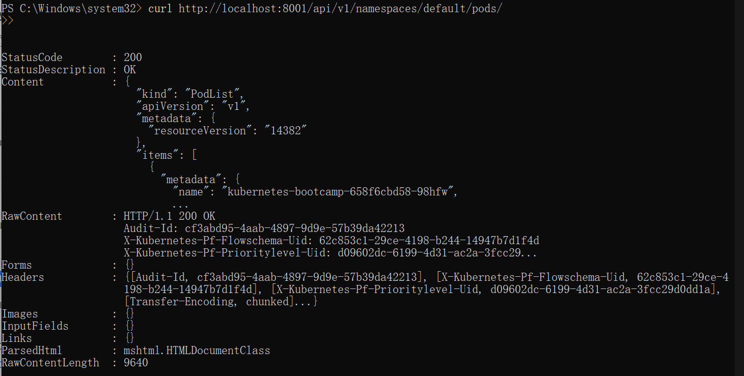
- Explore-intro
I.Check application configuration
1.Let's verify that the application we deployed in the previous scenario is running. We'll use the kubectl get command and look for existing Pods:
- Next, to view what containers are inside that Pod and what images are used to build those containers we run the kubectl describe pods command:
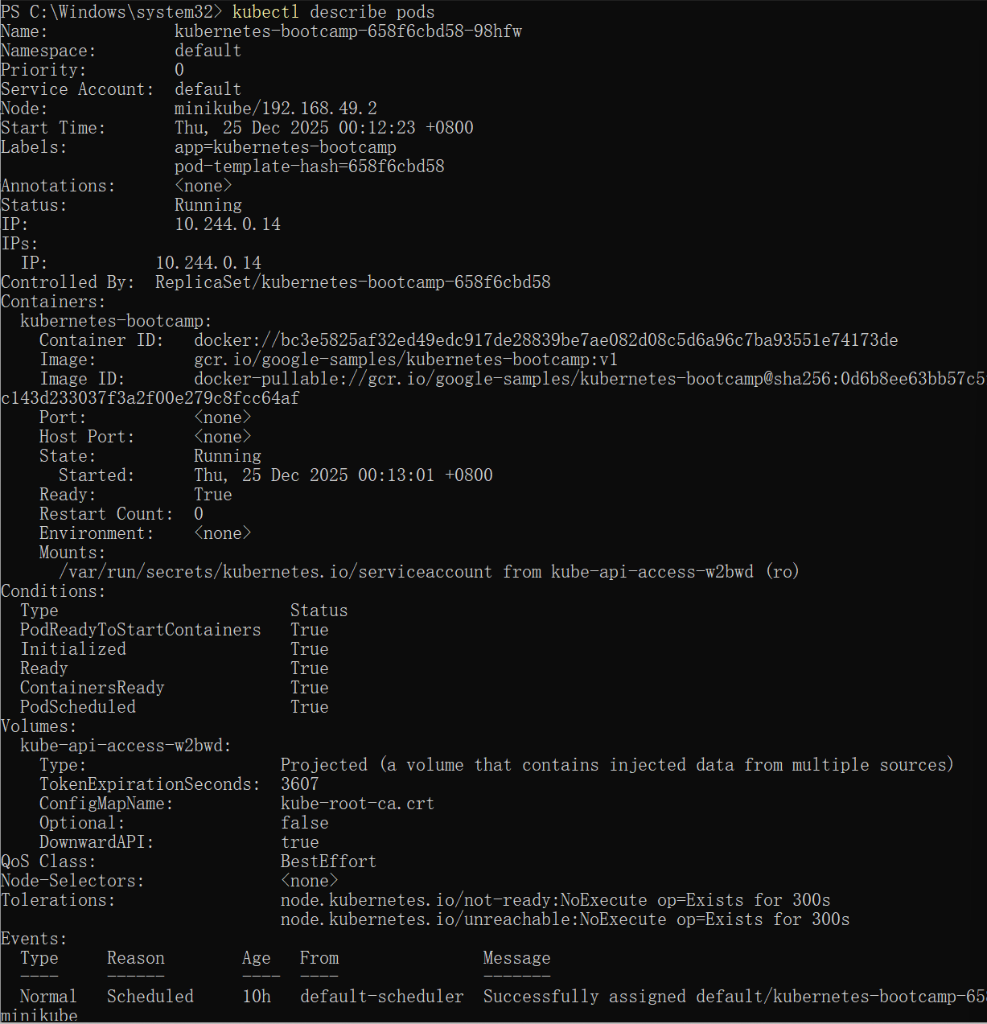
II.Show the app in the terminal
1.Recall that Pods are running in an isolated, private network - so we need to proxy access to them so we can debug and interact with them. To do this, we'll use the kubectl proxy command to run a proxy in a second terminal. Open a new terminal window, and in that new terminal, run:
2.Now again, we'll get the Pod name and query that pod directly through the proxy. To get the Pod name and store it in the POD_NAME environment variable:
- To see the output of our application, run a curl request:
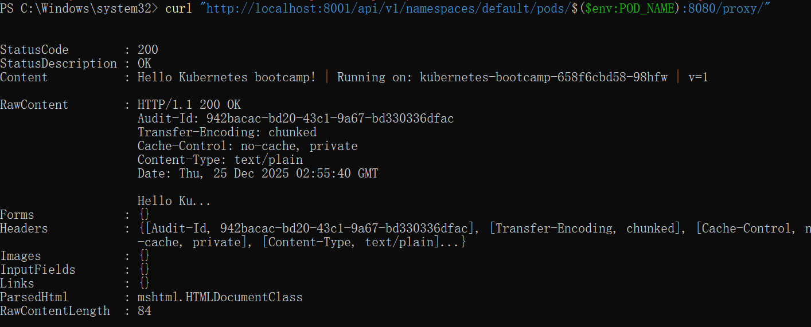
III.Executing commands on the container
- We can execute commands directly on the container once the Pod is up and running. For this, we use the exec subcommand and use the name of the Pod as a parameter. Let’s list the environment variables:
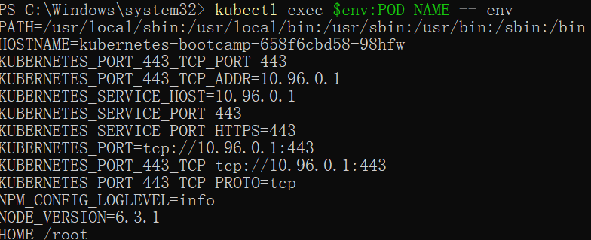
- Again, it's worth mentioning that the name of the container itself can be omitted since we only have a single container in the Pod.
Next let’s start a bash session in the Pod’s container
- We have now an open console on the container where we run our NodeJS application. The source code of the app is in the server.js file:
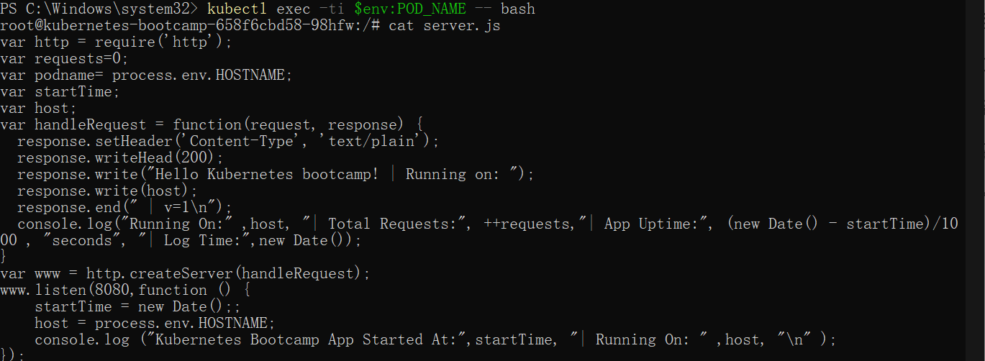
- ou can check that the application is up by running a curl command
- Expose-intro
- Let’s verify that our application is running. We’ll use the kubectl get command and look for existing Pods
- Next, let’s list the current Services from our cluster
- To expose the deployment to external traffic, we'll use the kubectl expose command with the --type=NodePort option:
- To find out what port was opened externally (for the type: NodePort Service) we’ll run the describe service subcommand:
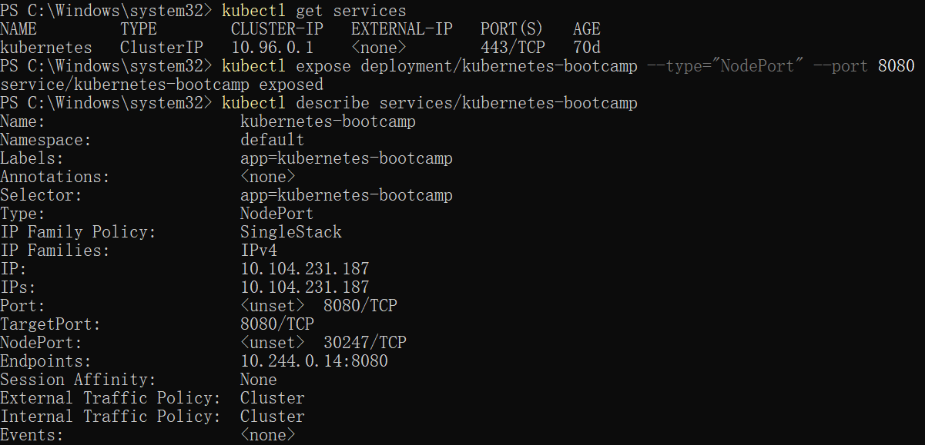
- Create an environment variable called NODE_PORT that has the value of the Node port assigned:
- Now we can test that the app is exposed outside of the cluster using curl, the IP address of the Node and the externally exposed port
- The Deployment created automatically a label for our Pod. With the describe deployment subcommand you can see the name (the key) of that label:
- Let’s use this label to query our list of Pods. We’ll use the kubectl get pods command with -l as a parameter, followed by the label values:
- Get the name of the Pod and store it in the POD_NAME environment variable:
- To apply a new label we use the label subcommand followed by the object type, object name and the new label:
- This will apply a new label to our Pod (we pinned the application version to the Pod), and we can check it with the describe pod command:
- We see here that the label is attached now to our Pod. And we can query now the list of pods using the new label:
- To delete Services you can use the delete service subcommand. Labels can be used also here:
- Confirm that the Service is gone:
- This confirms that our Service was removed. To confirm that route is not exposed anymore you can curl the previously exposed IP and port:
- This proves that the application is not reachable anymore from outside of the cluster. You can confirm that the app is still running with a curl from inside the pod:

