Lab7
1.Go to the Istio release page to download the installation file for your OS, or download and extract the latest release automatically (Linux or macOS):
$ curl -L https://istio.io/downloadIstio | sh -
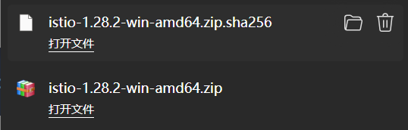
- Move to the Istio package directory. For example, if the package is istio-1.28.2:
3.Add the istioctl client to your path (Linux or macOS):
4.Install Istio using the demo profile, without any gateways:
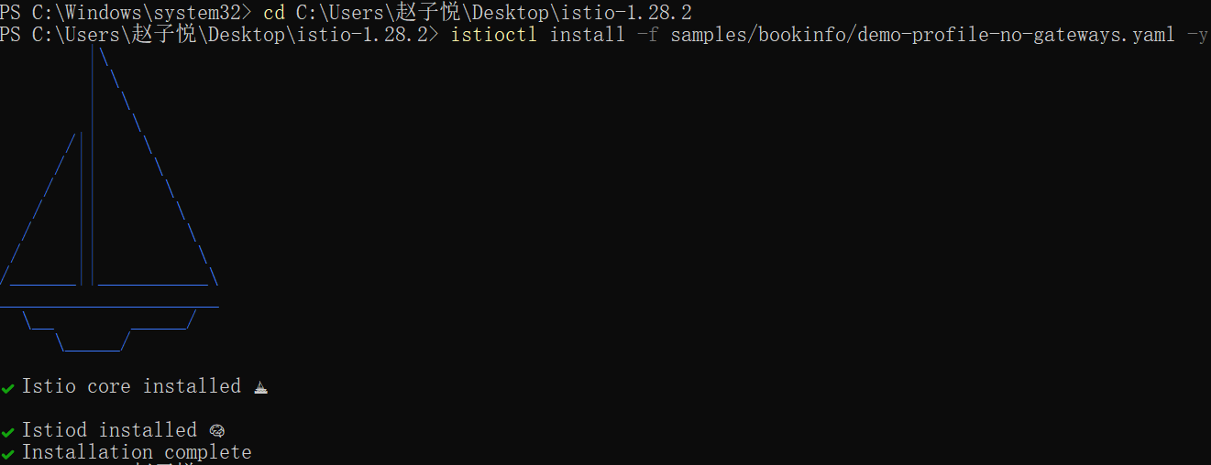
- Add a namespace label to instruct Istio to automatically inject Envoy sidecar proxies when you deploy your application later:
6.Install the Gateway API CRDs, if they are not already present: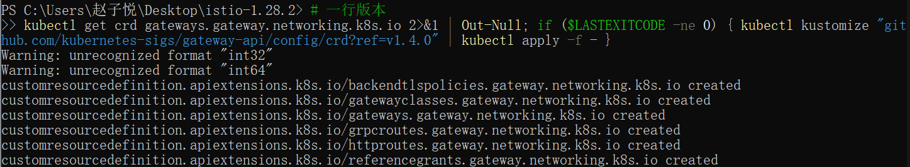
7.Deploy the Bookinfo sample application:
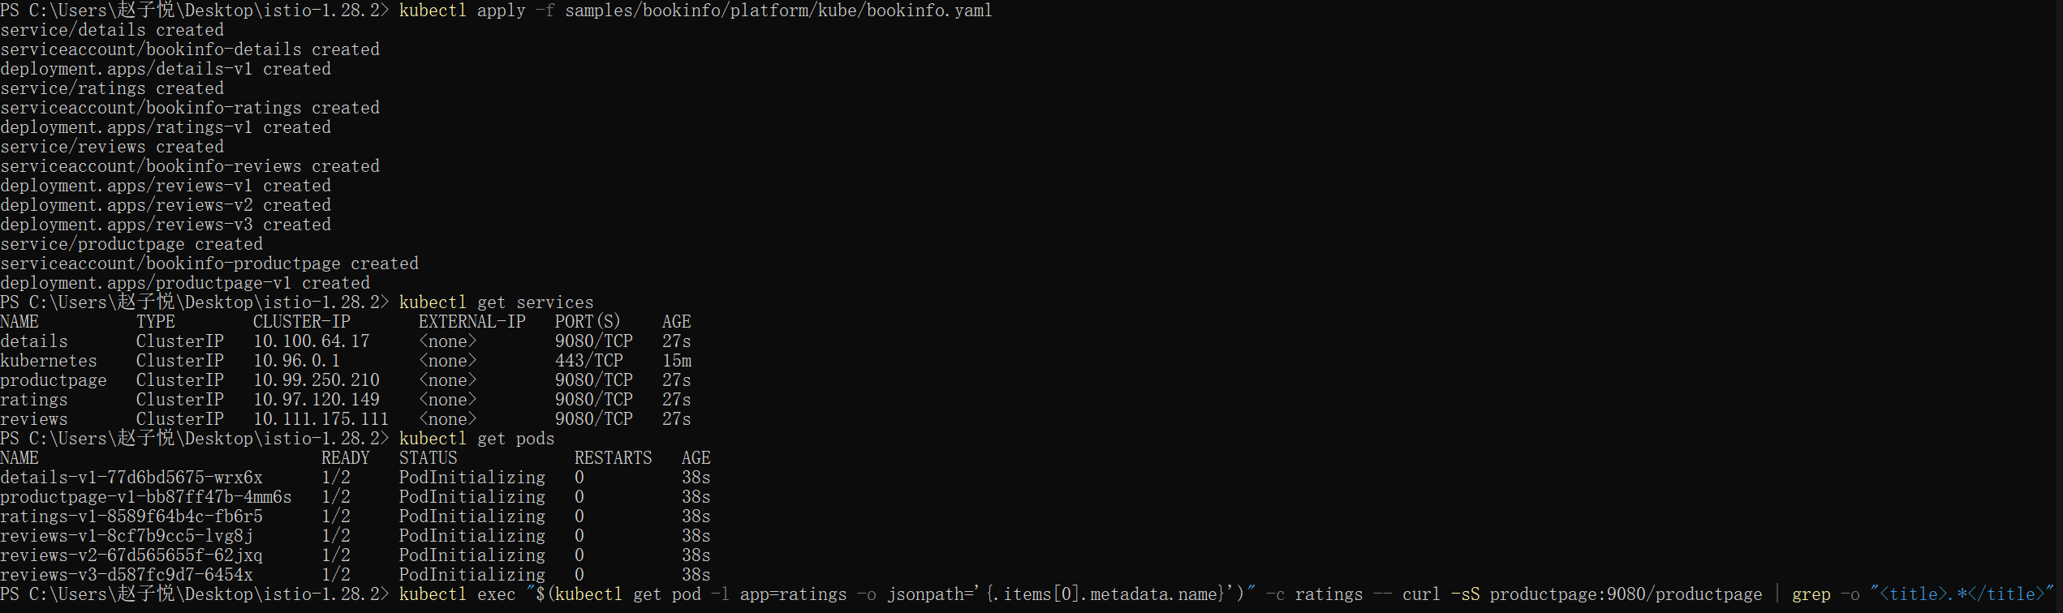
- Validate that the app is running inside the cluster by checking for the page title in the response:
- Create a Kubernetes Gateway for the Bookinfo application:
- Change the service type to ClusterIP by annotating the gateway:
- To check the status of the gateway, run:
- You will connect to the Bookinfo productpage service through the gateway you just provisioned. To access the gateway, you need to use the kubectl port-forward command:
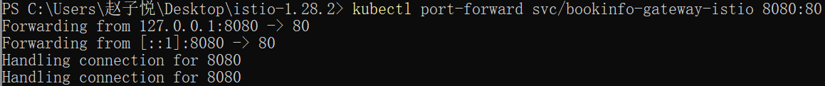
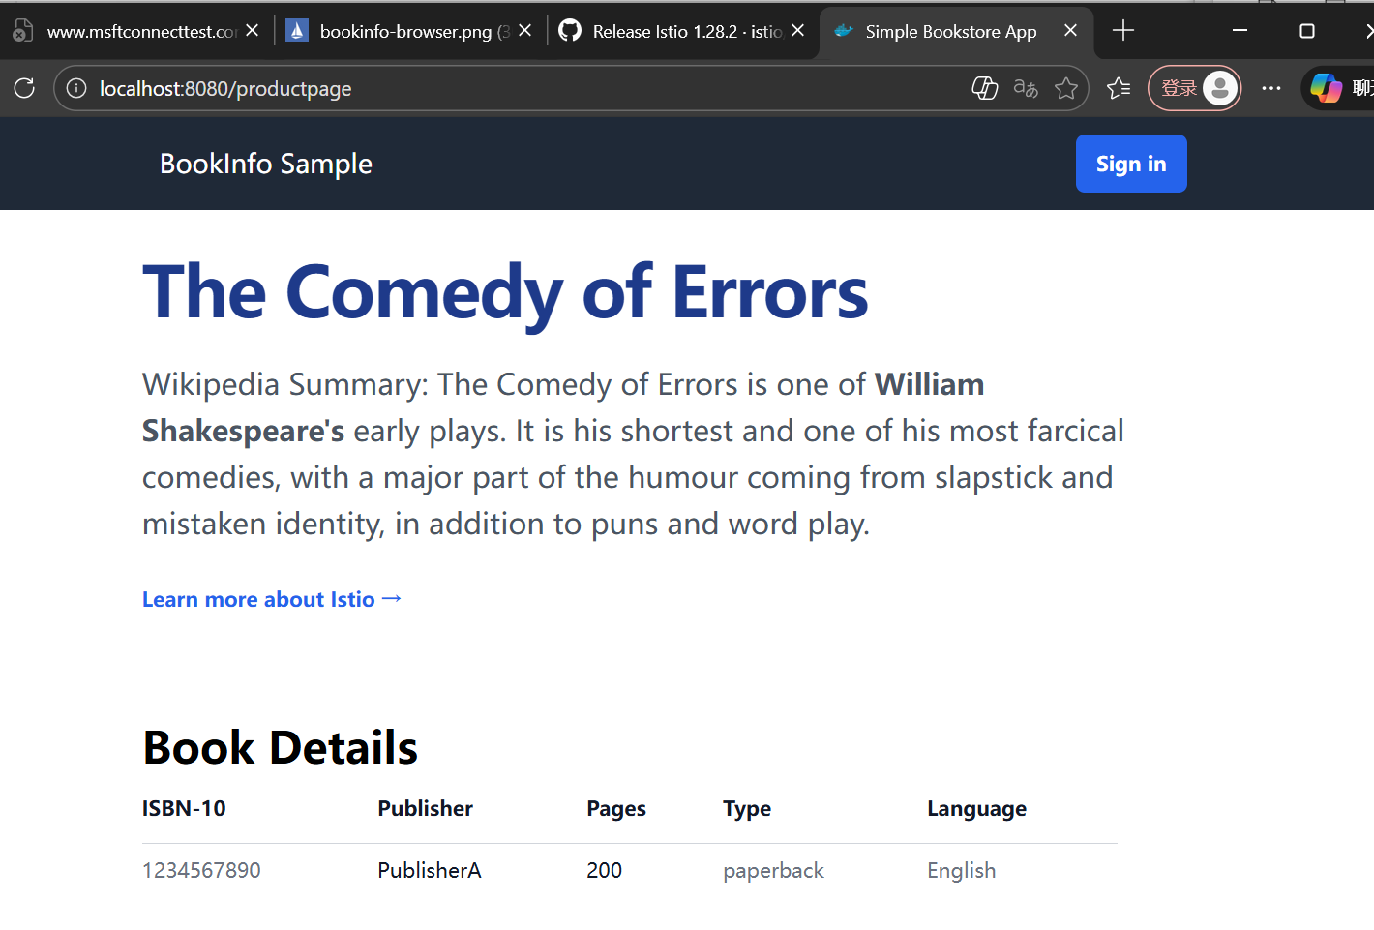
- Install Kiali and the other addons and wait for them to be deployed.
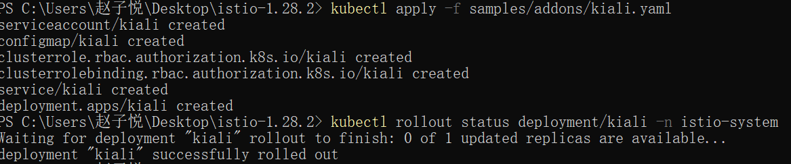
- Access the Kiali dashboard.
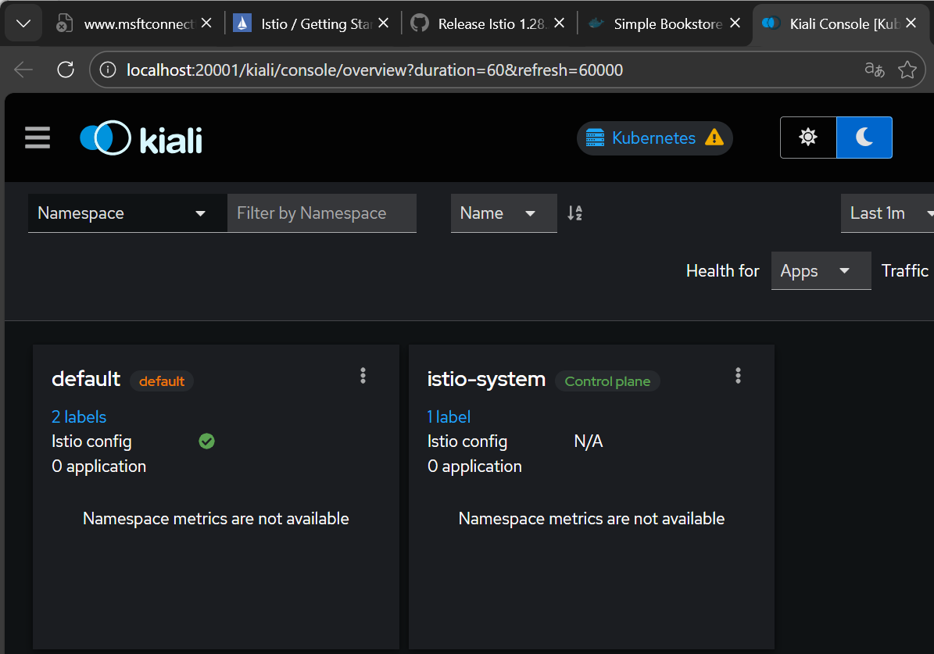
- Uninstall
