Lab8
- Traffic shifting
- To get started, run this command to route all traffic to the v1 version:
- Open the Bookinfo site in your browser. The URL is http://$GATEWAY_URL/productpage, where $GATEWAY_URL is the External IP address of the ingress.
Notice that the reviews part of the page displays with no rating stars, no matter how many times you refresh. This is because you configured Istio to route all traffic for the reviews service to the version reviews:v1 and this version of the service does not access the star ratings service.

3.Transfer 50% of the traffic from reviews:v1 to reviews:v3 with the following command:
- Wait a few seconds for the new rules to propagate and then confirm the rule was replaced:
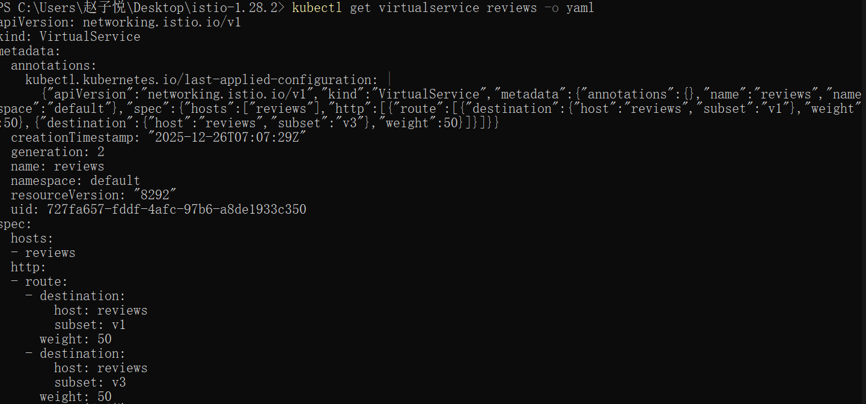
- Refresh the /productpage in your browser and you now see red colored star ratings approximately 50% of the time. This is because the v3 version of reviews accesses the star ratings service, but the v1 version does not.

- Assuming you decide that the reviews:v3 microservice is stable, you can route 100% of the traffic to reviews:v3 by applying this virtual service:
- Refresh the /productpage several times. Now you will always see book reviews with red colored star ratings for each review.
- Request-routing
1.Run the following command to apply virtual services that will route all traffic to v1 of each microservice:
- Display the defined routes with the following command: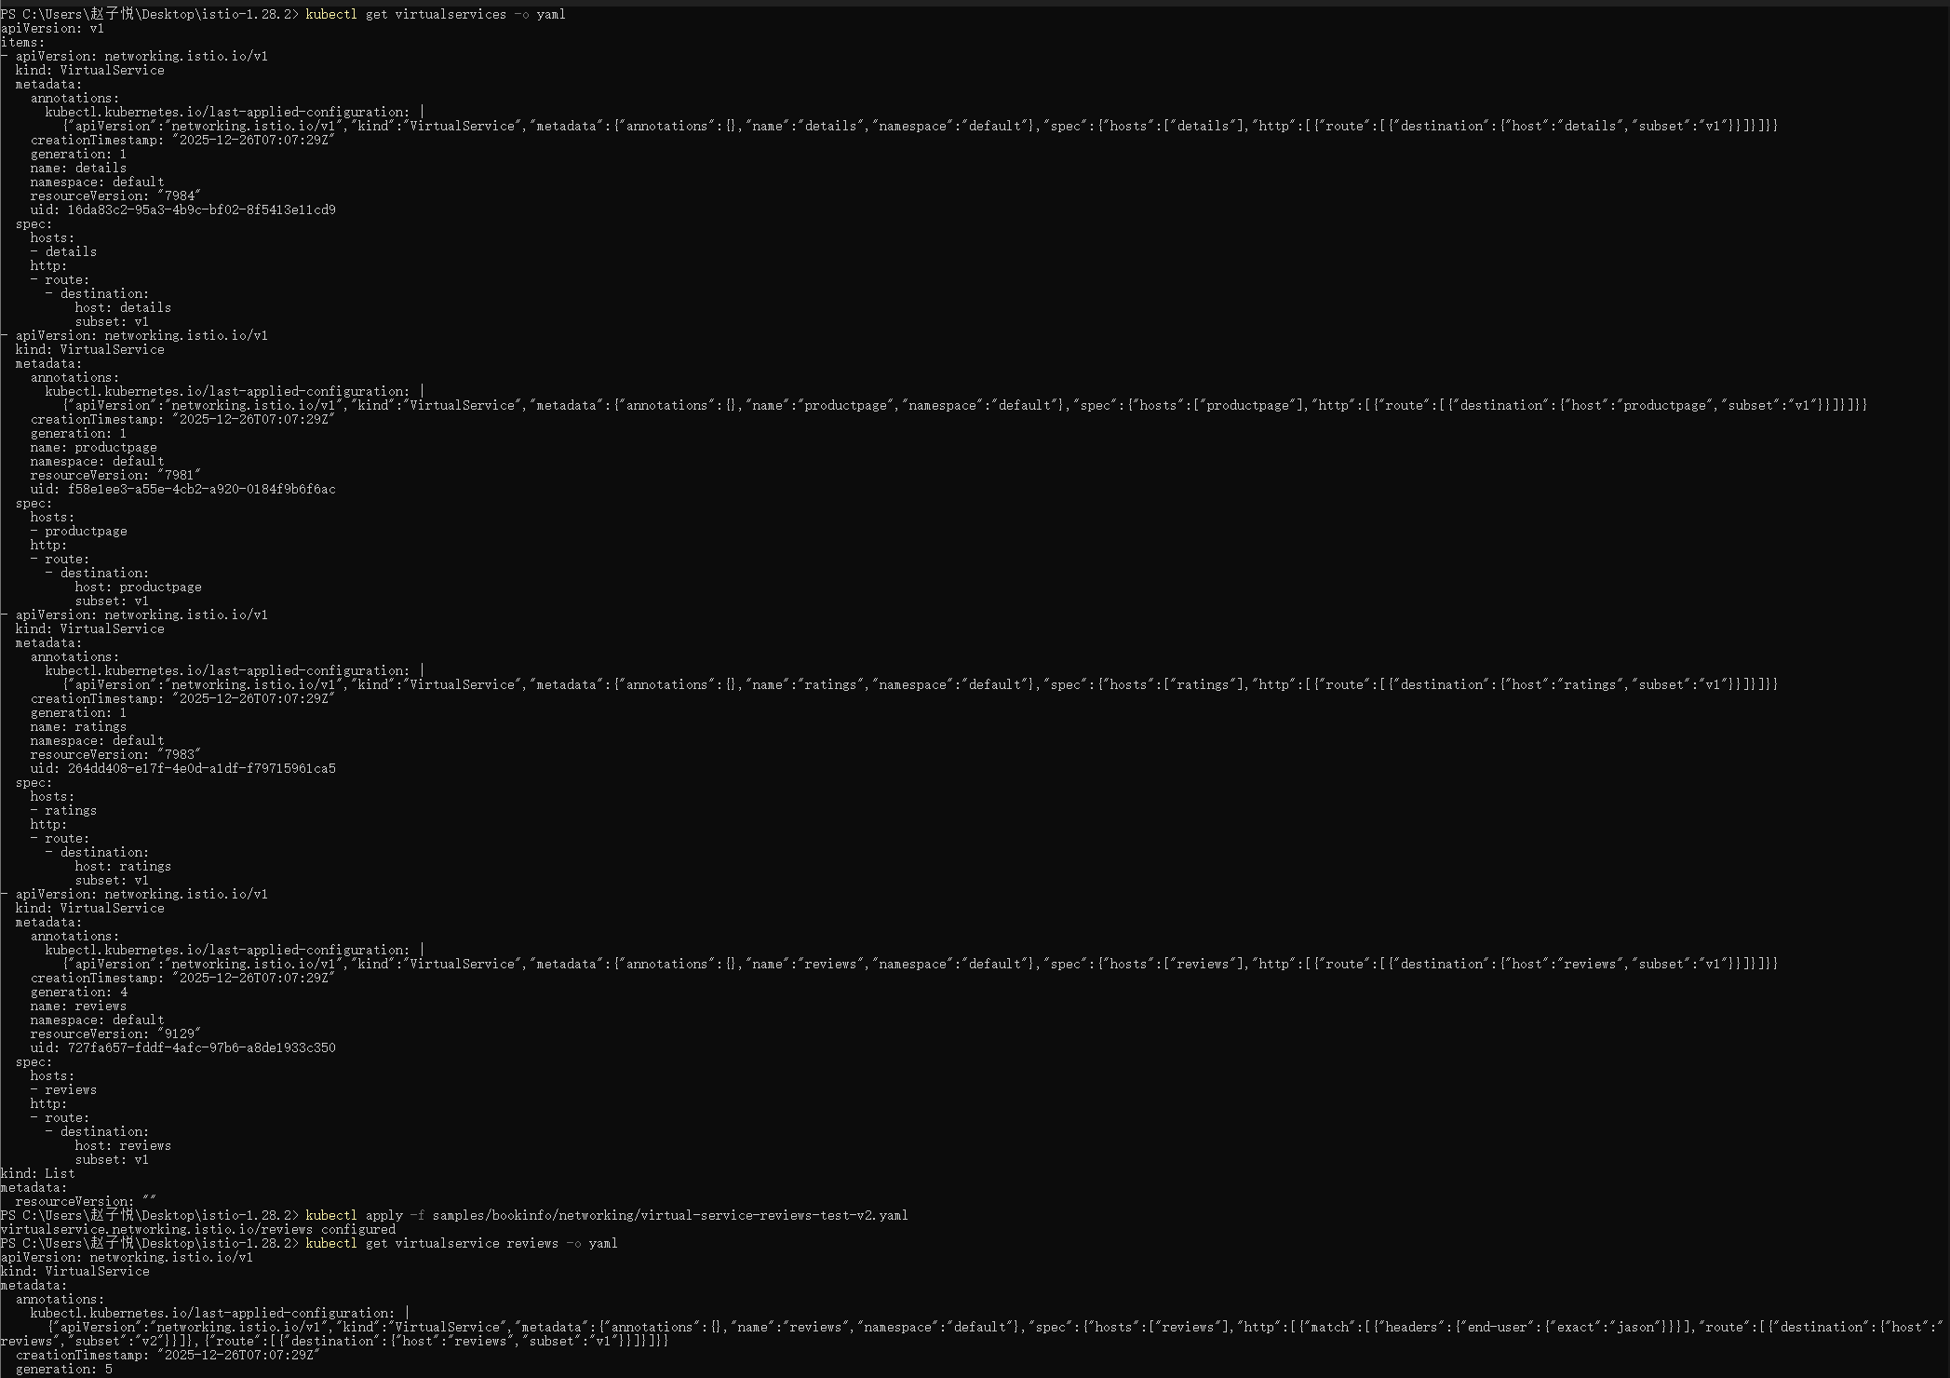
- You can easily test the new configuration by once again refreshing the /productpage of the Bookinfo app in your browser. Notice that the reviews part of the page displays with no rating stars, no matter how many times you refresh. This is because you configured Istio to route all traffic for the reviews service to the version reviews:v1 and this version of the service does not access the star ratings service.

4.Run the following command to enable user-based routing,remember, reviews:v2 is the version that includes the star ratings feature.
You can confirm the rule is created using the following command:
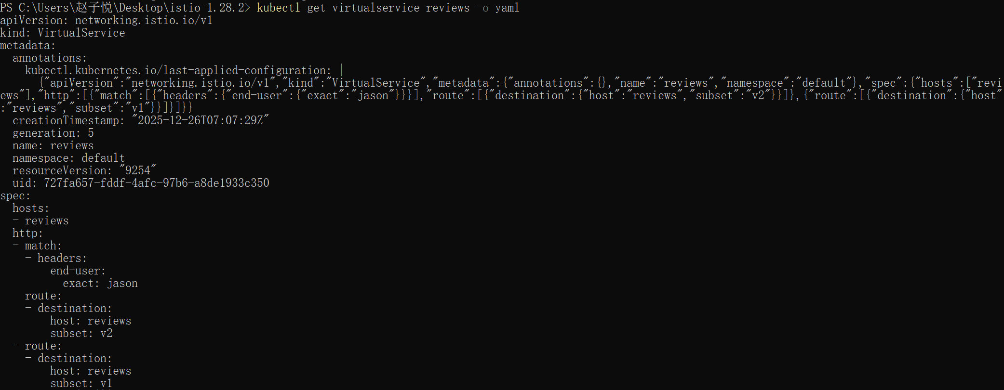
5.On the /productpage of the Bookinfo app, log in as user jason.
Refresh the browser. The star ratings appear next to each review.

- Fault-injection
- Create a fault injection rule to delay traffic coming from the test user jason.
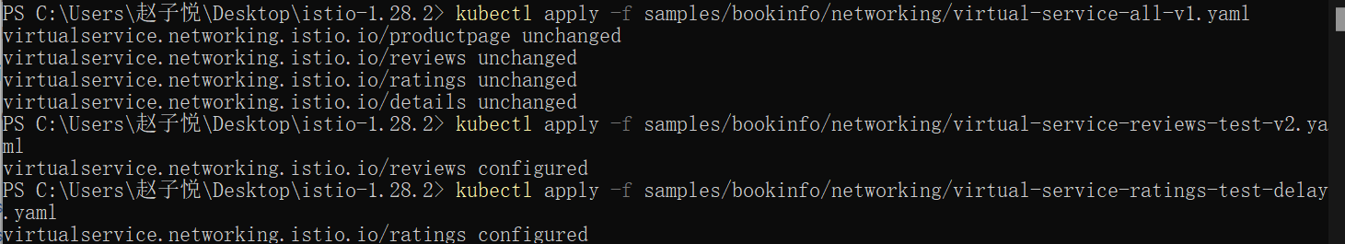
- Confirm the rule was created:
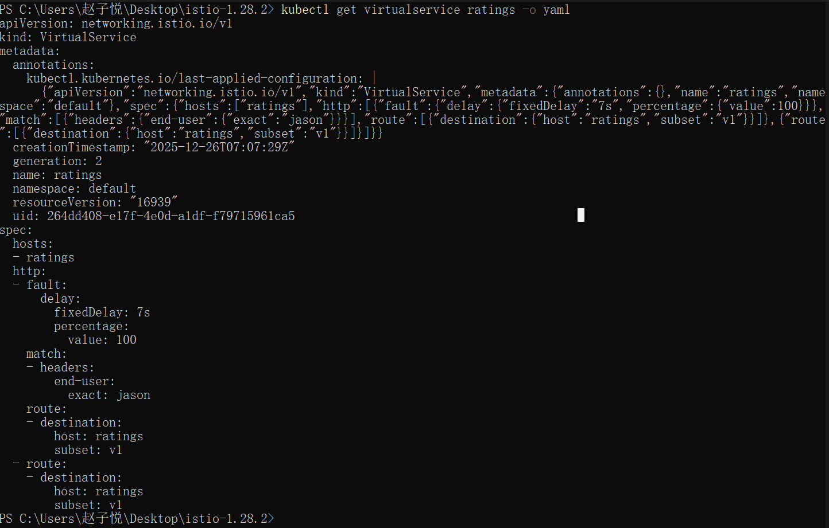
- Open the Bookinfo web application in your browser.On the /productpage web page, log in as user jason.There is a problem: the Reviews section displays an error message:
Injecting an HTTP abort fault
- Create a fault injection rule to send an HTTP abort for user jason:
- Confirm the rule was created:
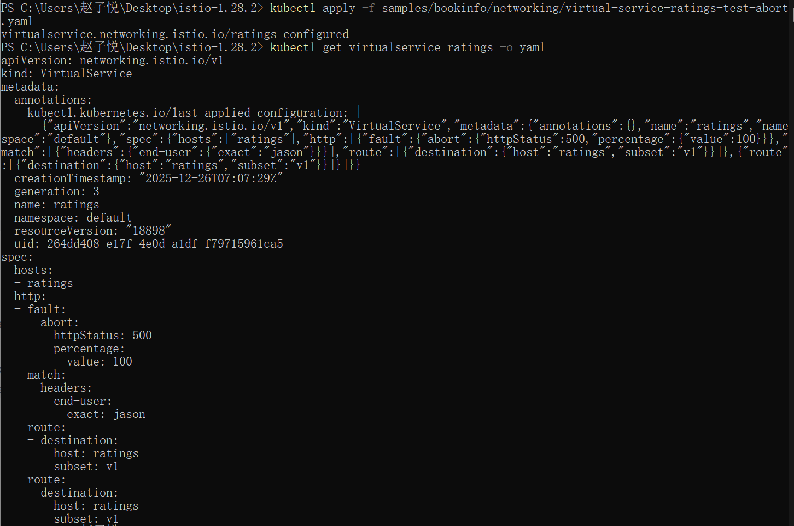
The “Ratings service is currently unavailable” message appears.
- Circuit breaking
- Create a destination rule to apply circuit breaking settings when calling the httpbin service:
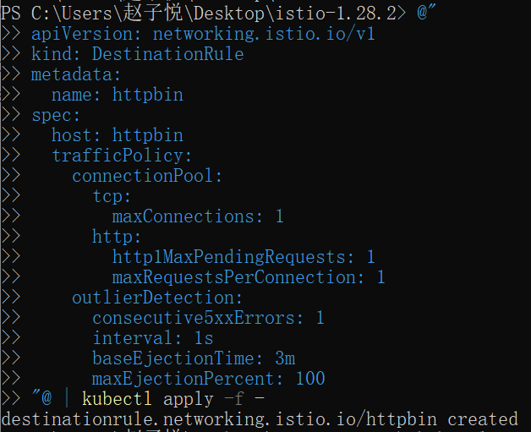
2.Verify the destination rule was created correctly:
