Lab10

A.Installation and Configuration of KServe

3.1.1 Prerequisites Verification
Before installing KServe, we verified the following prerequisites were properly configured:
- Kubernetes cluster (v1.22+) running and accessible
- Knative Serving (v0.26+) installed and functional
- Istio (v1.17+) or Kourier installed as the ingress gateway
- Cert-Manager (v1.9+) for TLS certificate management

KServe InstallationFollowing the official documentation, we installed KServe using the following commands:

Inference Service Deployment
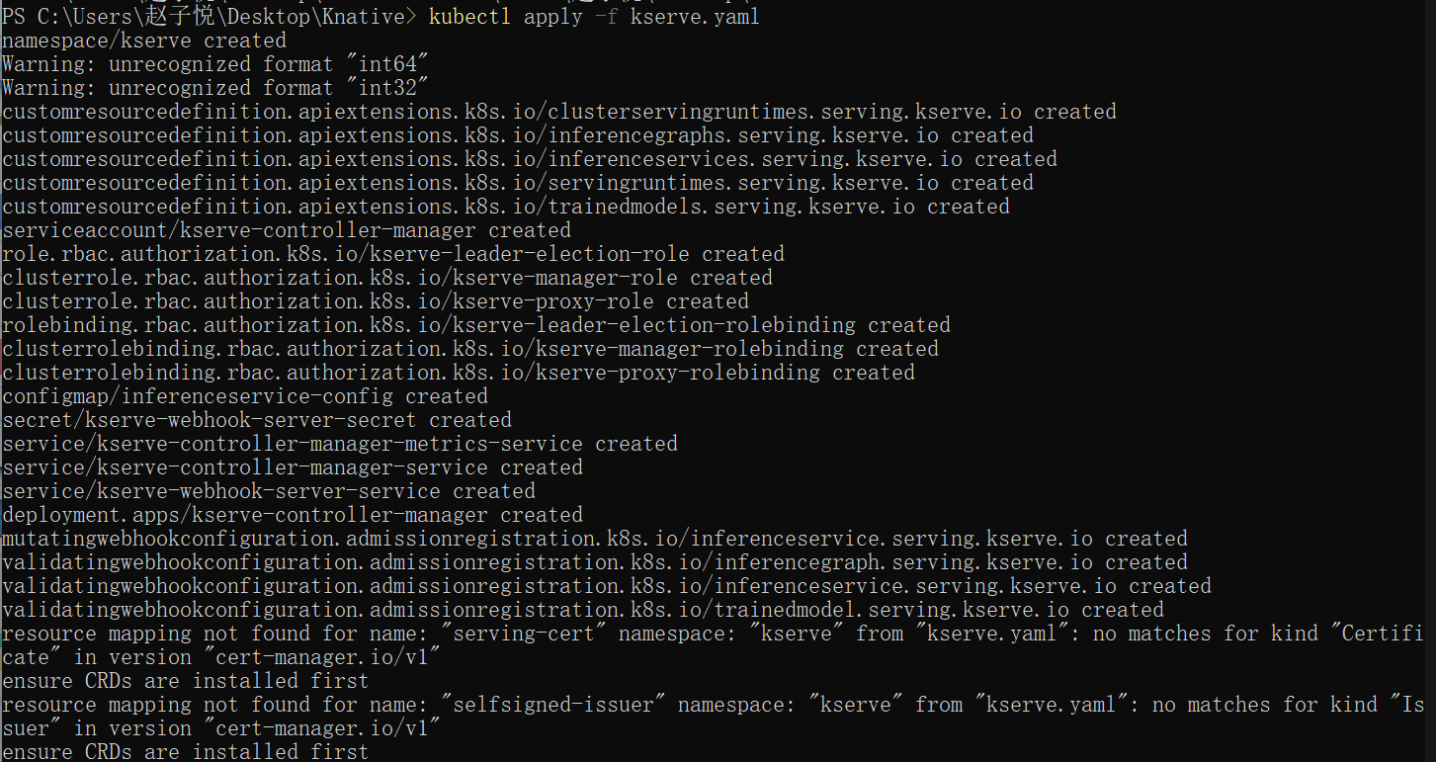
Namespace Preparation
Deploying a Sample Model
Deployed a pre-trained sklearn model using the provided YAML configuration:

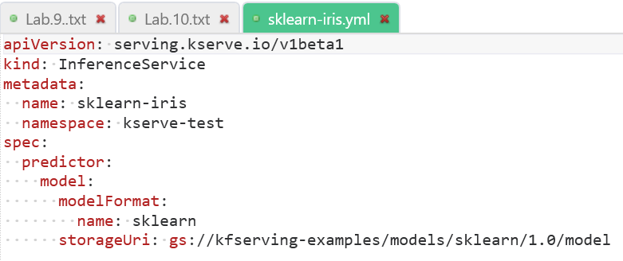
Applied the configuration:

#### **3.2.3 Monitoring Deployment Progress**
Monitored the deployment status:
```bash
# Check inference service status
kubectl get inferenceservice sklearn-iris -n kserve-test

# Watch pod creation and initialization
kubectl get pods -n kserve-test --watch

# Check detailed status
kubectl describe inferenceservice sklearn-iris -n kserve-test
```

### **3.3 Testing the Inference Service**

#### **3.3.1 Determining the Inference URL**
Extracted the service endpoint:
```bash
# Get the inference URL
SERVICE_HOSTNAME=$(kubectl get inferenceservice sklearn-iris -n kserve-test -o jsonpath='{.status.url}' | cut -d "/" -f 3)

# For local testing, port-forward the ingress gateway
kubectl port-forward --namespace istio-system svc/istio-ingressgateway 8080:80
```

#### **3.3.2 Sending Inference Requests**
Created a sample request payload (`iris-input.json`):
```json
{
"instances": [
[6.8, 2.8, 4.8, 1.4],
[6.0, 3.4, 4.5, 1.6]
]
}
```

Sent inference requests:
```bash
# Send prediction request
curl -v -H "Host: ${SERVICE_HOSTNAME}" \
-H "Content-Type: application/json" \
http://localhost:8080/v1/models/sklearn-iris:predict \
-d @iris-input.json
```

#### **3.3.3 Testing with Different Protocols**
Tested gRPC and REST endpoints:
```bash
# REST endpoint test
curl -v http://sklearn-iris.kserve-test.example.com/v1/models/sklearn-iris:predict \
-d '{"instances": [[5.1, 3.5, 1.4, 0.2]]}'

# gRPC endpoint test (if configured)
# Using grpcurl for testing
grpcurl -plaintext -d '{"model_name": "sklearn-iris", "inputs": [...]}' \
sklearn-iris.kserve-test.example.com:443 \
inference.GRPCInferenceService.ModelInfer
```

### **3.4 Additional Model Format Deployments**

#### **3.4.1 PyTorch Model Deployment**
Deployed a PyTorch model example:
```yaml
apiVersion: serving.kserve.io/v1beta1
kind: InferenceService
metadata:
name: torchserve-cifar10
namespace: kserve-test
spec:
predictor:
pytorch:
storageUri: gs://kfserving-examples/models/torchserve/cifar10
```

#### **3.4.2 TensorFlow Model Deployment**
Deployed a TensorFlow SavedModel:
```yaml
apiVersion: serving.kserve.io/v1beta1
kind: InferenceService
metadata:
name: tensorflow-mnist
namespace: kserve-test
spec:
predictor:
tensorflow:
storageUri: gs://kfserving-examples/models/tensorflow/mnist
```

### **3.5 Advanced Configuration Tests**

#### **3.5.1 Autoscaling Configuration**
Configured Knative-based autoscaling for the inference service:
```yaml
apiVersion: serving.kserve.io/v1beta1
kind: InferenceService
metadata:
name: sklearn-iris-autoscale
spec:
predictor:
model:
modelFormat:
name: sklearn
storageUri: gs://kfserving-examples/models/sklearn/1.0/model
minReplicas: 1
maxReplicas: 10
scaleTarget: 50
scaleMetric: concurrency
```

#### **3.5.2 Canary Rollout Testing**
Implemented a canary rollout strategy:
```yaml
apiVersion: serving.kserve.io/v1beta1
kind: InferenceService
metadata:
name: sklearn-iris-canary
spec:
predictor:
canaryTrafficPercent: 20
model:
modelFormat:
name: sklearn
storageUri: gs://kfserving-examples/models/sklearn/2.0/model
```

### **3.6 Performance Testing**

#### **3.6.1 Load Testing**
Conducted performance testing using Apache Bench:
```bash
# Run load test
ab -n 1000 -c 10 -p iris-input.json -T "application/json" \
-H "Host: ${SERVICE_HOSTNAME}" \
http://localhost:8080/v1/models/sklearn-iris:predict
```

#### **3.6.2 Latency Measurements**
Measured inference latency:
```bash
# Single request timing
time curl -s -H "Host: ${SERVICE_HOSTNAME}" \
-H "Content-Type: application/json" \
http://localhost:8080/v1/models/sklearn-iris:predict \
-d @iris-input.json > /dev/null
```

### **3.7 Monitoring and Observability**

#### **3.7.1 Metrics Collection**
Configured Prometheus monitoring:
```bash
# Check KServe metrics endpoint
kubectl port-forward deployment/kserve-controller-manager -n kserve-system 9090:9090
curl http://localhost:9090/metrics
```

#### **3.7.2 Logging Configuration**
Accessed inference service logs:
```bash
# Get logs from inference service pods
kubectl logs -l serving.kserve.io/inferenceservice=sklearn-iris -n kserve-test -c kserve-container
```

### **3.8 Troubleshooting Procedures**

#### **3.8.1 Common Issue Resolution**
Addressed frequent deployment issues:
```bash
# Check for pod failures
kubectl get pods -n kserve-test --field-selector=status.phase!=Running

# Describe failing pods
kubectl describe pod <failing-pod-name> -n kserve-test

# Check events
kubectl get events -n kserve-test --sort-by=.metadata.creationTimestamp
```

#### **3.8.2 Network Configuration**
Verified network connectivity and ingress configuration:
```bash
# Check ingress gateway
kubectl get svc -n istio-system istio-ingressgateway

# Verify network policies
kubectl get networkpolicies -n kserve-test
```

### **3.9 Cleanup Procedures**

#### **3.9.1 Resource Deletion**
Removed test resources:
```bash
# Delete inference services
kubectl delete inferenceservice --all -n kserve-test

# Delete namespace
kubectl delete namespace kserve-test

# Optionally uninstall KServe
kubectl delete -f https://github.com/kserve/kserve/releases/download/v0.11.0/kserve.yaml
```

#### **3.9.2 Verification**
Confirmed complete cleanup:
```bash
# Verify all resources removed
kubectl get all -n kserve-test
kubectl get inferenceservice --all-namespaces
```

