Lab9
- Installing knative serving using YAML files
- Install the required custom resources by running the command:
- Install the core components of Knative Serving by running the command:
Install a networking layer
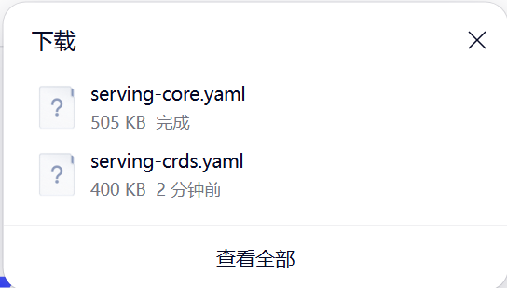
- Install the Knative Kourier controller by running the command:
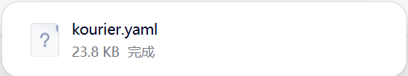
- Configure Knative Serving to use Kourier by default by running the command:
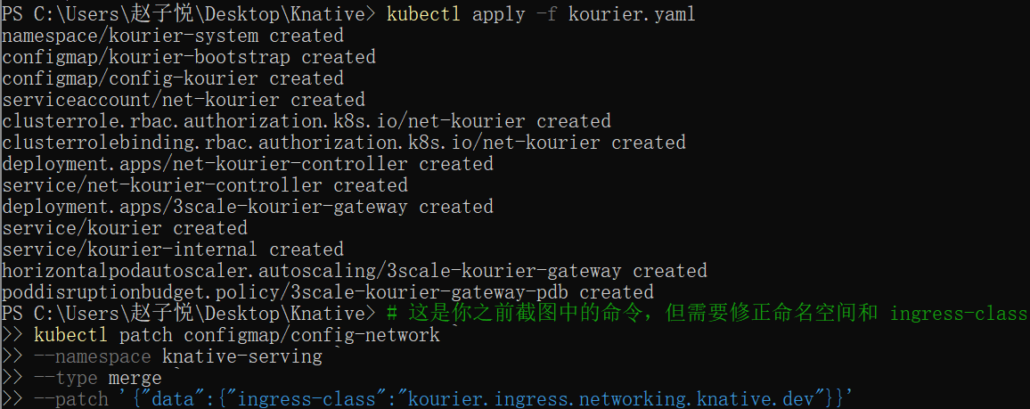
- Fetch the External IP address or CNAME by running the command:
- Verify the installation
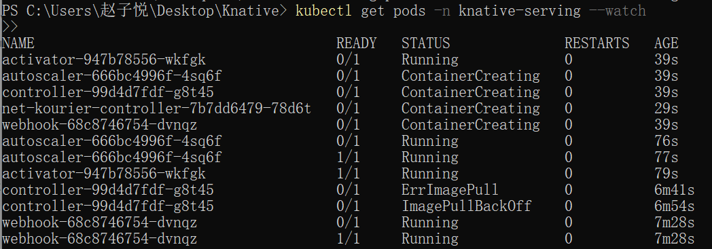
Configure DNS
- Configure Knative to use a domain reachable from outside the cluster:
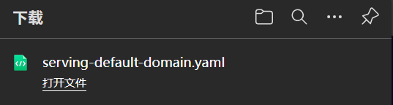
- After starting your application, get the URL of your application:
- Instruct curl to connect to the External IP or CNAME defined by the networking layer mentioned in section 3, and use the -H "Host:" command-line option to specify the Knative application's host name. For example, if the networking layer defines your External IP and port to be http://192.168.39.228:32198 and you wish to access the helloworld-go application mentioned earlier, use:
Install optional Serving extensions
- Install the components needed to support HPA-class autoscaling by running the command:
- Installing Knative Eventing using YAML files
Install the Knative Eventing component
- Install the required custom resource definitions (CRDs) by running the command:
- Install the core components of Eventing by running the command:
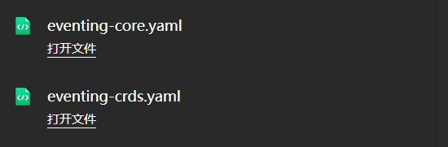
- Verify the installation
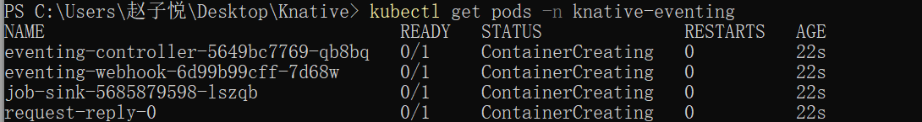
Install optional Eventing extensions
- Install the Kafka controller by running the command:
- Install the Kafka Sink data plane by running the command:
