GitHub Link:

MiniBank Project:
Solution:
MiniBank.java:
package MiniBank;

import MiniBank.src.exception.InvalidAmountException;
import MiniBank.src.exception.InsufficientFundsException;
import MiniBank.src.exception.BankException;
import java.io.Serializable;
import java.util.ArrayList;
import java.util.Comparator;
import java.util.LinkedHashMap;
import java.util.List;
import java.util.Map;
import java.util.Scanner;
import java.util.concurrent.ConcurrentHashMap;
import MiniBank.src.model.Account;
import MiniBank.src.model.SavingsAccount;
import MiniBank.src.model.CurrentAccount;
import MiniBank.src.model.FixedDepositAccount;
import MiniBank.src.model.annotation.MaxLength;
import java.io.IOException;
import java.nio.file.Path;
import java.util.Arrays;
import MiniBank.src.util.StatePersister;
import MiniBank.src.service.BankService;
import MiniBank.src.util.Repository;
import MiniBank.src.exception.AccountNotFoundException;
import MiniBank.src.util.ReportGenerator;
import MiniBank.src.util.TransactionLog;

record BankInfo(String name, String branch) {
}

enum MenuOption {
OPEN_ACCOUNT, DEPOSIT, WITHDRAW, TRANSFER, REPORT, EXIT
}

enum TransactionType {
DEPOSIT, WITHDRAW, TRANSFER
}

record Command(TransactionType type, String accountNumber, long amount) {
}

interface Transactable {
void deposit(long amount);

boolean withdraw(long amount);
}

interface InterestBearing {
double interestRate();

default double yearlyInterest(Account account) {
return account.getBalance() * interestRate();
}
}

@FunctionalInterface
interface WithdrawRule {
boolean allow(Account account, long amount);
}

interface Premium {
}

class Customer implements Cloneable, Serializable {
private static final long serialVersionUID = 1L;
private static long customerCounter = 100;

private final String customerId;

@MaxLength(100)
private final String name;

@MaxLength(150)
private final String email;

private final String mobile;
private Address address;

public Customer(String name, String email, String mobile) {
this(name, email, mobile, null);
}

public Customer(String name, String email, String mobile, Address address) {
synchronized (Customer.class) {
this.customerId = "CUST" + (++customerCounter);
}
this.name = name;
this.email = email;
this.mobile = mobile;
this.address = address;
}

public String getCustomerId() {
return customerId;
}

public String getName() {
return name;
}

public String getEmail() {
return email;
}

public String getMobile() {
return mobile;
}

public Address getAddress() {
return address;
}

@Override
public Customer clone() {
try {
Customer copy = (Customer) super.clone();

if (address != null) {
copy.address = new Address(
address.getLine(),
address.getCity(),
address.getPincode());
}

return copy;
} catch (CloneNotSupportedException e) {
throw new AssertionError(e);
}
}

public static class Address implements Serializable {
private static final long serialVersionUID = 1L;

private final String line;
private final String city;
private final String pincode;

public Address(String line, String city, String pincode) {
this.line = line;
this.city = city;
this.pincode = pincode;
}

public String getLine() {
return line;
}

public String getCity() {
return city;
}

public String getPincode() {
return pincode;
}
}
}

public class MiniBank {
private static final BankInfo BANK = new BankInfo("MiniBank", "Main Branch");

private static final Scanner SCANNER = new Scanner(System.in);

private static final Map<String, Account> ACCOUNTS = new ConcurrentHashMap<>();

private static final List<String> TRANSACTION_HISTORY = new ArrayList<>();

private static final Repository<Account> REPOSITORY = new Repository<>();

private static final BankService BANK_SERVICE = new BankService(REPOSITORY);

private static final Path ACCOUNT_FILE = Path.of("MiniBank", "data", "accounts.dat");

public static void main(String[] args) {
System.out.println("================================");
System.out.println(BANK);
System.out.println("================================");

loadAccounts();

boolean running = true;

while (running) {
displayMenu();
Integer choice = readInt("Enter your choice: ");

if (choice == null) {
continue;
}

MenuOption option = switch (choice) {
case 1 -> MenuOption.OPEN_ACCOUNT;
case 2 -> MenuOption.DEPOSIT;
case 3 -> MenuOption.WITHDRAW;
case 4 -> MenuOption.TRANSFER;
case 5 -> MenuOption.REPORT;
case 6 -> MenuOption.EXIT;
default -> null;
};

if (option == null) {
System.out.println("Invalid choice. Select 1 to 5.");
continue;
}

switch (option) {
case OPEN_ACCOUNT -> openAccount();
case DEPOSIT -> deposit();
case WITHDRAW -> withdraw();
case TRANSFER -> transfer();
case REPORT -> generateReport();
case EXIT -> {
saveAccounts();
running = false;
System.out.println("Thank you for using MiniBank. Goodbye!");
}
}
}
}

private static void displayMenu() {
System.out.println();
System.out.println("1. Open Account");
System.out.println("2. Deposit");
System.out.println("3. Withdraw");
System.out.println("4. Transfer");
System.out.println("5. Generate Report");
System.out.println("6. Exit");
}

private static Integer readInt(String prompt) {
System.out.print(prompt);
String input = SCANNER.nextLine().trim();

try {
return Integer.parseInt(input);
} catch (NumberFormatException e) {
System.out.println("Please enter a valid whole number.");
return null;
}
}

private static Long readLong(String prompt) {
System.out.print(prompt);
String input = SCANNER.nextLine().trim();

try {
return Long.parseLong(input);
} catch (NumberFormatException e) {
System.out.println(
"Please enter a valid whole-number amount.");
return null;
}
}

private static void openAccount() {
System.out.print("Owner name: ");
String name = SCANNER.nextLine().trim();

if (name.isEmpty()) {
System.out.println("Owner name cannot be empty.");
return;
}

System.out.println("1. Savings Account");
System.out.println("2. Current Account");
System.out.println("3. Fixed Deposit Account");

Integer type = readInt("Choose account type: ");
if (type == null) {
return;
}

Long balance = readLong("Opening balance: Rs. ");
if (balance == null || balance < 0) {
System.out.println("Opening balance cannot be negative.");
return;
}

try {
Account account = BANK_SERVICE.openAccount(name, balance, type);

ACCOUNTS.put(account.getAccountNumber(), account);
TRANSACTION_HISTORY.add(
"OPEN " + account.getAccountNumber() + " " + balance);

System.out.println("Account created successfully.");
System.out.println(account);

} catch (InvalidAmountException | IllegalArgumentException e) {
System.out.println("Account creation failed: " + e.getMessage());
}
}

private static Account findAccount(String prompt) {
System.out.print(prompt);
String accountNumber = SCANNER.nextLine().trim();

Account account = ACCOUNTS.get(accountNumber);

if (account == null) {
System.out.println("Account not found.");
}

return account;
}

private static void deposit() {
Account account = findAccount("Account number: ");
if (account == null) {
return;
}

Long amount = readLong("Deposit amount: Rs. ");
if (amount == null) {
return;
}

try {
BANK_SERVICE.deposit(account.getAccountNumber(), amount);

TRANSACTION_HISTORY.add(
"DEPOSIT " + account.getAccountNumber() + " " + amount);

logTransaction("DEPOSIT " + account.getAccountNumber() + " " + amount
);

System.out.println("Deposit successful.");
System.out.println(account);

} catch (AccountNotFoundException | InvalidAmountException e) {
System.out.println("Deposit failed: " + e.getMessage());
}
}

private static void withdraw() {
Account account = findAccount("Account number: ");
if (account == null) {
return;
}

Long amount = readLong("Withdrawal amount: Rs. ");
if (amount == null) {
return;
}

try {
BANK_SERVICE.withdraw(account.getAccountNumber(), amount);

TRANSACTION_HISTORY.add(
"WITHDRAW " + account.getAccountNumber() + " " + amount);

logTransaction("WITHDRAW " + account.getAccountNumber() + " " + amount
);

System.out.println("Withdrawal successful.");
System.out.println(account);

} catch (AccountNotFoundException
| InvalidAmountException
| InsufficientFundsException e) {
System.out.println("Withdrawal failed: " + e.getMessage());
}
}

private static void transfer() {
Account source = findAccount("Source account number: ");
if (source == null) {
return;
}

Account destination = findAccount("Destination account number: ");
if (destination == null) {
return;
}

Long amount = readLong("Transfer amount: Rs. ");
if (amount == null) {
return;
}

try {
BANK_SERVICE.transfer(
source.getAccountNumber(),
destination.getAccountNumber(),
amount);

TRANSACTION_HISTORY.add(
"TRANSFER " + source.getAccountNumber() + " "
+ destination.getAccountNumber() + " " + amount);

logTransaction("TRANSFER " + source.getAccountNumber() + " " +destination.getAccountNumber() + " " + amount);

System.out.println("Transfer successful.");
System.out.println(source);
System.out.println(destination);

} catch (AccountNotFoundException
| InvalidAmountException
| InsufficientFundsException e) {
System.out.println("Transfer failed: " + e.getMessage());

} catch (IllegalArgumentException e) {
System.out.println("Transfer failed: " + e.getMessage());

} finally {
System.out.println("Transfer operation completed.");
}
}

public static ArrayList<Account> sortedByBalance() {
ArrayList<Account> result = new ArrayList<>(ACCOUNTS.values());
result.sort(Comparator.comparingLong(Account::getBalance));
return result;
}

public static Map<String, Account> getAccounts() {
return new LinkedHashMap<>(ACCOUNTS);
}

public static List<String> getTransactionHistory() {
return new ArrayList<>(TRANSACTION_HISTORY);
}

private static void loadAccounts() {
if (!java.nio.file.Files.exists(ACCOUNT_FILE)) {
System.out.println("No saved accounts found.");
return;
}

try {
Account[] savedAccounts = StatePersister.load(ACCOUNT_FILE);

for (Account account : savedAccounts) {
ACCOUNTS.put(account.getAccountNumber(), account);
REPOSITORY.save(account);
}

Account.updateNextNumber(savedAccounts);

System.out.println("Saved accounts loaded: " + ACCOUNTS.size());

} catch (java.io.IOException | ClassNotFoundException e) {
System.out.println("Could not load saved accounts: " + e.getMessage());
}
}

private static void saveAccounts() {
try {
StatePersister.save(
ACCOUNTS.values().toArray(new Account[0]),
ACCOUNT_FILE);

System.out.println("Accounts saved successfully.");
} catch (java.io.IOException e) {
System.out.println("Could not save accounts: " + e.getMessage());
}
}

private static void generateReport() {
Path logDirectory = Path.of("MiniBank", "logs");
Path reportFile = Path.of(
"MiniBank", "data", "transaction-report.txt");

try {
ReportGenerator.generate(logDirectory, reportFile);
} catch (IOException | ArithmeticException e) {
System.out.println(
"Report generation failed: " + e.getMessage());
}
}

private static void logTransaction(String line) {
Path logFile = Path.of("MiniBank", "logs", "transactions.log");

try {
TransactionLog.append(logFile, line);
} catch (IOException e) {
System.out.println("Could not write transaction log: "
+ e.getMessage());
}
}

}

Account.java:
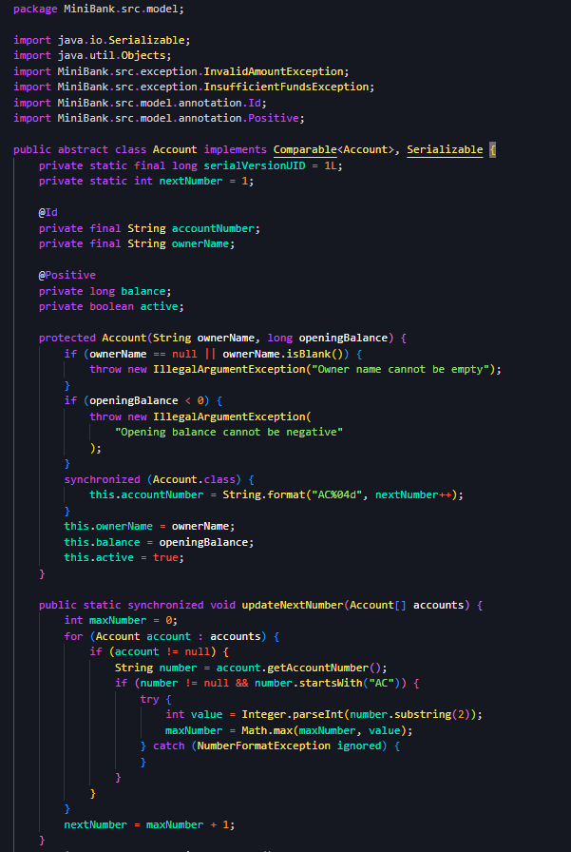
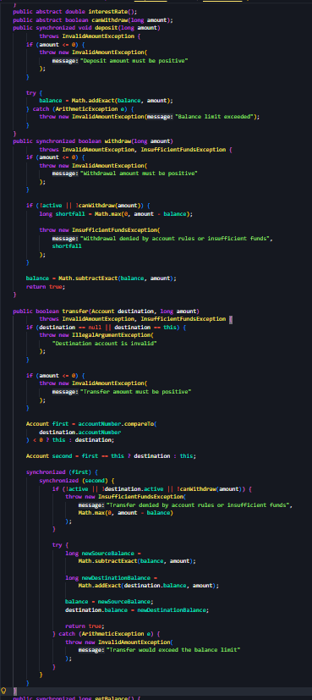
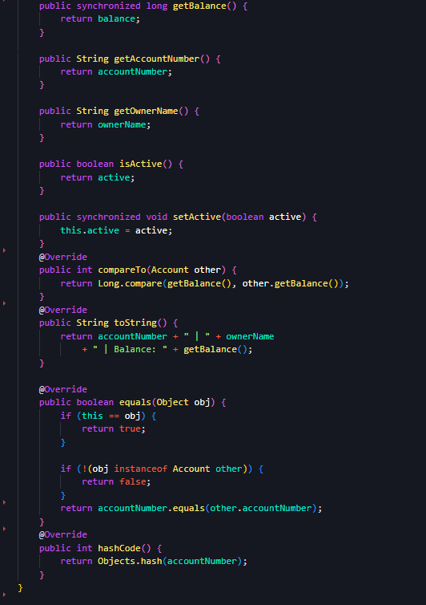
SavingsAccount.java:
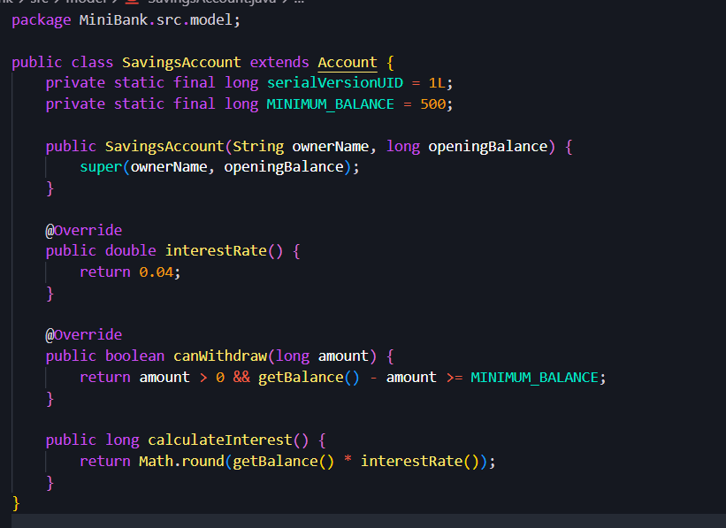
CurrentAccount.java:
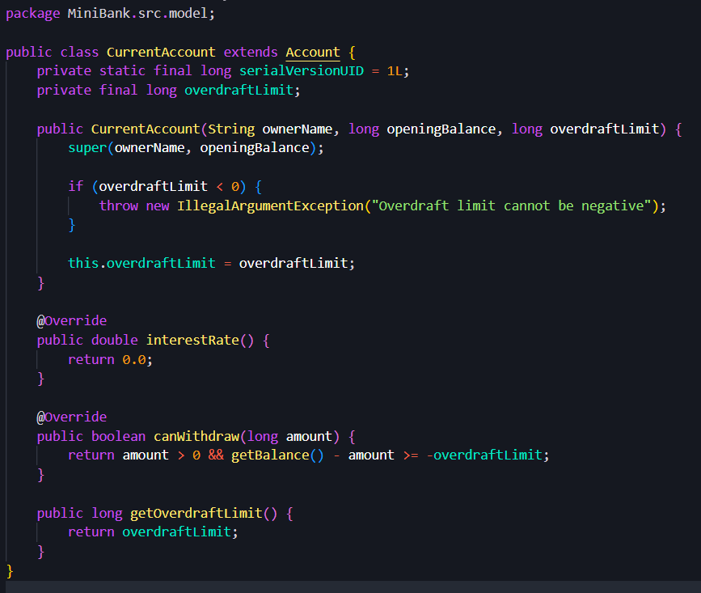
FixedDepositAccount.java:
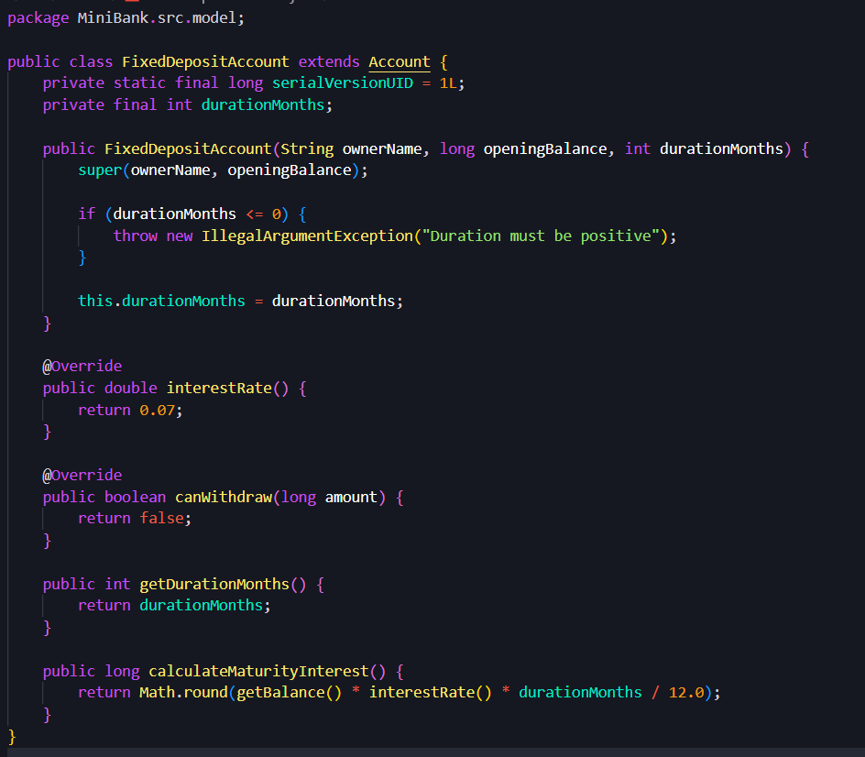
BankService.java:
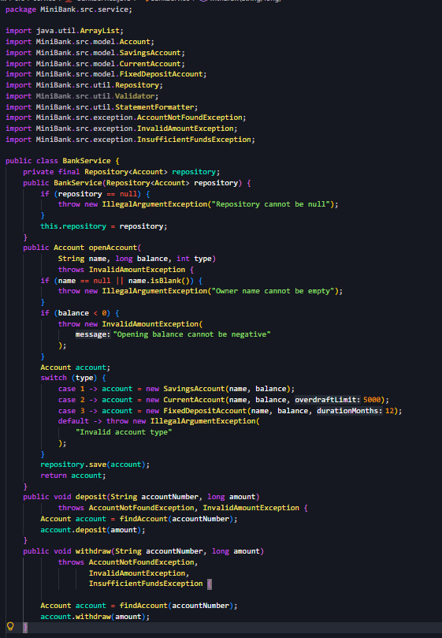
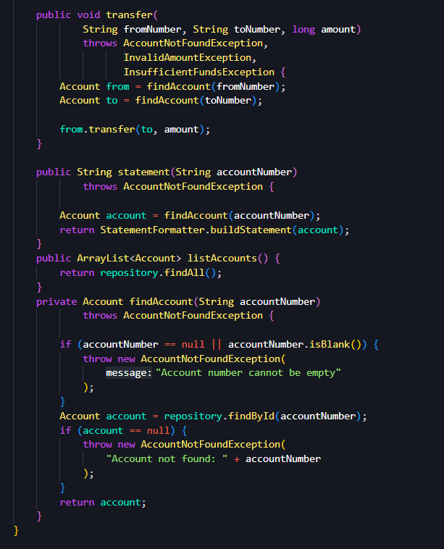
Repository.java:
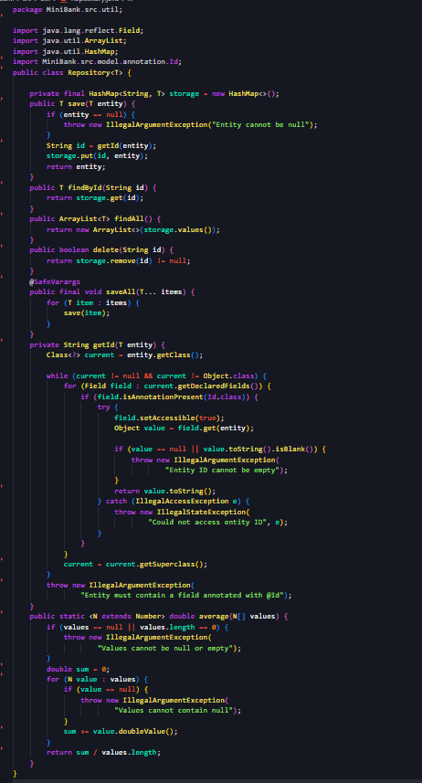
Validator.java:
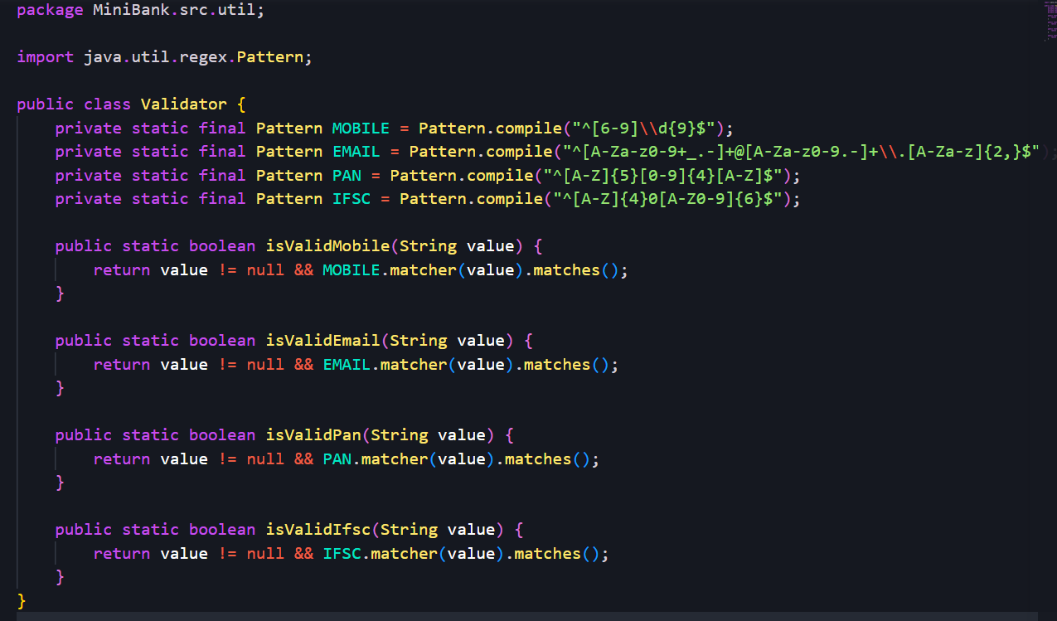
AnnotationValidator.java:
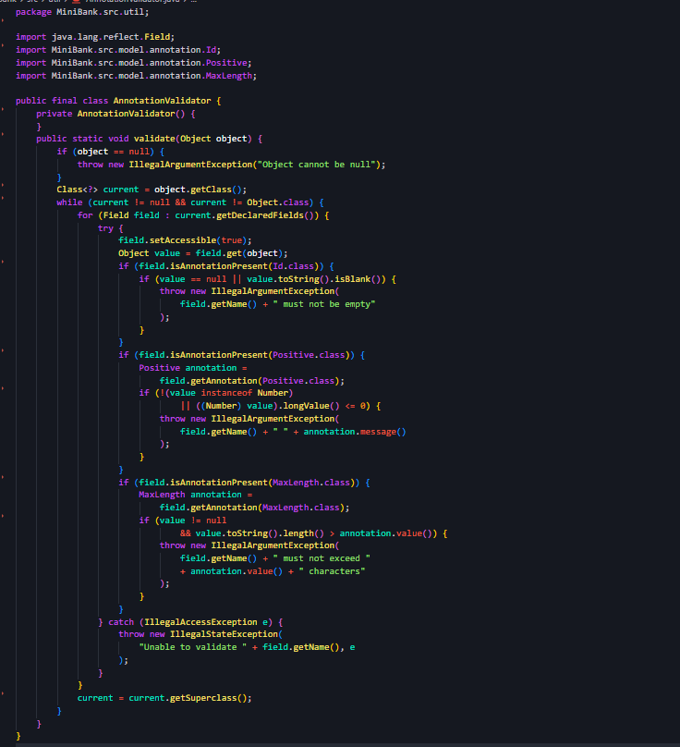
TransactionProcessor.java:
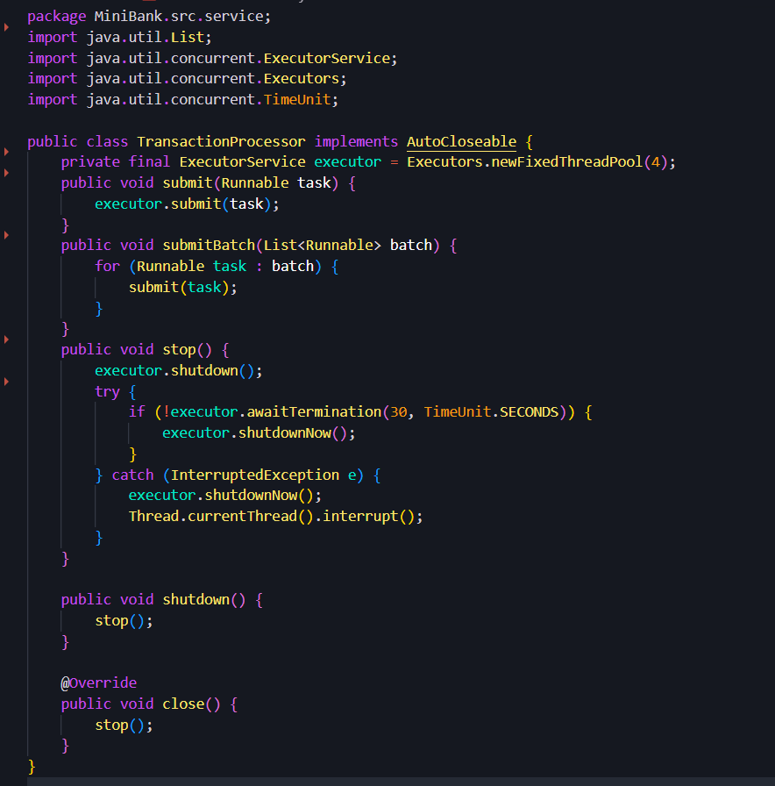
TransactionQueue.java:
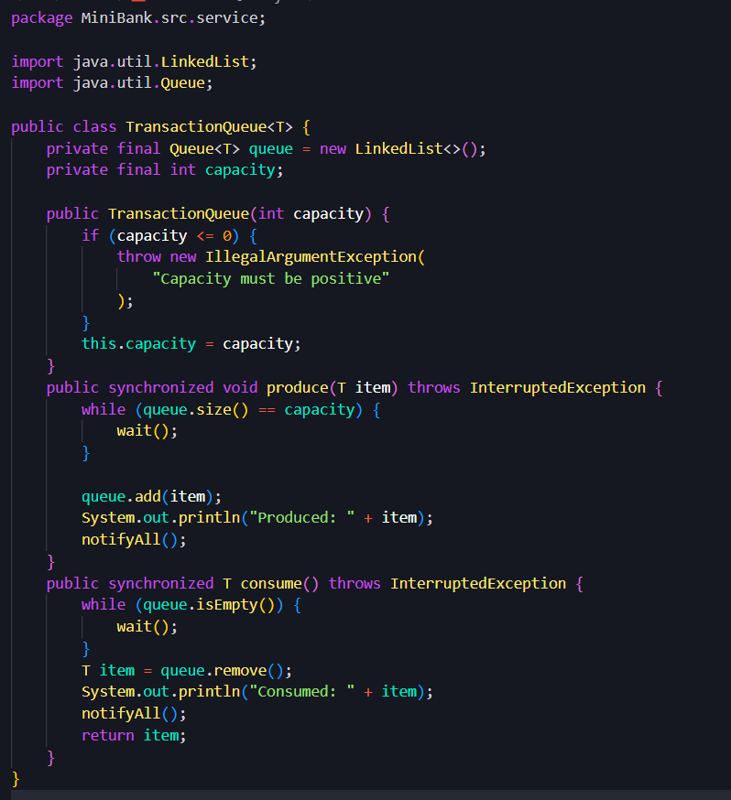
StatePersister.java:
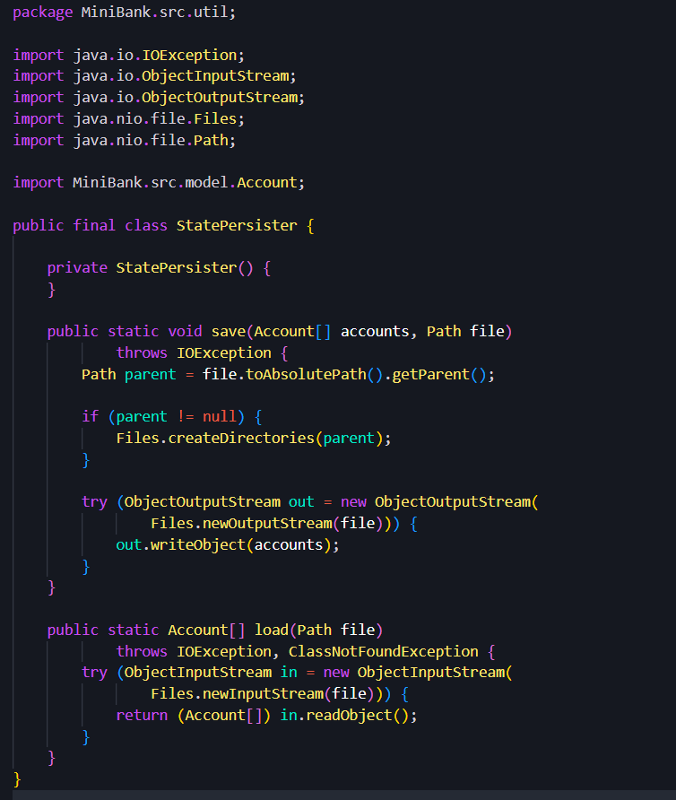
TransactionLog.java:
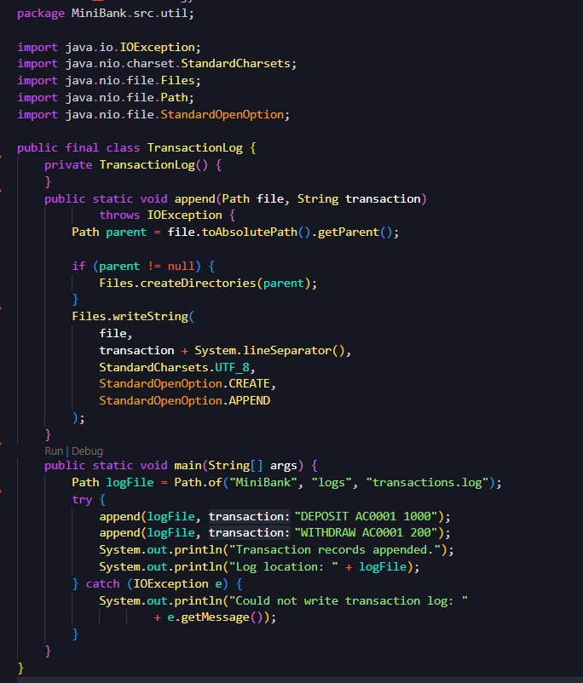
ReportGenerator.java:
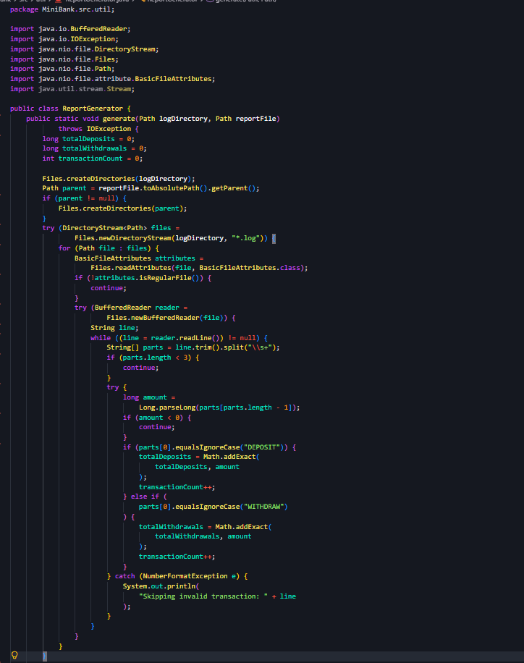
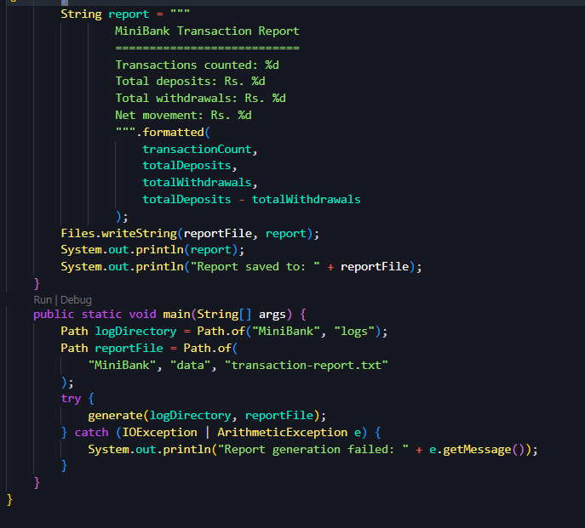
RepositoryJUnitTest.java:
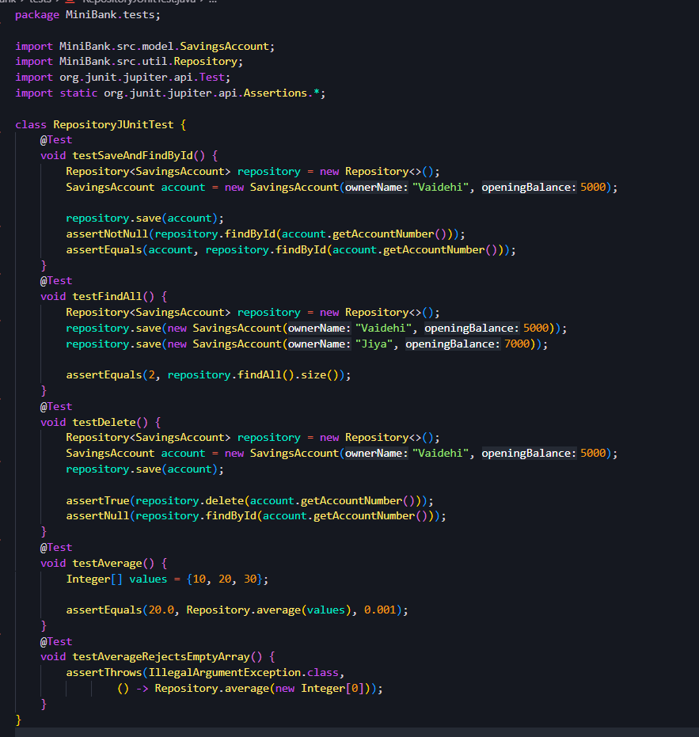

Output:
