PART A:
Problem Definition:
Save/load: make a small class Serializable, save an array of its objects to a file with ObjectOutputStream, then read it back into fresh objects and confirm the values survived. Mark one field transient and show it is not saved.
Solution:
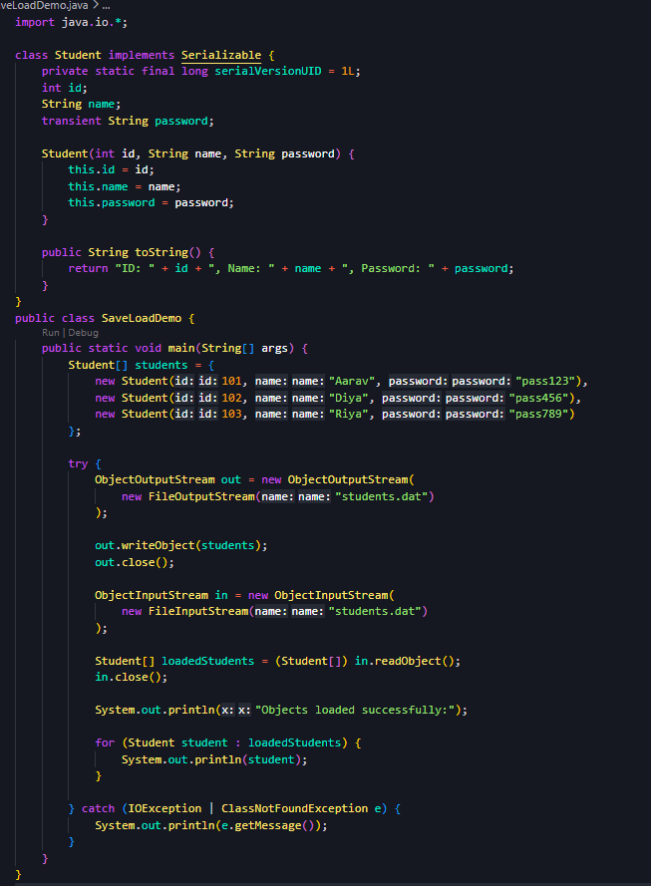
Output:
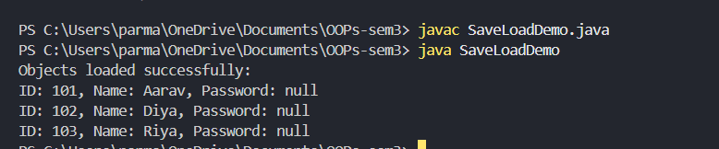
Problem Definition:
Log analyzer: create a few text files, then use Path/Files to read each line by line and count the total lines and how many contain a keyword across all files; also print each file’s size from its attributes.
Solution:
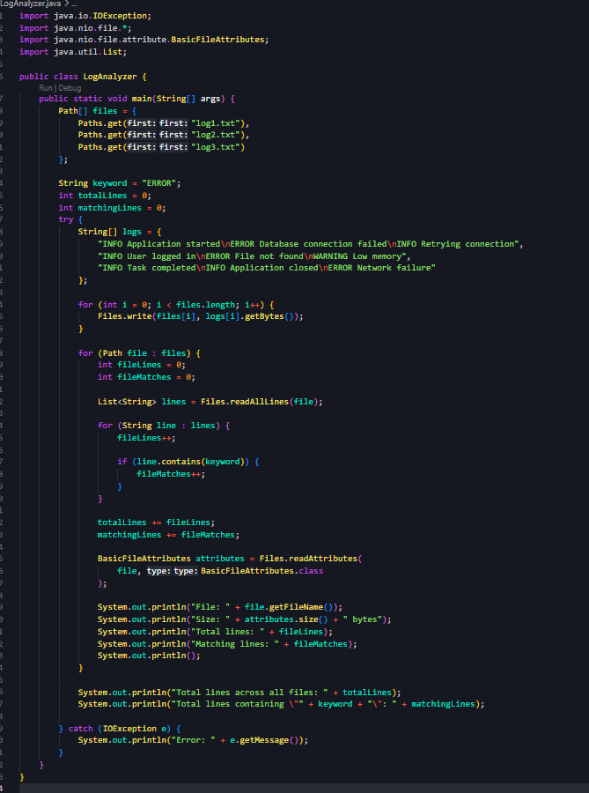
Output:
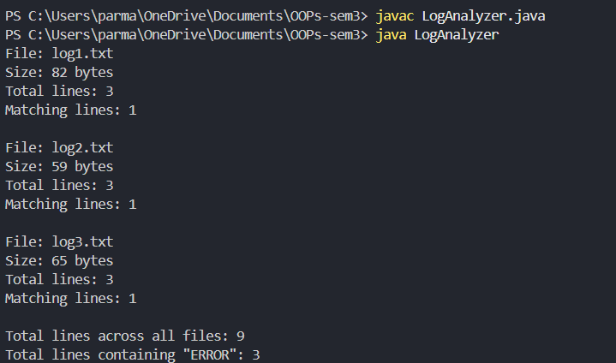
Problem Definition:
Walk a folder tree with NIO and produce a report of the files it contains (name, size, modified time), writing the summary to a file; decide what to include.
Solution:
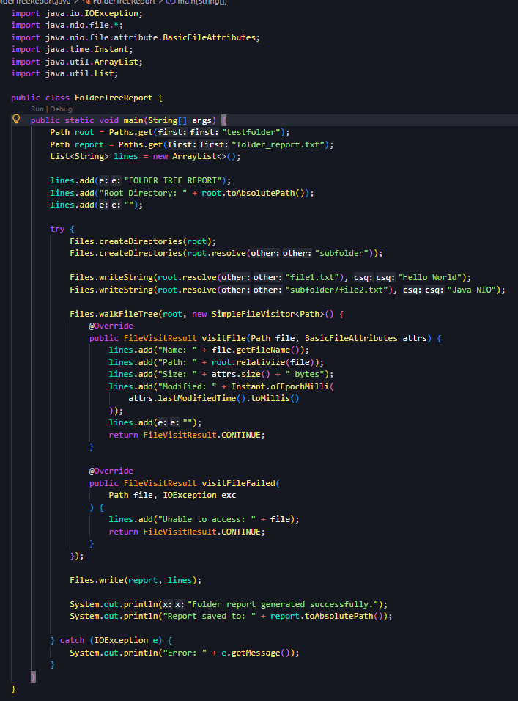
Output:
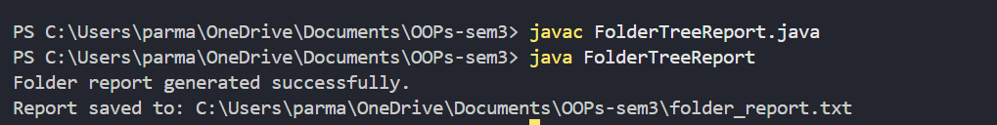
FolderReport.txt:
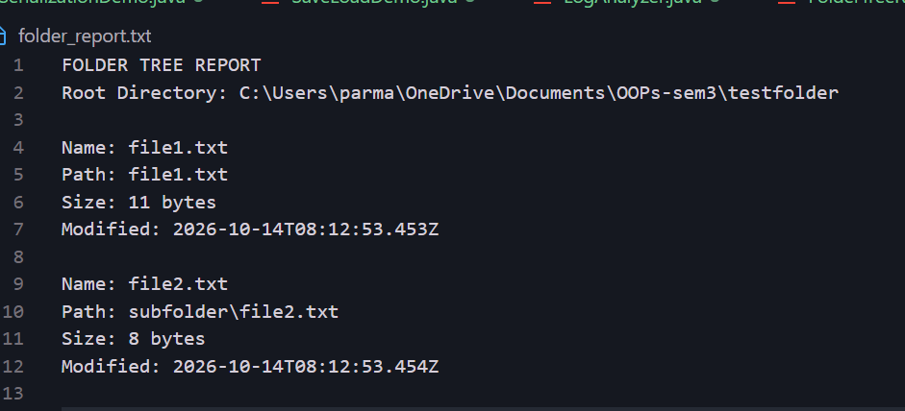
Key Questions / Analysis / Interpretation to be evaluated during/after Implementation

- What does it mean for a class to be Serializable, and why add serialVersionUID?
A class implementing Serializable allows its objects to be saved to a file or transferred as bytes. serialVersionUID identifies the class version during deserialization.
- What is the difference between a byte stream and a character stream?
• Byte stream: Handles raw binary data using InputStream and OutputStream.
• Character stream: Handles text using Reader and Writer.

- How does NIO’s Path/Files API differ from the old File class, and how is a directory stream iterated
Path and Files provide modern file operations, better exception handling, and support for attributes. The older File class offers basic file operations. A directory stream is iterated using a for-each loop over DirectoryStream<Path>.

