PART A:
Problem Definition:
Word frequency: split a paragraph into words, count each in a HashMap, and print the words sorted by frequency (highest first) using a Comparator.
Solution:
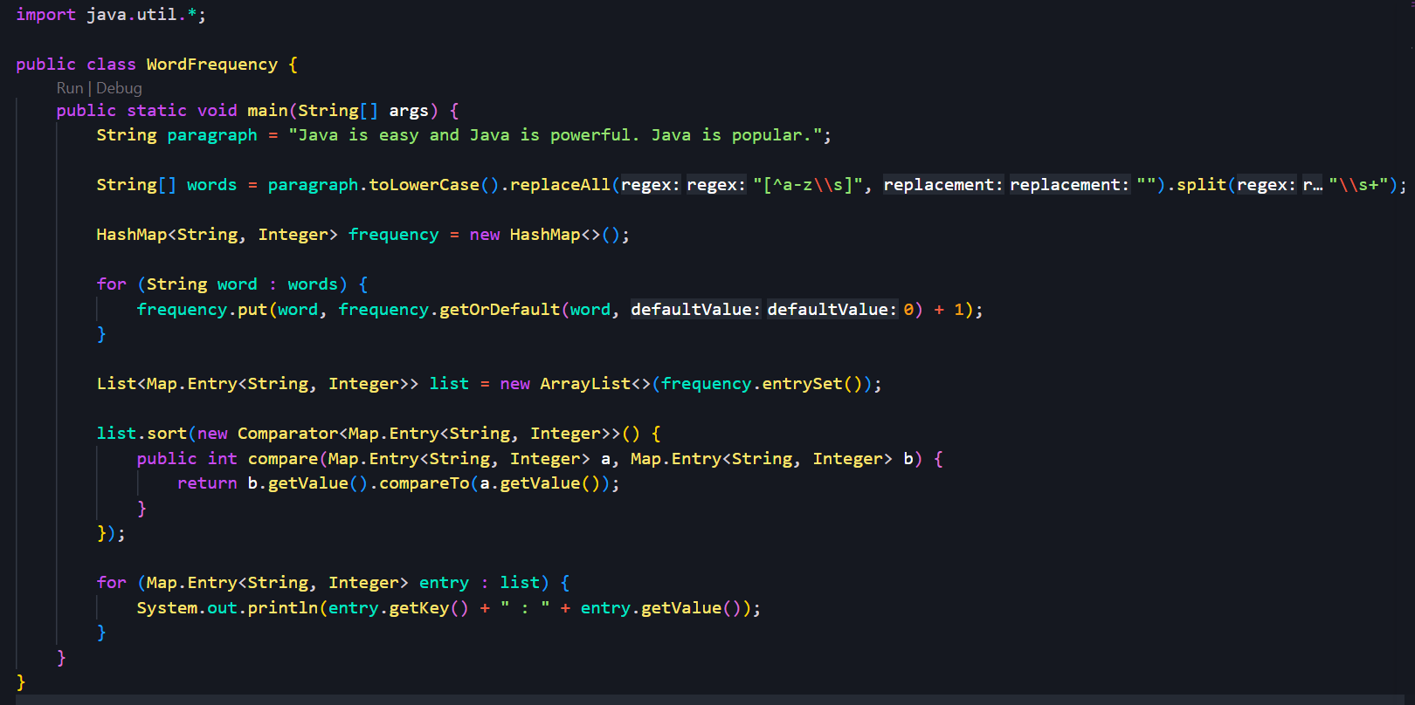
Output:
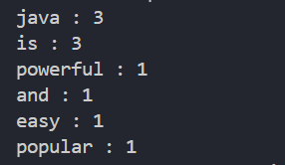
Problem Definition:
Unique visitors: from a list of login names with repeats, use a HashSet to count unique users and a LinkedHashSet to keep first-seen order; print the unique count and the first three distinct names.
Solution:
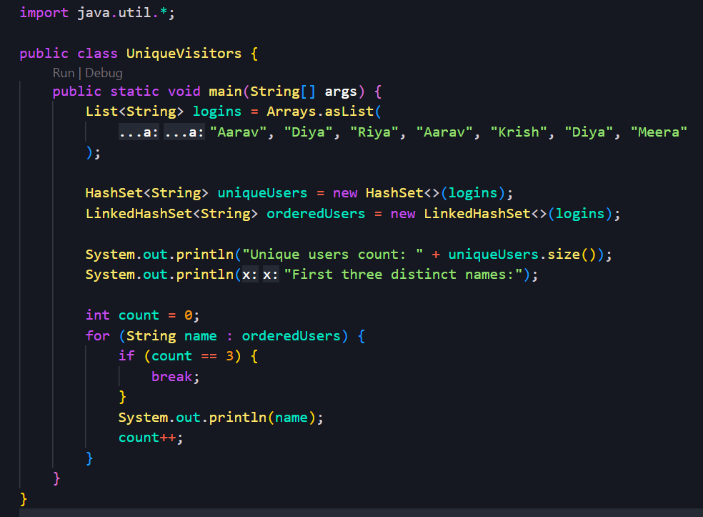
Output:
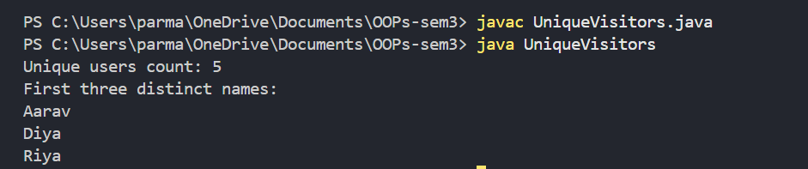
Problem Definition:
Build a leaderboard from player scores held in a Map and print the top-N sorted by score (ties broken by name); choose the data and sorting details.
Solution:
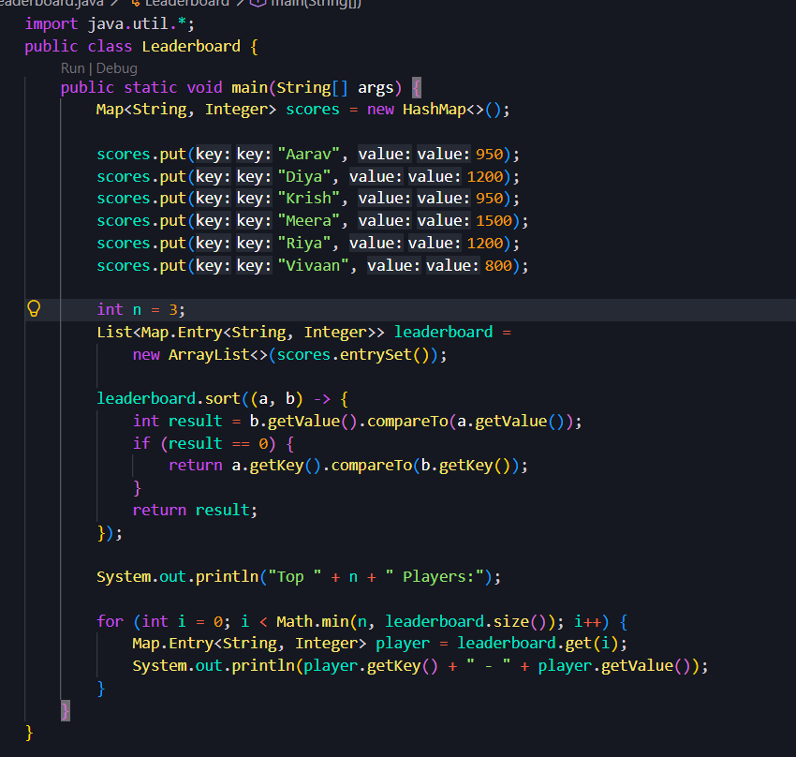
Output:
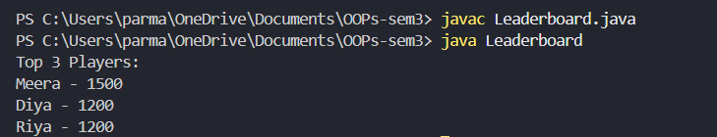

Key Questions / Analysis / Interpretation to be evaluated during/after Implementation
- What is the difference between a List, a Set and a Map?
• List: Ordered collection that allows duplicates.
• Set: Stores unique elements without duplicates.
• Map: Stores key-value pairs with unique keys.
- When do you use a HashMap versus a TreeMap?
• HashMap: When fast insertion and lookup are needed without sorted keys.
• TreeMap: When keys must remain sorted in natural order or by a comparator.
- What is the difference between Comparable and Comparator?
• Comparable: Defines the natural sorting order inside a class using compareTo().
• Comparator: Defines custom sorting order separately using compare().

