PART A:
Problem Definition:
Generic containers: a generic Box with get/set and a Pair; use them with different types to show type safety without casts, and write a generic method that returns the first element of any array.
Solution:
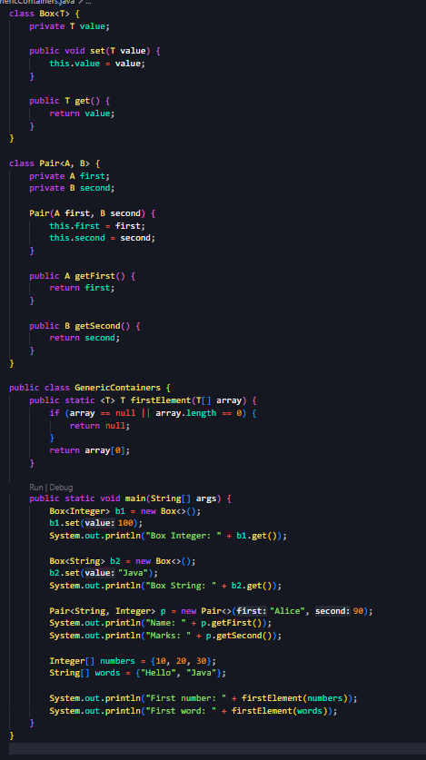
Output:
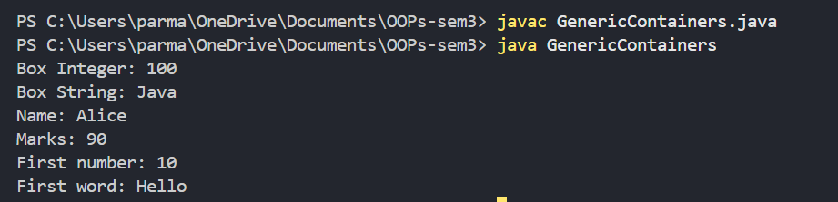
Problem Definition:
Bounded stats: a generic method double average(N[] values) that works for Integer[], Double[] and Long[]; note why it refuses non-Number types.
Solution:
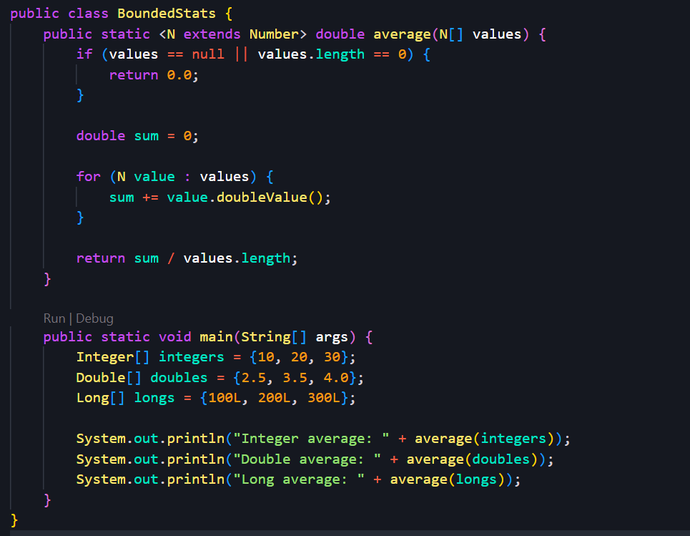
Output:
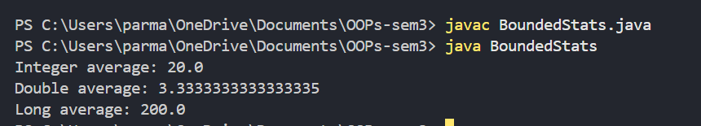
Problem Definition:
Implement a small generic container of your choice (e.g. a stack) backed by an array, reuse it for two different types, and handle the empty case sensibly.
Solution:
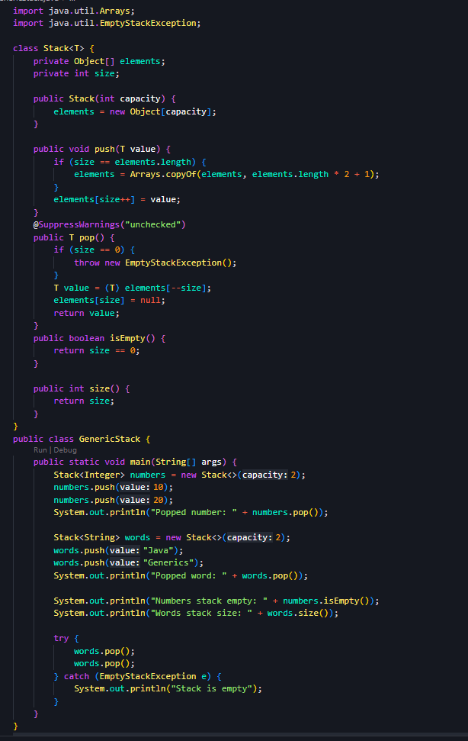
Output:
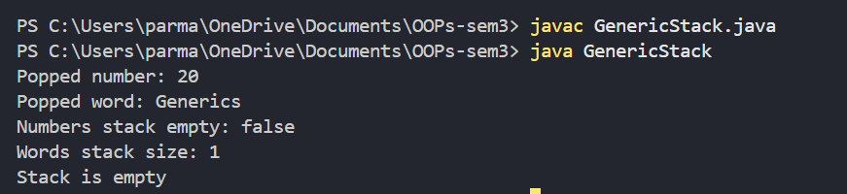
Key Questions / Analysis / Interpretation to be evaluated during/after Implementation:
- What problem do generics solve compared with using Object?
Generics provide type safety at compile time, reduce explicit type casting, and help prevent runtime type errors.
- What is a bounded type parameter, and why is useful?
A bounded type parameter restricts the types that can be used. <N extends Number> allows numeric types such as Integer, Double, and Long, enabling operations like doubleValue()
3.What is type erasure?
Type erasure is the process by which Java removes generic type information during compilation, replacing type parameters with their bounds or Object.

