PRACTICAL 5
PART A:
1. Shape Areas — Abstract Class and Polymorphism
(a) Create an abstract class named Shape with an abstract method area().
(b) Create three subclasses: Circle, Rectangle and Triangle. Each subclass should implement the area() method.
(c)In main, create a mixed Shape[] containing different shapes. Use one loop to print each area, calculate the running total and track the largest area.
This demonstrates polymorphism because all objects are handled using the common Shape reference.
Solution:
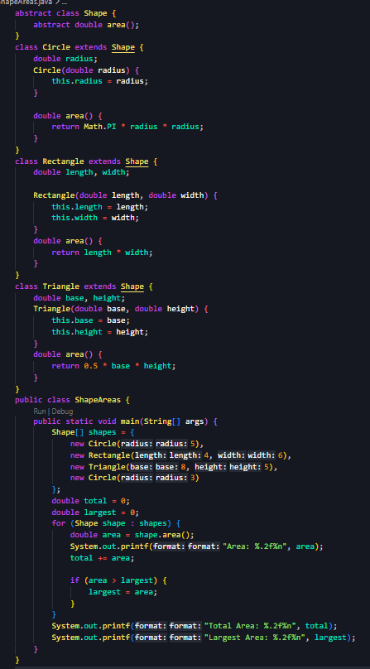
Output:
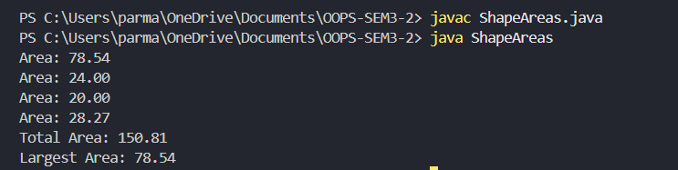

2. Payroll — Abstract Employee and Polymorphism
(a) Create an abstract class named Employee with name, id and an abstract method monthlySalary().
(b) Create FullTime (fixed salary), PartTime (hours × rate) and Intern (stipend). Each subclass constructor must call super(...) for the shared name and id.
(c) In main, create a mixed Employee[] and use a loop to print each salary, calculate the total salary and use instanceof to print a special note for interns.
Solution:
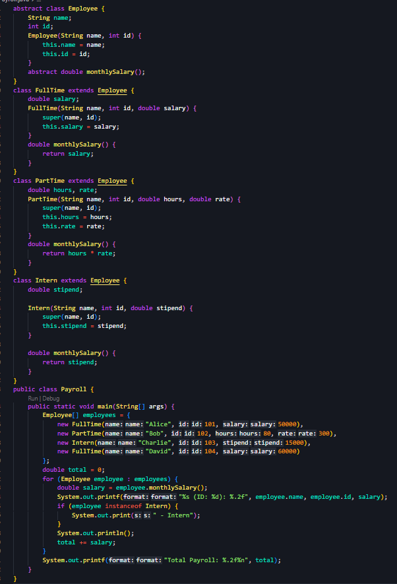
Output:
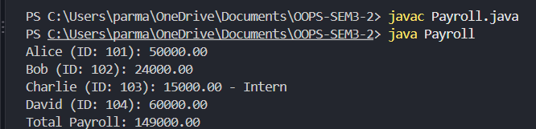
3. (For Advanced Learners – home) Media Late Fee
Model different media types where each type calculates its late fee differently. Book charges ₹2 per late day, DVD charges ₹5 per late day and Magazine charges ₹3 per late day.
Create an abstract Media class with an abstract lateFee() method. Store different media objects in a Media[] and calculate the total late fee using polymorphism.
Solution:
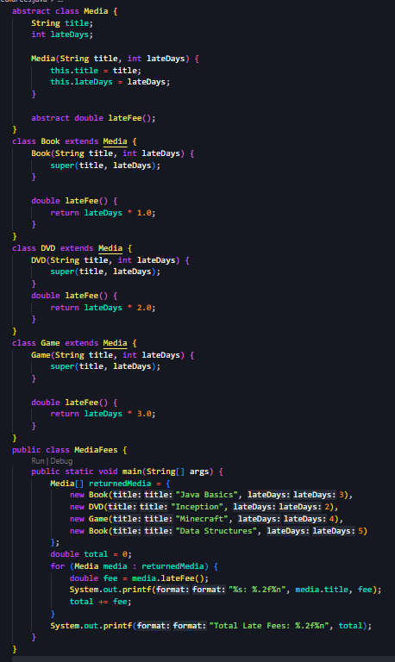
Output:
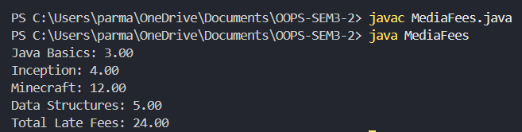s

Key Questions:

- What is the difference between an abstract class and a concrete class?
An abstract class cannot be instantiated and may contain abstract methods. A concrete class can be instantiated and provides implementations for its methods.

- What is dynamic method dispatch (run-time polymorphism)?
It is the mechanism where the method to be executed is determined at runtime based on the actual object, enabling run-time polymorphism.

- What does the super keyword do in a subclass constructor?
super() calls the constructor of the parent class. It is usually the first statement in a subclass constructor and initializes the inherited part of the object.

