
Faculty of Engineering and Technology

Devang Patel Institute of Advance
Technology & Research

Department Of Computer Science & Engineering

A.Y. 2026-2027[Odd]

Lab Manual

CEUE203: Object Oriented Programming.

Name: Vaidehi Parmar

ID: 25DCS073

Practical-6:
PART A:
1. Remote control: an interface Switchable with on()/off() and a default toggle(); Fan and
Light implement it. Loop over a Switchable[] toggling each. Then add a functional
interface that decides, given a device and an hour, whether it may switch on, and supply it
once as an anonymous class and once as a lambda.
Solution:
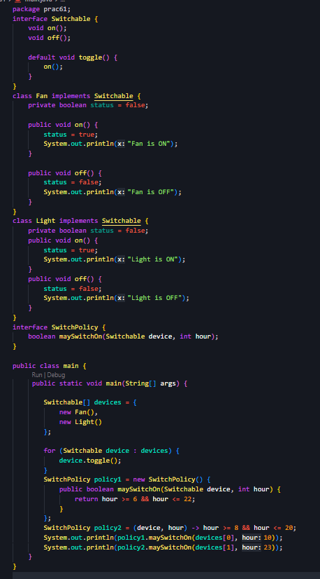

Output:
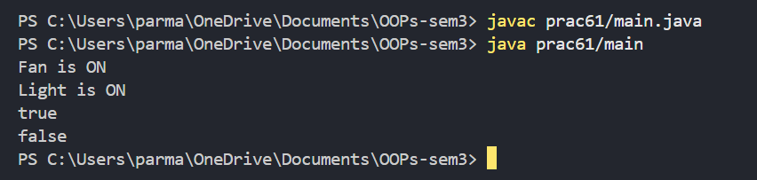
Problem Statement:
2. Notification senders: a functional interface Notifier with send(String); make email and
SMS senders as lambdas, hold them in an array, and broadcast one message through all.
Add a marker interface Urgent and send twice for senders marked urgent.
Solution:
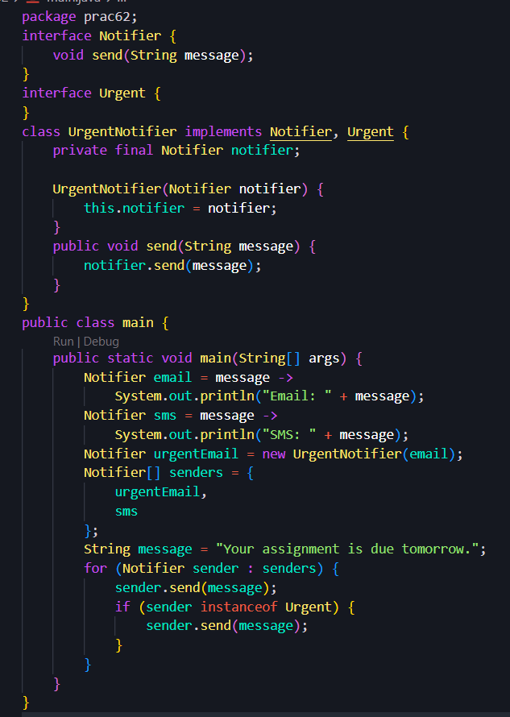
Output:
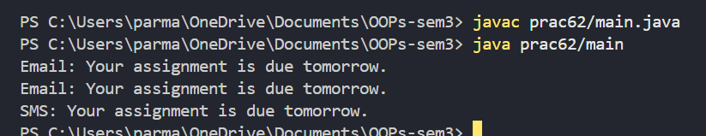
Problem Statement:
Build a small discount engine where each rule is a lambda the user picks at runtime and applies to a list of prices; organise it into packages and ship it as a runnable JAR.
Solution:
DiscountRule.java
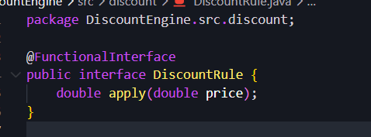
Main.java
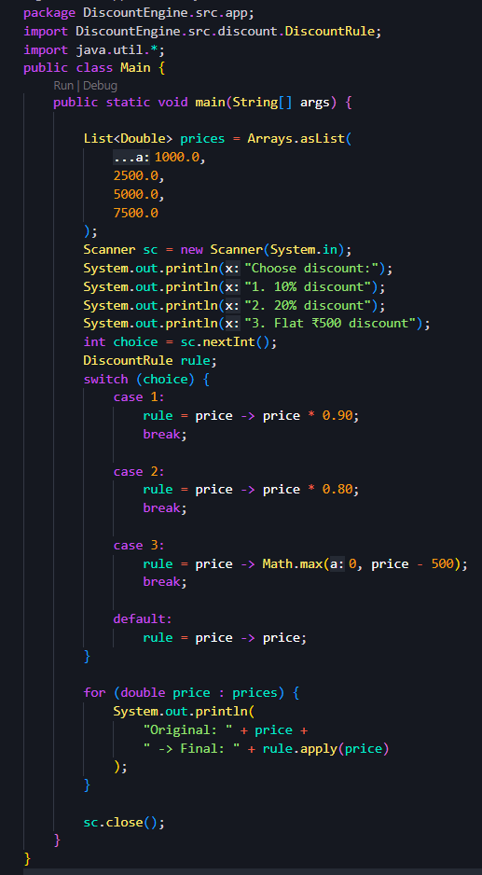
Output:
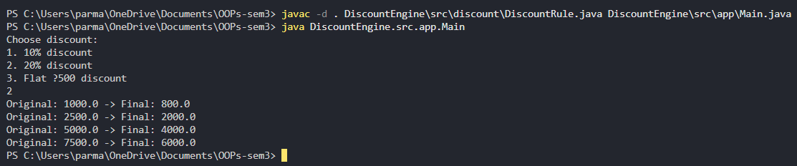

Key Questions:
- What is the difference between an interface and an abstract class?
Interface vs Abstract Class: An interface defines a contract that a class implements, while an abstract class can provide both abstract and concrete methods along with instance variables.

- What is a functional interface, and how does a lambda use it?
Functional Interface: An interface with exactly one abstract method. A lambda expression provides the implementation of that method.

- Why is a default method useful in an interface?
Default Method: It allows an interface to have a method with a body, so new methods can be added without breaking existing implementing classes.

