Part A:
Problem Definition:
- Form validator: define @NotBlank and @MaxLength(int) for fields and annotate a SignupForm. Write a checker that uses reflection to read each field’s annotations and returns the list of validation errors for a given object.
Solution:
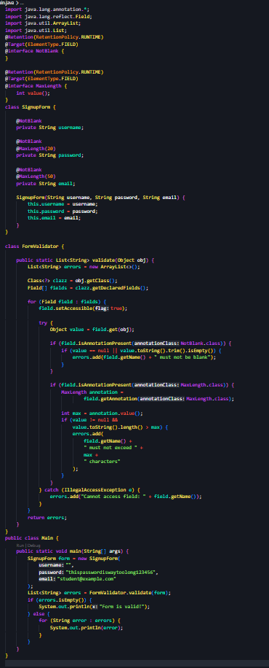
Output:
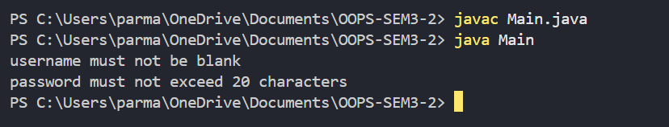

Problem Definition:
- Mini test runner: define a @Run annotation and mark some no-arg methods of a class with it. Use reflection to find and invoke only the @Run methods and report how many ran — the idea behind how JUnit finds @Test methods.
Solution:
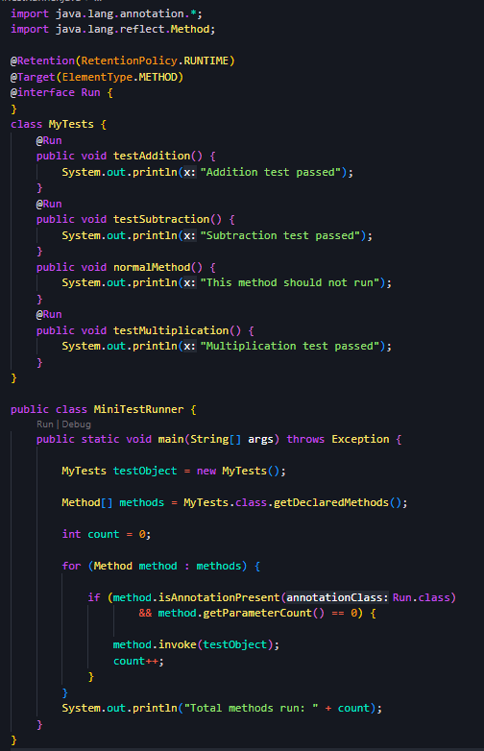
Output:
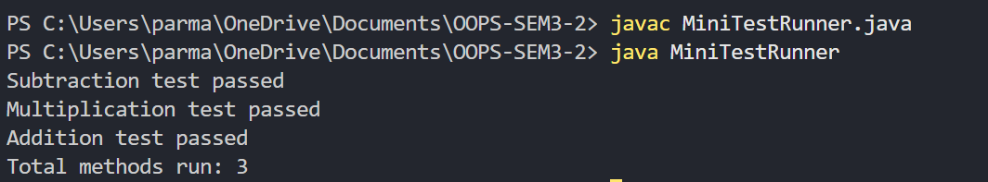

Problem Definition:
- Define a @Column(name) annotation and, by reflection, populate an object’s fields from a header row and a data row by matching column names; decide how to handle a missing column.
Solution:

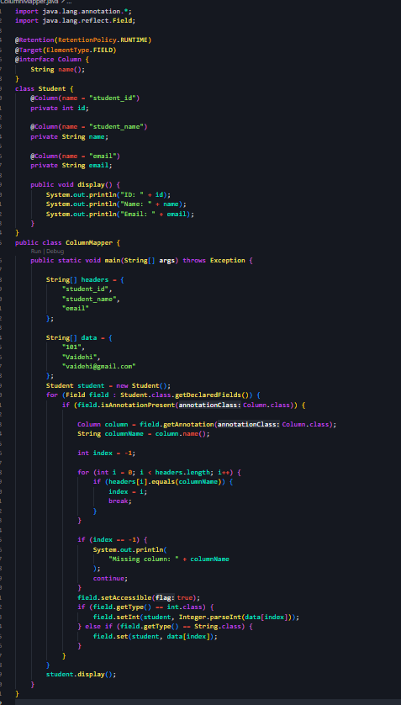
Output:
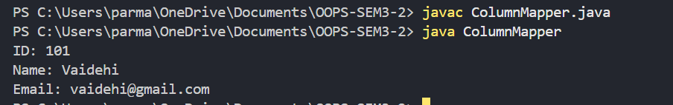

Key Questions:

- What are the meta-annotations @Retention and @Target used for?
@Retention: Specifies how long an annotation is kept (source, class, or runtime). @Target: Specifies where an annotation can be used, such as a class, method, or field.

- What is reflection, and what does getDeclaredFields() return?
Reflection: Allows a program to inspect and work with classes at runtime. getDeclaredFields() returns all fields declared directly inside a class.

- How do annotations plus reflection let a framework validate any object?
Annotations + Reflection: Annotations mark validation rules on fields, and reflection reads those annotations and checks each field's value against the rules.

