PRACTICAL-8:
Part A:
Problem Definition:
- Guarded calculator: read two numbers and an operator; throw a custom DivideByZeroException and catch invalid-number input separately, printing a clearmessage each time; loop until a valid calculation succeeds and use finally to log eachattempt.
Solution:
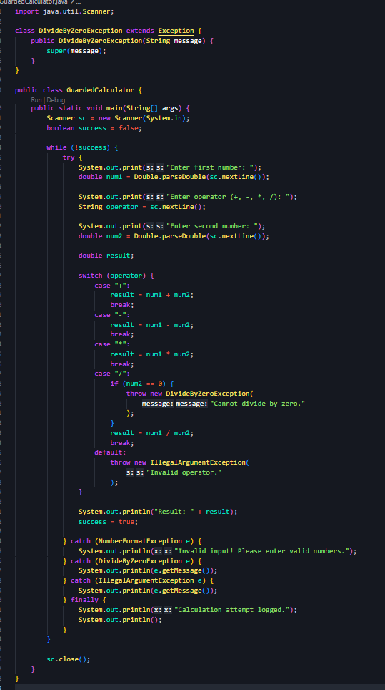
Output:
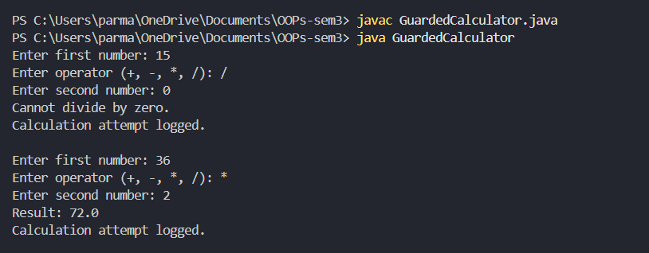

Problem Definition:
2. Stock issue: a Warehouse where issue(item, qty) throws a custom checked
OutOfStockException carrying the shortfall, and InvalidQuantityException for qty ≤ 0.
Process a list of requests, catching and reporting each failure without stopping the run.
Solution:
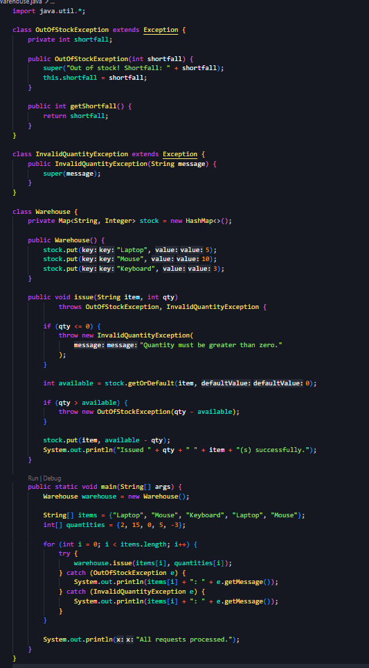
Output:
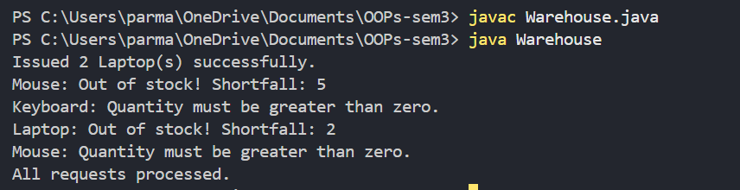

Problem Definition:
Create an AutoCloseable resource and use try-with- resources to prove it always closes — even when an exception is thrown inside the block — and that the original error is the one reported. Decide what to model as the resource.
Solution:
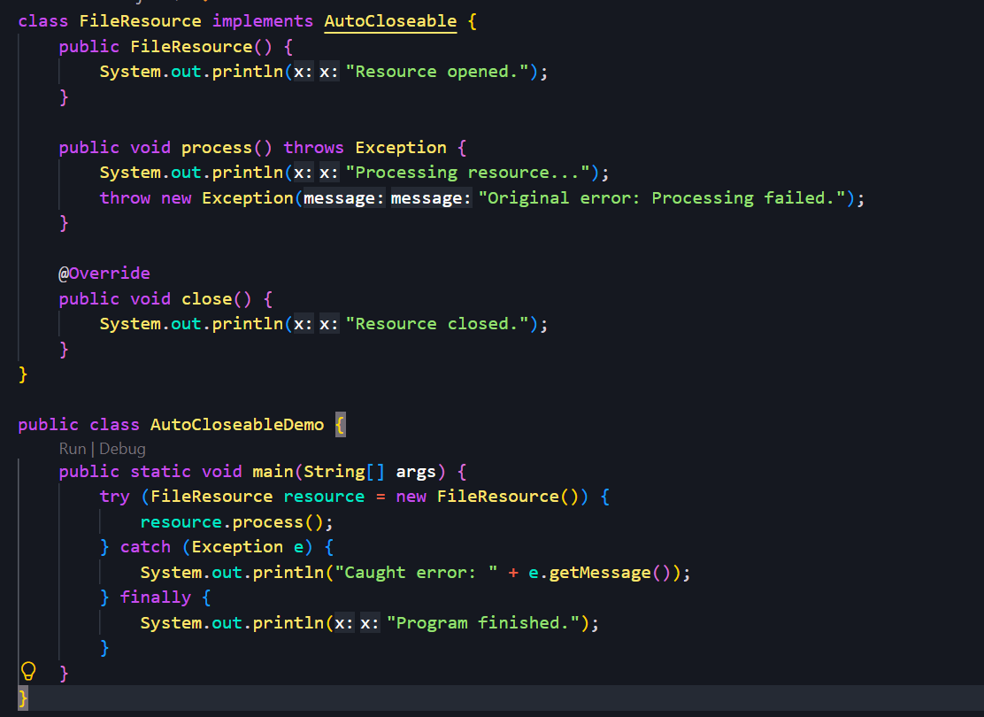
Output:
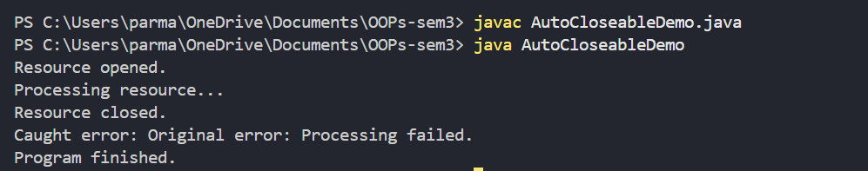

Key Questions / Analysis / Interpretation to be Evaluated During/After Implementation
1. What is the difference between a checked and an unchecked exception?
- Checked Exception: Checked at compile time. The programmer must handle it using try-catch or declare it using throws. Example: IOException.
- Unchecked Exception: Occurs at runtime and does not require explicit handling at compile time. Example: NullPointerException or ArithmeticException.
2. What is the purpose of the finally block, and when does it run?
The finally block is used to execute important cleanup code, such as closing resources or releasing connections. It generally runs whether an exception occurs or not, after the try and catch blocks.
3. How does try-with-resources guarantee a resource is closed?
The try-with-resources statement automatically closes resources that implement the AutoCloseable interface when the try block finishes, whether normally or because of an exception. This reduces resource leaks and eliminates the need to close resources manually in a finally block.

