Practical 9:
Problem Definition:
Counter race: several threads each increment a shared counter many times. Run it without synchronization to watch the total come out too low, then make the increment synchronized and confirm it is exactly right every run.
Solution:
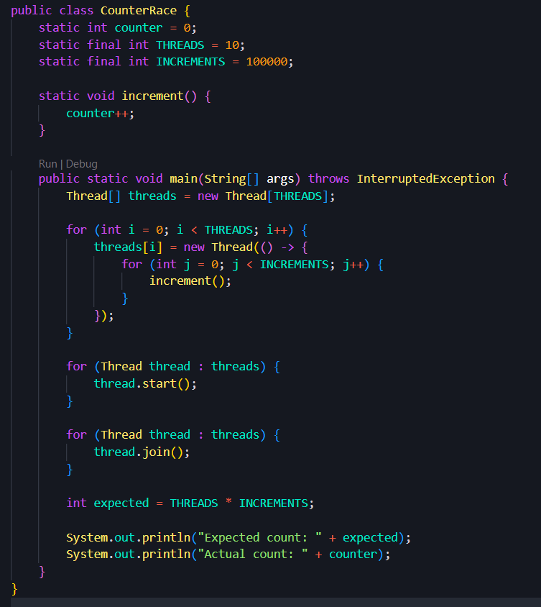
Output:
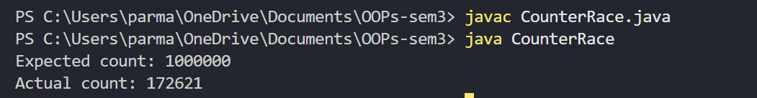
Problem Definition:
Seat booking race: a shared seatsLeft of 5 with about 10 threads each trying to book one seat. Without synchronization show that more than 5 can succeed (oversell); with a synchronized book() exactly 5 do.
Solution:
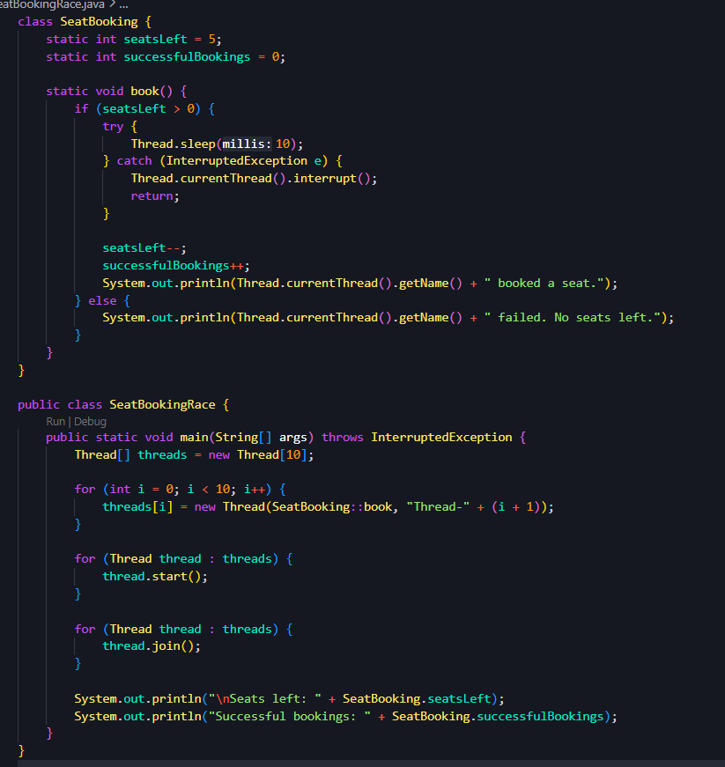
Output:
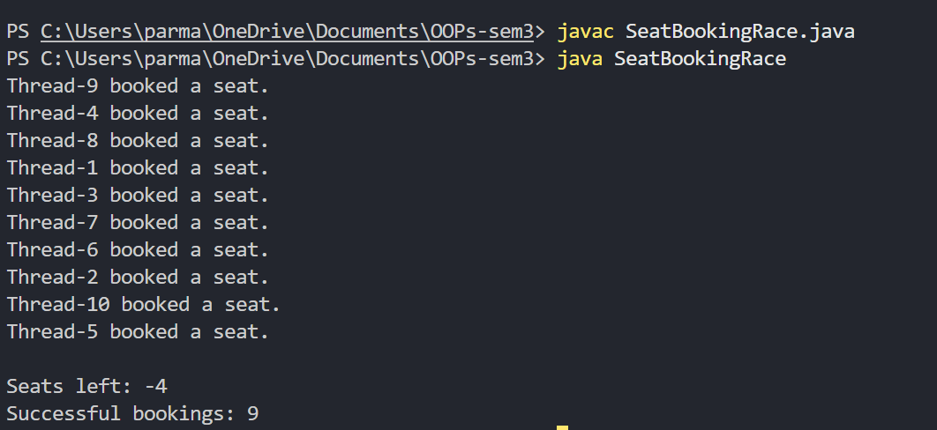
Problem Definition:
Split a large array of numbers across several threads that add into one shared total, show the wrong result, then fix it two ways and compare; decide how to measure the difference.
Solution:
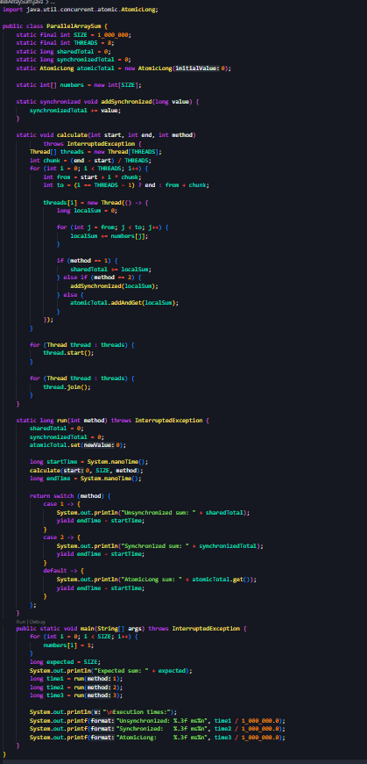
Output:
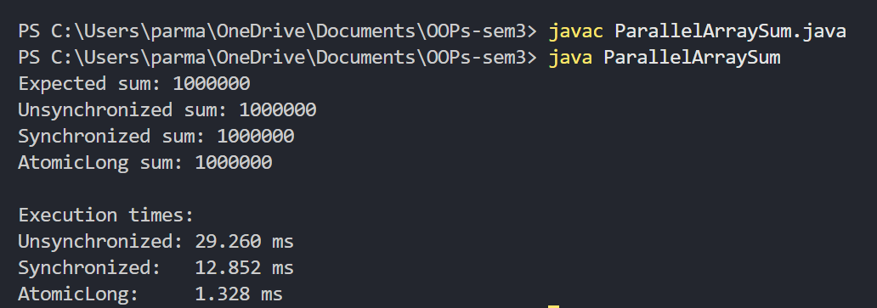
Key Questions:
1. What is a race condition, and why does it occur here?
A race condition occurs when multiple threads access and modify shared data simultaneously, and the final result depends on the order in which the threads execute. It can lead to incorrect or inconsistent results when proper synchronization is not used.
2. What does the synchronized keyword do?
The synchronized keyword in Java controls access to shared resources by allowing only one thread at a time to execute a synchronized method or block guarded by the same monitor lock. It helps prevent race conditions and ensures thread-safe access to shared data.
3. What are the states in a thread’s life cycle?
Java defines six thread states: NEW, RUNNABLE, BLOCKED, WAITING, TIMED_WAITING, and TERMINATED. A thread moves between these states during its life cycle, from creation and execution to waiting for resources or signals and eventually completing its task.

