

Faculty of Engineering and Technology

Devang Patel Institute of Advance
Technology & Research

Department Of Computer Science & Engineering

A.Y. 2026-2027[Odd]

Lab Manual

CEUE203: Object Oriented Programming.

Name: Vaidehi Parmar

ID: 25DCS073

PRACTICAL 3
PART A:
- Distinct points (Point.java + Driver.java with main)
(a) Create class Point with private int x, y and a constructor.
(b) Override toString() to return “(x, y)”.
(c) Override equals(Object) to be true when both x and y match, and hashCode() to agree
(e.g. Objects.hash(x, y)).
(d) In Driver.main: build a Point[] with some repeated coordinates.
(e) Count distinct points: for each point, use equals() to check whether it already
appeared earlier; count those that did not.
(f) Print “Distinct: N”.
Expected output: 5 points with 2 repeats → “Distinct: 3”.
SOLUTION:
Point.java
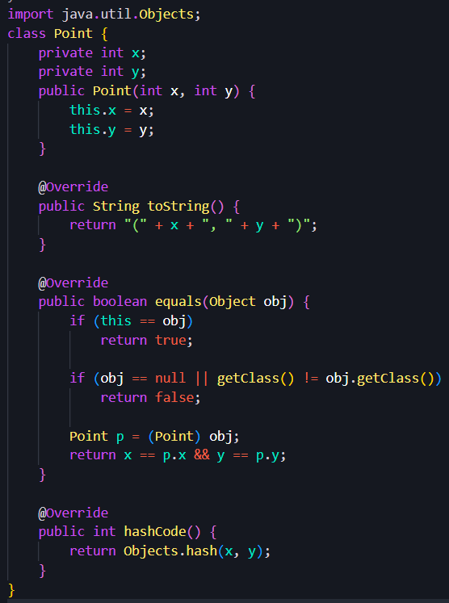
Driver.java

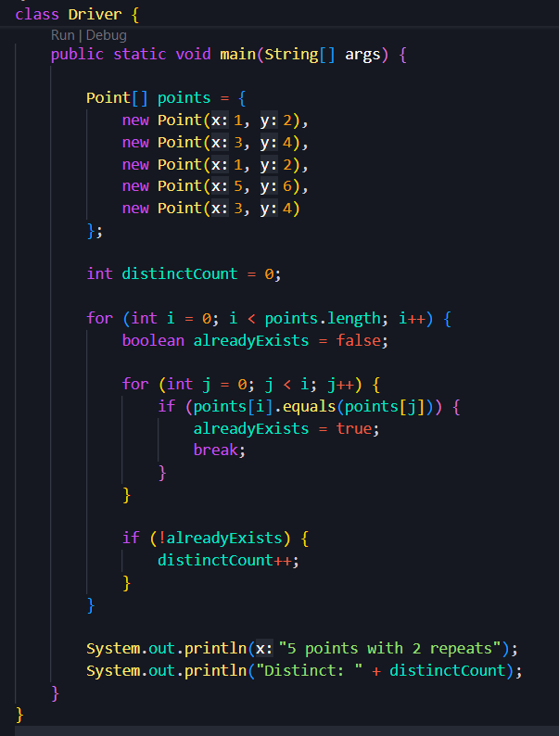

Output:
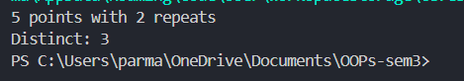

- Duplicate card check (Card.java + Driver.java)
(a) Create class Card with private String rank, suit and a constructor.
(b) Override toString() to return rank + “ of ” + suit (e.g. “Queen of Hearts”).
(c) Override equals()/hashCode() by rank + suit.
(d) In Driver.main: add cards to a Card[] one at a time; before adding each, use equals()
to check it against the earlier cards.
(e) Print “Duplicate found: <card>” the first time a repeat appears.
Expected output: a second “Ace of Spades” → “Duplicate found: Ace of Spades”.
Solution:
Card.java
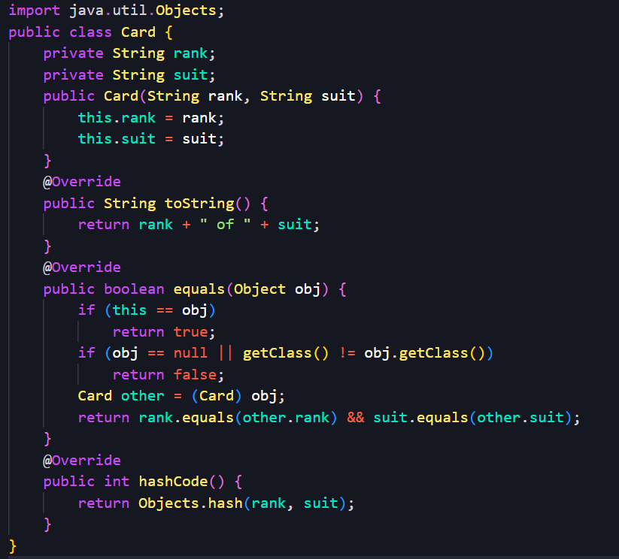
Driver2.java
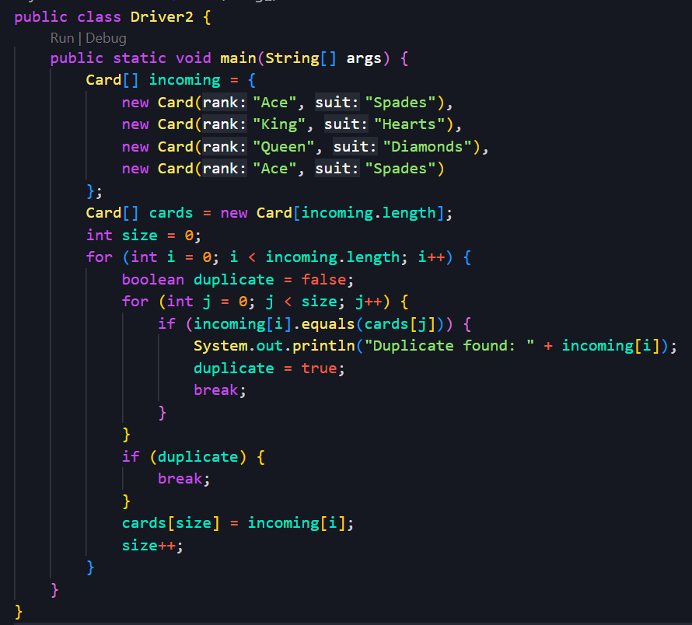

Output:
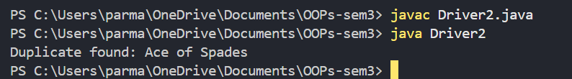
- Fractions (Fraction.java + Driver.java)
(a) Create class Fraction with private int num, den.
(b) In the constructor, reduce to lowest terms: compute g = gcd(num, den) and divide
both by g.
(c) Override toString() to return num + “/” + den.
(d) Override equals()/hashCode() using the reduced num and den.
(e) In Driver.main: create several equivalent fractions (1/2, 2/4, 3/6) and confirm they
are all equal and print the same.
Expected output: new Fraction(2,4) prints “1/2” and equals new Fraction(1,2).
Solution:
Fraction.java
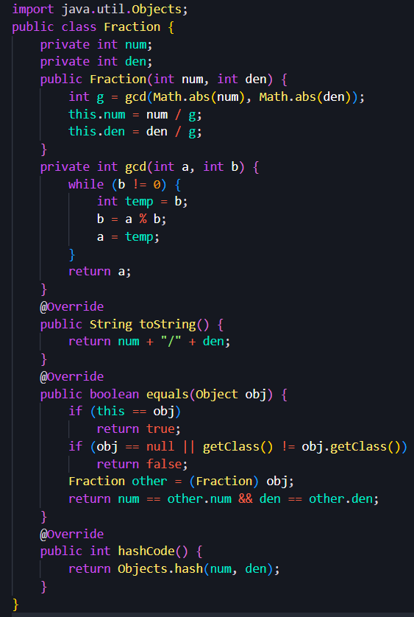
Driver3.java
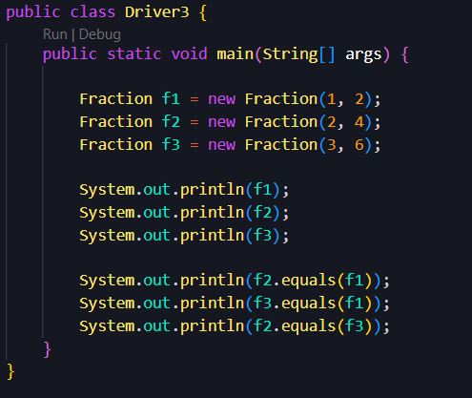
Output:
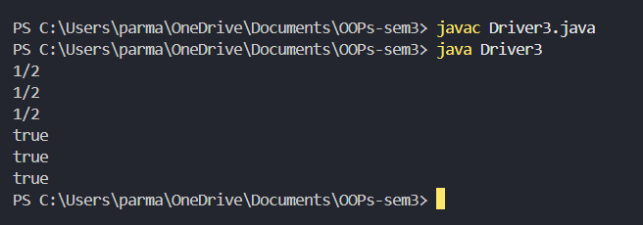

Key Questions:
- Why must equals() and hashCode() be overridden together?
Because if two objects are equal according to equals(), they must have the same hashCode(). Otherwise, collections like HashMap and HashSet may behave incorrectly.

- What does the default Object.toString() return, and why override it?
Object.toString() returns the class name + @ + hexadecimal hash code. Override it to provide meaningful, readable object information.

- What is the difference between a static nested class and an inner class?
• Static nested class: Does not require an instance of the outer class.
• Inner class: Requires an instance of the outer class and can access its instance members.

