
Faculty of Engineering and Technology

Devang Patel Institute of Advance
Technology & Research

Department Of Computer Science & Engineering

A.Y. 2026-2027[Odd]

Lab Manual

CEUE203: Object Oriented Programming.

Name: Vaidehi Parmar

ID: 25DCS073

PRACTICAL 4
PART A:
- Password strength (PasswordChecker.java + Driver.java)
(a) In PasswordChecker, check four rules — length ≥ 8, contains an uppercase letter,
contains a digit, contains a special character — using regex (e.g. “.*[A-Z].*”) or
String methods.
(b) Write strength(String pw) that counts how many rules pass and returns “Weak” (0–
1), “Medium” (2–3) or “Strong” (4).
(c) In Driver.main: test several passwords; for each, print which rules passed and the
final label.
Expected output: “abc” → Weak; “Abcd1234!” → Strong.
Solution:
PasswordChecker.java
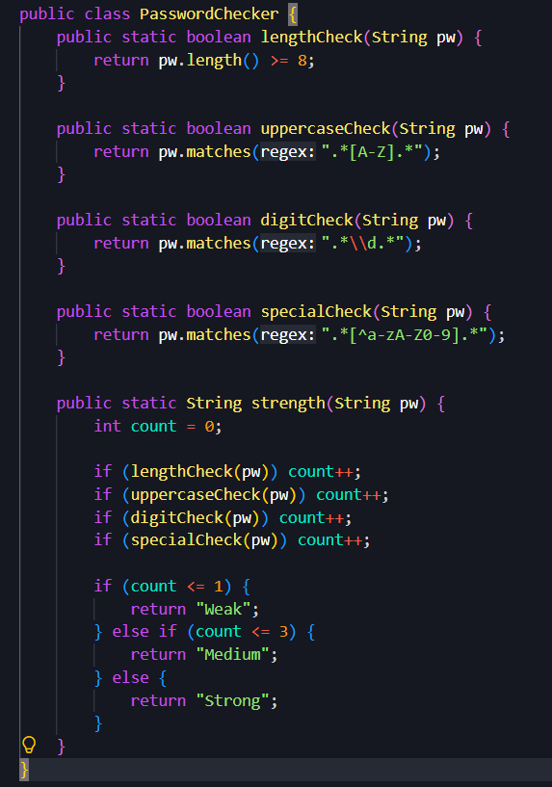
Driver4.java
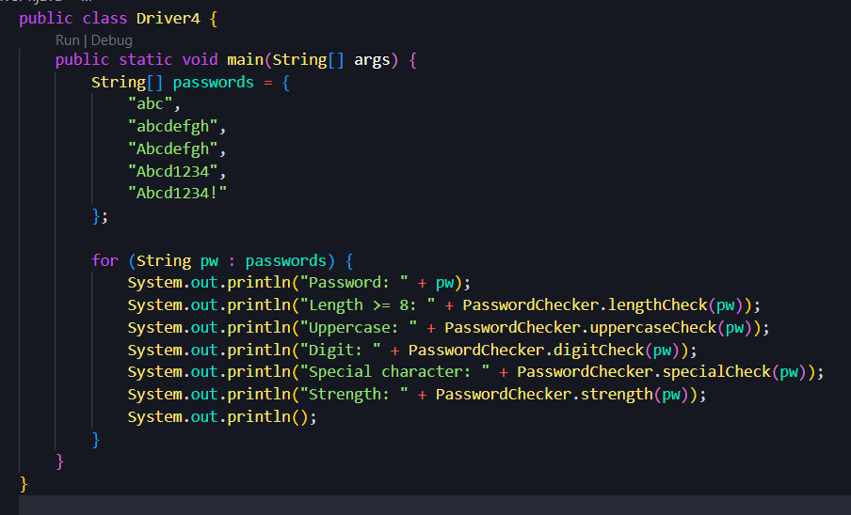
Output:
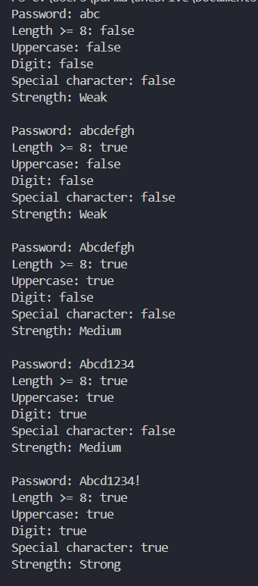
- Chat-log filter (ChatFilter.java + Driver.java)
(a) In Driver.main, define a String[] of log lines like “10:05 alice Hello there” (include
one malformed line with fewer than 3 parts).
(b) Read a keyword from the user.
(c) For each line, split into time/user/message with split(“ ”, 3); skip lines that do not
have 3 parts.
(d) If the message contains the keyword (case-insensitive), increment a counter and
append “time user: message” to a StringBuilder.
(e) Print “Matches: N” and the built report.
Expected output: keyword “hello” over 3 lines (1 malformed) → “Matches: 1” and
the matching line.
Solution:
ChatFilter.java
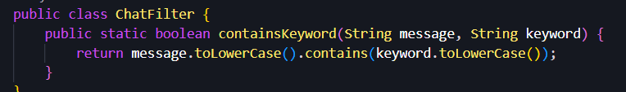
Driver5.java
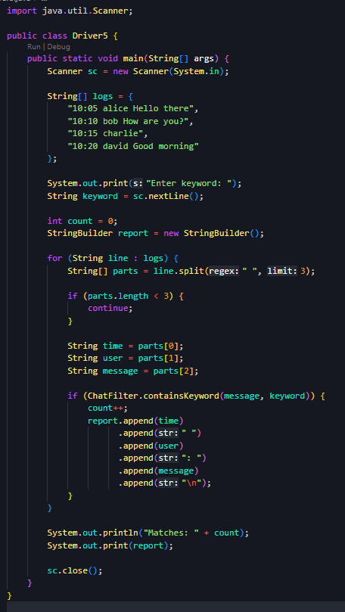
Output:
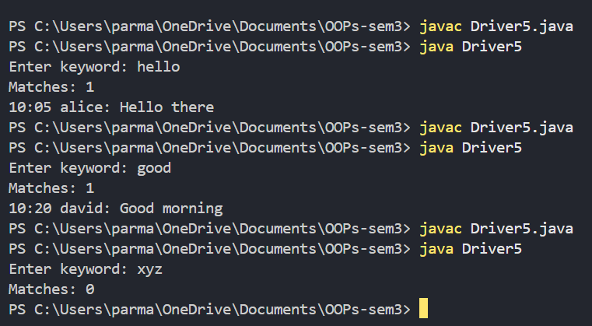
- Template filler (TemplateFiller.java + Driver.java)
(a) In Driver.main, define a template like “Dear {name}, order {id} ships {date}.” and
two parallel arrays: names {“name”, “id”} and values {“Riya”, “A07”} (note {date}
is not supplied).
(b) Compile a Pattern for \{(\w+)\} and get a Matcher on the template.
(c) Walk the matches with a StringBuilder: for each {placeholder}, look up its value in
the names array and replace with the value, or with “[?]” if not found.
(d) Print the filled template.
Expected output: the unsupplied {date} becomes [?].
Solution:
TemplateFiller.java
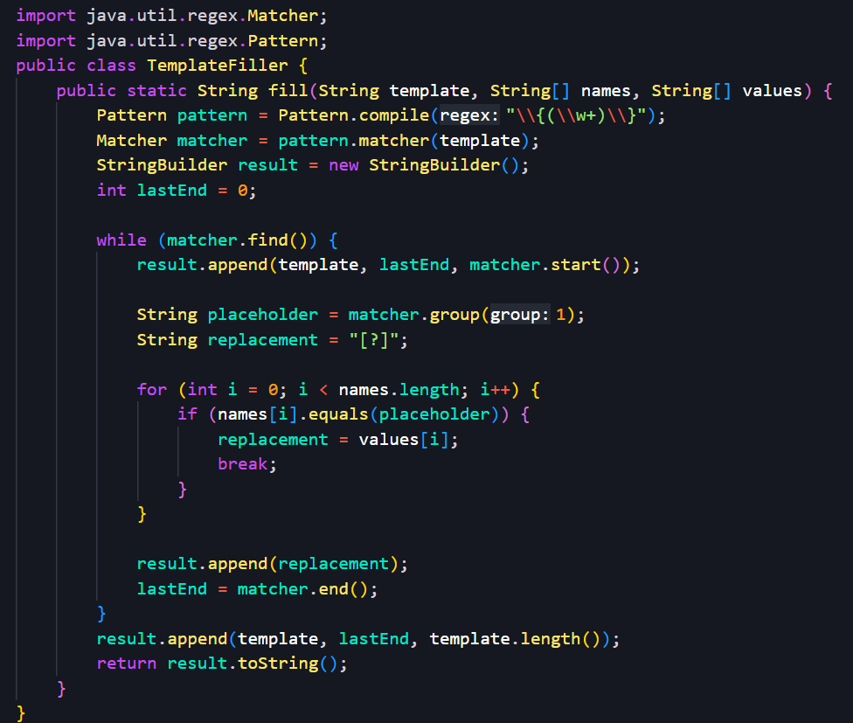
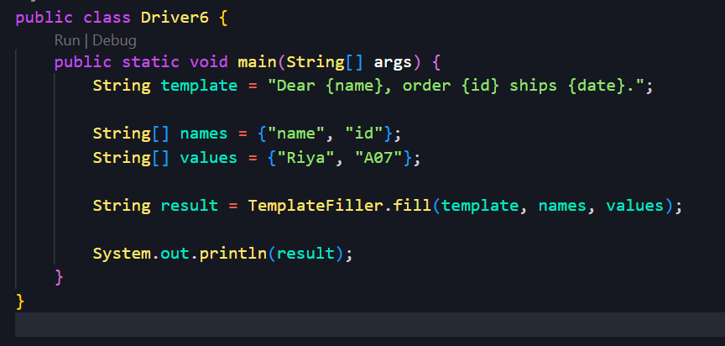
Driver6.java

Output:
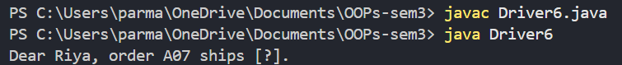

Key Questions:
- What is the difference between String, StringBuilder and StringBuffer, and when is each preferred?
String: Immutable; use for fixed text.
StringBuilder: Mutable and faster; use for frequent modifications in single-threaded code.
StringBuffer: Mutable and synchronized; use when thread safety is required.

- What does the regular expression [6-9][0-9]{9} match, and why use anchors?
[6-9][0-9]{9} matches a 10-digit number starting with 6–9. Anchors (^ and $) ensure the entire input matches the pattern.

- Why should input be validated at the boundary before it is used?
Input should be validated at the boundary to reject invalid or unsafe data early, before it enters the system and causes errors or security issues.

