Part A — Practice Programs (Hour 1)
Work these in your lab-NN/ folder before the project: do the first one or two in the lab; the
last (For Advanced Learners) is for home.
1. Thread-pool runner: with a fixed pool of 3 (ExecutorService), submit about 10 Runnable
tasks that print their id and sleep briefly; shut down and await completion, observing the
few threads being reused.
CODE:
import java.util.concurrent.ExecutorService;
import java.util.concurrent.Executors;
import java.util.concurrent.TimeUnit;

class Task implements Runnable {
private int taskId;

public Task(int taskId) {
this.taskId = taskId;
}

@Override
public void run() {
System.out.println("Task " + taskId + " started by " + Thread.currentThread().getName());
try {
Thread.sleep(500);
} catch (InterruptedException e) {
Thread.currentThread().interrupt();
}
System.out.println("Task " + taskId + " completed by " + Thread.currentThread().getName());
}
}

public class ThreadPoolRunner {
public static void main(String[] args) {
ExecutorService executor = Executors.newFixedThreadPool(3);

for (int i = 1; i <= 10; i++) {
executor.submit(new Task(i));
}

executor.shutdown();

try {
executor.awaitTermination(10, TimeUnit.SECONDS);
} catch (InterruptedException e) {
Thread.currentThread().interrupt();
}

System.out.println("All tasks finished.");
}
}
OUTPUT:
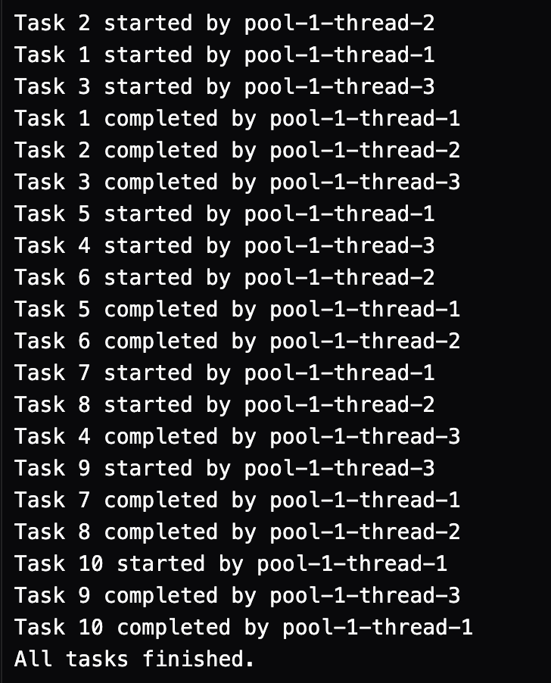

2. Producer–consumer: one thread adds numbers to a small shared buffer and another
removes them, coordinated with wait()/notify(); produce and consume a fixed number of
items in order with none lost.
CODE:
class SharedBuffer {
private final int[] buffer;
private int count = 0;
private int in = 0;
private int out = 0;

public SharedBuffer(int size) {
buffer = new int[size];
}

public synchronized void produce(int item) throws InterruptedException {
while (count == buffer.length) {
wait();
}
buffer[in] = item;
in = (in + 1) % buffer.length;
count++;
System.out.println("Produced: " + item);
notifyAll();
}

public synchronized int consume() throws InterruptedException {
while (count == 0) {
wait();
}
int item = buffer[out];
out = (out + 1) % buffer.length;
count--;
System.out.println("Consumed: " + item);
notifyAll();
return item;
}
}

class Producer implements Runnable {
private final SharedBuffer buffer;
private final int totalItems;

public Producer(SharedBuffer buffer, int totalItems) {
this.buffer = buffer;
this.totalItems = totalItems;
}

@Override
public void run() {
try {
for (int i = 1; i <= totalItems; i++) {
buffer.produce(i);
Thread.sleep(50);
}
} catch (InterruptedException e) {
Thread.currentThread().interrupt();
}
}
}

class Consumer implements Runnable {
private final SharedBuffer buffer;
private final int totalItems;

public Consumer(SharedBuffer buffer, int totalItems) {
this.buffer = buffer;
this.totalItems = totalItems;
}

@Override
public void run() {
try {
for (int i = 1; i <= totalItems; i++) {
buffer.consume();
Thread.sleep(100);
}
} catch (InterruptedException e) {
Thread.currentThread().interrupt();
}
}
}

public class ProducerConsumerDemo {
public static void main(String[] args) throws InterruptedException {
SharedBuffer buffer = new SharedBuffer(5);
int totalItems = 20;

Thread producerThread = new Thread(new Producer(buffer, totalItems));
Thread consumerThread = new Thread(new Consumer(buffer, totalItems));

producerThread.start();
consumerThread.start();

producerThread.join();
consumerThread.join();

System.out.println("Processing completed.");
}
}
OUTPUT:
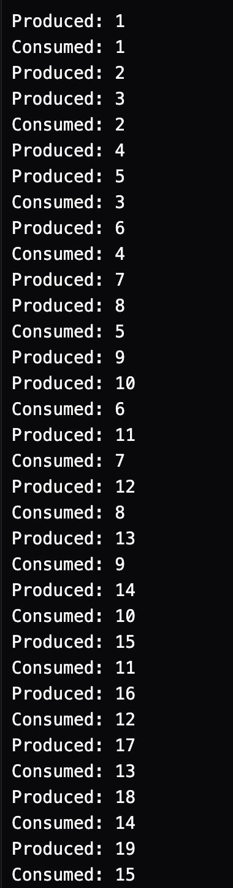
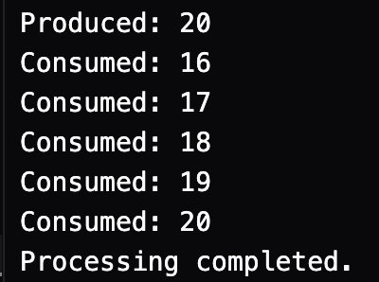

3. (For Advanced Learners – home) Reproduce a deadlock between two threads that lock
two objects in opposite order, then remove it with a consistent lock order. Choose the
scenario yourself.
CODE:
class Resource {
private final int id;

public Resource(int id) {
this.id = id;
}

public int getId() {
return id;
}
}

public class DeadlockDemo {
public static void main(String[] args) throws InterruptedException {
Resource r1 = new Resource(1);
Resource r2 = new Resource(2);

System.out.println("--- Running Safe Version (Consistent Lock Order) ---");
Thread safe1 = new Thread(() -> safeOperation(r1, r2, "Safe-Thread-1"));
Thread safe2 = new Thread(() -> safeOperation(r2, r1, "Safe-Thread-2"));

safe1.start();
safe2.start();

safe1.join();
safe2.join();

System.out.println("Safe Version completed successfully.\n");

System.out.println("--- Running Deadlock Version (Opposite Lock Order) ---");
Thread dead1 = new Thread(() -> unsafeOperation(r1, r2, "Deadlock-Thread-1"));
Thread dead2 = new Thread(() -> unsafeOperation(r2, r1, "Deadlock-Thread-2"));

dead1.start();
dead2.start();

dead1.join(2000);
dead2.join(2000);

if (dead1.isAlive() && dead2.isAlive()) {
System.out.println("Deadlock detected! Both threads are stuck.");
System.exit(0);
}
}

public static void safeOperation(Resource res1, Resource res2, String threadName) {
Resource first = res1.getId() < res2.getId() ? res1 : res2;
Resource second = res1.getId() < res2.getId() ? res2 : res1;

synchronized (first) {
System.out.println(threadName + " acquired lock on Resource " + first.getId());
try {
Thread.sleep(50);
} catch (InterruptedException e) {
Thread.currentThread().interrupt();
}
synchronized (second) {
System.out.println(threadName + " acquired lock on Resource " + second.getId());
}
}
}

public static void unsafeOperation(Resource res1, Resource res2, String threadName) {
synchronized (res1) {
System.out.println(threadName + " acquired lock on Resource " + res1.getId());
try {
Thread.sleep(50);
} catch (InterruptedException e) {
Thread.currentThread().interrupt();
}
synchronized (res2) {
System.out.println(threadName + " acquired lock on Resource " + res2.getId());
}
}
}
}

OUTPUT:

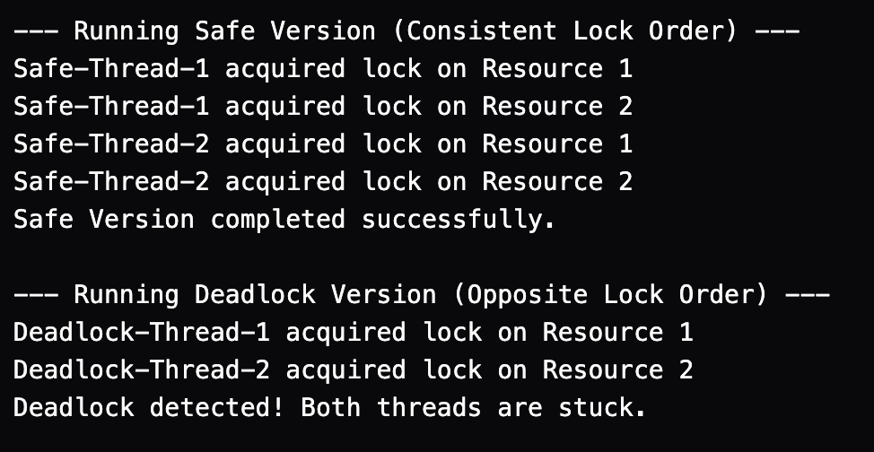

\Key Questions / Analysis / Interpretation to be Evaluated During/After Implementation

1. Why is a thread pool better than creating a new thread per task?
A thread pool reuses a fixed or configurable number of threads to execute multiple tasks, reducing the overhead of thread creation and destruction. It improves performance, manages system resources efficiently, and helps control the number of concurrent tasks.

2. How do wait() and notify() coordinate two threads?
The wait() method causes a thread to release the object's monitor lock and wait until another thread notifies it. The notify() method wakes one thread waiting on the same object's monitor. These methods must be called while holding that object's monitor, typically inside a synchronized method or block, and help coordinate communication between threads.

3. What causes a deadlock, and how does consistent lock ordering prevent it?
A deadlock occurs when two or more threads wait indefinitely for locks held by one another, preventing them from proceeding. Consistent lock ordering prevents this by ensuring that all threads acquire multiple locks in the same predefined order, reducing the possibility of circular waiting and avoiding deadlocks caused by inconsistent lock acquisition.

