PART A:
Problem Definition:
Assemble and test: build a tiny layered app (a model, a service using an ArrayList, and a menu main), then write two or three JUnit @Test methods checking that adding increases the count and an invalid action throws — practice before testing MiniBank.

Solution:
Task.java:
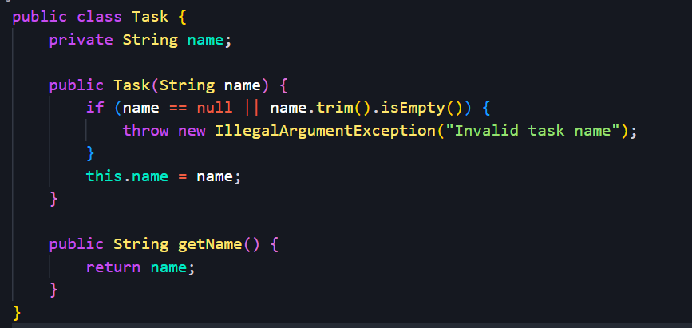
TaskService.java:
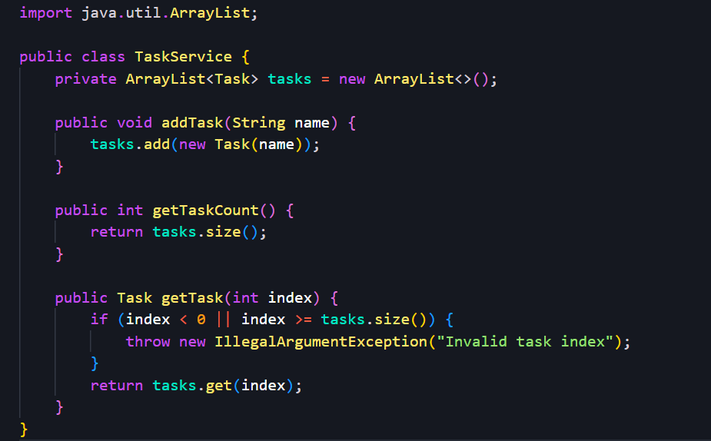
TaskApp.java:
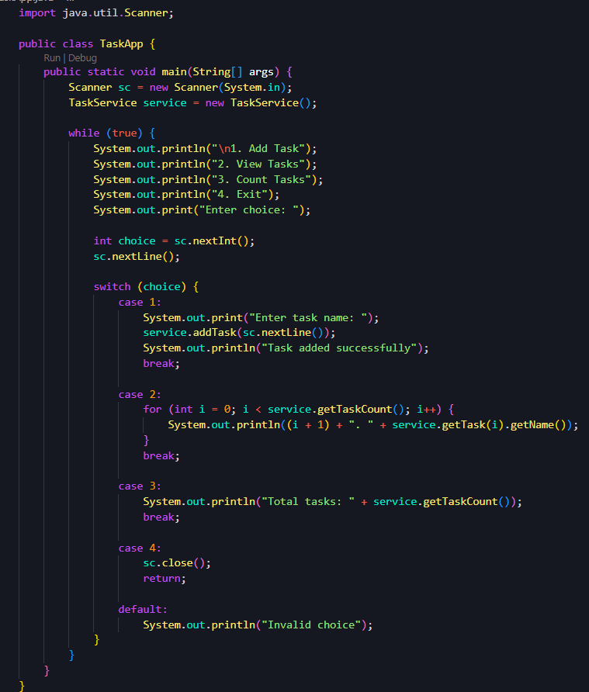
TaskServiceTest.java:
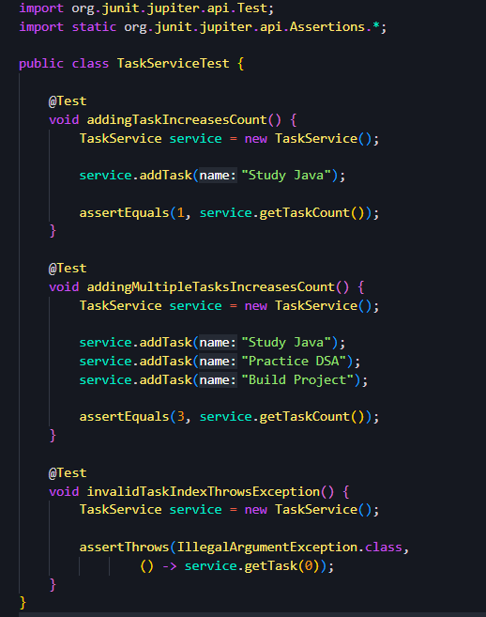
Output:
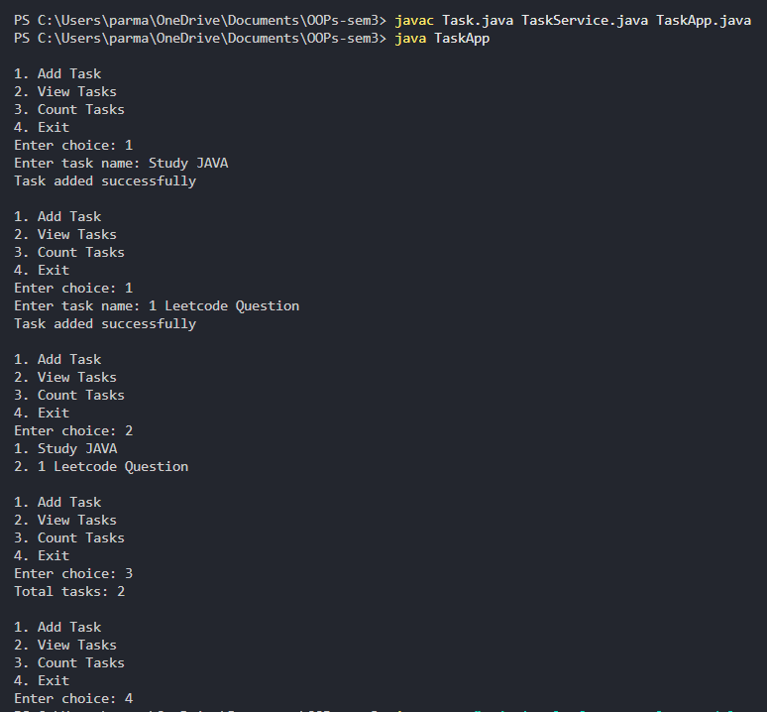
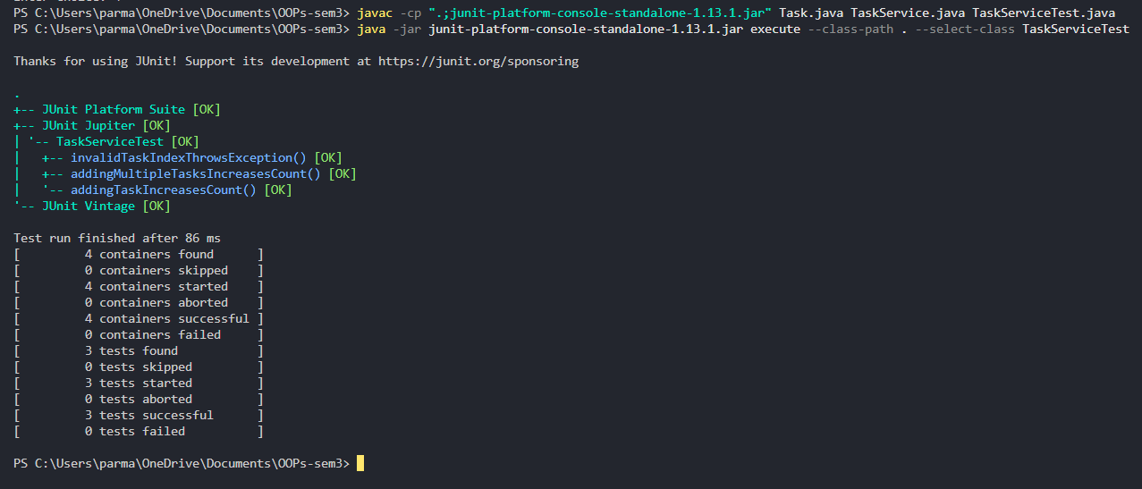

Problem Definition:
Organise that app into packages, build a runnable JAR, and add a test that saves and reloads its data unchanged.
Solution:
Src/app/TaskApp.java:
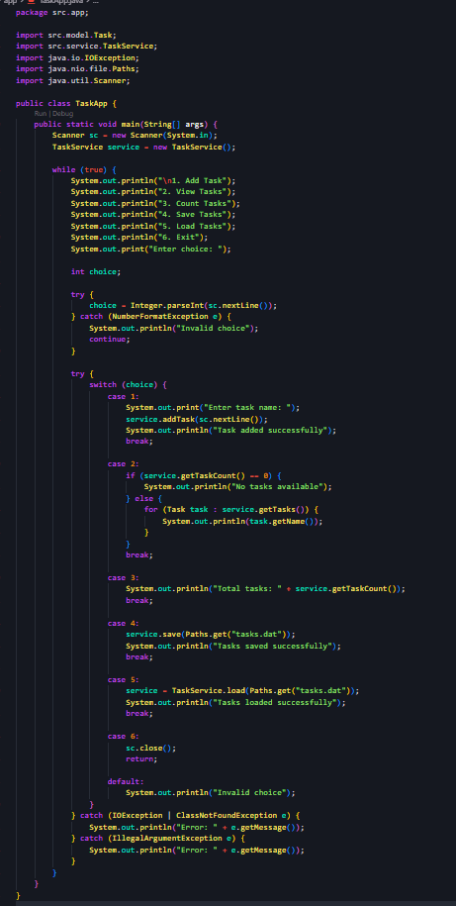
Src/model/Task.java:
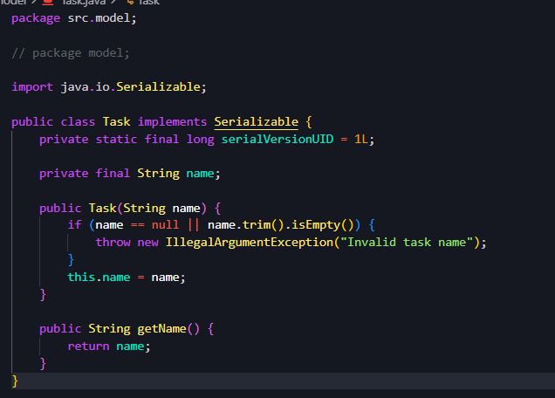
Src/service/TaskService.java:
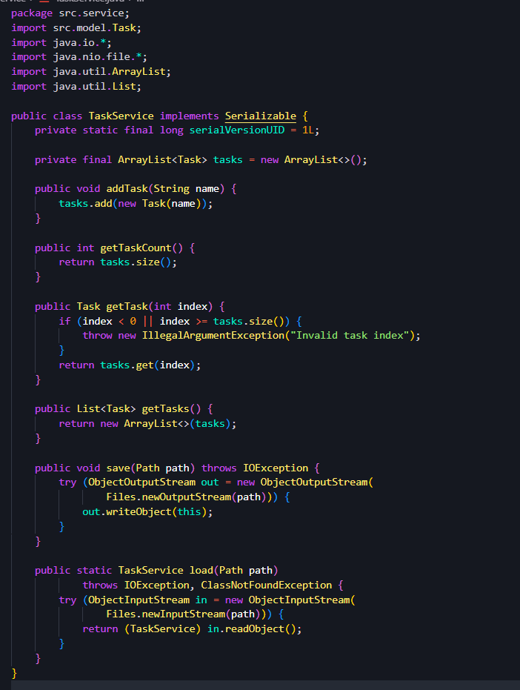
Output:
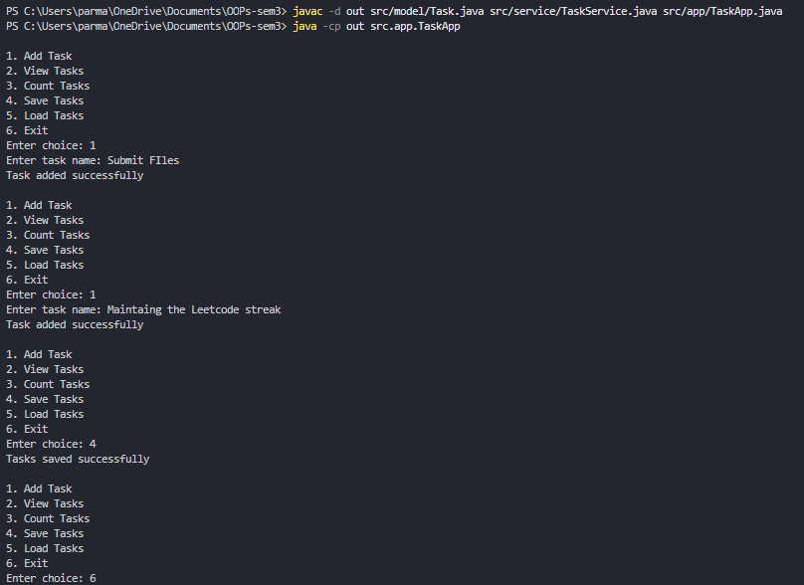
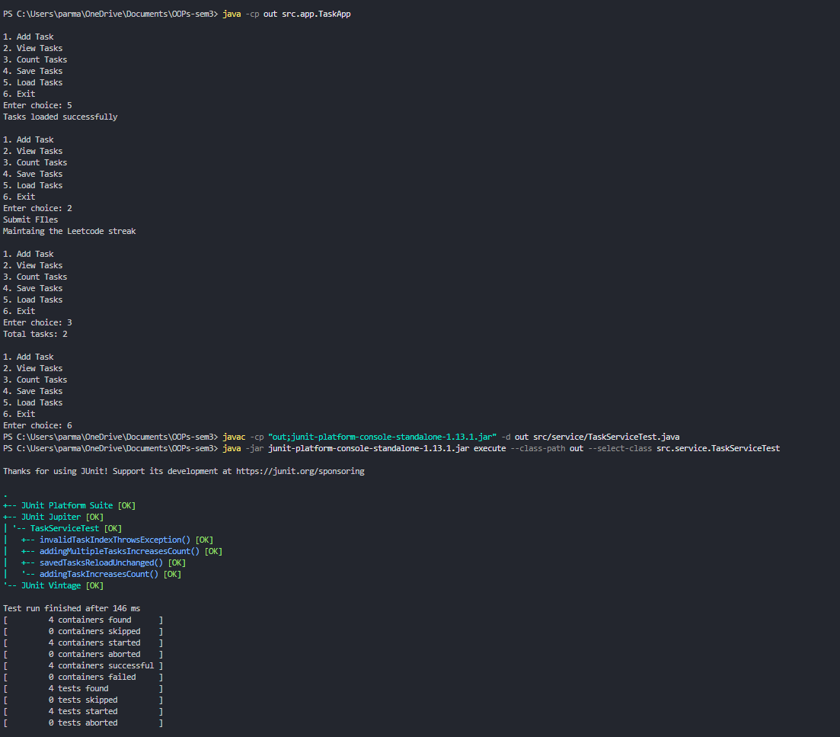
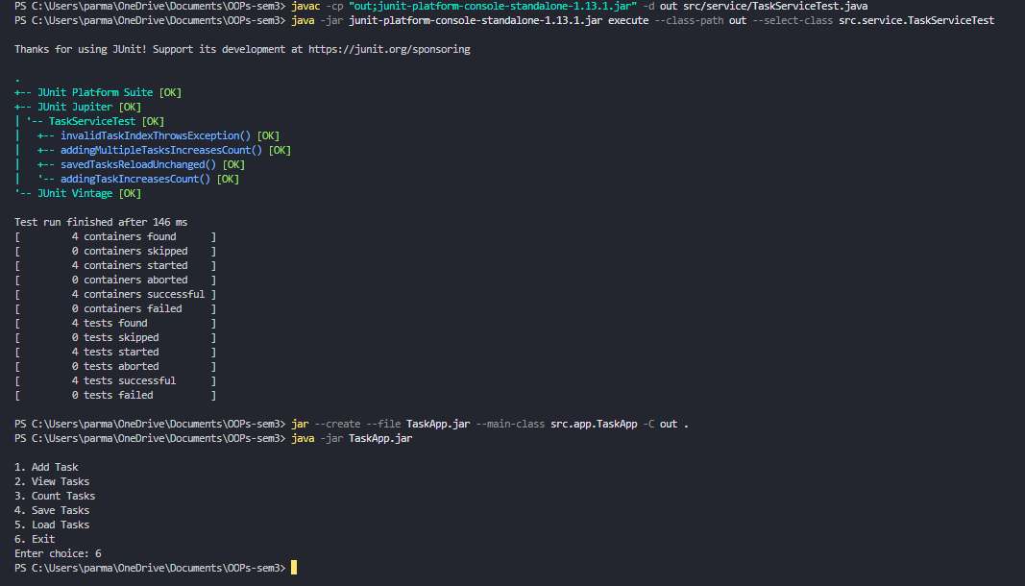
Key Questions / Analysis / Interpretation to be evaluated during/after Implementation
- What is a layered architecture (model, service, user interface), and why is it useful?
It separates the application into model (data), service (business logic), and user interface (interaction). It improves code organization, reusability, and maintainability.
- How do you assert in JUnit that a method throws an expected exception?
Use assertThrows().

assertThrows(IllegalArgumentException.class, () -> service.getTask(0));

- What does packaging the application as a runnable JAR provide?
It bundles compiled classes into a single JAR file that can be launched using java -jar TaskApp.jar.

