Practical 1: Project Initiation, Requirement Analysis, Sitemap, Wireframe, and GitHub Setup
Aim:
Initiate the semester-long StudentHub portal by identifying the problem
scope, user roles, key modules, navigation flow, and minimum 10 pages.
Create a sitemap, low-fidelity wireframe, project folder structure,
README file, and GitHub repository.
Sitemap:
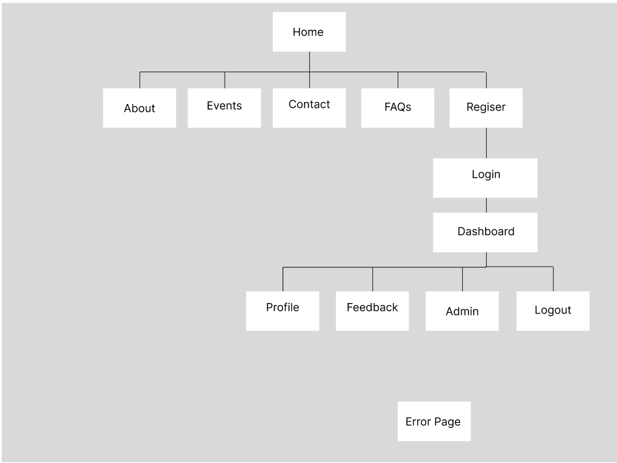
Wireframes:
Home Page:
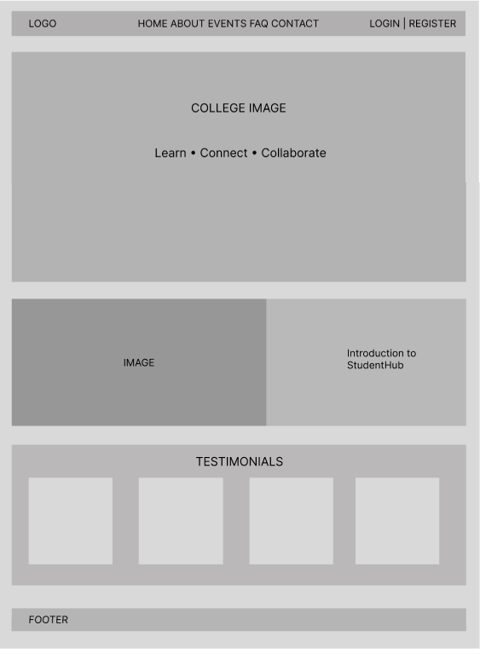
About:
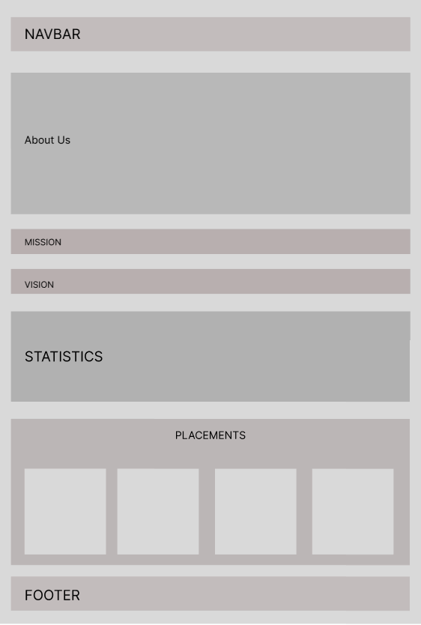
Register Page:
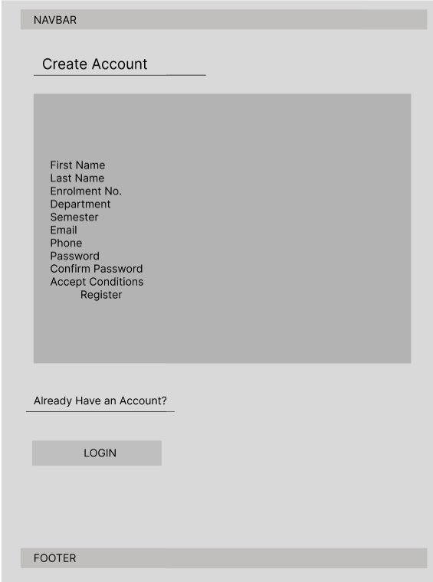
Login Page:
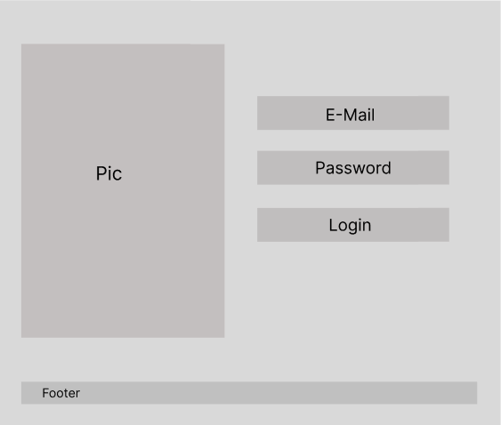
Dashboard:
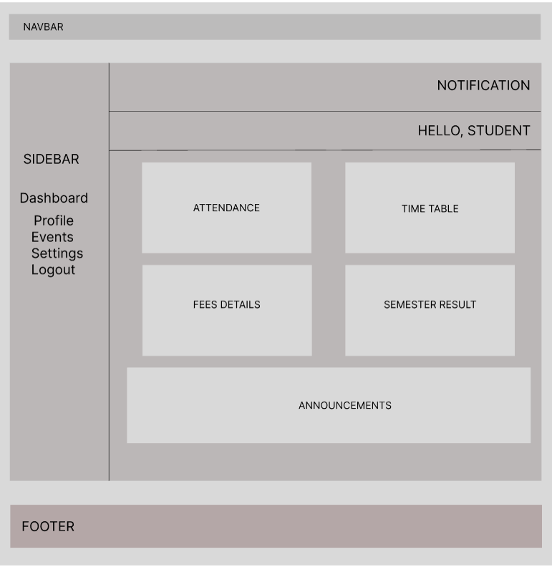
Events-Info Page:
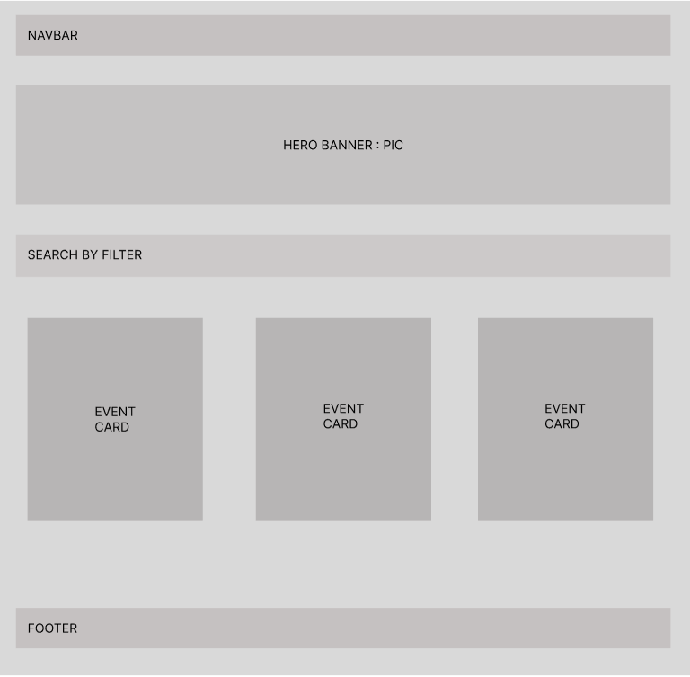
Profile Page:
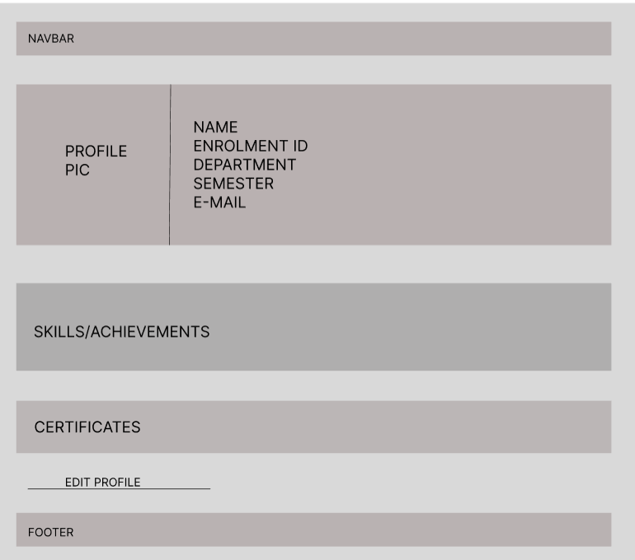
Contact Page:
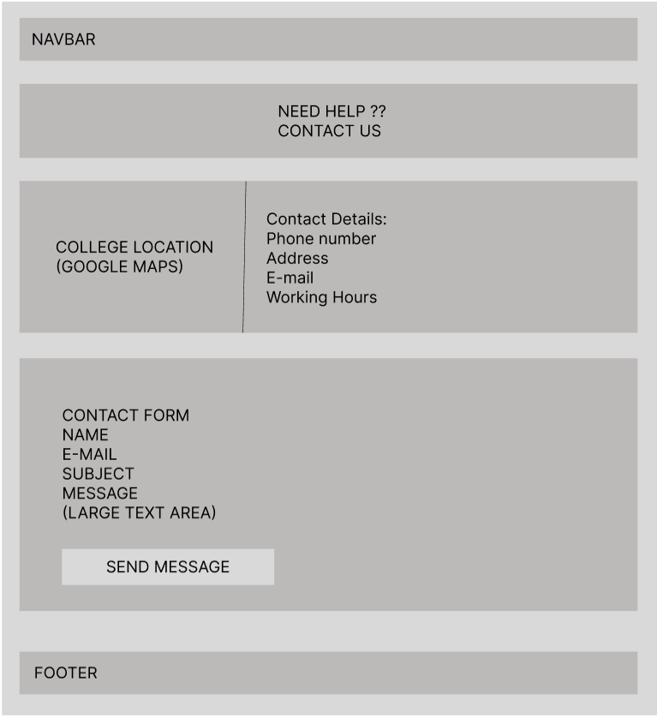
FAQs:
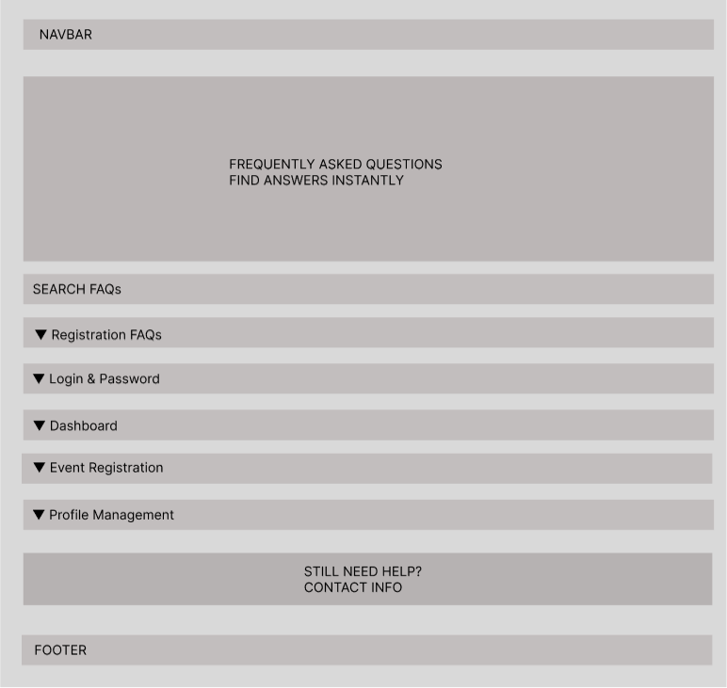
Feedback Page:
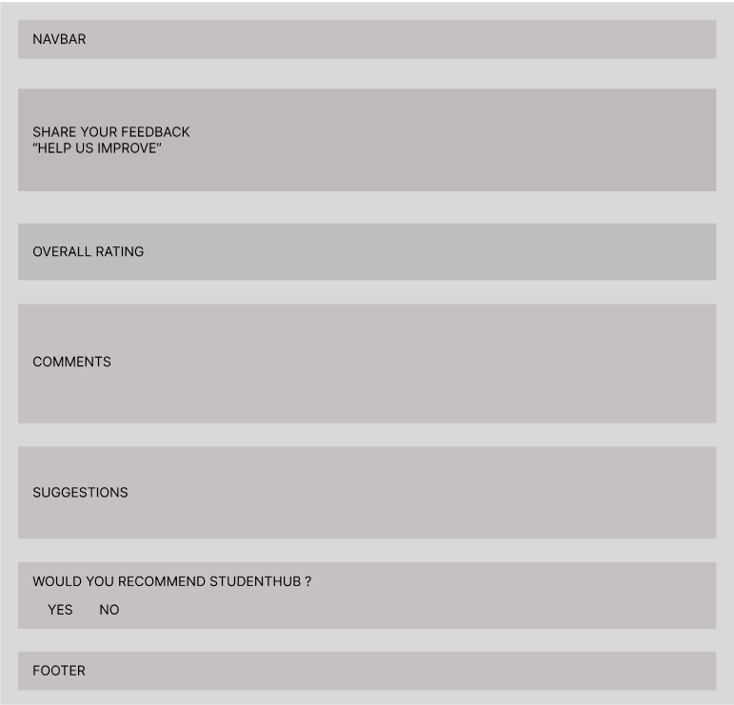
Folder Structure:
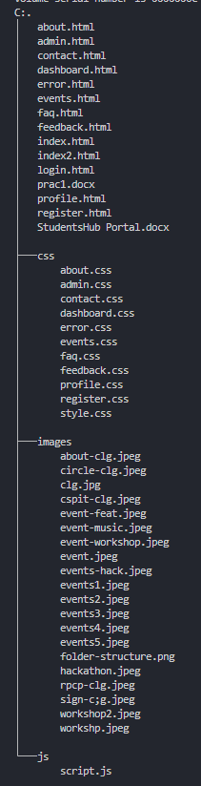
README file:
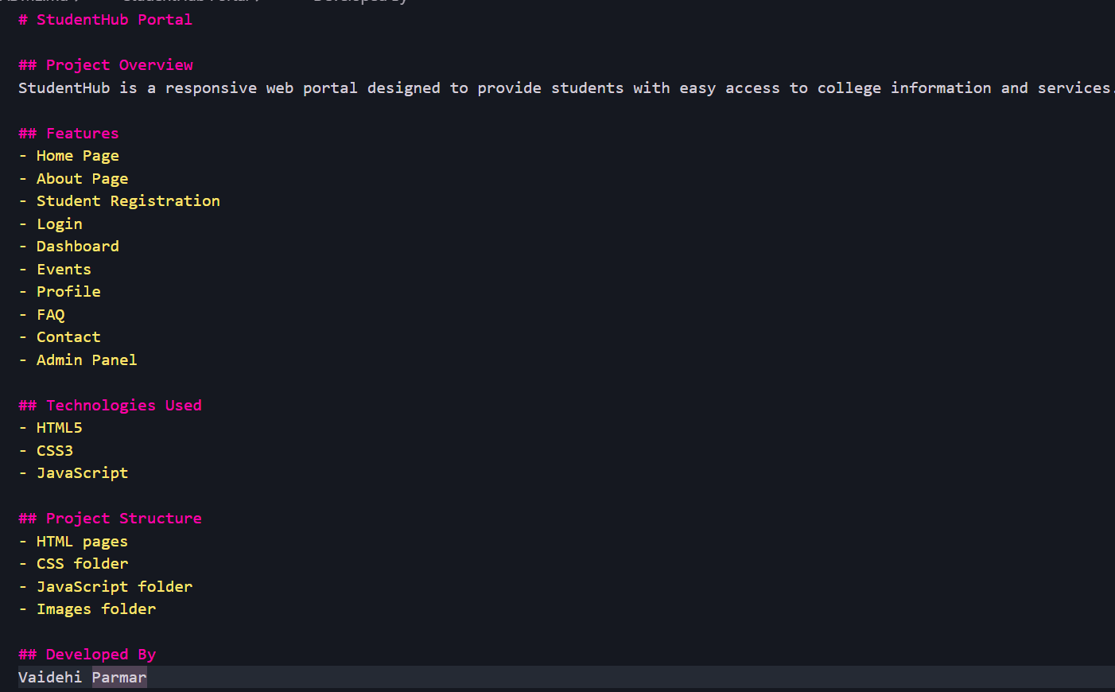

GitHub Repository:
Repo name: StudentsHub
Repo link: https://github.com/Cynthia758/StudentsHub
Requirement Analysis:
The StudentHub Portal requires separate user roles (Guest, Student, and Admin), a responsive and user-friendly interface, and modules for registration, login, dashboard, events, profile, FAQ, and contact. The system should provide smooth navigation and be structured for future backend integration.

