PRACTICAL 3:
Responsive UI Design using CSS Grid, Flexbox, and Bootstrap/Tailwind
Problem Definition:
Design responsive layouts for Home, About, Registration, Dashboard, and Events pages using CSS Grid and Flexbox. Optional to use CSS framework such as Bootstrap or Tailwind. Ensure mobile-first responsiveness.
Solution:
style.css:
*{
margin:0;
padding:0;
box-sizing:border-box;
}
html{
scroll-behavior:smooth;
}
body{
font-family:'Poppins',sans-serif;
background:#f8f7f2;
color:#222;
overflow-x:hidden;
}
:root{
--gold:#c8a64d;
--dark:#0d1728;
--white:#ffffff;
--light:#f8f7f2;
--shadow:0 15px 35px rgba(0,0,0,.18);
}
.container{
width:90%;
max-width:1200px;
margin:auto;
}
img{
width:100%;
display:block;
}
a{
text-decoration:none;
}
h1,h2,h3,h4{
font-family:'Playfair Display',serif;
}
section{
padding:10px 0;
}
.hero{
padding: 0px;
position: relative;
width: 100%;
min-height: 100vh;
background-image: url("../images/clg.jpg");
background-size: cover;
background-position: center;
background-repeat: no-repeat;
}
.overlay{
position:absolute;
top:0;
left:0;
width:100%;
height:100%;
background:rgba(0,0,0,.55);
}
.navbar{
width:100%;
padding:25px 7%;
display:flex;
justify-content:space-between;
align-items:center;
z-index:100;
}
.home-navbar{
position:absolute;
top:0;
left:0;
width:100%;
padding:25px 7%;
display:flex;
justify-content:space-between;
align-items:center;
z-index:100;
}
.logo a{
color:#fff;
font-size:34px;
font-weight:700;
letter-spacing:1px;
}
.nav-links{
display:flex;
gap:35px;
list-style:none;
}
.nav-links a{
color:#fff;
font-size:16px;
font-weight:500;
transition:.3s;
}
.nav-links a:hover{
color:var(--gold);
}
.nav-buttons{
display:flex;
gap:15px;
}
.login-btn{
color:#fff;
border:1px solid rgba(255,255,255,.5);
padding:12px 28px;
border-radius:40px;
transition:.3s;
}
.login-btn:hover{
background:rgba(255,255,255,.15);
}
.register-btn{
background:var(--gold);
color:#fff;
padding:12px 28px;
border-radius:40px;
transition:.3s;
}
.register-btn:hover{
background:#b28f36;
}
.primary-btn{
background:var(--gold);
color:#fff;
padding:15px 35px;
border-radius:40px;
display:inline-block;
transition:.35s;
}
.primary-btn:hover{
transform:translateY(-4px);
background:#b28f36;
}
.secondary-btn{
border:1px solid rgba(255,255,255,.5);
color:#fff;
padding:15px 35px;
border-radius:40px;
transition:.35s;
}
.secondary-btn:hover{
background:rgba(255,255,255,.12);
}
.home-hero-content{
min-height:100vh;
display:flex;
justify-content:center;
align-items:center;
flex-direction:column;
text-align:center;
color:#fff;
position:relative;
z-index:5;
}
.campus {
font-size: 60px;
}
.tagline{
color:#f2dc93;
letter-spacing:4px;
font-size:15px;
margin-bottom:18px;
}
.hero-content h1{
font-size:400px;
line-height:1.1;
margin-bottom:25px;
}
.description{
width:700px;
max-width:100%;
font-size:18px;
line-height:1.8;
opacity:.9;
margin-bottom:40px;
}
.hero-buttons{
display:flex;
gap:20px;
}
.hero-content{
animation:fadeUp 1.2s ease;
}
@keyframes fadeUp{
from{
opacity:0;
transform:translateY(40px);
}
to{
opacity:1;
transform:translateY(0);
}
}
@media(max-width:992px){
.nav-links{
display:none;
}
.hero-content h1{
font-size:58px;
}
.description{
width:100%;
}
}
@media(max-width:768px){
.hero-content h1{
font-size:42px;
}
.hero-buttons{
flex-direction:column;
}
.nav-buttons{
display:none;
}
.logo a{
font-size:28px;
}
}
.about {
padding: 120px 8%;
background: #faf8f3;
}
.section-tag{
font-weight: 800;
font-size: 40px;
}
.event-grid{
display:grid;
grid-template-columns:repeat(auto-fit,minmax(330px,1fr));
gap:35px;
margin-top:50px;
}
.event-card{
background:#fff;
border-radius:20px;
overflow:hidden;
display:flex;
flex-direction:column;
height:100%;
box-shadow:0 10px 30px rgba(0,0,0,.08);
transition:.4s;
}
.event-card img {
width:100%;
height:400px;
object-fit: cover;
display: block;
}
.event-card:hover{
transform:translateY(-12px);
box-shadow:0 18px 45px rgba(200,166,77,.25);
}
.event-info{
padding:25px;
display:flex;
flex-direction:column;
flex:1;
}
.event-info span{
display:inline-block;
font-size:13px;
font-weight:600;
letter-spacing:2px;
text-transform:uppercase;
color:#c8a64d;
margin-bottom:12px;
}
.event-info h3{
font-size:30px;
margin-bottom:15px;
color:#1b1b1b;
line-height:1.2;
}
.event-info p{
font-size:16px;
color:#666;
line-height:1.8;
margin-bottom:25px;
}
.event-info a{
color:#c8a64d;
font-weight:600;
font-size:15px;
transition:.3s;
}
.event-info a:hover{
padding-left:10px;
}
.section-heading{
text-align:center;
margin-bottom:70px;
}
.section-heading h2{
font-size:50px;
margin:15px 0;
}
.section-heading p{
color:#666;
font-size:18px;
}
.event-card::after{
content:"";
width:60px;
height:3px;
background:#c8a64d;
display:block;
margin:0 25px 25px;
transition:.4s;
}
.event-card:hover::after{
width:120px;
}
.testimonials{
background:#faf8f3;
padding:110px 0;
}
.testimonial-grid{
display:grid;
grid-template-columns:repeat(auto-fit,minmax(320px,1fr));
gap:35px;
margin-top:10px;
}
.testimonial-card{
position:relative;
background:#fff;
padding:40px 35px;
border-radius:20px;
box-shadow:0 10px 30px rgba(0,0,0,.08);
transition:.4s ease;
overflow:hidden;
}
.testimonial-card:hover{
transform:translateY(-10px);
box-shadow:0 18px 40px rgba(200,166,77,.20);
}
.quote{
position:absolute;
top:15px;
right:25px;
font-size:80px;
color:rgba(200,166,77,.12);
font-family:serif;
}
.stars{
color:#c8a64d;
font-size:18px;
letter-spacing:4px;
margin-bottom:20px;
}
.testimonial-card p{
color:#666;
font-size:15px;
line-height:1.8;
margin-bottom:25px;
}
.testimonial-card h4{
font-size:24px;
color:#222;
margin-bottom:5px;
padding-top:18px;
border-top:1px solid rgba(200,166,77,.4);
}
.testimonial-card span{
color:#888;
font-size:14px;
}
.about{
background:#faf8f3;
padding:120px 0;
}
.about .container{
max-width:900px;
margin:auto;
}
.about-content{
position:relative;
background:linear-gradient(135deg,#ffffff,#fcfaf4);
padding:60px;
border-radius:25px;
box-shadow:0 20px 45px rgba(0,0,0,.08);
transition:all .4s ease;
}
.about-content:hover{
transform:translateY(-8px);
box-shadow:0 25px 60px rgba(200,166,77,.18);
}
.about-content::before{
content:"";
position:absolute;
left:35px;
top:60px;
width:5px;
height:90px;
background:#c8a64d;
border-radius:20px;
}
.section-tag{
color:#c8a64d;
font-size:14px;
letter-spacing:3px;
text-transform:uppercase;
font-weight:600;
}
.about-content h2{
font-size:46px;
line-height:1.2;
color:#222;
margin:20px 0;
}
.about-content > p{
color:#666;
font-size:16px;
line-height:1.9;
margin-bottom:40px;
}
.about-features{
display:grid;
grid-template-columns:repeat(2,1fr);
gap:20px;
margin-bottom:40px;
}
.feature{
background:#faf8f3;
padding:22px;
border-radius:16px;
border:1px solid transparent;
transition:all .35s ease;
}
.feature:hover{
background:#fff;
border-color:#c8a64d;
transform:translateY(-6px);
box-shadow:0 12px 30px rgba(200,166,77,.12);
}
.feature h4{
font-size:20px;
color:#222;
margin-bottom:10px;
}
.feature p{
margin:0;
color:#666;
font-size:14px;
line-height:1.7;
}
.about .primary-btn{
margin-top:10px;
}
@media(max-width:768px){
.about{
padding:80px 0;
}
.about-content{
padding:40px;
}
.about-content::before{
display:none;
}
.about-content h2{
font-size:34px;
}
.about-features{
grid-template-columns:1fr;
}
}
.page-hero{
background:var(--light);
padding:170px 0 120px;
text-align:center;
}

.hero-content{
max-width:850px;
margin:auto;
min-height:auto;
color:var(--dark);
}

.hero-content span{
display:inline-block;
color:var(--gold);
font-size:14px;
letter-spacing:3px;
text-transform:uppercase;
font-weight:600;
margin-bottom:20px;
}
.hero-content h1{
font-size:70px;
line-height:1.1;
margin-bottom:25px;
}
.hero-content p{
width:700px;
max-width:100%;
margin:auto;
color:#666;
font-size:18px;
line-height:1.9;
}
.about-main{
background:var(--light);
padding:110px 0;
}
.about-text{
max-width:850px;
margin:auto;
text-align:center;
background:#fff;
padding:60px;
border-radius:25px;
box-shadow:0 20px 45px rgba(0,0,0,.08);
transition:.4s;
}
.about-text:hover{
transform:translateY(-8px);
box-shadow:0 25px 60px rgba(200,166,77,.18);
}
.about-text span{
display:inline-block;
color:var(--gold);
letter-spacing:3px;
text-transform:uppercase;
font-size:14px;
font-weight:600;
margin-bottom:18px;
}
.about-text h2{
font-size:48px;
color:#222;
margin-bottom:25px;
}
.about-text p{
color:#666;
line-height:1.9;
font-size:16px;
margin-bottom:20px;
}
.mission{
background:#fff;
padding:110px 0;
}
.mission .container{
display:grid;
grid-template-columns:repeat(auto-fit,minmax(320px,1fr));
gap:35px;
}
.mission-card{
background:var(--light);
padding:40px;
border-radius:20px;
box-shadow:0 10px 30px rgba(0,0,0,.08);
transition:.4s;
}
.mission-card:hover{
transform:translateY(-12px);
box-shadow:0 18px 45px rgba(200,166,77,.25);
}
.mission-card h3{
color:#222;
font-size:32px;
margin-bottom:18px;
}
.mission-card p{
color:#666;
line-height:1.8;
}
.why-us{
background:var(--light);
padding:110px 0;
}
.feature-grid{
display:grid;
grid-template-columns:repeat(auto-fit,minmax(280px,1fr));
gap:35px;
}

.feature-card{
background:#fff;
padding:35px;
border-radius:20px;
box-shadow:0 10px 30px rgba(0,0,0,.08);
transition:.4s;
}
.feature-card:hover{
transform:translateY(-10px);
box-shadow:0 18px 40px rgba(200,166,77,.20);
}

.feature-card h3{
font-size:28px;
margin-bottom:18px;
}
.feature-card p{
color:#666;
line-height:1.8;
}
.statistics{
background:#fff;
padding:110px 0;
}
.statistics .container{
display:grid;
grid-template-columns:repeat(auto-fit,minmax(220px,1fr));
gap:35px;
}
.stat{
text-align:center;
padding:35px;
background:var(--light);
border-radius:20px;
transition:.35s;
}
.stat:hover{
transform:translateY(-8px);
box-shadow:0 15px 35px rgba(200,166,77,.15);
}
.stat h2{
font-size:52px;
color:var(--gold);
margin-bottom:10px;
}
.stat p{
color:#666;
font-size:17px;
}

.register-card button {
width: 100%;
margin-top: 25px;
padding: 14px;
border: none;
border-radius: 30px;
background: var(--gold);
color: #fff;
font-size: 16px;
cursor: pointer;
transition: .3s;
}

.register-card button:hover {
background: #b28f36;
}

#themeToggle {
width: auto;
margin-top: 0;
padding: 10px 16px;
border: 1px solid var(--gold);
border-radius: 25px;
background: transparent;
color: var(--dark);
font-family: 'Poppins', sans-serif;
font-size: 14px;
cursor: pointer;
transition: .3s;
}
#themeToggle:hover {
background: var(--gold);
color: #fff;
}
body.dark-mode #themeToggle {
color: #fff;
}
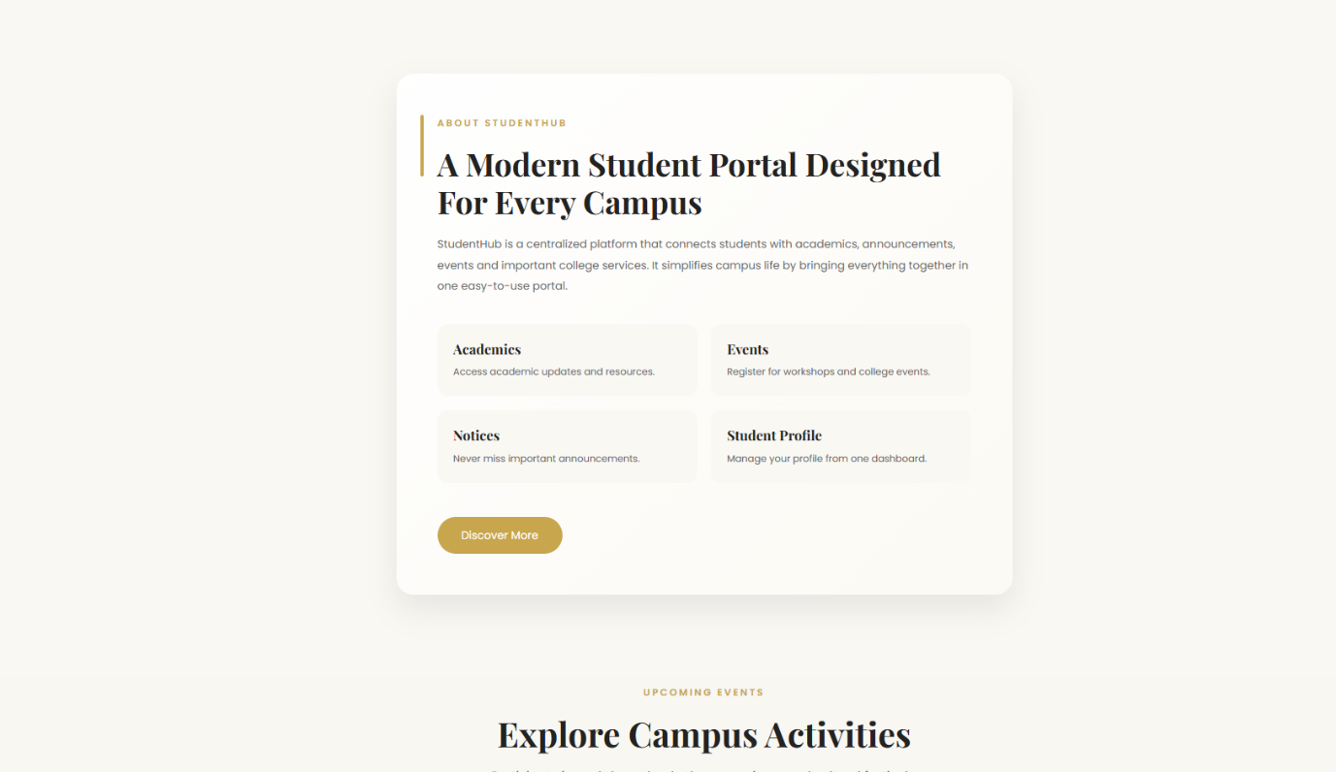
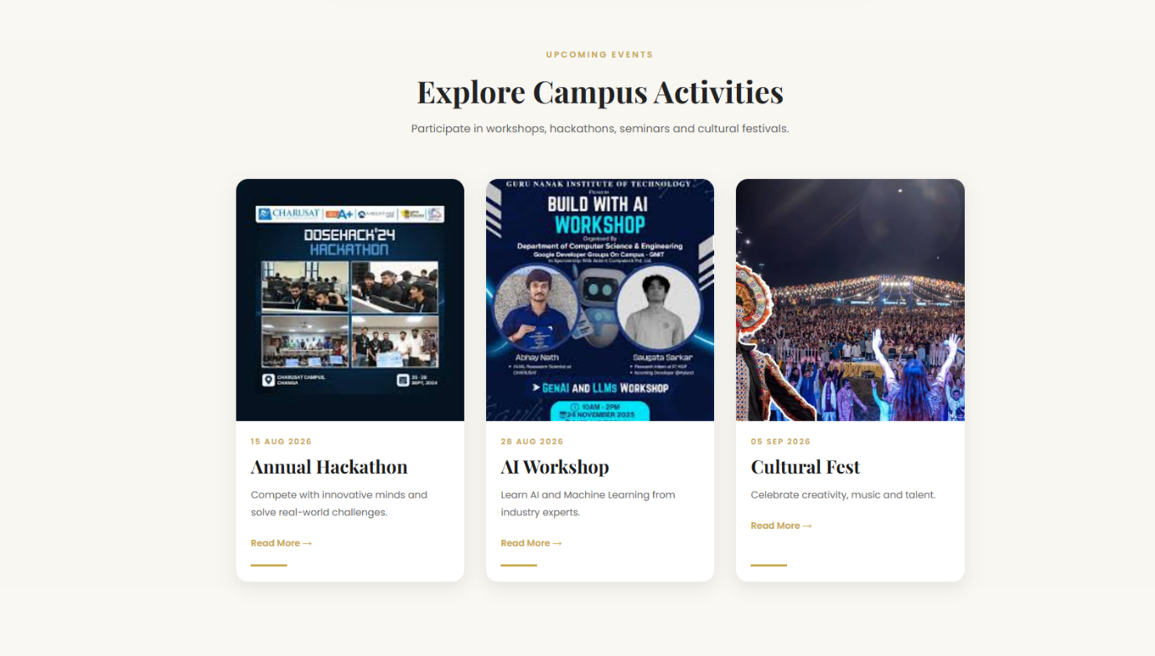
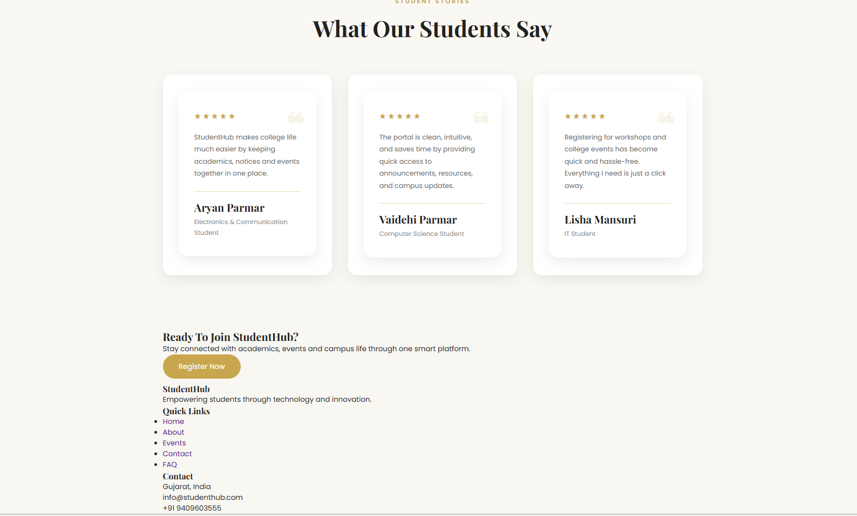
About.css:
*{
margin:0;
padding:0;
box-sizing:border-box;
}
html{
scroll-behavior:smooth;
}
body{
font-family:'Poppins',sans-serif;
background:#f8f7f2;
color:#222;
overflow-x:hidden;
}
:root{
--gold:#c8a64d;
--dark:#0d1728;
--white:#ffffff;
--light:#f8f7f2;
--shadow:0 15px 35px rgba(0,0,0,.18);
}
.navbar {
width: 100%;
padding:25px 7%;
display : flex;
justify-content: space-between;
align-items: center;
z-index:100;
}
.nav-links{
display:flex;
gap:35px;
list-style:none;

}
.nav-links a{
color:var(--dark);
font-size:16px;
font-weight:500;
transition:.3s;
}
.nav-links a:hover{
color:var(--gold);
}
.nav-buttons{
display:flex;
gap:15px;
}
.nav-buttons{
display:flex;
gap:15px;
}
.login-btn{
color:var(--gold);
border:1px solid var(--gold);
padding:12px 28px;
border-radius:40px;
transition:.3s;
}
.login-btn:hover{
background:rgba(255,255,255,.15);
}
.register-btn{
background:var(--gold);
color:#fff;
padding:12px 28px;
border-radius:40px;
transition:.3s;
}
.register-btn:hover{
background:#b28f36;
}
.page-hero{
position:relative;
height:80vh;
display:flex;
justify-content:center;
align-items:center;
text-align:center;
padding:0 8%;
overflow:hidden;
background:linear-gradient(
135deg,
#f8f7f2 0%,
#fcfaf4 55%,
#f4ebd8 100%
);
}

.page-hero::before{
content:"";
position:absolute;
width:450px;
height:450px;
border-radius:50%;
background:rgba(200,166,77,.2);
top:-180px;
right:-120px;
}

.page-hero::after{
content:"";
position:absolute;
width:320px;
height:320px;
border-radius:50%;
background:rgba(200,166,77,.3);
bottom:-120px;
left:-80px;
}

.about-hero-content{
position:relative;
z-index:2;
max-width:850px;
}

.about-hero-content span{
display:inline-block;
color:var(--gold);
letter-spacing:4px;
text-transform:uppercase;
font-size:14px;
font-weight:600;
margin-bottom:20px;
}

.about-hero-content h1{
font-size:68px;
color:var(--dark);
line-height:1.1;
margin-bottom:25px;
font-family:'Playfair Display',serif;
}

.about-hero-content p{
max-width:680px;
margin:auto;
color:#666;
font-size:18px;
line-height:1.8;
}

.hero-stats{
margin-top:60px;
display:flex;
justify-content:center;
gap:30px;
flex-wrap:wrap;
}

.hero-card{
width:180px;
background:#fff;
padding:28px;
border-radius:22px;
box-shadow:0 15px 35px rgba(0,0,0,.08);
transition:.4s;
animation:floatCard 4s ease-in-out infinite;
}

.hero-card:nth-child(2){
animation-delay:.6s;
}

.hero-card:nth-child(3){
animation-delay:1.2s;
}

.hero-card:hover{
transform:translateY(-12px);
box-shadow:0 25px 45px rgba(200,166,77,.25);
}

.hero-card h3{
color:var(--gold);
font-size:42px;
margin-bottom:10px;
font-family:'Playfair Display',serif;
}

.hero-card p{
color:#666;
font-size:16px;
font-weight:500;
}

@keyframes floatCard{

0%{
transform:translateY(0);
}

50%{
transform:translateY(-12px);
}

100%{
transform:translateY(0);
}

}

@media(max-width:768px){

.page-hero{
height:auto;
padding:120px 20px 80px;
}

.about-hero-content h1{
font-size:42px;
}

.about-hero-content p{
font-size:16px;
}

.hero-stats{
gap:20px;
margin-top:40px;
}

.hero-card{
width:150px;
padding:22px;
}

.hero-card h3{
font-size:32px;
}

}
/* ================= REGISTER FORM BUTTON ================= */

.register-card button {
width: 100%;
margin-top: 25px;
padding: 14px;
border: none;
border-radius: 30px;
background: var(--gold);
color: #fff;
font-size: 16px;
cursor: pointer;
transition: .3s;
}

.register-card button:hover {
background: #b28f36;
}

/* ================= THEME SWITCHER ================= */

#themeToggle {
width: auto;
margin-top: 0;
padding: 10px 16px;
border: 1px solid var(--gold);
border-radius: 25px;
background: transparent;
color: var(--dark);
font-family: 'Poppins', sans-serif;
font-size: 14px;
cursor: pointer;
transition: .3s;
}

#themeToggle:hover {
background: var(--gold);
color: #fff;
}

body.dark-mode #themeToggle {
color: #fff;
}
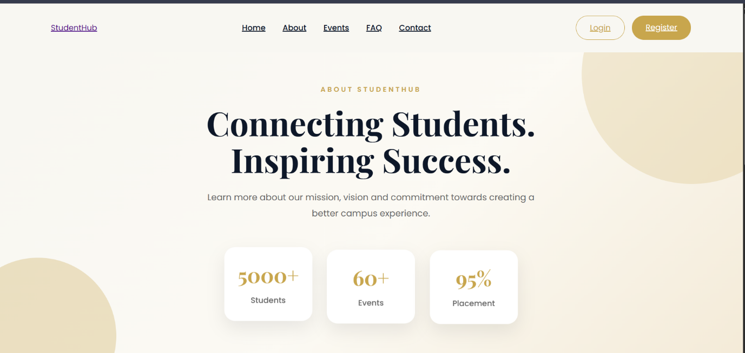
register.css:
*{
margin:0;
padding:0;
box-sizing:border-box;
}
html{
scroll-behavior:smooth;
}
body{
font-family:'Poppins',sans-serif;
background:#f8f7f2;
color:#222;
overflow-x:hidden;
}
:root{
--gold:#c8a64d;
--dark:#0d1728;
--white:#ffffff;
--light:#f8f7f2;
--shadow:0 15px 35px rgba(0,0,0,.18);
}
.container{
width:90%;
max-width:1200px;
margin:auto;
}
a{
text-decoration:none;
}
h1,h2,h3,h4{
font-family:'Playfair Display',serif;
}
section{
padding:10px 0;
}
.navbar{
width:100%;
padding:25px 7%;
display:flex;
justify-content:space-between;
align-items:center;
z-index:100;
}
.home-navbar{
position:absolute;
top:0;
left:0;
width:100%;
padding:25px 7%;
display:flex;
justify-content:space-between;
align-items:center;
z-index:100;
}
.logo a{
color:var(--dark);
font-size:34px;
font-weight:700;
letter-spacing:1px;
}
.nav-links{
display:flex;
gap:35px;
list-style:none;
}
.nav-links a{
color:var(--dark);
font-size:16px;
font-weight:500;
transition:.3s;
}
.nav-links a:hover{
color:var(--gold);
}
.nav-buttons{
display:flex;
gap:15px;
}
.login-btn{
color:var(--dark);
border:1px var(--gold);
padding:12px 28px;
border-radius:40px;
transition:.3s;
}
.login-btn:hover{
background:rgba(255,255,255,.15);
}
.register-btn{
background:var(--gold);
color:#fff;
padding:12px 28px;
border-radius:40px;
transition:.3s;
}
.register-btn:hover{
background:#b28f36;
}
.primary-btn{
background:var(--gold);
color:#fff;
padding:15px 35px;
border-radius:40px;
display:inline-block;
transition:.35s;
}
.primary-btn:hover{
transform:translateY(-4px);
background:#b28f36;
}
.secondary-btn{
border:1px solid rgba(255,255,255,.5);
color:#fff;
padding:15px 35px;
border-radius:40px;
transition:.35s;
}
.secondary-btn:hover{
background:rgba(255,255,255,.12);
}
.register-page{
background:var(--light);
min-height:100vh;
padding:120px 8% 70px;
display:flex;
justify-content:center;
align-items:center;
}

.register-container{
width:100%;
max-width:1150px;
display:grid;
grid-template-columns:1fr 1.1fr;
gap:60px;
align-items:center;
}
.register-left span{
color:var(--gold);
letter-spacing:3px;
font-size:14px;
font-weight:600;
}

.register-left h1{
font-size:42px;
color:var(--dark);
margin:18px 0;
line-height:1.3;
}

.register-left p{
color:#666;
line-height:1.8;
margin-bottom:35px;
}

.register-left ul{
list-style:none;
}

.register-left ul li{
margin:15px 0;
color:#444;
font-size:16px;
}
.register-card{
background:#fff;
padding:40px;
border-radius:18px;
box-shadow:0 10px 25px rgba(0,0,0,.08);
}

.register-card h2{
text-align:center;
margin-bottom:25px;
color:var(--dark);
font-size:34px;
}
form{
display:flex;
flex-direction:column;
}

label{
margin:12px 0 6px;
font-size:15px;
font-weight:500;
color:#444;
}

input,
select{
width:100%;
padding:13px 16px;
border:1px solid #ddd;
border-radius:10px;
font-size:15px;
outline:none;
transition:.3s;
background:#fafafa;
}

input:focus,
select:focus{
border-color:var(--gold);
background:#fff;
}

.login-link{
text-align:center;
margin-top:20px;
color:#666;
}

.login-link a{
color:var(--gold);
font-weight:600;
}

.login-link a:hover{
text-decoration:underline;
}
@media(max-width:900px){

.register-container{
grid-template-columns:1fr;
}

.register-left{
text-align:center;
}

.register-left h1{
font-size:34px;
}

}

@media(max-width:768px){

.nav-links,
.nav-buttons{
display:none;
}

.register-page{
padding:100px 20px 50px;
}

.register-card{
padding:30px;
}

}
/* ================= THEME SWITCHER ================= */

body {
transition: background-color 0.3s ease, color 0.3s ease;
}

body.dark-mode {
--dark: #f5f5f5;
--white: #151515;
--light: #202020;

background: #202020;
color: #f5f5f5;
}

/* Common dark mode elements */

body.dark-mode .navbar {
background: #151515;
}

body.dark-mode .nav-links a {
color: #f5f5f5;
}

body.dark-mode .logo a {
color: #f5f5f5;
}

body.dark-mode .login-card,
body.dark-mode .register-card,
body.dark-mode .info-card,
body.dark-mode .event-card,
body.dark-mode .testimonial-card,
body.dark-mode .about-content,
body.dark-mode .feature,
body.dark-mode .mission-card,
body.dark-mode .feature-card,
body.dark-mode .stat,
body.dark-mode .stat-card,
body.dark-mode .dashboard-section,
body.dark-mode .welcome-card,
body.dark-mode form {
background: #151515;
color: #f5f5f5;
}

body.dark-mode h1,
body.dark-mode h2,
body.dark-mode h3,
body.dark-mode h4 {
color: #f5f5f5;
}

body.dark-mode p {
color: #cccccc;
}

body.dark-mode input,
body.dark-mode select,
body.dark-mode textarea {
background: #202020;
color: #ffffff;
border-color: #555;
}

body.dark-mode input::placeholder,
body.dark-mode textarea::placeholder {
color: #aaa;
}

/* Theme button */

#themeToggle {
border: 1px solid var(--gold);
background: transparent;
color: var(--dark);
padding: 10px 16px;
border-radius: 25px;
cursor: pointer;
font-family: 'Poppins', sans-serif;
font-size: 14px;
transition: 0.3s;
}
:hover {
background: var(--gold);
color: #fff;
}

body.dark-mode #themeToggle {
color: #fff;
}
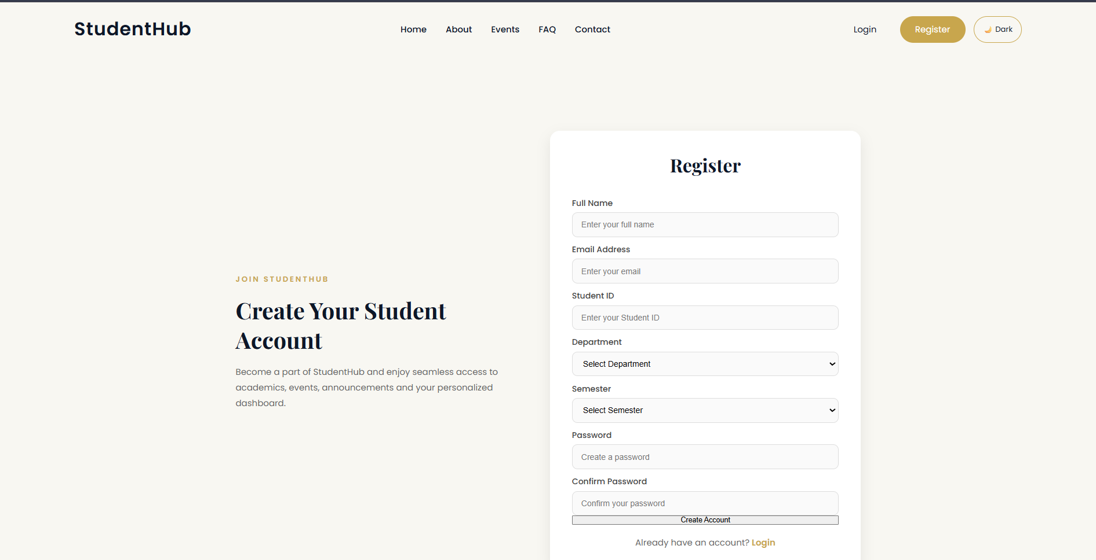
profile.css:
/* =====================================================
STUDENTHUB PROFILE PAGE
ELEGANT • MINIMAL • SOPHISTICATED
===================================================== */

/* =====================================================
ROOT COLORS
===================================================== */

:root {
--gold: #c8a64d;
--dark: #0d1728;
--white: #ffffff;
--light: #f8f7f2;

--shadow: 0 15px 35px rgba(0, 0, 0, 0.18);

/* Additional supporting colors */
--text: #30343b;
--muted: #777c84;

--border: #e5e1d7;

--gold-soft: #f5f0e3;
--gold-light: #dfcf9f;

--green: #657b69;
--green-soft: #edf2ed;
}

/* =====================================================
RESET
===================================================== */

* {
margin: 0;
padding: 0;
box-sizing: border-box;
}

html {
scroll-behavior: smooth;
}

body {
font-family: 'DM Sans', sans-serif;

background-color: var(--light);

color: var(--text);

min-height: 100vh;
}

/* =====================================================
HEADER
===================================================== */

header {
background-color: rgba(255, 255, 255, 0.97);

border-bottom: 1px solid var(--border);

position: sticky;

top: 0;

z-index: 100;
}

/* =====================================================
NAVBAR
===================================================== */

.navbar {
width: 90%;

max-width: 1200px;

min-height: 76px;

margin: auto;

display: flex;

align-items: center;

justify-content: space-between;
}

/* =====================================================
LOGO
===================================================== */

.logo a {
text-decoration: none;

color: var(--dark);

font-family: 'Playfair Display', serif;

font-size: 28px;

font-weight: 600;

letter-spacing: -0.5px;
}

.logo a::after {
content: ".";

color: var(--gold);
}

/* =====================================================
NAVIGATION LINKS
===================================================== */

.nav-links {
display: flex;

align-items: center;

gap: 32px;

list-style: none;
}

.nav-links a {
text-decoration: none;

color: #5f636a;

font-size: 13px;

font-weight: 500;

position: relative;

transition: color 0.25s ease;
}

.nav-links a::after {
content: "";

position: absolute;

left: 50%;

bottom: -8px;

width: 0;

height: 1px;

background-color: var(--gold);

transform: translateX(-50%);

transition: width 0.25s ease;
}

.nav-links a:hover {
color: var(--dark);
}

.nav-links a:hover::after {
width: 100%;
}

/* =====================================================
LOGOUT BUTTON
===================================================== */

.nav-buttons {
display: flex;

align-items: center;
}

.login-btn {
text-decoration: none;

color: var(--dark);

border: 1px solid #cbc6ba;

padding: 9px 19px;

font-size: 12px;

font-weight: 500;

transition: all 0.25s ease;
}

.login-btn:hover {
background-color: var(--dark);

border-color: var(--dark);

color: var(--white);
}

/* =====================================================
PROFILE SECTION
===================================================== */

.profile {
min-height: calc(100vh - 76px);

padding: 70px 0 90px;

background-color: var(--light);
}

/* =====================================================
MAIN CONTAINER
===================================================== */

.container {
width: 88%;

max-width: 1100px;

margin: auto;

display: grid;

grid-template-columns: 350px 1fr;

gap: 65px;

align-items: start;
}

/* =====================================================
PROFILE CARD
===================================================== */

.profile-card {
background-color: var(--white);

border: 1px solid var(--border);

border-radius: 8px;

padding: 42px 35px;

text-align: center;

position: relative;

box-shadow: 0 10px 30px rgba(13, 23, 40, 0.055);

transition: transform 0.3s ease,
box-shadow 0.3s ease;
}

.profile-card:hover {
transform: translateY(-3px);

box-shadow: 0 16px 35px rgba(13, 23, 40, 0.09);
}

/* Small gold line */

.profile-card::before {
content: "";

position: absolute;

top: 0;

left: 50%;

width: 48px;

height: 2px;

background-color: var(--gold);

transform: translateX(-50%);
}

/* =====================================================
PROFILE IMAGE
===================================================== */

.profile-card img {
width: 125px;

height: 125px;

object-fit: cover;

border-radius: 50%;

border: 1px solid var(--gold-light);

padding: 5px;

background-color: var(--white);

margin-bottom: 22px;
}

/* =====================================================
STUDENT NAME
===================================================== */

.profile-card h2 {
color: var(--dark);

font-family: 'Playfair Display', serif;

font-size: 28px;

font-weight: 500;

letter-spacing: -0.3px;

margin-bottom: 9px;
}

/* =====================================================
STUDENT DETAILS
===================================================== */

.profile-card p {
color: var(--muted);

font-size: 12px;

line-height: 1.8;
}

.profile-card p:last-of-type {
color: var(--gold);

font-size: 11px;

margin-top: 3px;
}

/* =====================================================
EDIT PROFILE BUTTON
===================================================== */

.primary-btn {
display: inline-block;

margin-top: 24px;

padding: 10px 25px;

background-color: var(--dark);

color: var(--white);

text-decoration: none;

border-radius: 3px;

font-size: 11px;

font-weight: 500;

transition: all 0.25s ease;
}

.primary-btn:hover {
background-color: var(--gold);

color: var(--white);

transform: translateY(-1px);

box-shadow: 0 6px 15px rgba(200, 166, 77, 0.2);
}

/* =====================================================
PERSONAL INFORMATION
===================================================== */

.profile-info {
padding-top: 5px;
}

/* =====================================================
SECTION HEADING
===================================================== */

.profile-info h2 {
color: var(--dark);

font-family: 'Playfair Display', serif;

font-size: 31px;

font-weight: 500;

letter-spacing: -0.4px;

padding-bottom: 17px;

margin-bottom: 5px;

position: relative;
}

.profile-info h2::after {
content: "";

position: absolute;

left: 0;

bottom: 0;

width: 45px;

height: 2px;

background-color: var(--gold);
}

.profile-info ul {
list-style: none;

margin-top: 15px;
}

.profile-info li {
min-height: 65px;

display: flex;

align-items: center;

border-bottom: 1px solid var(--border);

color: var(--muted);

font-size: 13px;

transition: background-color 0.25s ease,
padding-left 0.25s ease;
}

.profile-info li:first-child {
border-top: 1px solid var(--border);
}

.profile-info li:hover {
background-color: rgba(255, 255, 255, 0.55);

padding-left: 6px;
}

/* =====================================================
INFORMATION LABELS
===================================================== */

.profile-info li strong {
width: 150px;

color: var(--dark);

font-size: 12px;

font-weight: 600;
}

/* =====================================================
ATTENDANCE
===================================================== */

.profile-info li:nth-child(4) {
color: var(--green);

font-weight: 500;
}

/* =====================================================
ACHIEVEMENTS
===================================================== */

.profile-info li:nth-child(5) {
color: var(--gold);

font-weight: 600;
}

/* =====================================================
TABLET
===================================================== */

@media (max-width: 900px) {

.navbar {
width: 92%;
}

.container {
width: 90%;

grid-template-columns: 310px 1fr;

gap: 40px;
}

.profile-card {
padding: 38px 25px;
}

.profile-info h2 {
font-size: 28px;
}
}

/* =====================================================
MOBILE
===================================================== */

@media (max-width: 700px) {

.navbar {
min-height: auto;

padding: 17px 0;

flex-wrap: wrap;

gap: 14px;
}

.logo {
width: 100%;

text-align: center;
}

.nav-links {
order: 3;

width: 100%;

justify-content: center;

gap: 18px;
}

.nav-links a {
font-size: 11px;
}

.login-btn {
padding: 8px 16px;
}

.profile {
padding: 45px 0 65px;
}

.container {
width: 90%;

grid-template-columns: 1fr;

gap: 42px;
}

.profile-card {
padding: 40px 25px;
}

.profile-info {
padding-top: 0;
}

.profile-info h2 {
font-size: 27px;
}
}

/* =====================================================
SMALL MOBILE
===================================================== */

@media (max-width: 430px) {

.nav-links {
gap: 12px;
}

.container {
width: 92%;
}

.profile-card img {
width: 110px;

height: 110px;
}

.profile-card h2 {
font-size: 25px;
}

.profile-info h2 {
font-size: 25px;
}

.profile-info li {
min-height: 72px;

flex-direction: column;

align-items: flex-start;

justify-content: center;

gap: 4px;
}

.profile-info li strong {
width: auto;
}
}
/* ================= REGISTER FORM BUTTON ================= */

.register-card button {
width: 100%;
margin-top: 25px;
padding: 14px;
border: none;
border-radius: 30px;
background: var(--gold);
color: #fff;
font-size: 16px;
cursor: pointer;
transition: .3s;
}

.register-card button:hover {
background: #b28f36;
}

/* ================= THEME SWITCHER ================= */

#themeToggle {
width: auto;
margin-top: 0;
padding: 10px 16px;
border: 1px solid var(--gold);
border-radius: 25px;
background: transparent;
color: var(--dark);
font-family: 'Poppins', sans-serif;
font-size: 14px;
cursor: pointer;
transition: .3s;
}

#themeToggle:hover {
background: var(--gold);
color: #fff;
}

body.dark-mode #themeToggle {
color: #fff;
}
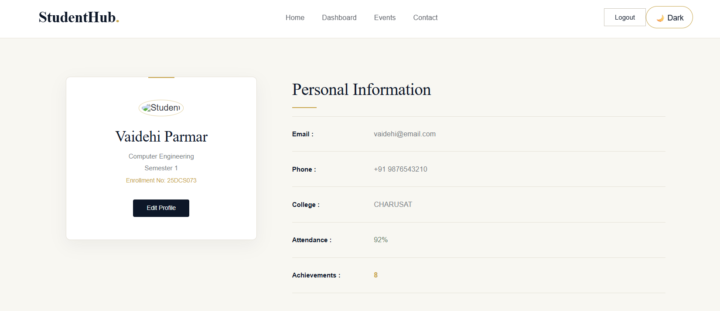
login.css:
*{
margin:0;
padding:0;
box-sizing:border-box;
}
html{
scroll-behavior:smooth;
}
body{
font-family:'Poppins',sans-serif;
background:#f8f7f2;
color:#222;
overflow-x:hidden;
}
:root{
--gold:#c8a64d;
--dark:#0d1728;
--white:#ffffff;
--light:#f8f7f2;
--shadow:0 15px 35px rgba(0,0,0,.18);
}
.container{
width:90%;
max-width:1200px;
margin:auto;
}
a{
text-decoration:none;
}
h1,h2,h3,h4{
font-family:'Playfair Display',serif;
}
section{
padding:10px 0;
}
/* ================= NAVBAR ================= */

.navbar{
width:100%;
padding:25px 7%;
display:flex;
justify-content:space-between;
align-items:center;
background:var(--white);
box-shadow:0 2px 12px rgba(0,0,0,.05);
}

.logo a{
font-size:32px;
font-weight:700;
color:var(--dark);
}

.nav-links{
display:flex;
list-style:none;
gap:35px;
}

.nav-links a{
color:#444;
transition:.3s;
}

.nav-links a:hover{
color:var(--gold);
}

.nav-buttons{
display:flex;
gap:15px;
}

.login-btn{
color:var(--dark);
border:1px solid var(--gold);
padding:10px 24px;
border-radius:30px;
}

.login-btn:hover{
background:var(--gold);
color:#fff;
}

.register-btn{
background:var(--gold);
color:#fff;
padding:10px 24px;
border-radius:30px;
}

.register-btn:hover{
background:#b28f36;
}

/* ================= LOGIN PAGE ================= */

.login-page{
background:var(--light);
min-height:calc(100vh - 90px);
display:flex;
justify-content:center;
align-items:center;
padding:60px 8%;
}

.overlay{
width:100%;
}

.login-container{
max-width:1100px;
margin:auto;
display:grid;
grid-template-columns:1fr 1fr;
gap:70px;
align-items:center;
}

/* Left */

.login-left span{
color:var(--gold);
letter-spacing:3px;
font-size:14px;
font-weight:600;
}

.login-left h1{
font-size:42px;
color:var(--dark);
margin:18px 0;
line-height:1.3;
}

.login-left p{
color:#666;
line-height:1.8;
}

/* Card */

.login-card{
background:#fff;
padding:40px;
border-radius:18px;
box-shadow:0 10px 25px rgba(0,0,0,.08);
}

.login-card h2{
text-align:center;
margin-bottom:25px;
color:var(--dark);
}

/* Form */

form{
display:flex;
flex-direction:column;
}

label{
margin:12px 0 6px;
font-weight:500;
color:#444;
}

input{
padding:13px 16px;
border:1px solid #ddd;
border-radius:10px;
font-size:15px;
outline:none;
transition:.3s;
}

input:focus{
border-color:var(--gold);
}

.login-options{
margin:18px 0;
display:flex;
justify-content:space-between;
align-items:center;
font-size:14px;
}

.login-options a{
color:var(--gold);
}

.login-options label{
display:flex;
align-items:center;
gap:8px;
margin:0;
}

button{
margin-top:10px;
padding:14px;
border:none;
border-radius:30px;
background:var(--gold);
color:#fff;
font-size:10px;
cursor:pointer;
transition:.3s;
}

button:hover{
background:#b28f36;
}

.register-link{
text-align:center;
margin-top:20px;
color:#666;
}

.register-link a{
color:var(--gold);
font-weight:600;
}

@media(max-width:900px){

.login-container{
grid-template-columns:1fr;
}

.login-left{
text-align:center;
}

.login-left h1{
font-size:34px;
}

}

@media(max-width:768px){

.nav-links,
.nav-buttons{
display:none;
}

.login-card{
padding:30px;
}

.login-page{
padding:40px 20px;
}

}
/* ================= REGISTER FORM BUTTON ================= */

.register-card button {
width: 100%;
margin-top: 25px;
padding: 14px;
border: none;
border-radius: 30px;
background: var(--gold);
color: #fff;
font-size: 16px;
cursor: pointer;
transition: .3s;
}

.register-card button:hover {
background: #b28f36;
}

/* ================= THEME SWITCHER ================= */

#themeToggle {
width: auto;
margin-top: 0;
padding: 10px 16px;
border: 1px solid var(--gold);
border-radius: 25px;
background: transparent;
color: var(--dark);
font-family: 'Poppins', sans-serif;
font-size: 14px;
cursor: pointer;
transition: .3s;
}

#themeToggle:hover {
background: var(--gold);
color: #fff;
}

body.dark-mode #themeToggle {
color: #fff;
}
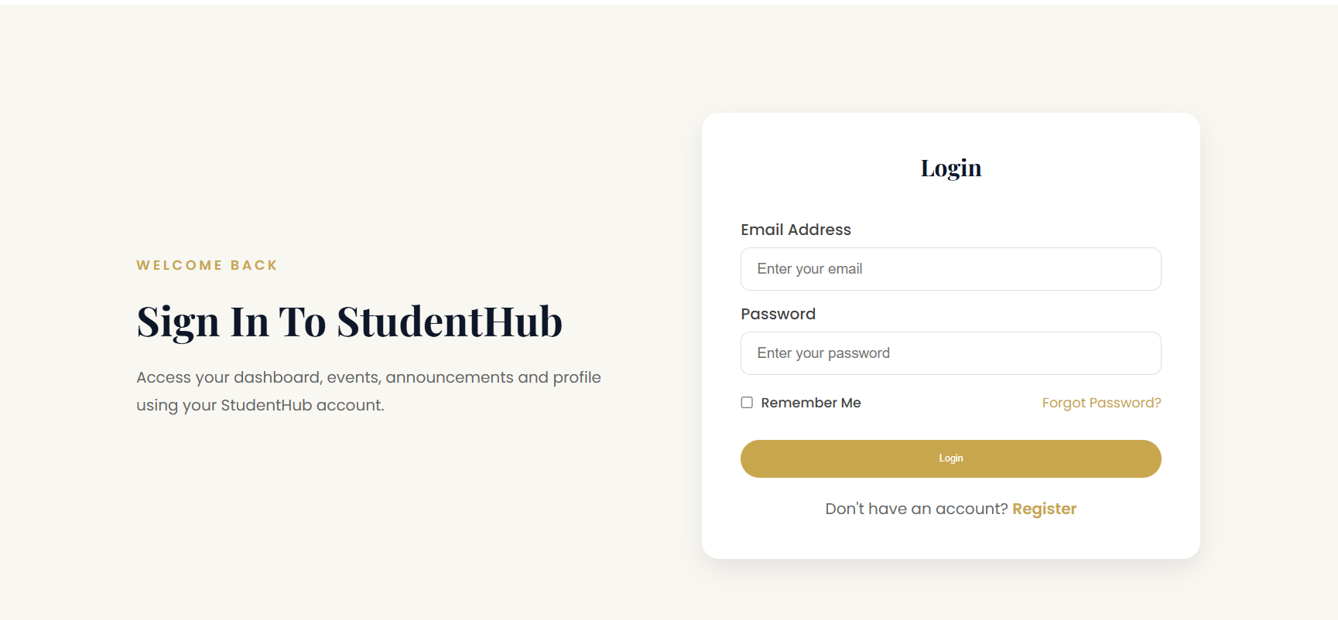
feedback.css:
:root {
--gold: #c8a64d;
--dark: #0d1728;
--white: #ffffff;
--light: #f8f7f2;
--shadow: 0 15px 35px rgba(0,0,0,.18);
}

* {
margin: 0;
padding: 0;
box-sizing: border-box;
}

html {
scroll-behavior: smooth;
}

body {
font-family: 'DM Sans', sans-serif;
background-color: var(--light);
color: var(--dark);
min-height: 100vh;
}

header {
width: 100%;
background-color: var(--white);
border-bottom: 1px solid rgba(13, 23, 40, 0.10);
position: sticky;
top: 0;
z-index: 100;
}

.navbar {
width: 90%;
max-width: 1200px;
min-height: 76px;
margin: auto;
display: flex;
align-items: center;
justify-content: space-between;
}

.logo a {
text-decoration: none;
color: var(--dark);
font-family: 'Playfair Display', serif;
font-size: 28px;
font-weight: 600;
letter-spacing: -0.5px;
}

.logo a::after {
content: ".";
color: var(--gold);
}

.nav-links {
display: flex;
align-items: center;
gap: 32px;
list-style: none;
}

.nav-links a {
text-decoration: none;
color: var(--dark);
font-size: 13px;
font-weight: 500;
position: relative;
transition: color 0.25s ease;
}

.nav-links a::after {
content: "";
position: absolute;
left: 50%;
bottom: -8px;
width: 0;
height: 1px;
background-color: var(--gold);
transform: translateX(-50%);
transition: width 0.25s ease;
}

.nav-links a:hover {
color: var(--gold);
}

.nav-links a:hover::after {
width: 100%;
}

.feedback-page {
min-height: calc(100vh - 76px);
display: flex;
justify-content: center;
align-items: center;
padding: 70px 20px;
background-color: var(--light);
position: relative;
overflow: hidden;
}

.feedback-page::before {
content: "";
position: absolute;
width: 280px;
height: 280px;
border: 1px solid rgba(200, 166, 77, 0.20);
border-radius: 50%;
top: -120px;
right: -90px;
}

.feedback-page::after {
content: "";
position: absolute;
width: 220px;
height: 220px;
border: 1px solid rgba(13, 23, 40, 0.06);
border-radius: 50%;
bottom: -110px;
left: -80px;
}

.container {
width: 100%;
max-width: 720px;
margin: auto;
position: relative;
z-index: 1;
}

.container h1 {
text-align: center;
color: var(--dark);
font-family: 'Playfair Display', serif;
font-size: 40px;
font-weight: 500;
letter-spacing: -0.5px;
margin-bottom: 12px;
}

.container h1::after {
content: "";
display: block;
width: 45px;
height: 2px;
background-color: var(--gold);
margin: 16px auto 0;
}

.container > p {
text-align: center;
color: rgba(13, 23, 40, 0.58);
font-size: 13px;
line-height: 1.7;
margin-bottom: 35px;
}

form {
background-color: var(--white);
padding: 40px;
border: 1px solid rgba(13, 23, 40, 0.09);
border-radius: 8px;
box-shadow: 0 12px 30px rgba(13, 23, 40, 0.06);
}

form input,
form select,
form textarea {
width: 100%;
border: 1px solid rgba(13, 23, 40, 0.15);
background-color: var(--white);
color: var(--dark);
font-family: 'DM Sans', sans-serif;
font-size: 13px;
padding: 13px 15px;
margin-bottom: 16px;
border-radius: 3px;
outline: none;
transition: border-color 0.25s ease, box-shadow 0.25s ease;
}

form input::placeholder,
form textarea::placeholder {
color: rgba(13, 23, 40, 0.45);
}

form select {
color: rgba(13, 23, 40, 0.65);
cursor: pointer;
}

form textarea {
resize: vertical;
min-height: 150px;
line-height: 1.6;
}

form input:focus,
form select:focus,
form textarea:focus {
border-color: var(--gold);
box-shadow: 0 0 0 3px rgba(200, 166, 77, 0.10);
}

form button {
width: 100%;
border: none;
background-color: var(--dark);
color: var(--white);
padding: 13px 20px;
border-radius: 3px;
font-family: 'DM Sans', sans-serif;
font-size: 12px;
font-weight: 600;
letter-spacing: 0.3px;
cursor: pointer;
transition: background-color 0.25s ease, transform 0.25s ease, box-shadow 0.25s ease;
}

form button:hover {
background-color: var(--gold);
color: var(--white);
transform: translateY(-2px);
box-shadow: var(--shadow);
}

form button:active {
transform: translateY(0);
}

@media (max-width: 800px) {
.navbar {
width: 92%;
}

.container h1 {
font-size: 36px;
}

form {
padding: 35px;
}
}

@media (max-width: 650px) {
.navbar {
min-height: auto;
padding: 17px 0;
flex-wrap: wrap;
justify-content: center;
gap: 14px;
}

.logo {
width: 100%;
text-align: center;
}

.nav-links {
gap: 18px;
flex-wrap: wrap;
justify-content: center;
}

.nav-links a {
font-size: 11px;
}

.feedback-page {
min-height: calc(100vh - 120px);
padding: 45px 15px;
}

.container h1 {
font-size: 32px;
}

.container > p {
font-size: 12px;
margin-bottom: 28px;
}

form {
padding: 25px 20px;
}
}

@media (max-width: 420px) {
.logo a {
font-size: 25px;
}

.nav-links {
gap: 12px;
}

.nav-links a {
font-size: 10px;
}

.container h1 {
font-size: 29px;
}

.container > p {
font-size: 11px;
}

form {
padding: 22px 17px;
}

form input,
form select,
form textarea {
font-size: 12px;
padding: 12px;
}
}
/* ================= REGISTER FORM BUTTON ================= */

.register-card button {
width: 100%;
margin-top: 25px;
padding: 14px;
border: none;
border-radius: 30px;
background: var(--gold);
color: #fff;
font-size: 16px;
cursor: pointer;
transition: .3s;
}

.register-card button:hover {
background: #b28f36;
}

/* ================= THEME SWITCHER ================= */

#themeToggle {
width: auto;
margin-top: 0;
padding: 10px 16px;
border: 1px solid var(--gold);
border-radius: 25px;
background: transparent;
color: var(--dark);
font-family: 'Poppins', sans-serif;
font-size: 14px;
cursor: pointer;
transition: .3s;
}

#themeToggle:hover {
background: var(--gold);
color: #fff;
}

body.dark-mode #themeToggle {
color: #fff;
}
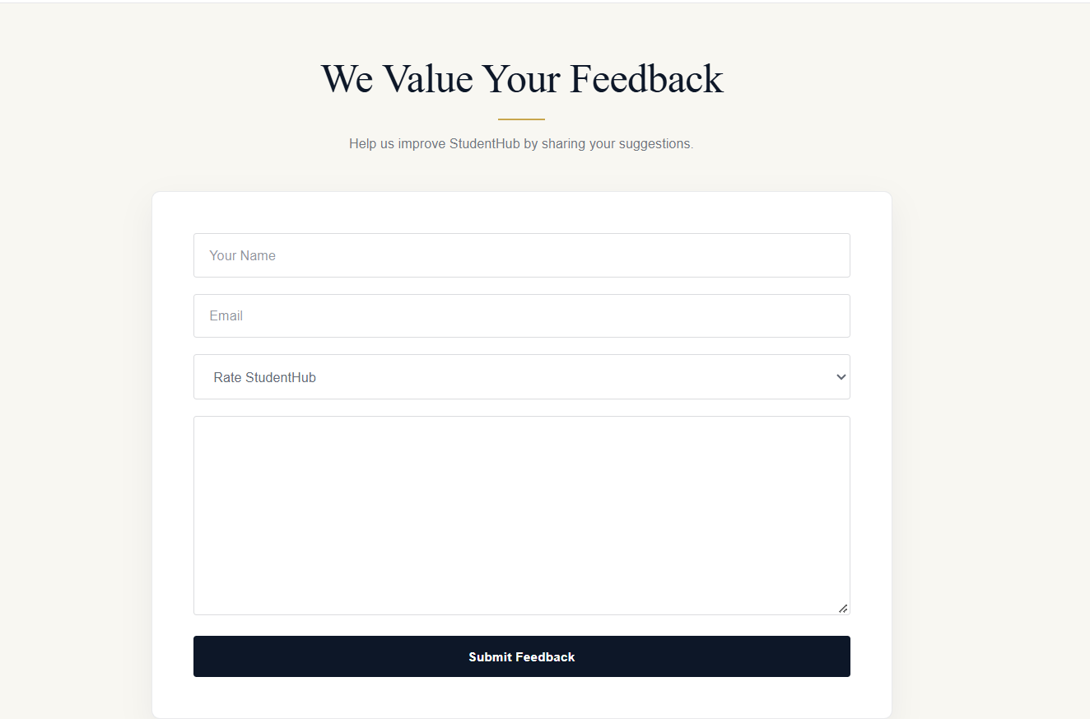
faq.css:
*{
margin:0;
padding:0;
box-sizing:border-box;
}
html{
scroll-behavior:smooth;
}
body{
font-family:'Poppins',sans-serif;
background:#f8f7f2;
color:#222;
overflow-x:hidden;
}
:root{
--gold:#c8a64d;
--dark:#0d1728;
--white:#ffffff;
--light:#f8f7f2;
--shadow:0 15px 35px rgba(0,0,0,.18);
}
.container{
width:90%;
max-width:1200px;
margin:auto;
}
a{
text-decoration:none;
}
h1,h2,h3,h4{
font-family:'Poppins',sans-serif;
font-weight:600;
}
section{
padding:10px 0;
}

.navbar{
display:flex;
justify-content:space-between;
align-items:center;
padding:20px 7%;
background:#fff;
box-shadow:0 2px 10px rgba(0,0,0,.05);
}

.logo a{
font-size:28px;
font-weight:700;
color:var(--dark);
}

.nav-links{
display:flex;
list-style:none;
gap:30px;
}

.nav-links a{
color:#444;
transition:.3s;
}

.nav-links a:hover{
color:var(--gold);
}

.nav-buttons{
display:flex;
gap:15px;
}

.login-btn{
border:1px solid var(--gold);
padding:10px 22px;
border-radius:30px;
color:var(--dark);
}

.register-btn{
background:var(--gold);
color:#fff;
padding:10px 22px;
border-radius:30px;
}

.page-hero{
padding:80px 20px 30px;
background:var(--light);
}

.overlay{
background:none;
}

.hero-content{
text-align:center;
}

.hero-content span{
color:var(--gold);
letter-spacing:2px;
font-size:14px;
font-weight:600;
}

.hero-content h1{
font-size:40px;
margin:12px 0;
color:var(--dark);
}

.hero-content p{
color:#666;
max-width:650px;
margin:auto;
line-height:1.8;
}

.faq-section{
padding:50px 0 80px;
}

.section-heading{
text-align:center;
margin-bottom:40px;
}

.section-heading span{
color:var(--gold);
font-size:14px;
letter-spacing:2px;
}

.section-heading h2{
margin-top:10px;
font-size:34px;
}

.faq-container{
display:grid;
gap:20px;
}

.faq-item{
background:#fff;
padding:25px;
border-radius:12px;
box-shadow:0 5px 15px rgba(0,0,0,.06);
transition:.3s;
}

.faq-item:hover{
transform:translateY(-4px);
}

.faq-item h3{
color:var(--dark);
margin-bottom:10px;
font-size:20px;
}

.faq-item p{
color:#666;
line-height:1.7;
}
.help-section{
text-align:center;
padding:70px 20px;
background:#fff;
}

.help-section h2{
font-size:32px;
margin-bottom:15px;
}

.help-section p{
color:#666;
margin-bottom:25px;
}

.primary-btn{
display:inline-block;
background:var(--gold);
color:#fff;
padding:14px 30px;
border-radius:30px;
transition:.3s;
}

.primary-btn:hover{
background:#b28f36;
}
footer{
background:var(--dark);
color:#fff;
padding:50px 8% 20px;
}

.footer-grid{
display:grid;
grid-template-columns:repeat(auto-fit,minmax(220px,1fr));
gap:30px;
}

footer h3{
margin-bottom:15px;
}

footer p,
footer li{
color:#ddd;
line-height:1.8;
}

footer ul{
list-style:none;
}

footer a{
color:#ddd;
}

footer a:hover{
color:var(--gold);
}

footer hr{
margin:30px 0 15px;
border:none;
height:1px;
background:#555;
}

.copyright{
text-align:center;
color:#bbb;
}
@media(max-width:768px){

.nav-links,
.nav-buttons{
display:none;
}

.hero-content h1{
font-size:30px;
}

.section-heading h2{
font-size:28px;
}

}

.register-card button {
width: 100%;
margin-top: 25px;
padding: 14px;
border: none;
border-radius: 30px;
background: var(--gold);
color: #fff;
font-size: 16px;
cursor: pointer;
transition: .3s;
}

.register-card button:hover {
background: #b28f36;
}

#themeToggle {
width: auto;
margin-top: 0;
padding: 10px 16px;
border: 1px solid var(--gold);
border-radius: 25px;
background: transparent;
color: var(--dark);
font-family: 'Poppins', sans-serif;
font-size: 14px;
cursor: pointer;
transition: .3s;
}

#themeToggle:hover {
background: var(--gold);
color: #fff;
}

body.dark-mode #themeToggle {
color: #fff;
}
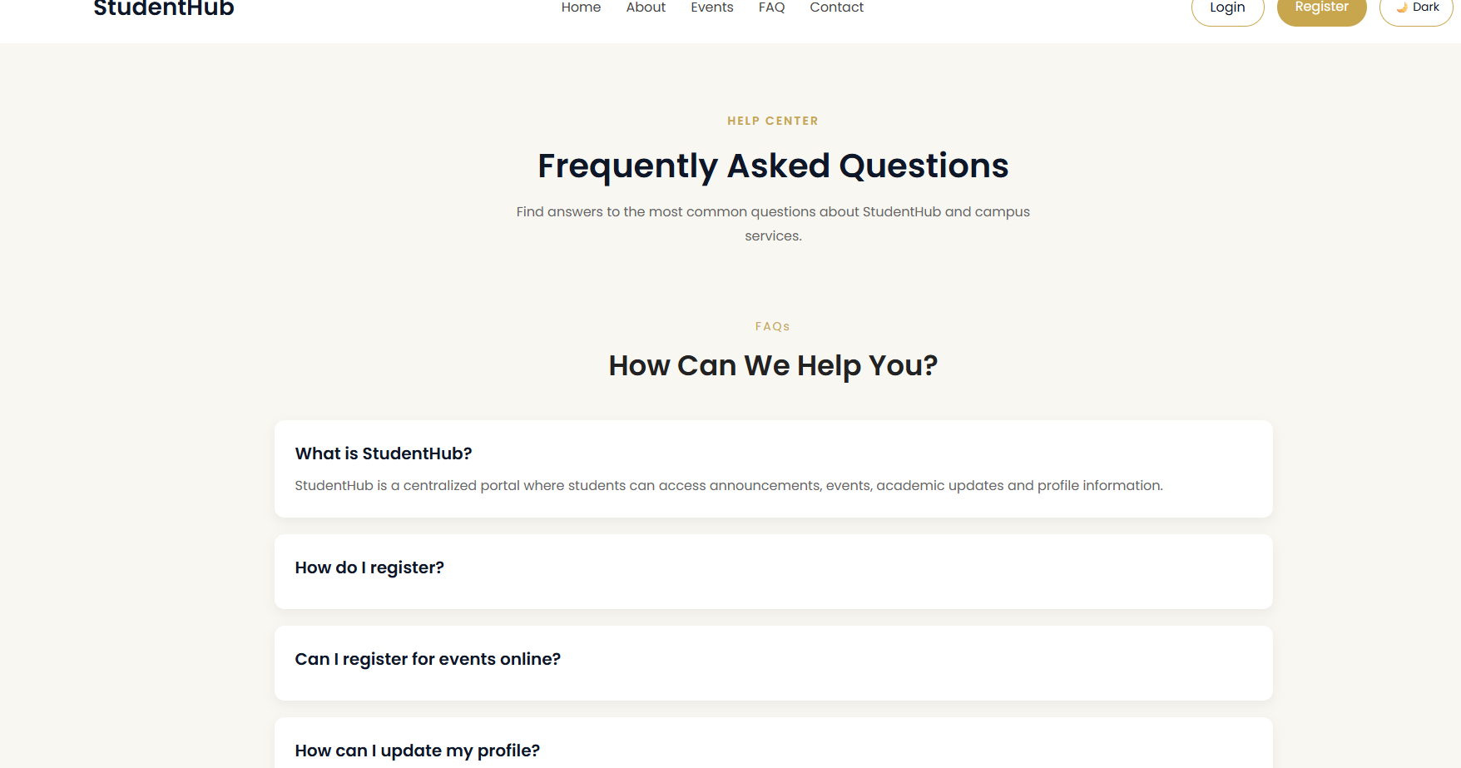
events.css:
*{
margin:0;
padding:0;
box-sizing:border-box;
}
html{
scroll-behavior:smooth;
}
body{
font-family:'Poppins',sans-serif;
background:#f8f7f2;
color:#222;
overflow-x:hidden;
}
:root{
--gold:#c8a64d;
--dark:#0d1728;
--white:#ffffff;
--light:#f8f7f2;
--shadow:0 15px 35px rgba(0,0,0,.18);
}
.container{
width:90%;
max-width:1200px;
margin:auto;
}
a{
text-decoration:none;
}
h1,h2,h3,h4{
font-family:'Poppins',sans-serif;
font-weight:600;
}
section{
padding:10px 0;
}
.hero{
padding: 0px;
position: relative;
width: 100%;
min-height: 100vh;
background-size: cover;
background-position: center;
background-repeat: no-repeat;
}
.navbar{
width:100%;
padding:25px 7%;
display:flex;
justify-content:space-between;
align-items:center;
z-index:100;
}
.home-navbar{
position:absolute;
top:0;
left:0;
width:100%;
padding:25px 7%;
display:flex;
justify-content:space-between;
align-items:center;
z-index:100;
}
.logo a{
color:var(--dark);
font-size:34px;
font-weight:700;
letter-spacing:1px;
}
.nav-links{
display:flex;
gap:35px;
list-style:none;
}
.nav-links a{
color:var(--dark);
font-size:16px;
font-weight:500;
transition:.3s;
}
.nav-links a:hover{
color:var(--gold);
}
.nav-buttons{
display:flex;
gap:15px;
}
.login-btn{
color:#fff;
border:1px solid rgba(255,255,255,.5);
padding:12px 28px;
border-radius:40px;
transition:.3s;
}
.login-btn:hover{
background:rgba(255,255,255,.15);
}
.register-btn{
background:var(--gold);
color:#fff;
padding:12px 28px;
border-radius:40px;
transition:.3s;
}
.register-btn:hover{
background:#b28f36;
}
.primary-btn{
background:var(--gold);
color:#fff;
padding:15px 35px;
border-radius:40px;
display:inline-block;
transition:.35s;
}
.primary-btn:hover{
transform:translateY(-4px);
background:#b28f36;
}
.secondary-btn{
border:1px solid rgba(255,255,255,.5);
color:#fff;
padding:15px 35px;
border-radius:40px;
transition:.35s;
}
.secondary-btn:hover{
background:rgba(255,255,255,.12);
}
.page-hero{
background:var(--light);
padding:70px 0 50px;
text-align:center;
}

.hero-content{
max-width:700px;
margin:auto;
}

.hero-content span{
color:var(--gold);
font-size:14px;
letter-spacing:3px;
font-weight:600;
}

.hero-content h1{
font-size:42px;
color:var(--dark);
margin:15px 0;
}

.hero-content p{
color:#666;
line-height:1.8;
}

.event-categories{
padding:60px 0;
}

.event-categories h2{
text-align:center;
margin-bottom:35px;
}

.category-grid{
display:flex;
justify-content:center;
gap:25px;
flex-wrap:wrap;
}

.category-card{
width:220px;
background:#fff;
padding:30px;
border-radius:15px;
text-align:center;
box-shadow:0 5px 15px rgba(0,0,0,.08);
transition:.3s;
}

.category-card:hover{
transform:translateY(-5px);
}

.category-card h3{
font-size:35px;
margin-bottom:15px;
}

.category-card p{
font-weight:500;
}
.upcoming-events{
background:#fff;
padding:70px 0;
}

.upcoming-events h2{
text-align:center;
margin-bottom:40px;
}

.event-grid{
display:flex;
justify-content:center;
gap:30px;
flex-wrap:wrap;
}

.event-card{
width:340px;
background:var(--light);
border-radius:15px;
overflow:hidden;
box-shadow:0 5px 15px rgba(0,0,0,.08);
}

.event-card img{
width:100%;
height:220px;
object-fit:cover;
}

.event-info{
padding:20px;
}

.event-info span{
color:var(--gold);
font-size:14px;
}

.event-info h3{
margin:12px 0;
}

.event-info p{
color:#666;
line-height:1.7;
margin-bottom:18px;
}

.event-info button{
background:var(--gold);
color:#fff;
border:none;
padding:12px 25px;
border-radius:30px;
cursor:pointer;
}

.event-info button:hover{
background:#b28f36;
}
.featured-event{
padding:70px 0;
}

.featured-event .container{
display:flex;
align-items:center;
gap:50px;
flex-wrap:wrap;
}

.featured-image{
flex:1;
}

.featured-image img{
width:100%;
border-radius:15px;
}

.featured-content{
flex:1;
}

.featured-content span{
color:var(--gold);
letter-spacing:2px;
font-size:14px;
}

.featured-content h2{
margin:15px 0;
}

.featured-content p{
color:#666;
line-height:1.8;
margin-bottom:25px;
}
.gallery{
background:#fff;
padding:70px 0;
}

.gallery h2{
text-align:center;
margin-bottom:40px;
}

.gallery-grid{
display:flex;
flex-wrap:wrap;
justify-content:center;
gap:20px;
}

.gallery-grid img{
width:350px;
height:220px;
object-fit:cover;
border-radius:12px;
transition:.3s;
}
.gallery-grid img:hover{
transform:scale(1.04);
}
footer{
background:var(--dark);
color:#fff;
padding:50px 0 20px;
}
.footer-grid{
display:flex;
justify-content:space-between;
gap:40px;
flex-wrap:wrap;
}

.footer-grid div{
flex:1;
min-width:220px;
}

footer h3{
margin-bottom:15px;
}

footer p,
footer li{
color:#ddd;
line-height:1.8;
}

footer ul{
list-style:none;
}

footer a{
color:#ddd;
}

footer a:hover{
color:var(--gold);
}

footer hr{
margin:30px 0 15px;
border:none;
border-top:1px solid rgba(255,255,255,.2);
}

.copyright{
text-align:center;
color:#bbb;
}
@media(max-width:768px){

.nav-links,
.nav-buttons{
display:none;
}

.hero-content h1{
font-size:32px;
}

.featured-event .container{
flex-direction:column;
}

}
.event-controls{
display:flex;
justify-content:center;
gap:15px;
flex-wrap:wrap;
margin-bottom:35px;
}

.event-controls input,
.event-controls select{
padding:12px 15px;
border:1px solid #ddd;
border-radius:8px;
font-family:Poppins;
outline:none;
}

.event-controls input{
width:250px;
}

#pagination{
margin-top:35px;
text-align:center;
}

#pagination button{
margin:5px;
padding:10px 15px;
border:none;
border-radius:6px;
background:#eee;
cursor:pointer;
}

#pagination button:hover{
background:#c8a64d;
color:white;
}
/* ================= REGISTER FORM BUTTON ================= */

.register-card button {
width: 100%;
margin-top: 25px;
padding: 14px;
border: none;
border-radius: 30px;
background: var(--gold);
color: #fff;
font-size: 16px;
cursor: pointer;
transition: .3s;
}

.register-card button:hover {
background: #b28f36;
}

/* ================= THEME SWITCHER ================= */

#themeToggle {
width: auto;
margin-top: 0;
padding: 10px 16px;
border: 1px solid var(--gold);
border-radius: 25px;
background: transparent;
color: var(--dark);
font-family: 'Poppins', sans-serif;
font-size: 14px;
cursor: pointer;
transition: .3s;
}

#themeToggle:hover {
background: var(--gold);
color: #fff;
}

body.dark-mode #themeToggle {
color: #fff;
}
dashboard.css:
@import url('https://fonts.googleapis.com/css2?family=Playfair+Display:wght@500;600;700&family=Poppins:wght@300;400;500;600&display=swap');

:root {
--gold: #c8a64d;
--dark: #0d1728;
--white: #ffffff;
--light: #f8f7f2;
--shadow: 0 15px 35px rgba(0,0,0,.18);
}

* {
margin: 0;
padding: 0;
box-sizing: border-box;
}

html {
scroll-behavior: smooth;
}

body {
background: var(--light);
color: var(--dark);
font-family: 'Poppins', sans-serif;
min-height: 100vh;
}

/* NAVBAR */

.top-header {
width: 100%;
height: 90px;
background: var(--white);

display: grid;
grid-template-columns: 1fr auto 1fr;
align-items: center;

padding: 0 7%;

border-bottom: 1px solid var(--light);

position: sticky;
top: 0;
z-index: 100;
}

.logo {
justify-self: start;
}

.logo a {
text-decoration: none;
color: var(--dark);

font-family: 'Poppins', sans-serif;
font-size: 20px;
font-weight: 500;
}

.logo a::after {
content: ".";
color: var(--gold);
}

.dashboard-nav {
display: flex;
align-items: center;
justify-content: center;
gap: 38px;
}

.dashboard-nav a {
text-decoration: none;
color: var(--dark);

font-size: 14px;
font-weight: 400;

position: relative;

transition: color 0.3s ease;
}

.dashboard-nav a::after {
content: "";

position: absolute;

left: 50%;
bottom: -8px;

width: 0;
height: 1px;

background: var(--gold);

transform: translateX(-50%);

transition: width 0.3s ease;
}

.dashboard-nav a:hover {
color: var(--gold);
}

.dashboard-nav a:hover::after {
width: 100%;
}

.logout-btn {
justify-self: end;

text-decoration: none;

border: 1px solid var(--gold);

background: var(--white);

color: var(--dark) !important;

padding: 10px 25px;

border-radius: 30px;

font-size: 13px !important;

transition: all 0.3s ease;
}

.logout-btn:hover {
background: var(--gold);

color: var(--white) !important;
}

.logout-btn::after {
display: none;
}

/* LAYOUT */

.dashboard-layout {
display: flex;
min-height: calc(100vh - 90px);
}

/* SIDEBAR */

.sidebar {
width: 225px;

background: var(--white);

padding: 45px 20px;

flex-shrink: 0;

border-right: 1px solid var(--light);

display: flex;
flex-direction: column;
}

.sidebar-title {
padding: 0 15px;

margin-bottom: 25px;
}

.sidebar-title span {
color: var(--gold);

font-size: 9px;

font-weight: 500;

letter-spacing: 2.5px;

text-transform: uppercase;
}

.sidebar ul {
list-style: none;
}

.sidebar li {
margin-bottom: 4px;
}

.sidebar li a {
display: flex;

align-items: center;

gap: 13px;

text-decoration: none;

color: var(--dark);

padding: 13px 15px;

border-radius: 8px;

font-size: 12px;

font-weight: 400;

transition: all 0.25s ease;
}

.sidebar li a:hover {
background: var(--light);

color: var(--gold);

padding-left: 19px;
}

.sidebar li.active a {
background: var(--light);

color: var(--gold);

position: relative;
}

.sidebar li.active a::before {
content: "";

position: absolute;

left: 0;

top: 50%;

transform: translateY(-50%);

width: 3px;

height: 20px;

background: var(--gold);

border-radius: 5px;
}

.nav-icon {
width: 18px;

text-align: center;

font-size: 13px;

color: var(--gold);
}

.sidebar-footer {
margin-top: auto;

padding: 20px 15px 0;

border-top: 1px solid var(--light);
}

.sidebar-footer p {
color: var(--dark);

font-size: 12px;

font-weight: 500;

margin-bottom: 3px;
}

.sidebar-footer span {
color: var(--gold);

font-size: 9px;
}

/* MAIN CONTENT */

.dashboard-content {
flex: 1;

padding: 65px 6%;

max-width: 1450px;

overflow: hidden;
}

/* PAGE INTRO */

.page-heading {
margin-bottom: 48px;
}

.eyebrow {
color: var(--gold);

font-size: 9px;

font-weight: 600;

letter-spacing: 3.5px;

text-transform: uppercase;

margin-bottom: 13px;
}

.page-heading h1 {
color: var(--dark);

font-family: 'Playfair Display', serif;

font-size: 48px;

font-weight: 600;

line-height: 1.12;

letter-spacing: -0.7px;

margin-bottom: 12px;
}

.heading-text {
color: var(--dark);

font-size: 13px;

font-weight: 300;

line-height: 1.8;

max-width: 650px;
}

/* STATS */

.stats {
display: grid;

grid-template-columns: repeat(4, 1fr);

gap: 20px;

margin-bottom: 45px;
}

.stat-card {
background: var(--white);

padding: 25px;

min-height: 145px;

border-radius: 18px;

box-shadow: 0 8px 25px rgba(0,0,0,.05);

transition: all 0.3s ease;
}

.stat-card:hover {
transform: translateY(-4px);

box-shadow: var(--shadow);
}

.stat-top {
display: flex;

justify-content: space-between;

align-items: center;

margin-bottom: 17px;
}

.stat-label {
color: var(--dark);

font-size: 10px;

font-weight: 400;
}

.stat-symbol {
color: var(--gold);

font-size: 9px;

font-weight: 600;
}

.stat-card h2 {
color: var(--gold);

font-family: 'Playfair Display', serif;

font-size: 35px;

font-weight: 600;

line-height: 1;

margin-bottom: 8px;
}

.stat-card p {
color: var(--dark);

font-size: 9px;

font-weight: 300;
}

/* CONTENT AREA */

.dashboard-grid {
display: grid;

grid-template-columns: 1.15fr 0.85fr;

gap: 25px;

margin-bottom: 35px;
}

.dashboard-section {
background: var(--white);

padding: 30px;

border-radius: 18px;

box-shadow: 0 8px 25px rgba(0,0,0,.045);
}

.section-heading {
display: flex;

align-items: flex-end;

justify-content: space-between;

padding-bottom: 18px;

border-bottom: 1px solid var(--light);

margin-bottom: 2px;
}

.section-label {
color: var(--gold);

font-size: 8px;

font-weight: 600;

letter-spacing: 2px;

text-transform: uppercase;

margin-bottom: 6px;
}

.section-heading h2 {
color: var(--dark);

font-family: 'Playfair Display', serif;

font-size: 24px;

font-weight: 600;
}

.section-heading > a {
color: var(--gold);

text-decoration: none;

font-size: 9px;

font-weight: 500;
}

.section-heading > a:hover {
text-decoration: underline;
}

/* EVENTS */

.event-list {
list-style: none;
}

.event-list li {
display: flex;

align-items: center;

gap: 16px;

padding: 15px 0;

border-bottom: 1px solid var(--light);
}

.event-list li:last-child {
border-bottom: none;
}

.date-box {
width: 50px;

height: 50px;

background: var(--light);

border-radius: 11px;

display: flex;

flex-direction: column;

align-items: center;

justify-content: center;

flex-shrink: 0;
}

.date-box span {
color: var(--dark);

font-family: 'Playfair Display', serif;

font-size: 18px;

font-weight: 600;

line-height: 1;
}

.date-box small {
color: var(--gold);

font-size: 7px;

font-weight: 600;

margin-top: 4px;
}

.item-content h3 {
color: var(--dark);

font-size: 11px;

font-weight: 500;

margin-bottom: 4px;
}

.item-content p {
color: var(--dark);

font-size: 9px;

font-weight: 300;
}

/* ANNOUNCEMENTS */

.announcement-list {
list-style: none;
}

.announcement-list li {
padding: 15px 0;

border-bottom: 1px solid var(--light);
}

.announcement-list li:last-child {
border-bottom: none;
}

.announcement-list h3 {
color: var(--dark);

font-size: 11px;

font-weight: 500;

line-height: 1.6;

margin-bottom: 4px;
}

.announcement-list p {
color: var(--dark);

font-size: 9px;

font-weight: 300;
}

.announcement-dot {
display: none;
}

/* ACTIVITY */

.activity-section {
margin-bottom: 30px;
}

.activity-list {
display: grid;

grid-template-columns: repeat(3, 1fr);

gap: 20px;

list-style: none;
}

.activity-list li {
background: var(--white);

padding: 22px;

border-radius: 15px;

box-shadow: 0 7px 22px rgba(0,0,0,.04);

transition: all 0.3s ease;
}

.activity-list li:hover {
transform: translateY(-3px);

box-shadow: var(--shadow);
}

.activity-check {
width: 28px;

height: 28px;

display: flex;

align-items: center;

justify-content: center;

border-radius: 50%;

background: var(--light);

color: var(--gold);

font-size: 10px;

margin-bottom: 12px;
}

.activity-list h3 {
color: var(--dark);

font-size: 10px;

font-weight: 500;

margin-bottom: 4px;
}

.activity-list p {
color: var(--dark);

font-size: 8px;

font-weight: 300;
}

/* TABLET */

@media (max-width: 1050px) {

.top-header {
padding: 0 5%;
}

.sidebar {
width: 205px;
}

.dashboard-content {
padding: 50px 5%;
}

.stats {
grid-template-columns: repeat(2, 1fr);
}

.dashboard-grid {
grid-template-columns: 1fr;
}
}

/* MOBILE */

@media (max-width: 700px) {

.top-header {
height: auto;

padding: 18px 6%;

display: flex;

flex-direction: column;

gap: 15px;
}

.logo {
align-self: center;
}

.dashboard-nav {
gap: 18px;

flex-wrap: wrap;

justify-content: center;
}

.logout-btn {
padding: 7px 17px;
}

.dashboard-layout {
flex-direction: column;
}

.sidebar {
width: 100%;

padding: 15px 6%;

border-right: none;

border-bottom: 1px solid var(--light);
}

.sidebar-title,
.sidebar-footer {
display: none;
}

.sidebar ul {
display: flex;

gap: 18px;

overflow-x: auto;

justify-content: center;
}

.sidebar li {
flex-shrink: 0;

margin: 0;
}

.sidebar li a {
padding: 7px 3px;

font-size: 11px;
}

.sidebar li.active a::before {
display: none;
}

.dashboard-content {
padding: 42px 6%;
}

.page-heading {
margin-bottom: 35px;
}

.page-heading h1 {
font-size: 37px;
}

.stats {
grid-template-columns: 1fr;

gap: 15px;

margin-bottom: 35px;
}

.dashboard-grid {
gap: 20px;
}

.dashboard-section {
padding: 24px;
}

.activity-list {
grid-template-columns: 1fr;
}
}

/* SMALL MOBILE */

@media (max-width: 420px) {

.logo a {
font-size: 21px;
}

.dashboard-nav {
gap: 14px;
}

.dashboard-nav a {
font-size: 11px;
}

.page-heading h1 {
font-size: 32px;
}

.section-heading h2 {
font-size: 21px;
}
}
/* ================= REGISTER FORM BUTTON ================= */

.register-card button {
width: 100%;
margin-top: 25px;
padding: 14px;
border: none;
border-radius: 30px;
background: var(--gold);
color: #fff;
font-size: 16px;
cursor: pointer;
transition: .3s;
}

.register-card button:hover {
background: #b28f36;
}

/* ================= THEME SWITCHER ================= */

#themeToggle {
width: auto;
margin-top: 0;
padding: 10px 16px;
border: 1px solid var(--gold);
border-radius: 25px;
background: transparent;
color: var(--dark);
font-family: 'Poppins', sans-serif;
font-size: 14px;
cursor: pointer;
transition: .3s;
}

#themeToggle:hover {
background: var(--gold);
color: #fff;
}

body.dark-mode #themeToggle {
color: #fff;
}
contact.css:
*{
margin:0;
padding:0;
box-sizing:border-box;
}
html{
scroll-behavior:smooth;
}
body{
font-family:'Poppins',sans-serif;
background:#f8f7f2;
color:#222;
overflow-x:hidden;
}
:root{
--gold:#c8a64d;
--dark:#0d1728;
--white:#ffffff;
--light:#f8f7f2;
--shadow:0 15px 35px rgba(0,0,0,.18);
}
.container{
width:90%;
max-width:1200px;
margin:auto;
}
a{
text-decoration:none;
}
h1,h2,h3,h4{
font-family:'Playfair Display',serif;
}
section{
padding:10px 0;
}
.hero{
padding: 0px;
position: relative;
width: 100%;
min-height: 100vh;
background-image: url("../images/clg.jpg");
background-size: cover;
background-position: center;
background-repeat: no-repeat;
}
.navbar{
width:100%;
padding:25px 7%;
display:flex;
justify-content:space-between;
align-items:center;
z-index:100;
}
.home-navbar{
position:absolute;
top:0;
left:0;
width:100%;
padding:25px 7%;
display:flex;
justify-content:space-between;
align-items:center;
z-index:100;
}
.logo a{
color:var(--dark);
font-size:34px;
font-weight:700;
letter-spacing:1px;
}
.nav-links{
display:flex;
gap:35px;
list-style:none;
}
.nav-links a{
color:var(--dark);
font-size:16px;
font-weight:500;
transition:.3s;
}
.nav-links a:hover{
color:var(--gold);
}
.nav-buttons{
display:flex;
gap:15px;
}
.login-btn{
color:var(--dark);
border:1px solid var(--gold);
padding:12px 28px;
border-radius:40px;
transition:.3s;
}
.login-btn:hover{
background:rgba(255,255,255,.15);
}
.register-btn{
background:var(--gold);
color:#fff;
padding:12px 28px;
border-radius:40px;
transition:.3s;
}
.register-btn:hover{
background:#b28f36;
}
.primary-btn{
background:var(--gold);
color:#fff;
padding:15px 35px;
border-radius:40px;
display:inline-block;
transition:.35s;
}
.primary-btn:hover{
transform:translateY(-4px);
background:#b28f36;
}
.secondary-btn{
border:1px solid rgba(255,255,255,.5);
color:#fff;
padding:15px 35px;
border-radius:40px;
transition:.35s;
}
.secondary-btn:hover{
background:rgba(255,255,255,.12);
}

.page-hero{
background:var(--light);
padding:70px 0 50px;
}

.overlay{
text-align:center;
}

.hero-content{
max-width:700px;
margin:auto;
}

.hero-content span{
color:var(--gold);
letter-spacing:2px;
font-size:14px;
font-weight:600;
}

.hero-content h1{
font-size:46px;
color:var(--dark);
margin:15px 0;
}

.hero-content p{
color:#666;
line-height:1.8;
}

.contact-info{
padding:60px 0;
}

.contact-info .container{
display:flex;
justify-content:space-between;
gap:25px;
flex-wrap:wrap;
}

.info-card{
flex:1;
min-width:250px;
background:#fff;
padding:30px;
border-radius:15px;
text-align:center;
box-shadow:0 5px 15px rgba(0,0,0,.08);
transition:.3s;
}

.info-card:hover{
transform:translateY(-5px);
}

.info-card h3{
color:var(--gold);
margin-bottom:15px;
}

.info-card p{
color:#666;
line-height:1.8;
}

.contact-form{
background:#fff;
padding:70px 0;
}

.contact-form .container{
display:flex;
justify-content:space-between;
gap:60px;
flex-wrap:wrap;
}

.form-left{
flex:1;
min-width:300px;
}

.form-left span{
color:var(--gold);
font-size:14px;
letter-spacing:2px;
}

.form-left h2{
font-size:38px;
margin:15px 0;
color:var(--dark);
}

.form-left p{
color:#666;
line-height:1.8;
}

.form-right{
flex:1;
min-width:320px;
}

form{
display:flex;
flex-direction:column;
}

form input,
form textarea{
margin-bottom:18px;
padding:14px 18px;
border:1px solid #ddd;
border-radius:10px;
outline:none;
font-size:15px;
font-family:'Poppins',sans-serif;
}

form input:focus,
form textarea:focus{
border-color:var(--gold);
}

form button{
background:var(--gold);
color:#fff;
border:none;
padding:14px;
border-radius:35px;
cursor:pointer;
transition:.3s;
font-size:16px;
}

form button:hover{
background:#b28f36;
}

.map-section{
padding:70px 0;
}

.map-section h2{
text-align:center;
margin-bottom:25px;
color:var(--dark);
}

.map-placeholder{
height:320px;
background:#ececec;
border-radius:15px;
display:flex;
justify-content:center;
align-items:center;
color:#777;
font-size:18px;
}

.office-hours{
background:#fff;
padding:70px 0;
}

.office-hours h2{
text-align:center;
margin-bottom:35px;
}

.hours-grid{
display:flex;
justify-content:space-between;
gap:20px;
flex-wrap:wrap;
}

.hours-grid div{
flex:1;
min-width:220px;
background:var(--light);
padding:25px;
border-radius:15px;
text-align:center;
box-shadow:0 5px 15px rgba(0,0,0,.08);
}

.hours-grid h3{
color:var(--gold);
margin-bottom:10px;
}
footer{
background:var(--dark);
color:#fff;
padding:50px 0 20px;
}

.footer-grid{
display:flex;
justify-content:space-between;
gap:40px;
flex-wrap:wrap;
}

.footer-grid div{
flex:1;
min-width:220px;
}

footer h3{
margin-bottom:15px;
}

footer p,
footer li{
color:#ddd;
line-height:1.8;
}

footer ul{
list-style:none;
}

footer a{
color:#ddd;
}

footer a:hover{
color:var(--gold);
}

footer hr{
margin:30px 0 15px;
border:none;
border-top:1px solid rgba(255,255,255,.2);
}

.copyright{
text-align:center;
color:#bbb;
}
@media(max-width:768px){

.nav-links,
.nav-buttons{
display:none;
}

.hero-content h1{
font-size:34px;
}

.contact-info .container,
.contact-form .container,
.hours-grid,
.footer-grid{
flex-direction:column;
}

}
/* ================= REGISTER FORM BUTTON ================= */

.register-card button {
width: 100%;
margin-top: 25px;
padding: 14px;
border: none;
border-radius: 30px;
background: var(--gold);
color: #fff;
font-size: 16px;
cursor: pointer;
transition: .3s;
}

.register-card button:hover {
background: #b28f36;
}

/* ================= THEME SWITCHER ================= */

#themeToggle {
width: auto;
margin-top: 0;
padding: 10px 16px;
border: 1px solid var(--gold);
border-radius: 25px;
background: transparent;
color: var(--dark);
font-family: 'Poppins', sans-serif;
font-size: 14px;
cursor: pointer;
transition: .3s;
}

#themeToggle:hover {
background: var(--gold);
color: #fff;
}

body.dark-mode #themeToggle {
color: #fff;
}
admin.css:
@import url('https://fonts.googleapis.com/css2?family=Poppins:wght@300;400;500;600&display=swap');

:root {
--gold: #c8a64d;
--dark: #0d1728;
--white: #ffffff;
--light: #f8f7f2;
--shadow: 0 15px 35px rgba(0,0,0,.18);
}

* {
margin: 0;
padding: 0;
box-sizing: border-box;
font-family: 'Poppins', sans-serif;
}

body {
background: var(--light);
color: var(--dark);
}

.dashboard-header {
background: var(--dark);
color: var(--white);

display: flex;
justify-content: space-between;
align-items: center;

padding: 18px 60px;
}

.logo a,
.dashboard-nav a {
text-decoration: none;
color: var(--white);
font-size: 22px;
font-weight: 600;
}

.logo a::after {
content: ".";
color: var(--gold);
}

.dashboard-nav {
display: flex;
align-items: center;
gap: 30px;
}

.dashboard-nav a {
font-size: 15px;
font-weight: 400;
transition: color 0.3s ease;
}

.dashboard-nav a:hover {
color: var(--gold);
}

.dashboard {
display: flex;
min-height: 90vh;
}

.sidebar {
width: 230px;
background: var(--white);
padding: 30px 20px;

border-right: 1px solid rgba(13, 23, 40, 0.08);
}

.sidebar h3 {
text-align: center;
margin-bottom: 25px;
color: var(--dark);
font-weight: 600;
}

.sidebar ul {
list-style: none;
}

.sidebar ul li {
margin: 15px 0;
}

.sidebar ul li a {
text-decoration: none;
color: var(--dark);

display: block;

padding: 10px 12px;

border-radius: 6px;

transition: all 0.3s ease;
}

.sidebar ul li a:hover {
background: var(--gold);
color: var(--white);
}

.sidebar ul li:first-child a {
background: var(--gold);
color: var(--white);
}

.dashboard-content {
flex: 1;
padding: 40px;
}

.welcome-card {
background: var(--white);

padding: 25px;

border-radius: 10px;

box-shadow: var(--shadow);

margin-bottom: 30px;

border-left: 3px solid var(--gold);
}

.welcome-card h1 {
color: var(--dark);
margin-bottom: 10px;
font-weight: 600;
}

.welcome-card p {
color: rgba(13, 23, 40, 0.65);
}

.stats {
display: grid;

grid-template-columns: repeat(auto-fit, minmax(180px, 1fr));

gap: 20px;

margin-bottom: 35px;
}

.stat-card {
background: var(--white);

text-align: center;

padding: 25px;

border-radius: 10px;

box-shadow: 0 5px 18px rgba(13, 23, 40, 0.08);

border-top: 2px solid var(--gold);

transition: all 0.3s ease;
}

.stat-card:hover {
transform: translateY(-4px);

box-shadow: var(--shadow);
}

.stat-card h2 {
color: var(--gold);

font-size: 32px;

margin-bottom: 10px;

font-weight: 600;
}

.stat-card p {
color: rgba(13, 23, 40, 0.6);

font-size: 14px;
}

.dashboard-section {
background: var(--white);

padding: 25px;

border-radius: 10px;

box-shadow: 0 5px 18px rgba(13, 23, 40, 0.08);
}

.dashboard-section h2 {
color: var(--dark);

margin-bottom: 15px;

font-weight: 600;

position: relative;

padding-bottom: 10px;
}

.dashboard-section h2::after {
content: "";

position: absolute;

left: 0;

bottom: 0;

width: 40px;

height: 2px;

background: var(--gold);
}

.dashboard-section ul {
list-style: none;
}

.dashboard-section li {
padding: 12px 0;

border-bottom: 1px solid rgba(13, 23, 40, 0.08);

color: rgba(13, 23, 40, 0.7);
}

.dashboard-section li:last-child {
border-bottom: none;
}

.dashboard-section li:hover {
color: var(--dark);
}

@media (max-width: 768px) {

.dashboard {
flex-direction: column;
}

.sidebar {
width: 100%;
border-right: none;
border-bottom: 1px solid rgba(13, 23, 40, 0.08);
}

.dashboard-header {
flex-direction: column;
gap: 10px;
text-align: center;
padding: 18px 25px;
}

.dashboard-nav {
gap: 18px;
flex-wrap: wrap;
justify-content: center;
}

.dashboard-content {
padding: 25px 20px;
}

.stats {
grid-template-columns: 1fr;
}
}
/* ================= REGISTER FORM BUTTON ================= */

.register-card button {
width: 100%;
margin-top: 25px;
padding: 14px;
border: none;
border-radius: 30px;
background: var(--gold);
color: #fff;
font-size: 16px;
cursor: pointer;
transition: .3s;
}

.register-card button:hover {
background: #b28f36;
}

/* ================= THEME SWITCHER ================= */

#themeToggle {
width: auto;
margin-top: 0;
padding: 10px 16px;
border: 1px solid var(--gold);
border-radius: 25px;
background: transparent;
color: var(--dark);
font-family: 'Poppins', sans-serif;
font-size: 14px;
cursor: pointer;
transition: .3s;
}

#themeToggle:hover {
background: var(--gold);
color: #fff;
}

body.dark-mode #themeToggle {
color: #fff;
}
