***TO-DO-LIST APPLICATION***

***SCCJ/00636/2021***

A To-Do List Application is a software development project aimed at providing users with an easy-to-use, efficient, and effective task management tool. The purpose of this report is to provide an overview of the development process for the To-Do List Application, including the methodology used, the development process, the technical architecture, and the testing process.

It’s a challenge to agree on one universal definition of a great to-do list app. When choosing our list, we’ve decided that the best apps must cater to a diverse set of requirements. Great to-do list apps:

* **Offer great flexibility.** The best to-do list app needs to be [neurodiverse](https://clickup.com/blog/what-neurodiverse-people-wish-employers-knew/) and function well no matter how it’s used. You should be able to set priorities (so you know what are important tasks), add tasks and subtasks, and view your tasks in different ways.
* **Remind you of deadlines.** You need an app to remind you to get things done. Whether it’s in-app, push, email, or SMS notifications, a great to-do list should be able to keep your important tasks top of mind.
* **Are easy and intuitive to use.** Adding tasks should be simple and straightforward, but also cater to your situation. The best apps should allow you to do this cross platform, in offline mode or through keyboard shortcuts.
* **Offer collaboration features.** You should be able to share your lists with others so you can make progress more transparent. It’s also important to have different privacy settings so you can decide what to share.
* **Function cross platform.** Besides Android and iOS, ideal to-do list apps should be accessible on web browser and other systems such as Linux.

**METHODOLOGY**

Agile methodology is often considered a good choice for developing a To-Do List application. Agile methodologies such as Scrum focus on delivering a working product quickly and iteratively, with frequent feedback from users and stakeholders. This allows for continuous improvement of the application based on user needs and can result in a more user-friendly and effective application.

Agile methodologies are also flexible and adaptable, making them well-suited to projects with evolving requirements or uncertain timelines. They emphasize collaboration and communication among team members and stakeholders, which can help ensure that the application meets the needs of its intended users.

**MODELS**

Structural model;

- describes the organization of the application's components and how they interact with each other. The user interface component includes the graphical elements of the application, such as the menu, buttons, lists, and forms that users interact with to manage their tasks. The user interface should be designed to be intuitive and easy to use, with clear visual cues and feedback that guide the user through the task management process. It should be designed to be scalable, maintainable, and adaptable, with clear separation of concerns between the user interface, data storage, and core functions. The model should also be designed to support future development and evolution of the application over time.

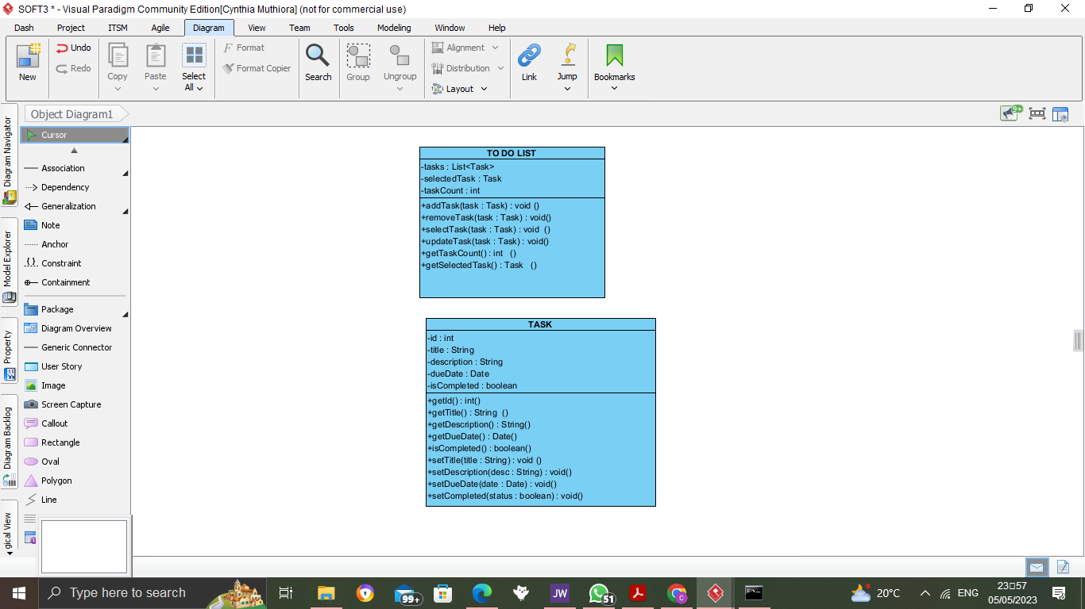

Interaction model;

- describes how users interact with the application and how the application responds to user actions. It identifies the main components of the user interface and how they are interconnected to support task management. It provide a clear and intuitive interface that allows users to easily manage their tasks, while also being flexible and customizable enough to meet the needs of different users. It should also be responsive and adaptive to different user interactions, providing an efficient and satisfying user experience.

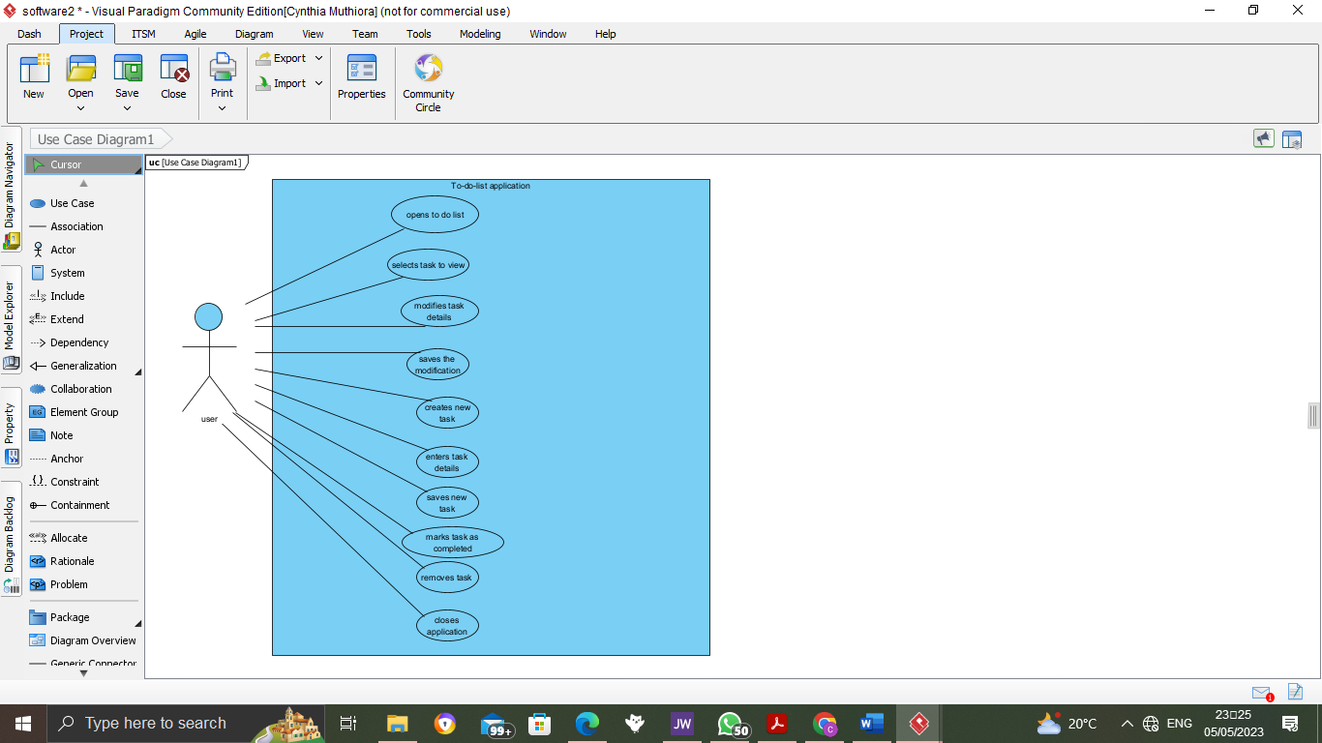

Behavioral model;

- describes the sequence of user actions and application responses that occur when using a To-Do List application. It includes steps for loading and saving task data, displaying tasks to the user, modifying tasks, and creating new tasks. The model assumes that the application stores task data in a database or file and updates this data as the user interacts with the application.

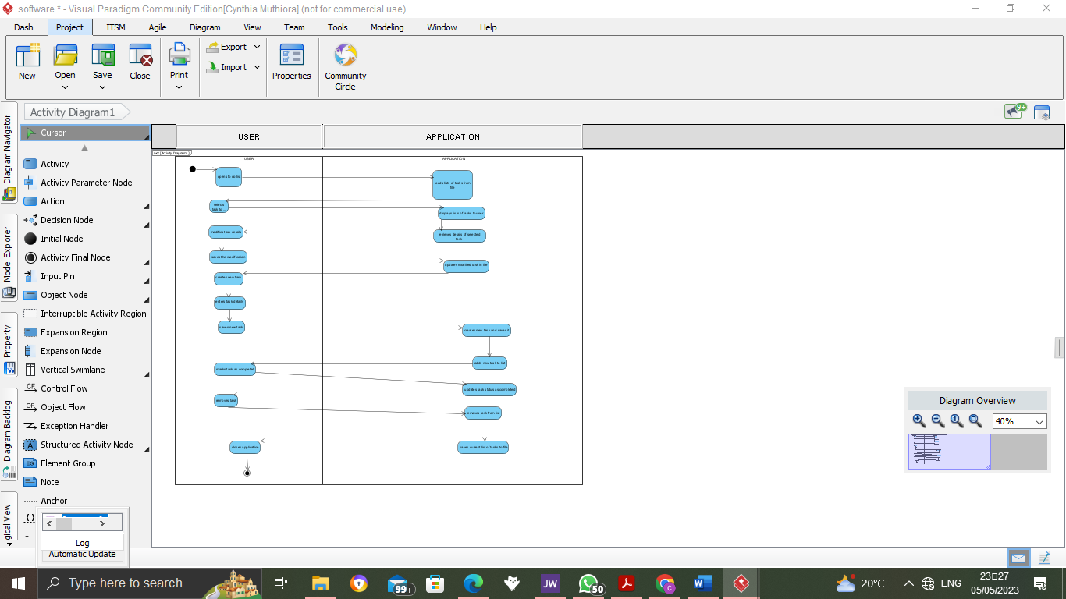

Context model;

- describes the environment in which the application operates, including the users, their tasks, and the broader context of task management. It should provide a comprehensive understanding of the users, their tasks, and the broader context of task management, in order to inform the design and development of a to do list application that is effective and useful for its intended users.