Cynthia Lipinski - Features

**User profile – Tier 1**

The user profile will have the user’s name, history, likes, playlists, and friend list. It will also have a profile picture, a customizable bio, and a banner. This would be available to be seen by all users.

**History – Tier 2**

The application will collect every song that the user has listened to, even if for a couple seconds, and compile them under the user’s history. The history will act as a playlist listing all the songs the user had listened to since creating the profile. This will be available to access through the user’s profile. If the user clicks on the song in the history the playlist will go back in the order of the songs that the user listened to them.

**Messaging – Tier 3**

The messaging feature will be available amongst all the users. Ideally there would be a ‘message’ button under the user’s name and picture and upon clicking it will allow the user to send a message either anonymously or with their name. In the navigation there would be a ‘messages’ tab that will store all the users messaging history and received messages.

**Timeline**

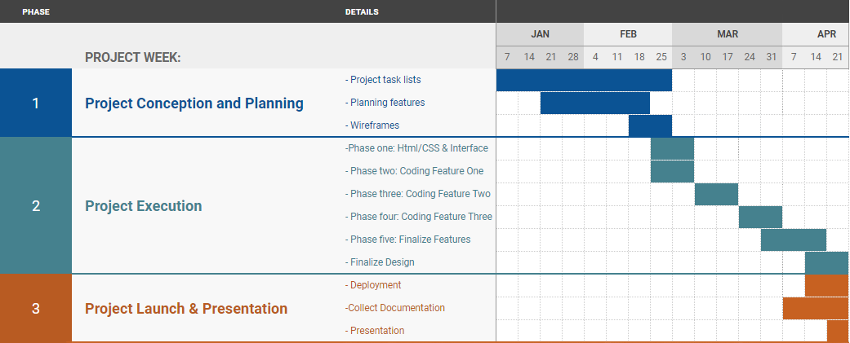

**Flowchart**

