爬虫后数据FM结果

libfm -task r -train fm1_train.txt -test fm1_test.txt -dim ‘1,1,8’ -iter 256 -method mcmc -out fm1.txt

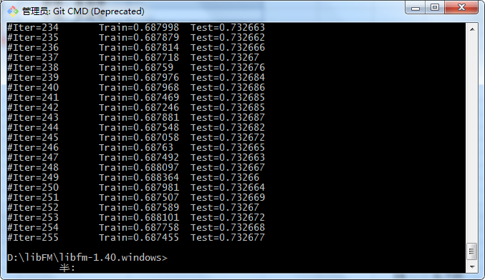

libfm -task r -train fm2_train.txt -test fm2_test.txt -dim ‘1,1,8’ -iter 256 -method mcmc -out fm2.txt

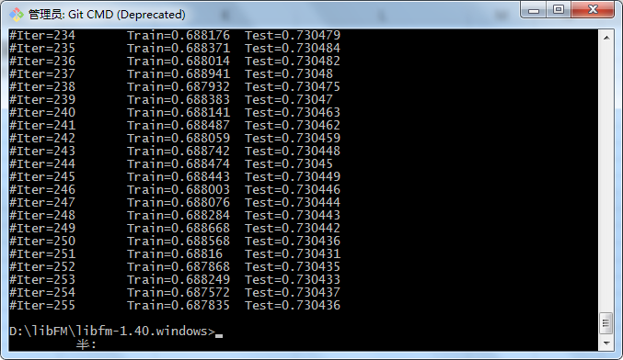

libfm -task r -train fm3_train.txt -test fm3_test.txt -dim ‘1,1,8’ -iter 256 -method mcmc -out fm3.txt

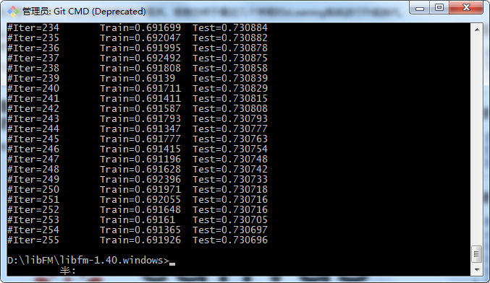

原始数据集

libfm -task r -train train11.txt -test test11.txt -dim ‘1,1,8’ -iter 256 -method mcmc -out f1.txt

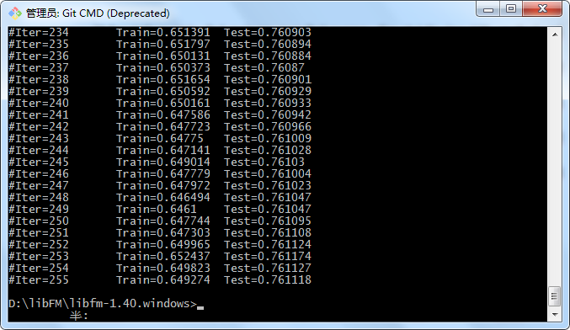

libfm -task r -train train22.txt -test test22.txt -dim ‘1,1,8’ -iter 256 -method mcmc -out f2.txt

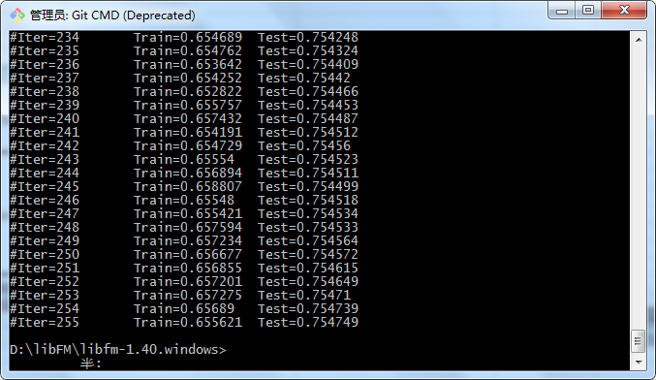

libfm -task r -train train31.txt -test test31.txt -dim ‘1,1,8’ -iter 256 -method mcmc -out f3.txt

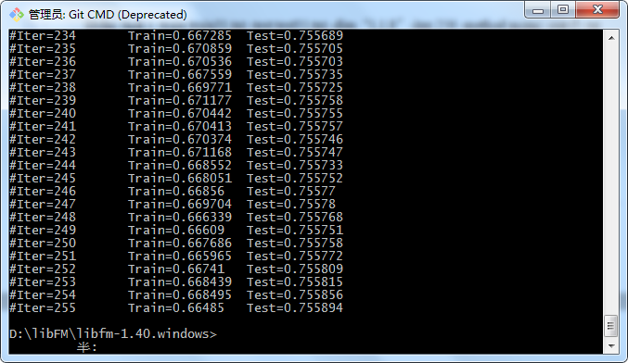

libfm -task r -train train42.txt -test test42.txt -dim ‘1,1,8’ -iter 256 -method mcmc -out f4.txt

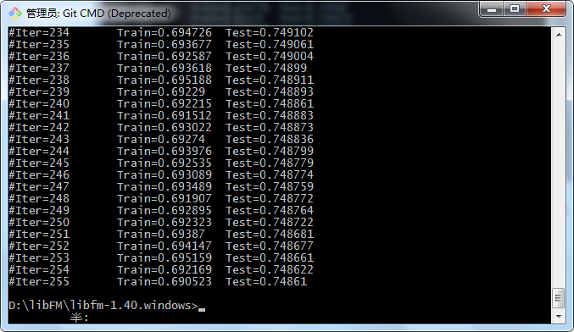

libfm -task r -train train52.txt -test test52.txt -dim ‘1,1,8’ -iter 256 -method mcmc -out f5.txt

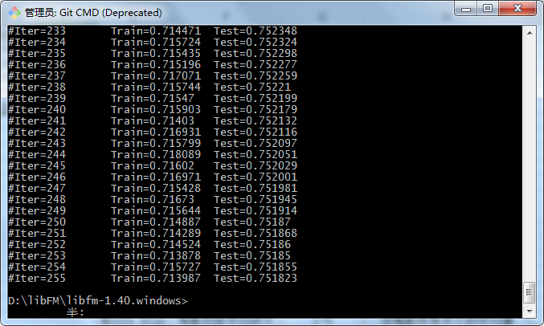

libfm -task r -train train62.txt -test test62.txt -dim ‘1,1,8’ -iter 256 -method mcmc -out f6.txt

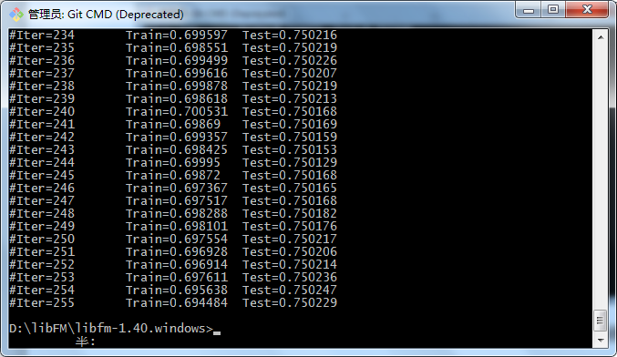

libfm -task r -train train72.txt -test test72.txt -dim ‘1,1,8’ -iter 256 -method mcmc -out f7.txt

