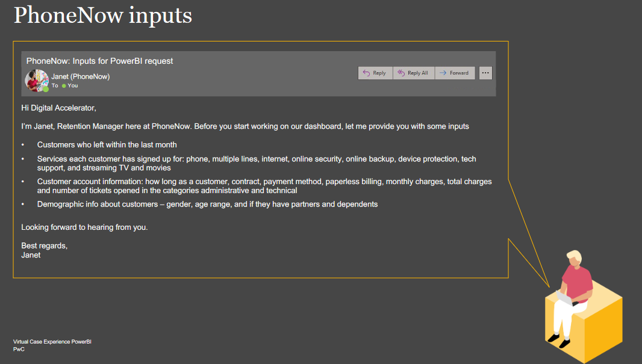

Dear Janet,

We were analysing the dataset with the information that you sent to us and observing the customers that left the company (Churn = Yes) we highlight the following findings:

* In the dataset we have 7043 customers, where 26.5% left the company.
* The most of them are Female, are single and does not have dependent.
* The average tenure is 17.98.
* The contract month-to-month is the most common with 88.5% of the total.
* The Fiber optic´s internet service is the most affect with 69.4% with the phone service with 90.9%.
* The total charges lost was 2.86M euros.

You can see this percentage on the dashboard attached.

With the dataset that you sent, we can suggest focus on internet service related on Fiber optic and phone service.

If you have any questions, don´t hesitated to contact me.

Kind regards,

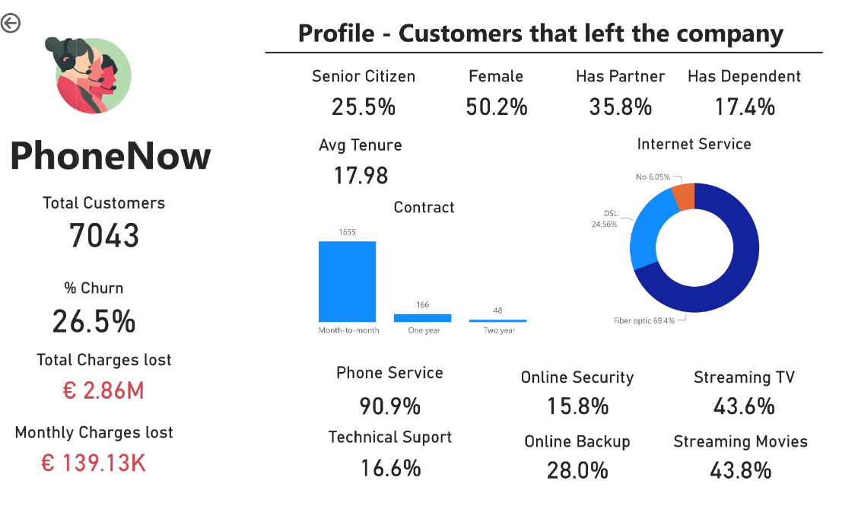Cynthyá