# Grass Rendering

## Project Proposal

### 1.What

The goal of our project is to realize a realistic real-time grass rendering simulation in OpenGl. The user should be able to move his camera in this field without breaking the illusion of realism. If we will have time, we could then try to implement some interesting effects, like adding flowers or implement the wind that moves the blades of grass to make the movement look like waves.

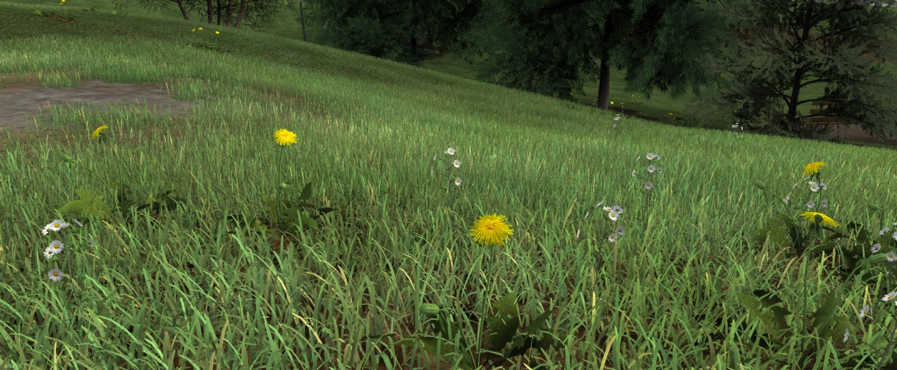

Figure 1 Example of real time grass rendering from <http://www.kevinboulanger.net/grass.html>

### 2.How

We still have difficulties to know what we are able or not to realize in OpenGl, but the basic idea is the following:

1. The terrain will be an .obj file made with Blender.
2. The grass will use billboard planes with two channels of texture: one for the color, and one for the alpha.
3. A stencil shader will be implemented. The objective of this shader will be to discard the fragments with a zero alpha value.
4. To multiply our grass, we will use a particle system. We will create a pattern of vertices as an .obj file and our particle system will repeat it all over the terrain.
5. For each vertex, a billboard plane of grass will be added.
6. To simulate the wind we will use two particles systems with two sorts of billboard grass. Each type of billboard will have a different movement (shearing matrix), so the wind will not seem too artificial.

We will of course add more details according to the deadline. For example, the possibility for our terrain to be curved or adding flowers, etc…