- Run process-run.py with the following flags: -l 5:100,5:100. What should the CPU utilization be (e.g., the percent of time the CPU is in use?) Why do you know this? Use the -c and -p flags to see if you were right.
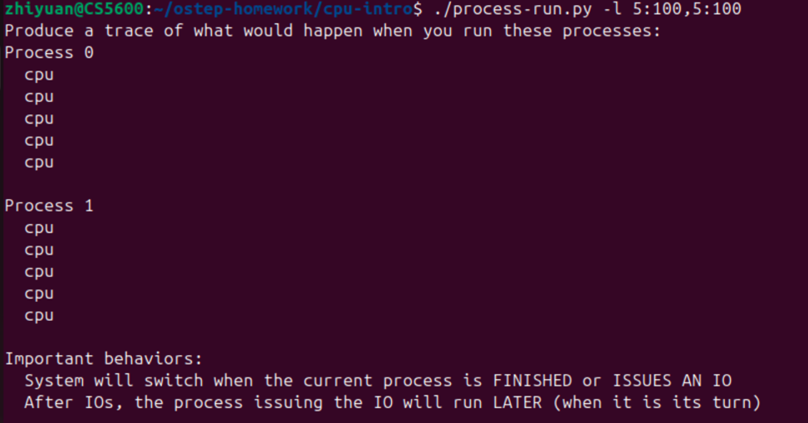
Should be 100%, cause p1 and p0 are always using cpu, no process
is blocked.
- Now run with these flags: ./process-run.py -l 4:100,1:0. These flags specify one process with 4 instructions (all to use the CPU), and one that simply issues an I/O and waits for it to be done. How long does it take to complete both processes? Use -c and -p to find out if you were right.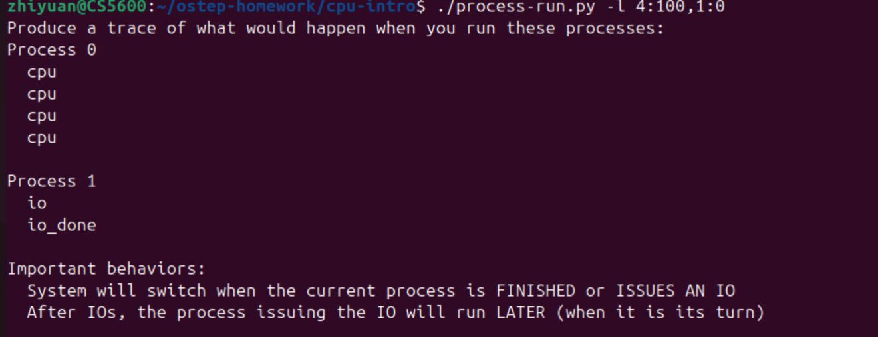
11 ticks, p0 using cpu for 4 ticks, p1 using cpu in io for 1 tick then blocked for 5 ticks then be done using cpu for 1 tick, 4+1+5+1=11 ticks.
- Switch the order of the processes: -l 1:0,4:100. What happens now? Does switching the order matter? Why? (As always, use -c and -p to see if you were right)
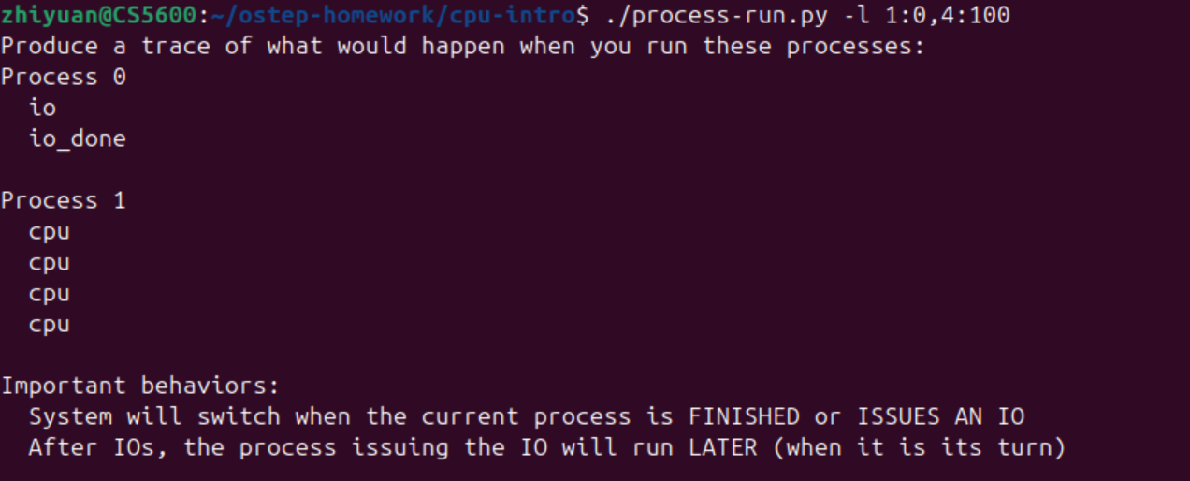
Should be 7 ticks, as p0 run first, it will use CPU for first tick then p1 start using CPU for 4 ticks, after io p0 using CPU for 1 tick.
- We’ll now explore some of the other flags. One important flag is -S, which determines how the system reacts when a process issues an I/O. With the flag set to SWITCH ON END, the system will NOT switch to another process while one is doing I/O, instead waiting until the process is completely finished. What happens when you run the following two processes (-l 1:0,4:100 -c -S SWITCH ON END), one doing I/O and the other doing CPU work?
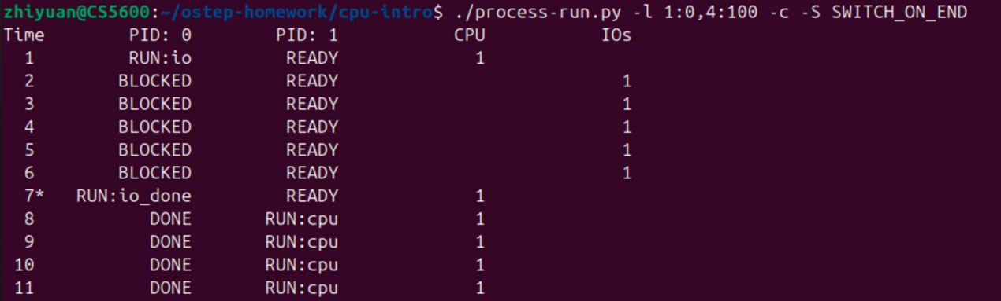
Same as question 2, cause p1 will not using CPU until p0 is done.
- Now, run the same processes, but with the switching behavior set to switch to another process whenever one is WAITING for I/O (-l 1:0,4:100 -c -S SWITCH ON IO). What happens now? Use -c and -p to confirm that you are right.
Same as question3, it will use 7 ticks.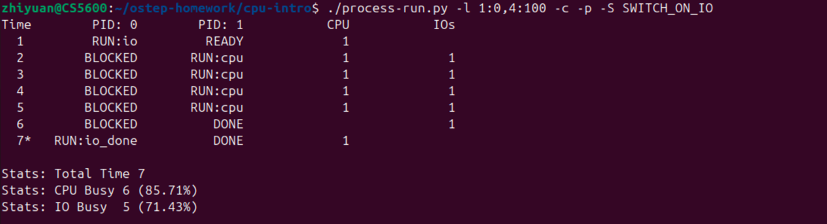
- One other important behavior is what to do when an I/O completes. With -I IO RUN LATER, when an I/O completes, the process that issued it is not necessarily run right away; rather, whatever was running at the time keeps running. What happens when you run this combination of processes? (./process-run.py -l 3:0,5:100,5:100,5:100 -S SWITCH ON IO -c -p -I IO RUN LATER) Are system resources being effectively utilized?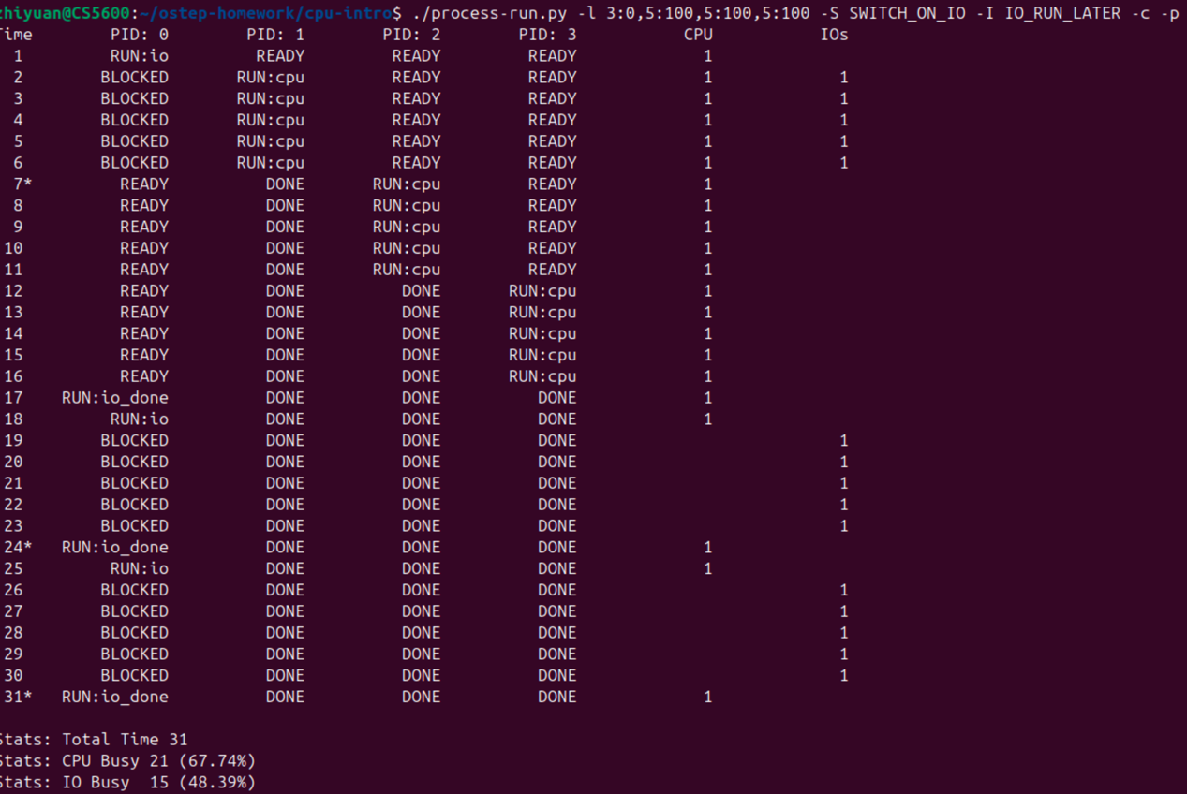
P0 will wait for CPU so it will be in io for 3 times and wait CPU for 10 ticks so it will takes 31 ticks.
- Now run the same processes, but with -I IO RUN IMMEDIATE set, which immediately runs the process that issued the I/O. How does this behavior differ? Why might running a process that just completed an I/O again be a good idea?
Compare the output with question 6, p0 will take over CPU immediately so that other process can using CPU while p0 is BLOCKED, which help save 10 ticks of CPU time. As CPU is always be using.
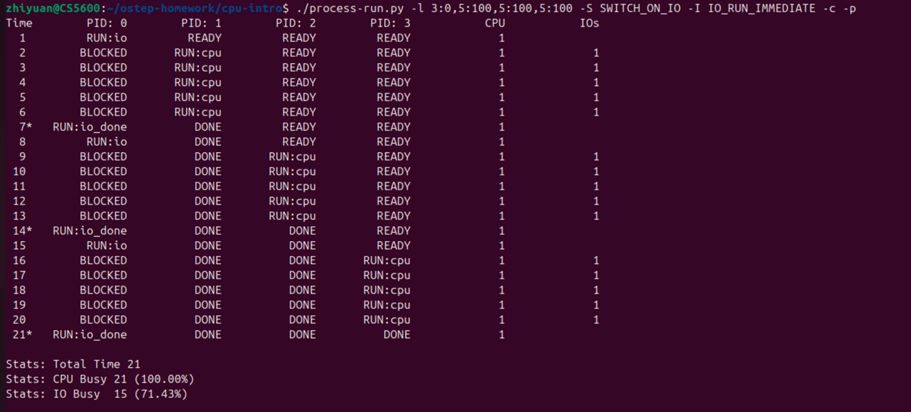

- Now run with some randomly generated processes using flags -s 1 -l 3:50,3:50 or -s 2 -l 3:50,3:50 or -s 3 -l 3:50, 3:50. See if you can predict how the trace will turn out. What happens when you use the flag -I IO RUN IMMEDIATE versus that flag -I IO RUN LATER? What happens when you use the flag -S SWITCH ON IO versus -S SWITCH ON END?
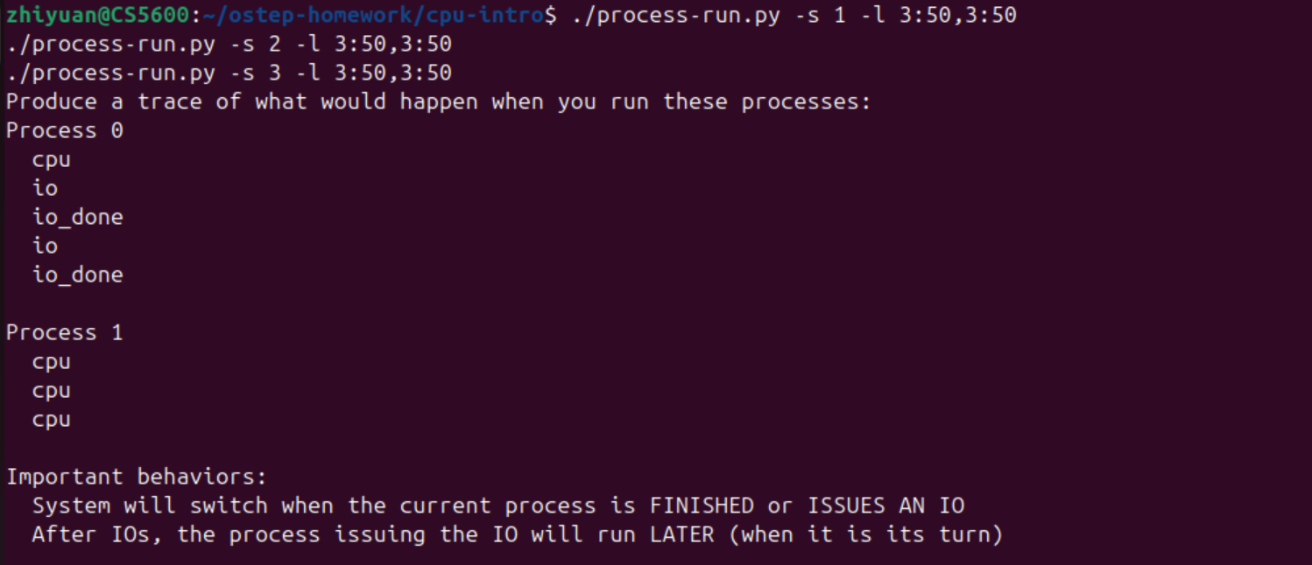
﻿hiyuan@CS5600:~/ostep-homework/cpu-intro$ ./process-run.py -s 1 -l 3:50,3:50 -S SWITCH_ON_IO -I IO_RUN_LATER -c -p
./process-run.py -s 1 -l 3:50,3:50 -S SWITCH_ON_IO -I IO_RUN_IMMEDIATE -c -p
./process-run.py -s 1 -l 3:50,3:50 -S SWITCH_ON_END -I IO_RUN_LATER -c -p
./process-run.py -s 1 -l 3:50,3:50 -S SWITCH_ON_END -I IO_RUN_IMMEDIATE -c -p
Time PID: 0 PID: 1 CPU IOs
1 RUN:cpu READY 1
2 RUN:io READY 1
3 BLOCKED RUN:cpu 1 1
4 BLOCKED RUN:cpu 1 1
5 BLOCKED RUN:cpu 1 1
6 BLOCKED DONE 1
7 BLOCKED DONE 1
8* RUN:io_done DONE 1
9 RUN:io DONE 1
10 BLOCKED DONE 1
11 BLOCKED DONE 1
12 BLOCKED DONE 1
13 BLOCKED DONE 1
14 BLOCKED DONE 1
15* RUN:io_done DONE 1

Stats: Total Time 15
Stats: CPU Busy 8 (53.33%)
Stats: IO Busy 10 (66.67%)

Time PID: 0 PID: 1 CPU IOs
1 RUN:cpu READY 1
2 RUN:io READY 1
3 BLOCKED RUN:cpu 1 1
4 BLOCKED RUN:cpu 1 1
5 BLOCKED RUN:cpu 1 1
6 BLOCKED DONE 1
7 BLOCKED DONE 1
8* RUN:io_done DONE 1
9 RUN:io DONE 1
10 BLOCKED DONE 1
11 BLOCKED DONE 1
12 BLOCKED DONE 1
13 BLOCKED DONE 1
14 BLOCKED DONE 1
15* RUN:io_done DONE 1

Stats: Total Time 15
Stats: CPU Busy 8 (53.33%)
Stats: IO Busy 10 (66.67%)

Time PID: 0 PID: 1 CPU IOs
1 RUN:cpu READY 1
2 RUN:io READY 1
3 BLOCKED READY 1
4 BLOCKED READY 1
5 BLOCKED READY 1
6 BLOCKED READY 1
7 BLOCKED READY 1
8* RUN:io_done READY 1
9 RUN:io READY 1
10 BLOCKED READY 1
11 BLOCKED READY 1
12 BLOCKED READY 1
13 BLOCKED READY 1
14 BLOCKED READY 1
15* RUN:io_done READY 1
16 DONE RUN:cpu 1
17 DONE RUN:cpu 1
18 DONE RUN:cpu 1

Stats: Total Time 18
Stats: CPU Busy 8 (44.44%)
Stats: IO Busy 10 (55.56%)

Time PID: 0 PID: 1 CPU IOs
1 RUN:cpu READY 1
2 RUN:io READY 1
3 BLOCKED READY 1
4 BLOCKED READY 1
5 BLOCKED READY 1
6 BLOCKED READY 1
7 BLOCKED READY 1
8* RUN:io_done READY 1
9 RUN:io READY 1
10 BLOCKED READY 1
11 BLOCKED READY 1
12 BLOCKED READY 1
13 BLOCKED READY 1
14 BLOCKED READY 1
15* RUN:io_done READY 1
16 DONE RUN:cpu 1
17 DONE RUN:cpu 1
18 DONE RUN:cpu 1

Stats: Total Time 18
Stats: CPU Busy 8 (44.44%)
Stats: IO Busy 10 (55.56%)

