|  |  |  |  |  |  |
| --- | --- | --- | --- | --- | --- |
| Student Name | |  | Student Number |  | |
| Unit Code/s & Name/s | | ICTPRG535 Build advanced user interfaces  ICTPRG556 Implement and use a model view controller framework | | | |
| Cluster Name  *If applicable* | | Web Interface Cluster | | | |
| Assessment Type | | Case Study  Assignment  Project  Other *(specify)* | | | |
| Assessment Name | | UI Design and Develop Research Questions | Assessment Task No. | | 1 of 2 |
| Assessment Due Date | |  | Date Submitted | / / | |
| Assessor Name | |  | | | |
| **Student Declaration:** I declare that this assessment is my own work. Any ideas and comments made by other people have been acknowledged as references. I understand that if this statement is found to be false, it will be regarded as misconduct and will be subject to disciplinary action as outlined in the TAFE Queensland Student Rules. I understand that by emailing or submitting this assessment electronically, I agree to this Declaration in lieu of a written signature. | | | | | |
| Student Signature |  | | Date | / / | |
| **PRIVACY DISCLAIMER:** TAFE Queensland is collecting your personal information for assessment purposes. The information will only be accessed by authorised employees of TAFE Queensland. Some of this information may be given to the Australian Skills Quality Authority (ASQA) or its successor and/or TAFE Queensland for audit and/or reporting purposes. Your information will not be given to any other person or agency unless you have given us written permission or we are required by law. | | | | | |

|  |  |
| --- | --- |
| Instructions to Student | **General Instructions:**  You are required to answer 18 questions using your own research skills to provide the answers along with examples that illustrate your answers. You are also required to include a list of references at the end which includes all the sources you accessed. Ensure you use an appropriate reference style. There are websites available which generate them for you. One of these is [MyBib - Free Harvard Referencing Generator](https://www.mybib.com/tools/harvard-referencing-generator)  **Acceptable Answers:**  The answers provided to the questions in this assessment must be of a level of academic quality, using correct sentence structure, punctuation and spelling. While no minimum length is stated for each question, it is required that you provide answers that clearly demonstrate your knowledge, supported by an appropriate example or diagram.  An example unacceptable answer to a question:  Q: Describe the process of submitting assessment to Connect:  A: you click upload and select your file.  **Information / Materials Provided:**  A computer with internet access provided in classroom  Word processing software on classroom computers  **Work, Health and Safety:**  The environment should be assessed for safety prior to class. Special considering should be taken regarding potential ICT related hazards such as tripping hazards, electromagnetic radiation, ergonomics and posture.  TAFE Queensland health and safety policies and procedures should be followed at all times.  **Details of Location:**  TAFE will provide simulated work environment in the classroom all practical activities should be completed in the classroom with teacher/tutor assistance; however, it is possible to complete these tasks on a home computer with internet access, web browser and office suits or similar.  **Time Restrictions:**  Students can start completing this assessment from week 2, however students have until week 7 to complete and submit the assessment.  **Level of Assistance Permitted:**  Teachers and tutors should be available in class, and accessible by email for students working from home. Staff cannot directly provide students answers but can guide them to where to go to complete tasks individually.  If you are unable to submit an assessment you must notify your teacher before the assessment due date and supply a doctor’s certificate and an extension approval from the team manager.  Reasonable adjustments will be made for students as and when appropriate, after consultation with the Accessibility and Counselling team. You must see your teacher prior to assessment regarding this.  RPL (Recognition of Prior Learning) is available for this unit. Speak to your teacher/assessor to check if you qualify for RPL.  **Assessment Criteria:**  To achieve a satisfactory result, your assessor will be looking for your ability to demonstrate the following key skills/tasks/knowledge to an acceptable industry standard:   1. Object-Oriented programming 2. Client-Side programming 3. HTTP protocol 4. Debugging and testing tools relative to MVC applications 5. Principles of the MVC design pattern 6. HTTP request + response concepts 7. HTTP methods, routing and query parameters 8. Convention vs configuration in application development 9. HTML templates and dynamic rendering 10. Data models and view models 11. Web Design languages: 12. Hypertext Markup Language 13. Cascading Style Sheets 14. JavaScript 15. User Interface prototyping techniques. |

|  |  |
| --- | --- |
|  | **Number of Attempts:**  You will receive up to two (2) attempts at this assessment task. Should your 1st attempt be unsatisfactory (U), your teacher will provide feedback and discuss the relevant sections / questions with you and will arrange a due date for the submission of your 2nd attempt. If your 2nd submission is unsatisfactory (U), or you fail to submit a 2nd attempt, you will receive an overall unsatisfactory result for this assessment task. Only one re-assessment attempt may be granted for each assessment task.  ***For more information, refer to the Student Rules.*** |
| Submission details | Insert your details on page 1 and sign the Student Declaration. Include this template with your submission.  **Due Date:** Week 15  You are required to answer the questions in this document in the space provided under each question and save the document as:  ClusterName_StudentNameorNumber_AssessmentNumber.  For example:  WebInterface_123456789_AT1  Or  WebInterface_SteveSmith_AT1  For re-submissions, an “R” must be added to the file name. For example:  WebInterface_SteveSmith_AT1_R  Assessment to be submitted to the appropriate assessment folder in **Connect.**  TAFE Queensland Learning Management System: Connect url: [*https://connect.tafeqld.edu.au/d2l/login*](https://connect.tafeqld.edu.au/d2l/login)   * Username; 9 digit student number * For Password: Reset password go to [*https://passwordreset.tafeqld.edu.au/default.aspx*](https://passwordreset.tafeqld.edu.au/default.aspx) |
| Instructions for the Assessor | To be judged competent in this assessment item the student is required to demonstrate competence in all indicators shown in the marking guide.  Depending on the delivery mode and/or timetable constraints, the Study Guide and the Study Schedule must be customised to suit the mode.  **Specifications of Assessment:**  There are 18 main questions that must all be answered correctly to achieve a satisfactory result for this assessment. Students will be able to resubmit their work a second time if they are not successful on the first attempt.  **Equipment pr Material Requirements:**   * A computer with internet access * Word processing software   **Details of Location:**  TAFE will provide a simulated work environment in the classroom; however, it is possible to complete these tasks on a home virtual network using a computer with internet access.  **Level of Assistance Permitted:**  Teachers and tutors should be available in class, and accessible by email for students working from home. Staff cannot directly provide students answers but can guide them to where to go to complete tasks individually.  **Interactions:**  Teamwork skills are essential in the IT industry; therefore, students should work in teams to consult and collaborate on the practical activities. However, each student is required to complete the tasks individually.  **Contingencies:**  Reasonable adjustments will be made for students as and when appropriate, after consultation with the Accessibility and Counselling team. – You must see your teacher prior to assessment regarding this.  **Work Health and Safety:** A work health and safety check of the assessment environment is to be conducted prior to the assessment and any hazards addressed appropriately. |
| Note to Student | An overview of all Assessment Tasks relevant to this unit is located in the Unit Study Guide. |

1. Provide a Diagram that demonstrates the communication that occurs when a browser requests the webpage: [www.google.com](http://www.google.com) include a description of the technologies used to allow the HTTP request and response to occur.

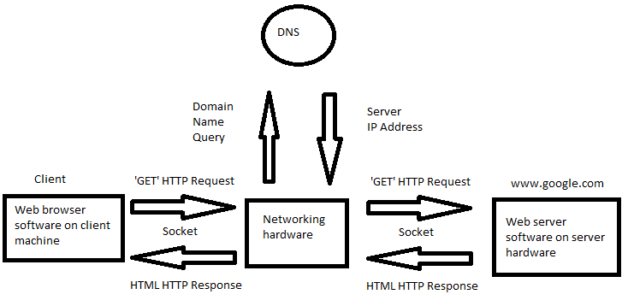

A Web browser is a piece of software that interfaces with web severs via http requests. They present data received from the server to the user in a graphical user interface (GUI). Firefox, chrome, internet explorer are all good examples of web browsers.

A socket is a connection to another piece of software. This connection can be thought of as a pipe, what ever goes in come out on the other side.

Networking hardware carries the data from one place to another and routes it accordingly. Routers, network switches, and physical cables are all examples of networking hardware.

DNS (Domain Name System) are servers that know what IPs are behind domains. A domain looks like this “ [www.google.com](http://www.google.com)” and an IP address look like “123.123.123.123”.

Web server software hosts websites for web browsers to access. A web server can run additional programs such as ftp server software.

Server hardware is a purpose-built computer designed for running server hosting software. Server hardware usually has a high amount of memory, a high amount of storage, and a high performance CPU. Servers are usually utilised in datacentres.

1. Match the following HTTP Response Codes to the correct description

***Status Code:*** *405, 500, 200, 400, 201, 415*

|  |  |
| --- | --- |
| HTTP Status Code | Description of Status Code |
| 500 | Internal Server Error |
| 400 | Bad Request |
| 405 | Method Not Allowed |
| 200 | Okay |
| 201 | Created |
| 415 | Unsupported Media Type |

1. Describe three different components of a HTTP Request
2. Request line. This is a single line at the top of the request which describes the request method (e.g. get, post, put, etc…) the request path (e.g. /index.html) and the http protocol version (e.g. HTTP/1.1)
3. The headers. This provides additional information about the request. This can generally be split into 3 parts; request headers (user-agent, accept, accept-encoding), general headers (connection information), and representation headers (body information e.g. content-type, content-length)
4. The body. This contains the data of the request such as the webpage html or form data
5. Consider the following webrequest:

<https://www.webaddress.com?firstname=william&lastname=shakespeare>

Identify any provided parameters, including the keys and values and describe this style of providing parameters, including how they may be interpreted by the server.

This is a request to [www.webaddress.com](http://www.webaddress.com) using the https protocol.

The “?” in the URL signifies that data after is query parameters

The “&” sign separates each parameter from each other so that the server can interpret multiple parameters

The “=” sign is between the parameters key and value for example firstname=william means that the parameter “firstname” has a value of “william”.

This server will interpret the parameters as follows:

* Firstname is “william”
* Lastname is “shakespeare”

Consider the following Class and method definitions:

|  |  |
| --- | --- |
|  | public class Note  {  public int NoteID { get; set; }  public string NoteText { get; set ; }  }  public ActionResult CreateNote(Note note)  {  Console.WriteLine(note.NoteID);  Console.WriteLine(note.NoteText);  } |

a) If a client was attempting to use the method ‘CreateNote’ defined above, how could they pass the data required for the ‘note’ object, and what is the name of the concept that assists in mapping the input parameters to the Model.

This concept is called model binding. A client would pass the data through by providing the note object in json in the requests body.

This is what the request would look like:

|  |  |
| --- | --- |
|  | POST / HTTP/1.1  Host: www.webaddress.com  Content-Type: application/json  {  "noteID": 0,  "noteText": "The note text"  } |

b) Describe appropriate response codes to send as a response from a method that is creating a new object, including codes that could be used for both success and failure.

If we successfully created the object then we should send 201 created with a location header pointing to the new object. Alternatively, we could send 204 No Content or 200 OK to say that the object was created

If we could not create the object due to the object already existing then we should respond with 409 Conflict to tell the client that the data provided conflicts with existing data.

If we could not create the object due to a server error then we should respond with 500 Internal Server Error to tell the client that we could not create the object due to a server error.

If we could not create the object due to the client providing invalid data then we should respond with 400 Bad Request to tell the client that what they sent us is invalid.

1. Describe the concept of routing, in the context of handling a HTTP request to a method in an MVC application and returning HTML content.

Routing is where the MVC application picks the appropriate controller and endpoint that a request should go to based on the request method, request path, request content, and response types allowed. The appropriate controller and endpoint will be handed the request and the endpoint will generate the response and return it to the client.

Describe the purpose of using Models to represent the structure of data in relation to representing data in a view, and receiving data from a view when using HTML template engines

Models are used to define the schema of data, and to hold the data itself. In addition to this, models can have validation rules to enforce that the model is valid. For example, this can be useful in ensuring that the length of a message does not exceed a pre-defined maximum.

Models have a static schema which means that no matter what, any fields defined in the model will exclusively be present. This makes models a great option for data mapping/binding. When a model is used in a view, the fields of the model can be used as values on the page such as the email and birthday.

1. Define the paradigm of ‘Convention over configuration’ and provide an example of where this is beneficial in an MVC application

The ‘convention over configuration’ paradigm is a software development approach that encourages defining reasonable default values instead of explicit configuration. This makes development simpler and faster by not requiring developers to define everything manually.

This approach can be seen in MVC quite often. One notable example is the controller names and locations. The application can automatically map/route endpoints and controllers to their respective paths. For instance, we have a “users” controller with a “get” endpoint and the endpoint takes a ID value. MVC can automatically figure out that this endpoint should be mapped to the url “/users/{ID}” without explicit configuration.

1. Describe at least 2 Debugging tools that can help in the development of an MVC application, including the primary function and features provided

Browser side dev tools such as element inspection, network activity recording, javascript console, and more…

Chrome provides a tool called “dev tools” it includes all of the above features. Browser side debugging tools can help solve UI issues, identify performance concerns, test your ideas real time, and identify client side bugs (bad requests, invalid data, logic errors, etc…)

Server side debugging such as breakpoints, watches, logging. Most server side languages have debugging features built in, by far the best tool is breakpoints. Using conditional breakpoints on the server side can help pause program execution exactly when the variables match what’s required.

There isn’t really a specific tool that implements the above functionality as almost all languages have their own debugging implementation

1. \Describe at least 2 Testing tools and methods that can help in the development of an MVC application, including the primary function and features provided

NUnit is a open source unit testing framework for .NET and C#. NUnit allows developers to write tests for individual methods and classes within a MVC application and ensure they are functioning as expected. The primary features of NUnit are:

1. Output validation. (Ensuring that a method has the expected output for the test to pass)
2. Parallel test execution. (Running multiple tests at the same time)
3. Test case sourcing. (Importing data from a file to build tests)
4. Test execution ordering. (Useful when one test depends on another test running before it)

Puppeteer is an open source high level web browser automation api. It allows the developer to write test cases that automate tasking in a web browser. Some tasks may include user interaction, data scraping, screenshots. This allows the developer to check that not only their GUI works as expected but also the server side software.

The main features of puppeteer are:

1. Simple intuitive API. (Easy to write code for)
2. Headless browser testing. (Can run test cases without opening a browser window)
3. Automated user interaction. (Can navigate and interact with a website programmatically)
4. Screenshot and pdf generation. (Can make generating documentation easier)
5. Create a diagram that clearly demonstrates the architecture of the MVC Design Pattern, describing the connections between the various parts

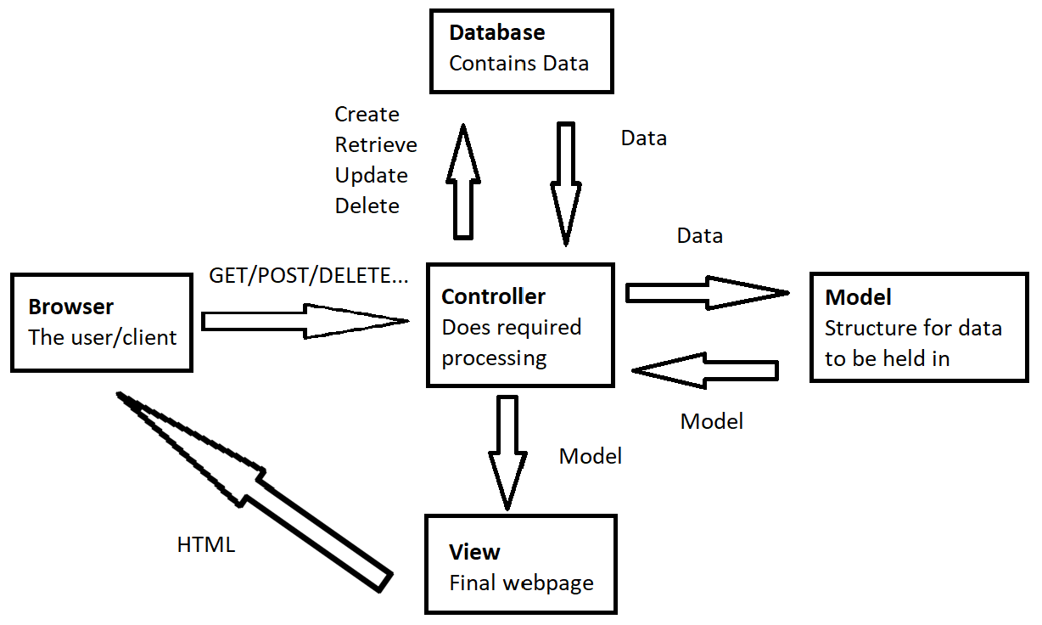

1. Describe the aspects of the MVC design pattern that assist in creating an application that is Scalable, Maintainable, and Reusable:

In a MVC (Model View Controller) application, all views controllers and models are separated. This means that, for example, if you needed to change a view you can do so without reprogramming the model or controller. This makes the program more maintainable.

In addition to this it makes code more reusable. Due to the nature of all Models, views, and controllers being separated it would be trivial to reuse a model in a different view or to reuse a view in different controllers.

MVC applications are more scalable in general due to the MVC design pattern. You can upgrade or replace a controller when you need to be able to handle more traffic, you can add new models, views, or controllers without disrupting existing functionality. This design pattern also allows multiple developers to be working on different Models, Views, or controllers without interfering with oher developers’ code. Thus making it more practical to scale the application.

1. Describe Client-Side programming including an example language, providing at least one situation where it may be the preferred choice over Server-Side programming.

Client-side programming is where a program runs on the clients machine instead of the server. This can be useful in providing information quicker (not connecting to the server in the first place), performing client-side logging, sending complex requests to the server, dynamic real-time webpages, and more… One example where this may be useful is theme switching. Lets say that the webpage needs to change the theme. Instead of sending a request to the web-server for new content with the desired theme, the client’s machine can change/generate the content which can reduce server load and decrease loading times.

A commonly used client-side language is JavaScript

1. Describe the purpose of each of the following languages in the context of designing a User Interface for a web application including an example in each language:

a) Hyper Text Markup Language

HTML is used to define a webpages’ elements and layout.

An example of html is:

|  |  |
| --- | --- |
|  | <html>  <b>Hello World</b>  </html> |

The above html would display “Hello World” in bold

b) Cascading Style Sheets

CSS is used to define the style of a webpage and manipulate how elements are displayed.

An example of CSS is “color:Red;”. This can be used inline or defined in a style element.

An inline example is:

|  |  |
| --- | --- |
|  | <html>  <b style=”color:Red;”>Hello World</b>  </html> |

The above would display “Hello World” in bold and with a red font.

c) JavaScript

Javascript is used to run programs on the client’s machine within the web page. This can manipulate elements, send requests, interact with the browser, and more.

An example of javascript is “alert(1);”

Javascript can be defined in html via the <script> element:

|  |  |
| --- | --- |
|  | <script>  alert(1);  </script> |

The above will create a pop-up alert with the content “1”

1. Describe the difference between the following User Interface concepts: Wireframe, Mock-up, Prototype. Include in your answer a description of the importance of each concept.

**Wireframing** is a visual representation that can be quickly modified and does not include much detail. Wireframes are usually used early in a projects development to help confirm a interfaces layout and structure with the client. The key trails of wireframing are; lack of colour, lack of fine detail (such as images), being reviewed while designing, comments to help provide additional detail, no functionality implemented. Wireframing is an important step which can help avoid large changes later in the project.

**Mock-Up** is a more refined visual representation of the UI. Mock-Ups usually have final graphics, fonts, colours, and styles present on them but lack functionality at this stage. The primary purpose of a mock up is to finalise the UI with the client before development. Similarly, to the previous step, Mock-Ups are important because they help work out the fine details with the client before large scale development commences.

**Prototype** is a detailed interactable representation of the final product. Not all features are implemented at this stage but important core functionality is most likely present. Prototypes are primarily used to provide internal testing and collect feedback from the client on the user interaction. Features can still be changed, removed, or implemented at this stage but may be more difficult than previous stages. Prototypes are crucial in fixing bugs and tackling development problems before release.

1. List and Describe at least 2 Object Oriented Programming languages, including the features of OOP languages that assist in developing User Interface applications.

C# and java are both object-oriented programming languages they are commonly used in the industry and have good UI frameworks available to them. Their main features are automatic memory management, garbage collection, portability, and reliability.

Object oriented languages are well suited to UI implementation due to;

1. Inheritance of functionality:

Functionality of UI components can be defined once and inherited by components that utilise that functionality. For example, buttons can redirect to different views but a text component can implement this functionality as well by inheriting it. This allows for more customisability in development and reduces time spent writing redundant or repeated code.

1. Encapsulation of functionality

Components can encapsule their functionality, this can make implementation easier. For example, buttons can change colour when hovered over. The developer does not need to make external methods to watch for a hover event. The button handles this functionality on its own. Making code cleaner

1. Abstraction of UI functionality

Abstraction allows for components to hide complicated logic and present easy methods for a developer to integrate into their project. For example, when changing the text of a component, the developer simply sets the text of the component. In changing this text, abstraction hides the need for recalculating text wrapping or changing the size of UI components. This allows a developer to write more readable, cleaner code faster.