Back end development assignment

Craig Pritchard

Student ID; l38564408

Contents

ER Diagram 2

Introduction 3

Overview 3

Development 5

Validation 5

Technologies used 6

References 6

# ER Diagram

Segment of ER diagram for requirements of a space mission

Report of the programming segment to the assignment. The objective of this assignment was to create an ER diagram describing the necessary information for a space mission and functional localhost site to go along with it and then write a report explaining the process of how the site was created written in the third person

In this assignment you will find a small ER diagram showing the relation of different vehicles to the overall task of a space mission

# Introduction

A website was created so that people can manage entries into a space agency database and view data stored in there. It is created using PHP, SQL, phpMyAdmin and HTML.

# Overview

When the mission is conducted it is integral that a scientist on the command team can produce a server and run a database to store the details of the current and past missions and any astronauts involved, this is necessary to provide any information that someone may need immediately in a neat and tidy table rather than just being presented as a jumbled mess of words and numbers that would take time and effort to search through for the information required.

This requires the use of an SQL database to compile all the information and store it away until it is needed and also the use of a PHP writing program to pull desired information from the database and present it to the user without the need of scrolling through the data by hand.

The process of the system starts at the MySQL site which will contain a database with tables containing the mission details and information on any astronauts, these tables are used to store any info that may be needed by a worker on the mission’s team at a later date. The database is made up of four tables – astronaut, attends, targets and mission.

After the database is prepared a set of PHP files each named corresponding to a table in the MySQL page would be required to collect information needed to fill the tables and each PHP file would contain a different table to avoid the inputs becoming jumbled and sorted into the wrong table, if that was to happen the worker it could result in the entire database needing to be rebuilt from the beginning.

These PHP files contain HTML forms to allow people to enter info for the database to receive and these forms get filled in on a localhost server with two parts for each which are called the add page and the view page, these pages are named after their purpose where one adds the details to the table and the other presents the gathered data to the user.

The HTML forms will be paired with PHP commands such as echo which tell the program what text should be shown and which text should stay in the background, and the if command to change what shows up on screen when a certain input is put in wrong. If the commands are entered properly when someone enters their details the data will appear in the MySQL table and all should run smoothly but if one of the lines isn’t annotated correctly the whole site wouldn’t function.

Once the required data is entered the MySQL database will pull the data from the website and neatly organize everything in an instant and the data will be saved too.

After the data is saved the operator can go to the view page of the site to see all of the data without needing to access the MySQL site to avoid any tampering with the tables by unauthorised personal.

The view sites can be used to make sure all the information in the table is valid and correct before the date of the mission launch which is important as a date entered wrong could cause an astronaut to arrive to their mission late which would in turn cause the mission to be put on hold and doing this could cause serious effects to the mission outcome.

If there is a mistake entered into the database the operator can edit the data to correct the issue once they are alerted to the issue.

# Development

The XAMPP control panel running a localhost Apache server was used at first to test the website on a local machine. Then a virtual machine was set up using Microsoft Azure which runs a Linux environment. Codes were written locally then pushed to GitHub and pulled onto virtual machine. An Apache server also runs from the virtual machine to host the website online.

# Validation

If a certain piece of information is necessary for the table then the person behind the site can request verification on certain items on the table which makes it where an area cannot be left blank when attempting to make a submission. This is done by writing required in the HTML form entry.

# Technologies used

PHP was used because it is friendly with HTML and is easy to pair HTML form with PHP. It is a back-end language with no licencing fees and is easy to use. It is very commonly used for web development (see figure 1).

Figure 1 (Kamaruzzaman, M. 2021):

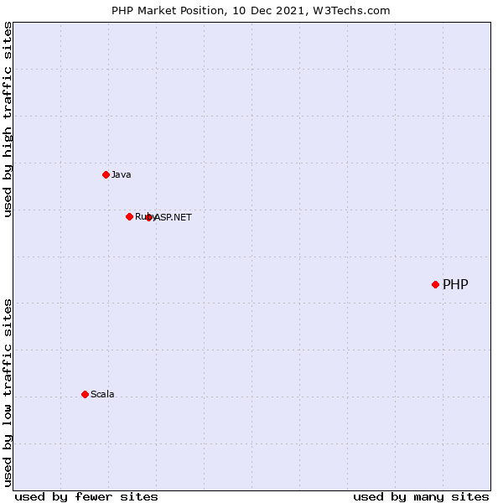

MySQL was used because it works inside PHP and it can work inside the virtual environment on Linux easily. It was the most popular database in 2020 (see figure 2).

Figure 2 (Stack Overflow):

GitHub was used because it is an easy way to keep track of changes in files and it is easy to move them from the local machine to virtual machine.

# References

Kamaruzzaman, M. (2021). *Top 10 Databases to Use in 2021*. [online] Medium. Available at: <https://towardsdatascience.com/top-10-databases-to-use-in-2021-d7e6a85402ba>.

‌ Stack Overflow. (n.d.). *Stack Overflow Developer Survey 2020*. [online] Available at: https://insights.stackoverflow.com/survey/2020#technology-databases-all-respondents4.